BONE GAP
BY LAURA RUBY

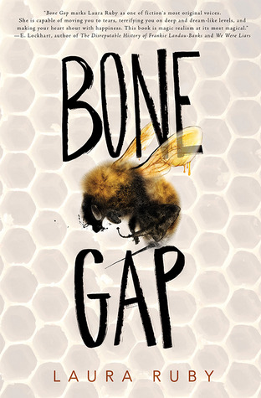
http://www.lauraruby.com/index2.php

http://www.lauraruby.com/index2.php

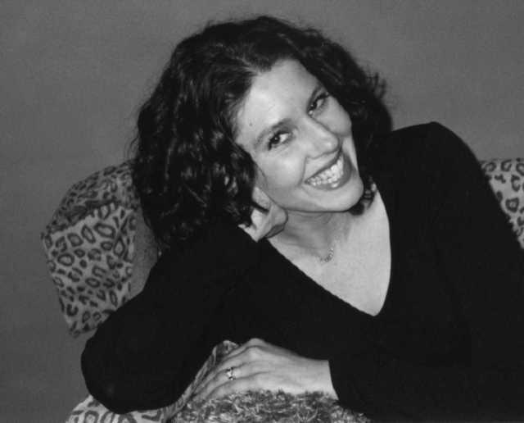
https://www.goodreads.com/author/show/73699.Laura_Ruby
Laura Ruby is the author of the young adult novel Bone Gap, a National Book Award Finalist and winner of the Michael L. Printz Award. She is also the author of children’s mystery Lily’s Ghosts, the children’s fantasy The Wall and the Wing, a sequel, The Chaos King and YORK trilogy beginning with The Shadow Cipher. She also writes contemporary fiction for older teens, and her debut young-adult novel, Good Girls, was a Book Sense Pick for fall 2006 and an ALA Quick Pick for 2007.

Her books have been nominated for the Edgar Award, the Carnegie Medal, and ALA Best Books for Young Adults, and have been included on the Chicago Public Library’s Best of the Best list and the New York Public Library’s Best Books for the Teen Age list, among others.

She is on the faculty of Hamline University’s MFA in Writing for Children and Young Adults program.

Ruby has been a featured speaker at BookExpo, the National Council of Teachers of English (NCTE) annual convention, the Miami Book Festival, the Florida Association of Media Educators (FAME) convention, the Midwest Literary Festival, the International Reading Association's annual convention, and Illinois Reading Council annual conference, among other venues, and she has presented programs and workshops for both adults and children at numerous schools and libraries.

https://www.highlightsfoundation.org/272/laura-ruby/

SUMMARY:

Bone Gap is full of mystery, gaps, and a parallel universe of magic. A young, beautiful girl named Roza, goes missing, but the people of Bone Gap were not surprised by her disappearance. Brothers Finn and Sean O’Sullivan who live on their own, question the disappearance of Roza. Finn, the protagonist of the novel, knows Roza was kidnapped, and taken from the cornfields by a dangerous man whose face he cannot recollect whatsoever. The story intertwines the characters of Finn, Roza, Petey, and the people of Bone Gap with their crazy pasts and horrible presents to understand themes of love, loss, mystery, and forgiveness in two parallel universes.

QUOTES:

- “Even now- after the people of Bone Gap had decided that Roza left the same mysterious way she had come, as if she were some shining gift that on one could claim, and that they would never have the privilege of understanding her past or being a part of her future- Finn was scanning the crowd for Roza’s glossy coiling hair, the lively bounce of her step, the smile so sunny that it seemed to blaze with a light on its own. But the people here didn’t bounce or blaze, they only pointed and whispered” (30-31).
-This quote introduces the conflict in the novel, which is Roza’s unknown disappearance. The people of Bone Gap gossip and whisper about Finn and Sean O’Sullivans’ past. Their word about Roza missing is dismissed because their mother left them at young age before and the community think people come and go as they please. Finn must prove a point to the community, but most importantly to his brother who loves Roza. Finn begins his investigation and finds himself in an emotional journey of love and loss.

- “He dug his fingernails into his wounded hand. No. He would do this. He had to. But they all looked the same. Or did they? Bees looked the same, and he had picked out the queen not because of her special stripes or even her size but because of the purposeful way she moved. She might be the only one fighting. But maybe Roza wouldn’t be able to move either, maybe she was as docile and unknowing as the rest. He closed his eyes and tried to picture her, but her features jumbled in his head, everyone’s and no one’s” (298).
-This quote is significant because it reveals Finn’s inability to facially recognize people. He never looks people in the eyes and he is always overthinking things in his head. The people of Bone Gap consider him lost or awkward. They call him Spaceman, Moonface because he is considered “weird.” However, Finn doesn’t actually have any serious mental disorder.
He suffers from prosopagnosia, a cognitive disorder of face perception. As the novel progresses, Finn’s character reveals his good intentions on wanting to find Roza and helping the people he love, his brother Sean, and the girl of his dreams, Petey.

- “Petey could have been a bee or a butterfly with her tattered silver wings veined with gold, the silver mask hiding her face. But because Petey was Petey, she had paired the wings and mask with a white T-shirt, a pair of cut-offs, and Converse gym shoes” (344).
-Priscilla Willis, “Petey” is the girl Finn is in love with. Although she is considered ugly to the community, Finn is in love with her. She, however, does not believe someone like Finn could be in love with her. Her character is important because their friendship symbolizes hope. When no one else believes Finn, she does. Petey and Finn’s relationship is based not on physical attraction, but emotional and mental connection.

TEACHING THE BOOK:

- This book can be used in a classroom for high school students grades 9th-12th. The text carries themes of identity, friendship, love, and obsession. These themes can be relatable to young readers who are continuously learning about themselves, and the worldly views. The characters in the novel present ways to cope with others who may not have the same point of view.

- I would use this book as reference to writing assignments. I would use quotes from the novel and have students write about a similar experience to one of the characters in the novel. If they cannot relate to any of the characters, I would suggest a writing assignment on what they would do in the situation of a specific character like Finn or Sean.

- This book also utilizes a lot of symbols, metaphors, and similes. This text can be used to identify them by taking notes of what and why they are presented in the text. Some examples are the community, gaps, the bee, the butterfly, the scare crow, and the family photo.

- The book offers a mystery yet to be solved which can be interesting for young readers who need something captivating to keep them reading until the very end.
TEXT COMPLEXITY

● Lexile: HL810L Ages 14-17
I believe that the reading range for this novel could be 13-17 because a younger, growing audience in 7th and 8th grade would still be able to benefit from reading the novel. The language is easy enough for young readers to comprehend and understand.

QUALITATIVE:
● Dale-Chall Formula:
Raw score 2.3679
Adjusted Score: (3.6365 + 2.3679)
Final Score: 6

New Dale-Chall Readability Index:
Grade level: Grades 7 - 8

QUANTITATIVE:
The novel connects with Exeter Quality #7: Themes that allow the possibility of emotional and intellectual growth through engagement with personal issues.

Just like the protagonist Finn who undergoes a roller coaster of emotions from no one believing in him, to him being the hero at the end of the novel, his character emotionally grows throughout the novel. This novel portrays characters for young readers to identify with or understand. There are topics such as loneliness, relationships with family and loved ones, and losing someone. Grades 7th-12th would be old enough to grasp these concepts and ideas represented through the characters in the novel.

Adolescents in the Search for Meaning: Tapping the Powerful Resource of Story

Bone Gap would fit Chapter 5: Books about Facing Death and Loss.
Loss is a major theme throughout the novel. Sean and Finn both lost their mother at a young age. She left them and Sean, being the eldest had to take care of his younger brother, Finn. The main conflict, is losing Roza. Roza lived with Sean as his lover, and a sister figure to Finn. Finn also loses hope in himself throughout his journey because the people of Bone Gap, the cops, and even his brother think he is lying.

Young adults would benefit from reading Bone Gap because they can learn lessons about losing someone, whether they end up returning or not. Young adults might also be able to understand a peer who lost a significant person in their life such as Sean and Finn who lost their mother.

More Works by Laura Ruby
https://lauraruby.com/books.php#top

