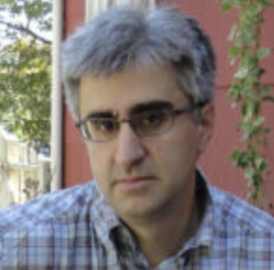
⋆ Len Vlahos ⋆
https://lenvlahos.com/
“Because the world really needs one more author site...Really.”
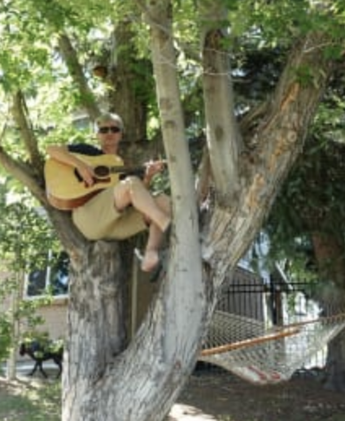
Vlahos grew up in Yonkers, New York in a what seems like a very middle-class family. He was drawn to the arts early on, he fell in love with music first. In the mid-eighties he attended NYU for film until he dropped out, so he was able to focus on Woofing Cookies, a punk-pop band. When the band eventually broke up, Vlahos found himself wanting to follow his other passion, books. Since he was constantly writing music for his band Len Vlahos was already familiar with the process.
Now Vlahos lives in Denver with his family where they own a bookstore named Tattered Cover.
☆Other Works by Vlahos☆
-The Scar Boys
-Scar Girl
-Hard Wired

⋆ LIFE IN A FISHBOWL ⋆
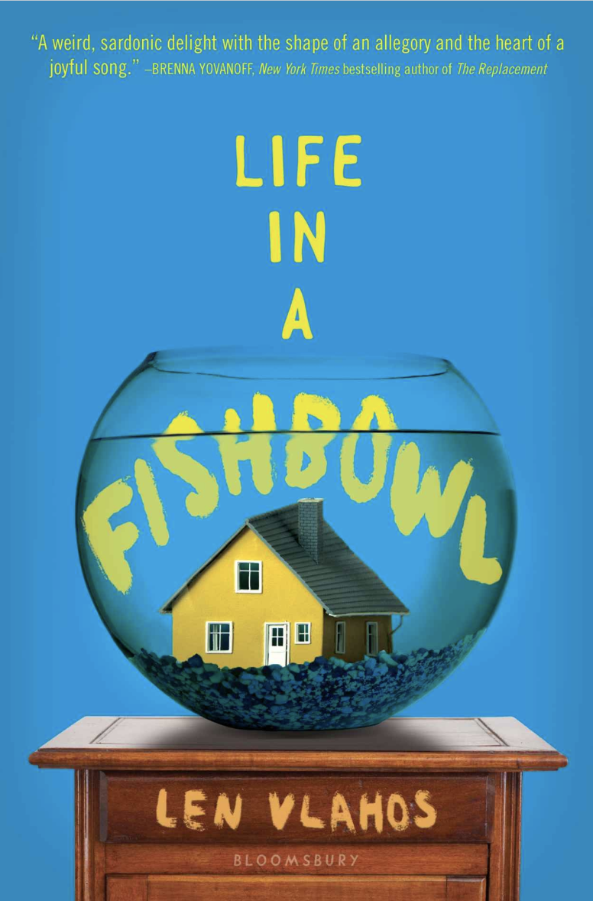
The novel follows the Stone family through the discovery that Jared Stone, the father, has a high-grade glioblastoma multiforme, a brain tumor. Unlike most novels where a family member becomes ill, the father informs his family of his illness through news teams showing up at the family's front door! Jared Stone decided to auction his life to the highest bidder on ebay because he wanted his family to be well provided for after he was gone, which was at the longest four months. A network producer ends up buying the man's life and films the families every second turning the family's worst nightmare into a reality tv show.
☆ The story is told in third person but follows multiple characters' stories as they adjust to the situation at hand, it even follows the brain tumors path, Glio.
☆ Publication: January 3, 2017

⋆ Significant Quotes ⋆
“*HUMAN LIFE FOR SALE*  Forty-five-year-old man with four months to live is selling his life to the highest bidder. You may do with him as you please- slavery, murder, torture, or just pleasant conversations…. There is a reserve for this auction” (Vlahos 29). | This quote demonstrates the ebay listing that Mr. Stone made to sell his own life to the highest bidder. It shows how desperate he was trying to figure out a way to take care of his family even after death. The desperation behind his words is clear, even in the add, hoping that someone will save his family financially. Stones character is revealed even in a haunting time like finding out he is going to die.
“I’m not going to tell America that I was just sad because of my dad’s illness….. she had come to ask, which she read from a prepared script, she left the room without saying a word” (Vlahos 252-253). | This passage displays Jackie's strong will. Although she is perceived as a quiet girl, she is not one to doubt. She shows her strong will and the fact that she wants her family's tragedy to stop being filmed, she stands up when no one else does.
“Deirdre took a deep breath and closed her eyes, looking for the courage to do what her Jared wanted, but it wasn’t there ...Deirdre was prepared to stay there until the end of time” (Vlahos 308-309). | Deirdre, the mother of the family, stands up and takes back control of the Stone family's life in the last few pages of the novel. She takes a stand to the network by not letting them control her family's actions any further. By her killing her husband she is putting him out of his misery and his entire families.

⋆ Teaching it to a Classroom ⋆
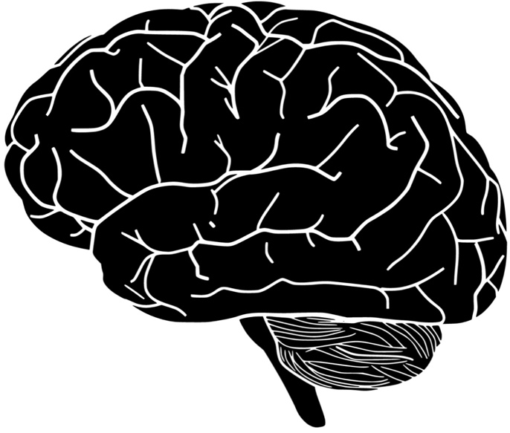
☆ Recommended Reading Level: 10th grade & up
☆ Interest Students Ages: 13 to 17
I believe that this novel would be a great read for students in 9th and 10th grade or late high school. There are a few cuss words in the work which is why I wouldn’t suggest it to a much younger audience. The work could impact children who have gone through any struggles interacting with a sick loved one as well. This novel could also be taught with Fahrenheit 451; students could discuss the rebellion aspects in each novel.
The book falls under chapter 4, 5, 6, and 7 in the Adolescents in the Search for Meaning: Tapping the Powerful Resource of Story. The book falls under chapter four due to the fact that a few students understand what it feels like to have a parent who is terminally ill. Although some of the book is far fetch, it would be able to help students who are struggling in facing death deal with the experience. Chapter five can be seen throughout the entire book. When Mr. Stone discovers his tumor, the entire family begins to mourn before he is even gone. Chapter six is able to be seen when Jackie is trying to discover her place within her family. She is extremely close with her father and is bullied by her sister often so has to figure out how to fit in with the new challenges. Finally, chapter seven is shown in the novel through the entire family's journey of discovering how to survive with Mr. Stones death sentence.
To teach this novel to a classroom I would have them write a journal entry about how they believe they would act if they were in Jackie’s situation. I would have them then discuss ways that they could get through the situation as groups, what resources they could lean on for help.

⋆ Text Complexity ⋆
☆ Lexile Range: 810L- 1000L
☆ Lexile Range: ~4th Grade
☆ Dale-Chall: 7.7
☆ Dale-Chall: Grades 9-10
The text complexity for Life in a Fishbowl according to Lexile Range is around fourth grade. However, since the novel does touch on a few sensitive topics and contains profanity I would agree with the Dale-Chall range. Dale-Chall range places the novel at 7.7, which is ninth or tenth grade. I believe this grade level is more appropriate for the text. Vlahos placed the book at an interest level of age thirteen through seventeen.

