Angeles Rojas
English 112B
10/26/2020
The Way I Used to Be
- Author
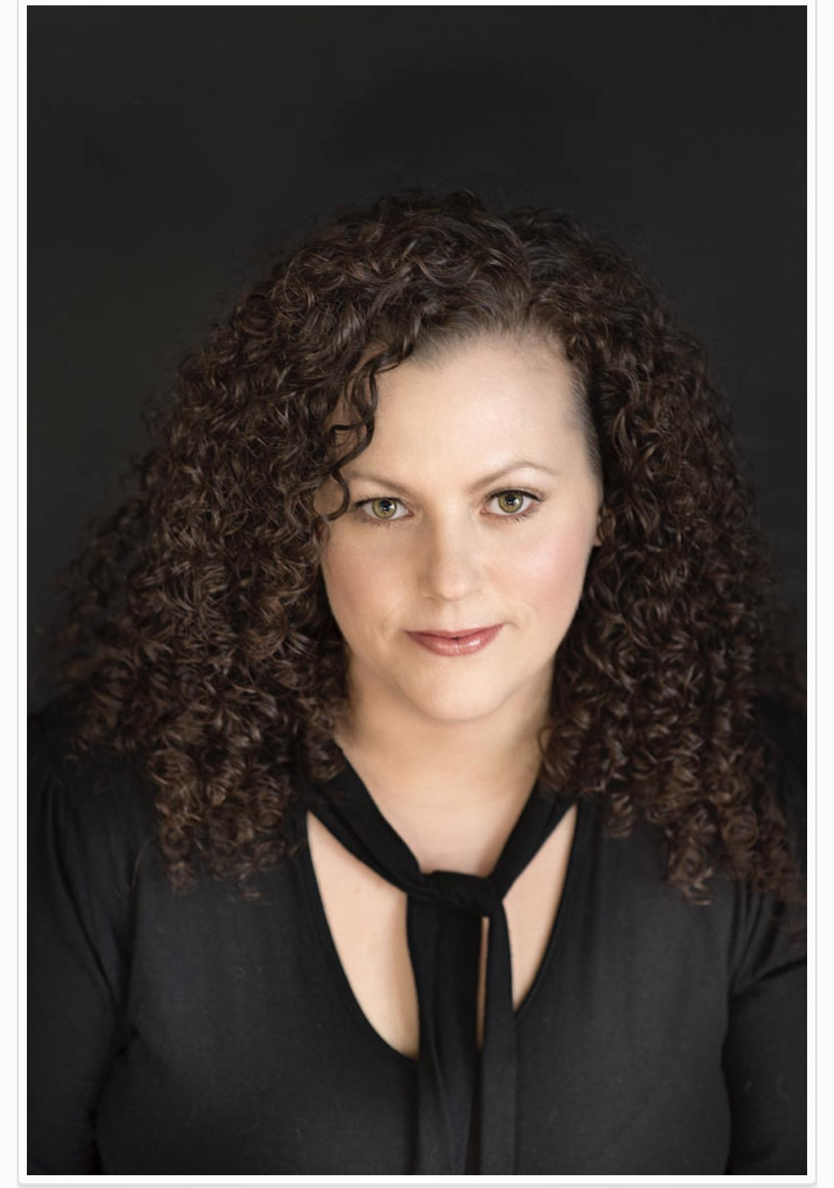
Amber Smith grew up in Buffalo, NY but currently lives in Charlotte, North Carolina with her partner and all of her rescued dogs. She has written several best selling novels such as The Way I Used To Be, Last To Let Go and Something Like Gravity. She is a strong advocate against issues such as sexual assault, violence and also advocates for equality for the LGBT community, she uses her writing to talk about these issues in the hope that they will spark a conversation and hopefully create some change down the line.
- Summary:
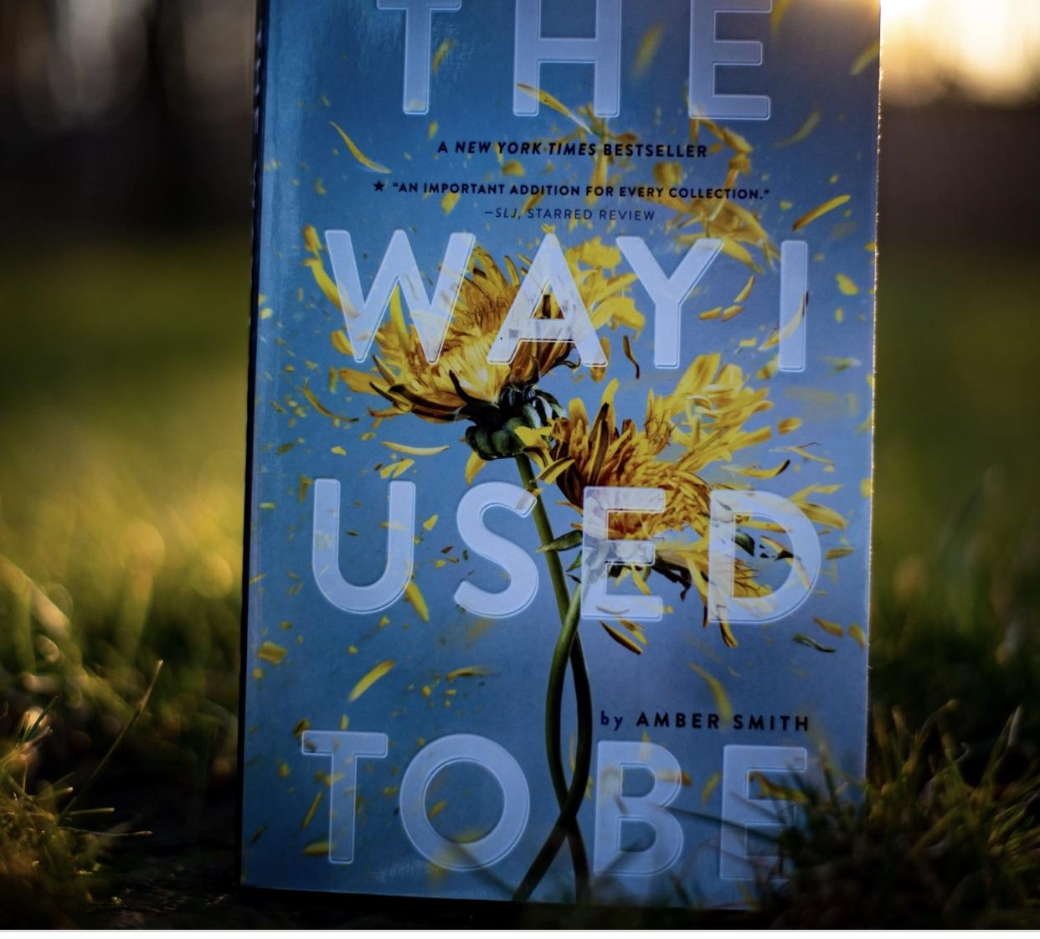
https://sarahboubookreviewshome.files.wordpress.com/2019/01/td0_5388.jpg?w=1400
This novel centers around Eden, a typical teenage girl just starting her freshman year of high school. Eden has always been close to her family, especially her older brother, Caelin, she’s always been a good kid but that all changes the night her brother’s best friend rapes her. Eden is afraid to tell anyone about what happened to her because she believes that Kevin would hurt her again but mostly afraid that no one would believe her so she decides to keep quiet. Throughout the four different parts of the novel which represent Eden’s four years in high school we get to see her struggle with what happened to her and turn to self destructive behavior in order to regain some control over her life, control that she feels has always been taken away from her.
- Quotes
“I don’t want to be on my bed…” (223) This quote shows how much the trauma is still present inside Eden, years have passed since what Kevin did to her and she still chooses to sleep on the floor instead of her bed. Her bed is a constant reminder of what happened to her and ever since that first night, when she refused to lay down on the floor instead, throughout the novel there are references to her sleeping on the floor in a sleeping bag in order to avoid sleeping in her bed. The fact that even in her intoxicated state she still refuses to sleep in her bed shows how even though she pretends to hide it and the trauma is still so deeply engraved within her.
“This isn’t who I was supposed to be. I used to be a nice, sweet, good person…” (346) This quote is important because it shows that Eden feels like she is a completely different person than she was before she was raped. This is what gives the novel its title. Eden feels like she can’t be that person ever again, like what happened to her has filled her with so much hatred that that's all she has, all that she can be. She believes that she has to be this tough, harsh person because the previous Eden was destroyed and there is nothing left of her to save.
“...All these maybes swimming around make me think that “maybe” could just be another word for hope” (367). This quote is at the end of the book and symbolizes that Eden has finally regained hope. Ever since Kevin raped her she lost all hope for herself, for her future she believed that her life was over and that there was no way of her ever gaining it back. By expressing all the possibilities that are open to her she shows that she has finally understood that her life isn’t over, that she still has a chance to decide what she wants to do with it. This quote is important because it shows that Eden is finally beginning her healing the proper way without any of the self destructive behavior. That there is finally something that fills her other than hatred towards Kevin.
- Teaching The Novel
When it comes to teaching this book I’m not sure it will fit in to any potential unit that has to be discussed inside the classroom however I do think this is a good book and that it is important that students have access to it. Instead of incorporating it into any specific unit I would do what my AP Literature teacher did my senior year which was assign “outside reading” and essentially created a book club with those of us who chose the same book. The assignment would consist of a list of books to choose from, those who chose the same book would be grouped together. The students would get three weeks to read the book four if we have a material heavy unit that might take up most of their time, each week they would meet up with their groups and discuss what they have read. This book would be great for that because at the end it has a list of questions that can be used to facilitate a discussion which would be helpful to get the conversation started. At the end of the three or four weeks each student would write a short essay about the novel. It would also be interesting to have Speak by Laurie Halse Anderson as another one of the books on the list and have both groups discuss the novels together and see how they compare and contrast.
- Complexity
Qualitative Complexity: According to ATOS the level this novel is 4.4 which means it is a novel with language easy enough for a fourth grade level reader to comprehend. I would agree with this as the language of the novel itself is very easy to understand however the subject it discusses should be reserved for an older child which ATOS also mentions as it shows that the interest level would be 9-12 grade.
According to the Dale-Chall website the level of this novel is 5-6 which matches up fairly well to what ATOS classified it. Again I agree with this because the language of the book is not at all complicated but the subject is and should be reserved for an older audience.
Quantitative Complexity: This novel contains language revolving sexual assault and encounters as well as curse words. This will appeal to a high school age group of kids who are usually the ones that gravitate towards more mature texts. The novel demonstrates Exeter qualities numbers three, six and seven as it talks about realistic issues that are often not found in the canon that can directly affect the young readers on both an emotional and an intellectual level. This novel can be most closely compared to the novel Speak by Laurie Halse Anderson which also talks about the issue of sexual assault of a young high school girl and her experience overcoming her trauma.
- Why Should Teens Read This Novel
Teens should read this novel because it deals with real life issues. It shows how much sexual violence can affect the victims and it also shows how it is okay to speak out if you ever experience something like what Eden suffered through. It also shows that being a victim yourself is not an excuse to victimize others which is what Detective Dorian tells Eden when she brings up what happened to Kevin with his uncle.

