Mariah Scott
Dr. Warner
English 112B
October 31, 2022

Rule of Wolves
By Leigh Bardugo
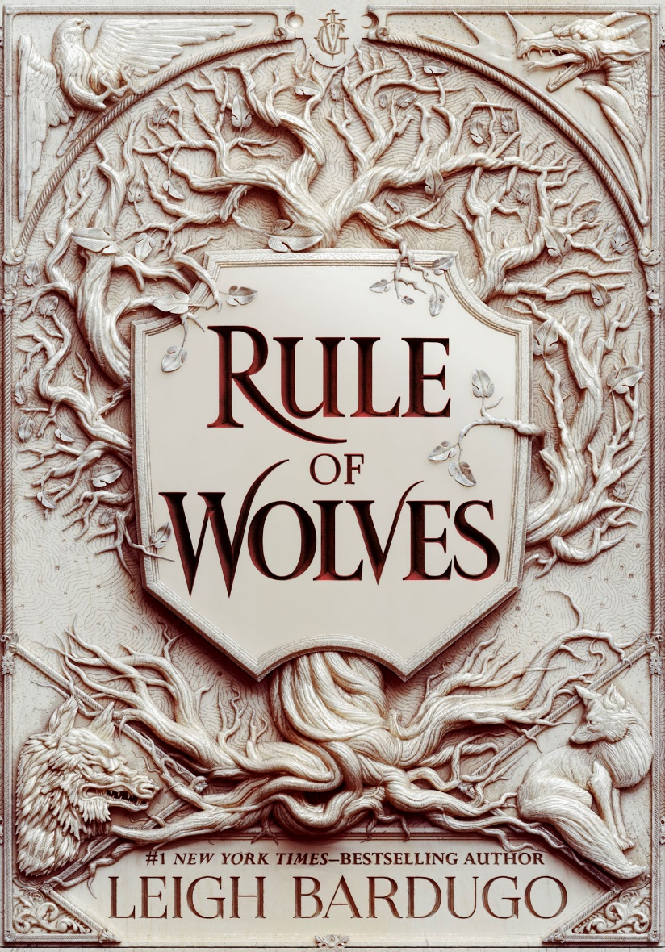

About the Leigh Bardugo

(Photos from https://www.leighbardugo.com/)
Leigh Bardugo is the author of several young adult literature books. Her works include the Grishaverse series— The Shadow and Bone trilogy, Six of Crows duology, and the King of Scars duology. Bardugo also recently made her adult novel debut with a paranormal fantasy titled The Ninth House. Her series Shadow and Bone recently received a television adaptation through Netflix.
- Bardugo is an Israeli American author, she grew up in Jerusalem, Israel before moving to Los Angeles, California.
- She attended Yale University and received her degree in English in 1997.

Rule of Wolves summary:
Rule of Wolves is the second novel in the King of Scars duology. The action-packed fantasy novel follows the perspective of multiple characters, specifically Nikolai Lantsov, the king of Ravka known as the demon king for the literal demon that possesses him. Nikolai struggles to hold power over his kingdom in the war with Fjerda while also trying to control the demon that possesses him. The novel also follows perspectives from Zoya Nazyalensky—General of Nikolai’s armies who is dubbed the Stormwitch for the spirit of a dragon that resides in her, and Nina Zenik—A Grisha who can control the dead and a Ravkan spy in Fjerda. Throughout the novel they all work together to get Ravka through the war with Fjerda.
Quotes:
“Nikolai knew a king did not belong on the front lines, but he also knew he couldn’t hang back and let the others wage this war. His officers were mostly former infantry, grunts who had risen through the ranks and earned the respect of their men. There were the aristocrats too, but Nikolai didn’t trust them in precarious positions. Old men like Duke Keramsov had fought in long-ago wars and could have provided valuable experience, but most refused the call. Their fighting days were over. They’d built their homes and now they wanted to rest in their beds, tell stories of old victories, and complain about their aches and pains” (71).
This quote shows Nikolai’s willingness to put his country and his people before himself. This quote also signifies how he feels that he must put himself at the front of this war in order to gain the respect of his people—he is finding his place as king in a kingdom where most question his right to the throne. He wants to earn the respect of his country—not have it just because of his supposed birthright.
“Maybe this boy was a Lantsov. Maybe he was the valet’s son… It was bad enough Opjer cared nothing for the bastard son he’d sired, but to add insult to injury by trying to deny him a perfectly good throne? It spoke of a fundamental lack of manners” (104).
Nikolai’s right to the throne is a heavy topic throughout the novel. His people question his right to rule because it is believed his biological father is not actually the former king of Ravka. Nikolai’s struggle to gain the respect of his people can be seen throughout, many refer to him as the “bastard king” and do not believe he is the “true” king of Ravka. This quote signifies Nikolai’s questioning of why a name gives power—why is he any less of a king because of his lineage? Nikolai’s love of for his people and country can be seen throughout Rule of Wolves, and those around him believe he is best suited to be king because he puts his people before himself despite the lack of trust or respect he receives in return.
“None of this had been fated; none of it foretold. There had been no prophecies of a demon king or a dragon queen, a one-eyed Tailor, Heartrender twins. They were just the people who had shown up and managed to survive. But maybe that was the trick of it: to survive, to dare to stay alive, to forge your own hope when all hope had run out. For the survivors then, Zoya whispered to herself as the people before her knelt and chanted her name. And for the lost” (582).
This quote from Zoya signifies how much they have all lost to the war, but how they each managed to survive despite all the hardships they have endured. Each character has had to make hard decisions for survival. Nothing is set in stone, and they have managed to survive despite how many forces were against them.

In the classroom:
If I was teaching Rule of Wolves in the classroom, I would direct this book towards high school seniors/ older teens because of the content of violence and war themes throughout the novel. The novel’s highlighting of topics of discrimination, grief, trauma, and making hard decisions while tying into the idea of perseverance and endurance would be beneficial for older teens to read in order to observe from multiple perspectives and develop empathy while also reminding that there are times when decisions are difficult to make—but perseverance is a must.
Regarding how the text would fit into Adolescents in the Search for Meaning: Tapping the Powerful Resource of Story, Rule of Wolves can be compared to chapters 4-8. Chapter 4 about real life experiences coincides with the choices Nikolai, Zoya, and Nina must make throughout the novel in order to win the war, they each endure violence, loss, and abuse at the hands of others. Chapter 5 deals with death and loss, a heavy theme throughout the novel specifically concerning Zoya and Nina—Zoya has lost nearly everyone she loves, Nina lost her lover and struggles with mourning and processing her grief. Chapter 6 on identity and discrimination can be compared to the discrimination Nina faces due to her Grisha abilities as well as the discrimination Nikolai faces for his lineage. Chapter 7 discusses courage and survival—which are reoccurring themes throughout the novel as the characters endure the hardships they are put through. Chapter 8 discusses books on fantasy, Rule of Wolves is a high fantasy novel—the Grishaverse world is an action packed, complex, fantasy world filled with myth and magic that continues to expand.
Quantitative text complexity—
Dale-Chall readability scores:
Raw score: 3.7511
Adjusted score: 3.6365 + 3.7511
Final score: 7.4
Grade level: Grades 9-10
ATOS score: 8.0
Qualitative: Rule of Wolves is a fast-paced novel better suited for older teens, the language of the novel is complex and requires some previous knowledge of the Grishaverse series to fully understand past events that are referenced throughout the novel. The length of the novel is around 600 pages—a heavier read, that would require more time invested. The terminology, as well as the fantasy language throughout is somewhat difficult to follow at first—but becomes more understandable as the novel progresses.

