Alexa Moreno
ENGL 112B
Professor Warner
9 October 2023
How Dare The Sun Rise by Sandra Uwiringiyimana
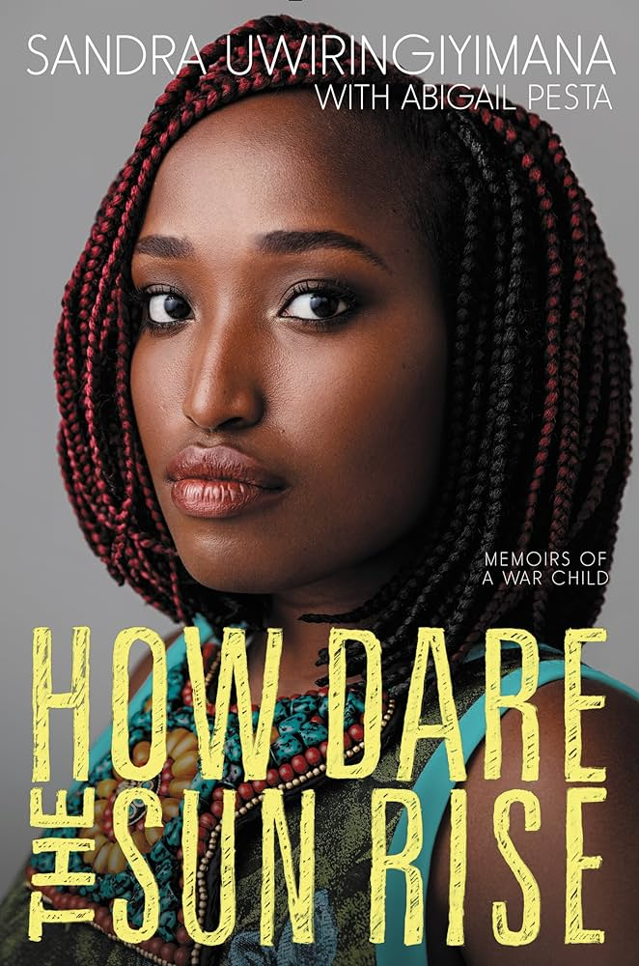
Background on the book & author
How Dare the Sun Rise is a book written by Sandra Uwiringiyima. She grew up in the Democratic Republic of the Congo and moved around frequently at a young age so she and her family could stay safe from the war going on. While in a refugee camp in Gutumba (a village on the western side of Burundi which is on the border of the Democratic Republic of the Congo), she experienced a horrific massacre of her friends, family, and community, and almost lost her own life at 10 years old. This story is her memoir of going through this tragic experience, surviving, and then moving to the U.S. in 2007 for a new life that included its own set of struggles. In this book, she highlights the beauty of her life in Africa as well as the tragedy. She brings the audience with her as she works her way through the new and unexpected roadblocks in America such as racism and culture adjusting. She finds solace in God, family, and friends, and in speaking her truth. (Pass around the book so that people can take a look at the pictures on the inside of survivors of the massacre)
Introduction of Quote #1
I’m warning you, this first quote is not one for the faint of heart, but it is significant to the the whole of the story. This is what happened in the massacre in Gutumba from Uwiringiyimana’s perspective and experience. Also, this is a shortened version for the sake of time. They were tricked by some men claiming to be there to get them out of the tent that they were hiding in from the attackers. They knew the tent was about to be lit on fire.
Quote #1
- “Mom came to a stop at the door of the tent. She stood there, waiting to be saved, as promised. I was finally close enough to see the faces of the men who said they would deliver us from this hell. Their eyes glowed with fiery light, their backs to the flames… They looked at us. ‘Bashiriremo!’ one of them barked. ‘Shoot them!’ Suddenly, I saw sparks- bright blasts of gunfire- hitting my mother. They looked like fireworks. The bullets went into her belly, and she crumpled. She was still carrying my sister on her back… I knew that I had to hide… I kept seeing sparks fly in front of me. A future as an orphan flashed before my eyes. I prayed to God. ‘If you keep my parents alive, I will be good’ I promised. At the time, I knew my mother had just been gunned down. She must be dead. Deborah must be dead too. My little six-year-old sister gone… I kept praying. I begged God to please let us all survive… Then I blacked out… I awoke when something hot hit my leg… The tent was in flames… I felt like I was in a movie scene- A ten-year-old girl sitting in the center of the frame, while a war raged around her… I managed to crash my way through the burning debris of the tent… Limbs, bones, and bloody bodies lay everywhere. I smelled burning flesh. I saw men with guns, machetes, torches. They were marching around the camp, looking for survivors to kill… A man was being burned alive across the camp, screaming in agony on his knees. I learned later that he was a beloved pastor who had led the prayers in the camp every morning before the sun rose… Now this man was on fire… Before I could run, a man grabbed me by the shirt. He looked at me and I looked at him. ‘Mbabarira,’ I said. ‘Forgive me.’... I thought I must've done something terribly wrong to bring on such wrath… The man pointed a gun to my head. I felt the metal barrel on my temple. I waited for the blast. In that moment, I thought it was all over. ‘Good-bye, life,’ I said.” (8-11) (about 2 minutes ot read)
Significance to the overall book
This would be the experience that changed her life totally and completely. It would haunt her and drive her for the years to come. She lost her younger sister, Deborah, and many of her friends and community members but thankfully her mother, father, and other siblings lived.
Introduction to Quote #2
Uwiringiyima has a long, but beautiful, last name that has a different kind of origin from where most of us may have inherited ours from our family. She was given this last name by her parents and it means “one who believes in God’ which is a big theme in her story as well as an aspect of her name that she feels helps define her. Throughout the story we see the push and pull of religion in her life. There are moments where the tragedy feels so great that she doesn’t believe that God will help them in the way she hopes. Other times, she is brought back very strongly to her roots. Once she came to America in Rochester, New York, she and her family found a new church that they loved.
Quote #2
- “Pastor Linda, a white woman, quickly became one of my favorite people. She was compassionate and kind, and she and my mom became good friends, even though they couldn’t communicate well. They seemed to have a deep understanding and respect for one another… She liked to sing, and she taught me a song called ‘Blessed Be Your Name.’ It was the first song I learned in English. One day, she and Princesse and I were singing with with her in her living room, and I started to cry. There was a refrain in the song that made me think of Deborah: ‘You give and take away. You give and take away. My heart will choose to stay. Lord, blessed be your name.’... “I decided to confide in her that I missed my little sister. Linda didn’t know exactly what had happened to Deborah, but she consoled me, saying, ‘God has a plan, even though you can’t see it at the moment.’ Her guidance and faith were soothing to me. She reminded me of all the wonderful things I loved about church and community. I thought about how being Christian doesn’t mean that everything is perfect all the time, or that you don’t face any struggles. In that moment, I really thought about what God meant to me personally. I had been angry at him, but I decided to give him another chance,” (136-138). ( about 1 minute)
Significance to the overall book
She found that she could work through her feelings about the loss of her sister and her terrible experience. She struggled to come to terms with what happened because other members of her family didn’t talk about it much.
Introduction to Quote #3
Even though Uwiringiyimana’s family left Africa for the U.S. in order to find a better life, she discovered that America came with a whole new set of problems. Being black in America had her being treated in ways she unexpected. When she was in school, she hoped to form a community with her peers. When she noticed that there was a lot of ignorance surrounding black people (in a general sense) she took action.
Quote #3
- “To help us all understand one another, I became president of the Black History Club on campus. We decided to do a photo exhibit with some of the black students to help people get to know us a little better. We took portraits and did brief write-ups for everyone- little introductions with a few details about our lives and interests. We called the exhibit ‘Shades of Black.’ When the exhibit opened, an idiot student decided it would be hilarious to change the sign to ‘50 Shades of Light Black’ and drape paper chains all over the walls- a nod to the book Fifty Shades of Grey. But when the black students came in and saw the chains, as you can imagine, they felt incredibly insulted. We were trying to honor black students, and someone had filled the room with symbols of slavery. The kids started crying. I went to the dean. He knew me by now. I had spoken with him before about inappropriate comments on campus and ways to make minorities feel more at home… I explained that this was devastating for the black students on campus… It was a white boy… This was a small manifestation of a much larger issue on campus. These kinds of antics were not what I was expecting from my college experience. After that, I called my mom and burst into treats… ‘Mom, I don’t want to be here,’ I said. ‘I don’t think they like black people.’... I really wanted to leave the school, but I stayed. Someone had to push for change. I got more involved. I joined a committee with the dean and others to establish a diversity program… It helped me survive my freshmen year. But a much bigger battle was yet to come.” (232-234). (about 1 minute and 20 seconds)
Significance to the overall book
Throughout the books we see her going through all kinds of new experiences as someone from an entirely different country and culture. The things she never thought about, such as the state of her hair and her dress, were seen as “statements” in America. Simply being was a statement.
Why young adults should read this book
Stories such as this one make us aware of more than just ourselves and our small bubble of the world. It may connect as personal experiences for some, I pray not as many as there probably are, and as a means to educate others, like myself. It may kickstart someone to help those struggling and be more sympathetic to the people around them. We can also learn about the beauty of a different culture versus the story that the media has fed us.
In a classroom setting, how I would use this book
There are many ways that I could go about teaching this book in a classroom setting because it's a true story. A speaker would be an amazing way to tell a perspective of their own as well as showing pictures and providing interviews from other survivors. We could focus on different areas in the books from cultural differences, racism, immigration, refugees, people’s religious beliefs, and societal expectations. “What have they gone through or seen others around them go through that is similar to what Uwiringiyimana did when she got to the U.S.?” They could answer this question on their own. Uwiringiyimana has made many big speeches and interviews and it would be beneficial for the students to watch one or some from her.
Resources for you to learn more and help out
Jimbere Fund is a non-profit organization run by Uwiringiyimana’s sister, Adele, and her sister’s husband. They revitalize distressed communities in rural Congo.
Refugee Point is an organization that has helped tens of thousands of refugees find safety and a way to continue life.
Text Complexity
The New Dale-Chall readability formula puts the books at reading scale score of 41, an average reading difficulty, grade level 5-6, and an age range of 10-11. That being said, the content might be for older readers as it is dark. But that might be more of a personal preference. The language in this story is very simple and easy to follow. I find that a lot of the information needed to understand the story is provided without the need for much previous knowledge at all. I knew far too little about war and was still able to understand what was going on with no issues. This story has symbolism but not a lot of deciphering of language as she speaks frankly. Uwiringiyimana’s experiences aren’t typical for the majority of people when it comes to the war but it still reaches many who need to have someone speak up for the voices unheard. What could be something that even more people could relate to would be her experience with American culture and also the racism she endured. That is, unfortunately, a too well-known issue many face in America. We also see her relationship with immigrant parents having trouble adjusting to the world their children are growing up in America which differs from their own cultures.
This book speaks of a true story and that makes it far different than fictional YA literature. That being said, there were many ways that the author chose to present information to make a bigger impact. For example, when Uwiringiyimana was going through the recount of the tragedy, she stopped at one point to point out a man aflame and tell a short anecdote of her and her mother listening calmly and happily to him preaching in the mornings before switching back to what was really happening at the moment. There were also many moments where she would end a chapter after a good point to say something about how that calmness threw her off for what struggle would come next. She expressed the complexity of the characters and how their views either helped her or gave her a roadblock. I find that the story has an overall chronological order as it shows her coming-of-age, but she weaves in anecdotes of her childhood or flashbacks throughout the story which provides a deeper understanding for the readers. The author is a strong female protagonist who makes plenty of mistakes and has mental health issues, but ultimately creates amazing things as well. Her direct language doesn’t sugarcoat the realities of what she or others went through and through this she allows the audience to decipher this new unknown territory how they may. As she grows, the audience has the ability to do so with her. While the story is telling her perspective, we see many different kinds of “characters” (who are real people) and their own internal and external struggles to create a deeper complexity.

