Alice Nguyen
Mary Warner
ENGL112B
October 9, 2023

Book Talk - Openly Straight by Bill Konigsberg
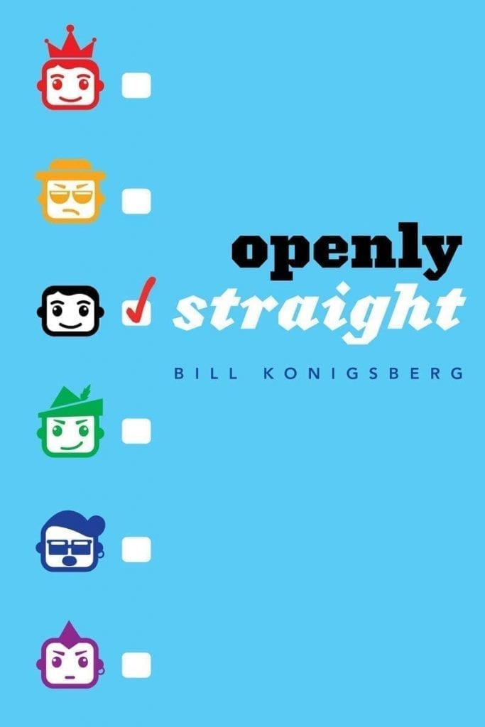
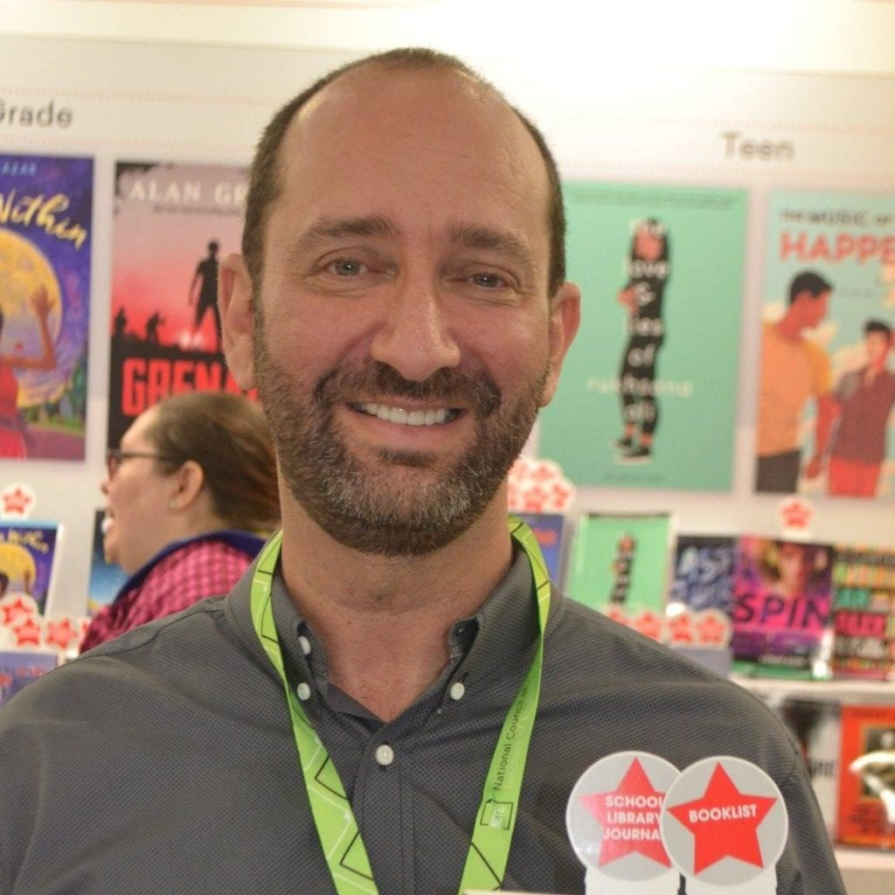
https://billkonigsberg.com
Bill Konigsberg was expected to be a sports player as a child but turned to writing for ESPN. He starts writing novels since sports isn't his forte, just only having knowledge of it. His works immediately excelled in popularity, Openly Straight being his second one, giving him great achievements and awards like getting an award named after him.

Openly Straight follows a story where Rafe transfers into a new high school that is an all's boy's school, hiding his own queerness. The title humorizes the situation where Rafe doesn't want to be openly gay anymore and will do his best to "be straight" to fit in. While Rafe tries to fit in as a straight person, he turns out to be a bumbling mess, unintentionally hurting others while protecting himself.

Quotes
He looked me in the eye. His eyes were a translucent blue. He looked kind. I didn’t want to look away. I realized that not being the gay kid here allowed me more access. I wasn’t supposed to hold eye contact with jocks back in Boulder. It was understood: They accepted me, and I didn’t freak them out with eye contact. Here, no such contract had been made. Ben blinked at me, I blinked back, and when it began to feel a bit too close, I averted my eyes. (19)
The fear of holding eye contact is okay here because in Rafe’s old school, he was bullied for doing normal things.

Soon we were all laughing, and even Steve was smiling as everyone got real honest with one another. A wave of relief passed through me, and I realized I truly liked these guys. I hadn’t laughed this much with a group of guys since, well, ever. (28)
Rafe hasn’t felt normal and happy in a while. Just like holding eye contact, he was deprived from having fun with classmates because of his queerness.

what would it take for me to be that comfortable in my body, to express myself like that? Even once? I’m pretty chill, I’m pretty comfortable, but there’s a diference between normal comfortable and being forty-something and shaking your backside to a bad hip-hop song in an Illinois restaurant full of strangers. (52)
This is the same chapter Rafe finds out his teacher knows he's gay through his mom. He's doing his best to be seen as normal in a new school but his gayness is what's affecting his normalcy.

If I used this book in class, the lesson would to be understand why Rafe is hiding himself. I see lots of faults in him as he's transitioning to a new school that would make me not like him at all, but that goes to show how difficult it is to be seen as the "other." Especially during a time when social interactions are memorable and important, it's good to read how intense and scary it is to be one of the few people in a society that is "different" than others. This book fits well with te category of “Books about Identity, Discrimination, and Struggles with Decisions”

The book itself is an easy read. It scored an HL680L on the Lexile score and even lower on certain passages. High low means that though this book speaks about social issues that involve high school age range, the complex of the text can be read by younger grades like middle school and apparently 4th graders on the https://readabilityformulas.com. Reading the book was really easy to understand since the language isn’t too complex and actually relies on conversational English to make the character more young and relatable, but the setting being in high school and constant fear of bullying is what makes it more towards 14-17.

