Eros Karadzhov
Dr. Mary Warner
English 112B
6 November 2023
Darius the Great is Not Okay
By Adib Khorram
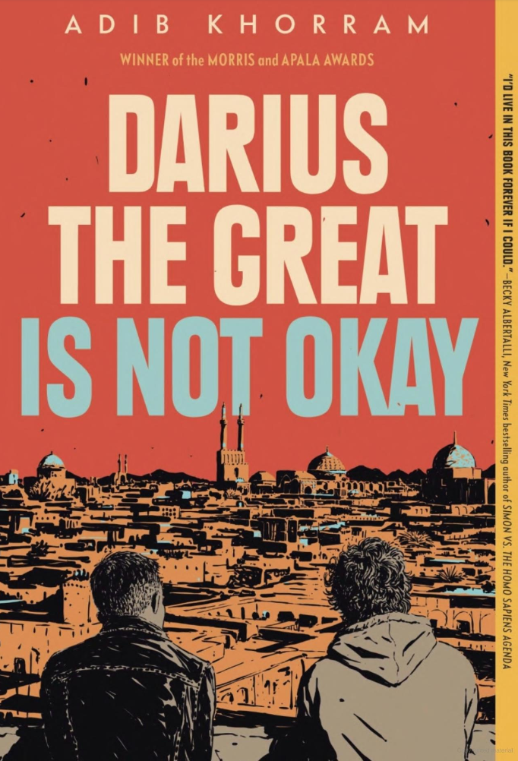

About the Author
https://adibkhorram.com/
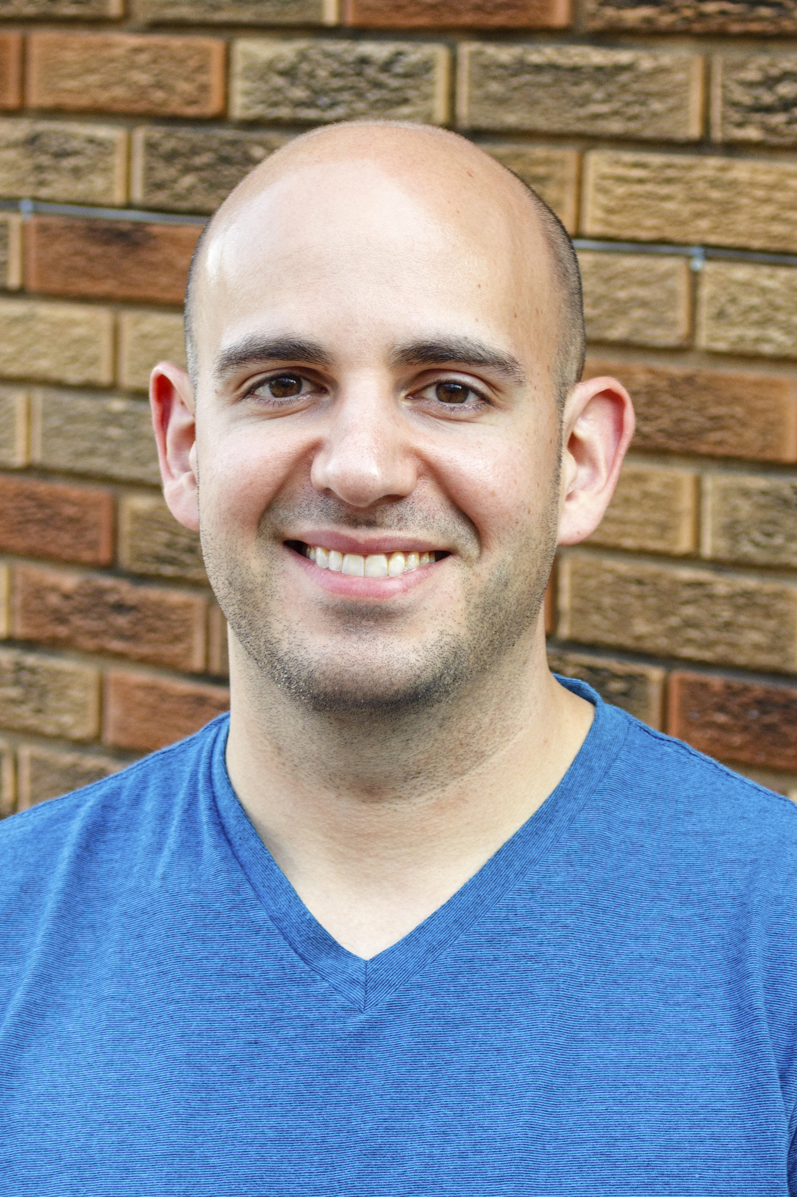

Source: https://authorsunbound.com/adib-khorram/
Adib Khorram is a queer Iranian-American author. He was born and raised in Kansas City, Missouri. A theater kid in high school, he went on to study design and technical theater at Southern Illinois University, Edwardsville, with an emphasis in lighting design, and spent several years in the event production industry.
- Adib Khorram comes from an Iranian background.
- Darius the Great is Not Okay is Khorram’s first novel and it won YALSA’s William C. Morris Award for Best Debut Author Writing for Teens, the Asian/Pacific American Literature Association’s Young Adult Award, and a Boston Globe-Horn Book Award Honor, among other accolades.
- His novel comes with a companion novel: Darius the Great Deserves Better. A companion novel is a book that exists in the same world but focuses on different characters and tells different stories.

Summary
Darius the Great is Not Okay follows the story of Darius, an Iranian-American high schooler who suffers from clinical depression and obesity for which he is bullied by his classmates and father. After dinner one night, Darius’ family decides to visit Iran for Nowruz, the Persian New Year, and because of his uncle who does not have much time left to live. In Iran, Darius meets some of his family but quickly realizes that he does not fit into the Iranian culture; naturally, he is mocked for standing out. Nonetheless, the family travels together to numerous scenic and culturally-famous places which allows Darius to bond with his relatives, ultimately becoming good friends with Sohrab—a Persian boy around his age—and mending his relationship with his father. The days pass quickly and Darius returns back to the U.S. with his parents and sister, but the trip to Iran proved an excellent setting to heal the protagonist’s psychological wounds and his problematic relationships.
Quote #1:
“And then Sohrab said, ‘Ayatollah Darious,” and all three of them laughed.
At me.
I thought I understood Sohrab.
I thought we were going to be friends.
How had I misjudged him so badly?
Maybe Dad was right.
Maybe I would always be a target.
Even for things I couldn’t help. Like being from America. Like having a foreskin.
Those things were normal back home, but not in Iran.
I would never fit in. Not anywhere.” (95-6)

In this quote, Darius takes his father’s sharp words that have grated his ears for years to heart, falling into a depressive state and contemplating his own identity. In America, the protagonist is bullied at school and when he shares this struggle with his father, he gets shamed for his weight and how he does not stand up for himself. Likewise, in Iran the bullying repeats when Darius and Sohrab go out to play soccer: the other boys mock him for being uncircumcised when they shower together after the match. Moreover, Darius’ relatives also point out his obesity. The bullying, therefore, highlights how different countries are universally similar, if not identical, when it comes to social standards and social phenomena; yet, culturally the countries differ.
However, the key takeaway is that Darius’ anxiety and passiveness once again makes him an easy target for bullying, thus proving his father’s point. Or does it? Darius is as pure as a tear and means no harm to nobody, so he quickly retreats to his shell and later begins to question himself instead of his white American dad and the Persian boys’ hurtful nonsense. And, although Sohrab sided with the boys for reasons revealed later in the text, there is hope for Darius because he simply needs affirmation from at least one person to feel normal with a sense of belonging.

Quote #2:
“Sohrab followed me down the hall.
‘Darioush. Wait.’
I kept going. The back of my neck was heating up. I didn’t want to start crying again. And if I did, I didn’t want Sohrab to see me.
He brushed my shoulder but I shrugged him off.
‘I’m sorry,’ he said. ‘About before.’
He followed me into my bedroom at the end of the hall and closed the door behind him.
‘It’s fine.’ I kept my back to him and took as long as I could to put my shoes away. I tucked the laces inside and lined them up perfectly parallel at the foot of my bed.
‘No. It was not nice. I should not have said it. I should have stopped them.’
I sighed.
I wanted Sohrab to leave.
‘It’s okay. I get it.’
Sometimes you’re just wrong about people.
‘Thank you for bringing these back. They’re the only shoes I brought.’
‘Darioush. Please.’ Sohrab rested his palm on my shoulder. It was warm and tentative, like he thought I would pull away.
I thought I would too.
‘I was …’ He paused, and I looked over to see him swallow, his sharp Adam’s apple bobbing up and down. ‘It was nice. You know? Not being the one that Ali-Reza was making fun of.’
I mean, I could understand where Sohrab was coming from.
It sucked being a target all the time.
‘But he is not my friend, Darioush. Or Hossein. I’m not like them’
‘Okay.’
‘I’m sorry. Really.’
Sohrab smiled—not a squinty one, but almost like a question—and I knew he really meant it.
‘It’s okay. I just took it wrong is all.’
‘No.’ Sohrab squeezed my shoulder. ‘I was very rude. And I am sorry. Will you give me another chance?’
I thought I had been wrong about Sohrab.
But maybe I had been right.
Maybe Sohrab and I really were destined to be friends.
Maybe we were.
‘Okay.’
Sohrab’s smile brightened into a squint. ‘Friends?’
I smiled too.
It was impossible not to.
‘Friends.’ (106-7)

Sohrab’s apology unveils the reality that Darius’ anxiety and depression conceals. Darius has never been alone; how could he? He is a normal boy living in a normal society, surrounded by normal people with normal problems of their own. This is a crucial moment for Darius because not only does he face the realization that there are kids out there just like him, victims to bullying, but he is also given an example that taking the initiative can go a long way. After clarifying his reasons for siding with Ali-Reza and Hossein, Darius is exposed to the power of conversing with others. Up until this point, Darius led monologues in his head, needlessly drawing assumptions instead of facing his problems. Naturally, his mental health stood in the way, but the time has come for him to move forward and show that he, too, is capable of being normal: he stays in the conversation, forgives, and embraces the second chance to be friends with Sohrab. In a sense, Sohrab serves as a role model for Darius by showing him that more often than not, you have to fight for your happiness.

Quote #3:
“Dad’s face had turned red and blotchy. ‘Darius.’ He sighed and uncrossed his long legs to stand up. ‘You’ve always been good enough for me. I loved you from the first moment I saw your little hands on the ultrasound. And felt your little feet kicking in your mom’s belly. I loved you the first time I got to hold you and look into your beautiful brown eyes and know you felt safe in my arms.’
Dad’s hands twitched like he wished I was still a baby he could hold.
‘And I’ve loved you more every day. Watching you grow up. Watching you grow into yourself. Watching you learn to cope with a world I can’t always protect you from. But I wish I could.’
He cleared his throat.
‘Being your dad is my first, best destiny.’
It wasn’t true.
How could he say that?
‘Remember those stories you used to tell me?’
I sniffled.
‘Remember? When I was little?’
‘Of course.’ He closed his eyes and smiled. ‘I loved putting you to bed.’
‘Then why did you stop, if you loved it so much?’
Dad bit his lip. ‘You remember that?’
‘I remember.’
Dad sighed and folded himself back down to sit on the ledge of the roof. He glanced up at me but didn’t hold my eyes—just patted the spot beside him.
I sat down, but farther away from him.
Dad looked up, like he was going to speak, but then looked at his hands and swallowed. His Adam’s apple bobbed up and down, up and down.
‘You’re wrong. I want you to feel things, Darius. But I’m scared for you. You have no idea how scared. I take my eyes off you one moment and if it’s the wrong moment, you could be drowning in depression, bad enough to … to do something. And I can’t protect you from that. No matter how hard I try.’
‘I’m not going to hurt myself, Dad.’
‘I nearly did.’
All the atmosphere on the rooftop fled, blown away by Dad’s explosive admission.
‘You … what?’
‘When you were seven. My meds weren’t doing their job. And I got to thinking about how you and your mother would be better off without me.’
‘Oh.’
‘I got so bad, I was thinking about it. All the time. Dr. Howell put me on a pretty strong tranquilizer.’
‘Um.’
‘It made me into a zombie. That’s why I couldn’t tell you stories. I could barely tell the time of day.’
I didn’t know.
‘I lost myself for a long time, Darius. I didn’t like who I became on those pills, but they saved my life. They kept me here. For you. And your mom. And by the time I was doing better and Dr. Howell tapered me off, your sister was born and I just … things were different. She was a baby, and she needed me. And I didn’t know if you even wanted stories anymore. If you were ever going to forgive me.’” (224-5)

This is a moment packed with meaning. Firstly, this conversation between Darius and his father reaffirms how the only way to get to know someone is through actually conversing. Up until this point, Darius only made assumptions, at times quite harsh ones, about why his father acts like a bully. In the end, Darius’ dad explains his pains and troubles and the two begin their relationship anew. Secondly, Darius here applies successfully what he learns from Sohrab: to participate in conversations and more importantly, to forgive. Darius acknowledges that his dad messed up and that there is no justifying his bullying, but he proves to himself once again that he can be, and is, the bigger man. Thirdly, through his father’s “humanity” here, Darius in a sense finds his identity. In fact, he always had a crystal clear identity, but his thoughts were simply clouded because he thoughts everybody else seemed to fit so perfect in their roles. A parent’s duty is to be a role model for their children, and being vulnerable and honest to yourself about your own emotions is so crucial; however, his father always put up a facade where he would act tough, ultimately putting pressure on Darius, which unintentionally invalidated Darius’ feelings and identity. Therefore, this particular moment aims to convey how crucial familial connections are because afterward, Darius proves he is a capable young man possessing the necessary confidence to assert himself in the outside world.

Classroom Use
Darius the Great is Not Okay would be a perfect fit to set up the stage and examine teenagers and young adults’ problems here in the U.S. and compare them to other countries’ challenges. The ultimate goal would be to create a safe space for students to share their background and the difficulties they have faced in their families, at school, and society as a whole in a similar way to Darius. Although at first glance Darius’ problems appear insignificant in comparison to extreme scenarios, such as bad health conditions, dealing with severe traumas, loss, and so on, it is likely that some students experience insecurities, lack of confidence, and bullying. The way Darius handles these problems would offer the students at least one perspective and how to navigate through teenage years: actively seek for a support system if you need it, be it family, friends, or any form of relationship that is not invalidating due to implemented toxic social constructs. As evident from the text, Darius’ problems and depression take a positive direction whenever he holds a conversation with others, which ultimately teaches that change comes with some form of action. The final message of the book, therefore, is that it is OK to be the protagonist of your own life; indeed, in life, everyone has the power to choose the role they want to play.

Why should you give this book to teens?
This book is an excellent source for teens to understand one commonly encountered perspective of their peers about themselves and the world. Moreover, growing up as a teenager, I always thought that the “adult world” is so different and so out of reach. I believed that adults had it all figured out, somehow, at some point. Darius the Great is Not Okay juxtaposes Darius and his father who are obviously a generation apart that becoming an adult does not magically change who you are and that all your problems vanish into thin air. Accordingly, Darius’ father shows both how to be a bad parent, as observed at the beginning of the novel, and a great parent by the end of it. This will not only assist teens with navigating their teenage years, but also prepare them at least a little bit with parenthood.
Other Reasons:
- The book conveys how bullying is never justified, even if it is rooted in culture, religion, family, or society.
- The text highlights how fragile and eager for affirmation teens can be and that they should be taken seriously from parents and society.
- Darius and Sohrab’s friendship serves as an example that connecting with others can be a remedy for various problems/conditions, such as depression.

How it fits best in Chapters 4-8 in Adolescents in the Search for Meaning:
Chapter 4: Books about Real-Life Experiences:
- All the characters are commonly seen ones in real life who struggle with common issues: depression, identity, alienation, bullying, etc.
- Familial, religious, cultural, and social issues that occur within every household, regardless of one’s background. Although Darius’ background is both Persian and American, the setting would have remained relatively similar if he was purely American or Persian.
- Alienation due to generational gap is conveyed purely as a myth; indeed, the real problem lies elsewhere: lack of communication and a mindset trapped in a specific time period that is obsolete.
- The “cliché” concept “power of friendship” in the text emphasizes how some, if not most, humans are social creatures who require validation and a support system to feel safe. Every human has parents, and most also have friends who contribute to their growth as an individual; therefore, every student can relate to Darius’ experiences.
Chapter 5: Books about Facing Death and Loss:
- In the text, Darius faces an inevitable situation that will likely happen in the near future because his grandfather in Iran has a brain tumor that will not get better. Accordingly, Babou changes his behavior due to his condition: he is sometimes kind and caring, and other times cruel and cold. Although Darius meets his grandfather in real life for the first time, he is still emotionally shook because mortality and sanity, especially the combination of the two, is a brand-new experience.
- Likewise, Darius’ father reveals how depression has impacted his life, ultimately driving him close to the edge. Therefore, Darius learns about mental health and how he could have lost his father early in his life. As someone who also suffers from depression, Darius also learns about the danger of following his father’s footsteps. Darius is lucky because unlike his father, he has someone who already went through the path of depression and so he not only learns to be compassionate about others but also to manage his condition.
- Students who have parents, relatives, or friends with health issues/conditions can empathize with their feelings and at least begin to understand them, even if they are sometimes irrational or impulsive.
Chapter 6: Books about Identity, Discrimination, and Struggles with Decisions:
- Darius comes from a multicultural background: part American and part Persian. But is he more American or more Persian? This is one of the questions addressed and resolved in the book; indeed, they are both equally part of him and one part does not need to dominate over the other. Students who speak multiple languages or are multicultural can reflect upon their own identities and how this is not a disadvantage but rather a huge advantage.
- Discrimination based on culture, religion, physical traits, and so on are social constructs that humans buy into. But for what reason, and how does it benefit society? Students can address these questions and form their own opinions on how one can change for the better if they deem change necessary.
- Darius struggles to be the protagonist of his own life, typically not standing up for himself against his father and classmates, even though they are clearly in the wrong. Teens can utilize this opportunity to see the aftermath of not taking action when it is desperately needed.
Chapter 7: Books about Courage and Survival:
- Darius’ courage to communicate his feelings and to hear others out, including forgiving his friend and father, in the end is rewarded with peace of mind, confidence, and their relationships taking a positive turn. Teens can take note that life smiles upon the courageous and rewards them in two ways: it either mends the situation, or it ends a “chapter” in one’s life so that they can move on and seek something better.
- Although Darius suffers from depression, he still attempts to make friends in hopes of finding people who would accept and understand him. Teens can learn from Darius’ experience here that this is both courageous and part of surviving socially and emotionally.
- Darius’ father almost faced death, and his grandfather faces death; however, Darius still chooses to survive and fight through life’s challenges. He does not give up hope even though life appears so fragile and uncertain.
Chapter 8: Books on Allegory, Fantasy, Myth, and Parable:
- Darius just like his father suffers from depression, but ultimately both of them chose to take matters in their own hands, refusing depression to take over and drag them into despair and possibly death. The message in the book, therefore, is that even during hard times, we are still largely in control of our choices and lives.
- The story’s setting and themes are simple, but this is why the parables are so clear. For example, the outside world in the text is left out, centering around Darius and his family in order to highlight the importance of one’s identity and voice.
Quantitative
Lexile: HL710L
ATOS:
- Book Level: 4.7
- Interest Level: Upper Grades (UG 9-12)
- AR Points: 10
- Word Count: 67,290
Dale-Chall:
- Raw Score: 4
- Adjused Score: 3.6365 + 4 = 7.72
- Grade Level: 9-10
- Age Range: 14-15
New Dale-Chall:
- Score: 34.5
- Grade Level: 7-8
- Age Range: 12-13
Flesch-Kincaid:
- Score: 6.55
- Grade Level: 7
- Age Range: 12-13

Qualitative
1. Structure
First-person POV that follows the protagonist Darius’ experiences, emotions, and tone in the U.S. and Iran. With a linear plot and conventional structure that separates the protagonist’s interactions with other characters and the problems he faces with each of them, the book is easy to understand and follow. Furthermore, the characters’ perspectives and thoughts are directly disclosed through dialogues. Lastly, the book is broken down into short chapters of no more than 10 pages that focus on specific moments in Darius’ journey, making it a fast read.
2. Language Conventions and Clarity
The language is simple, direct, and clear. Although at times the text incorporates Farsi, Iran’s language, the protagonist explains in great detail every time the concept and meaning of words and phrases. The themes in the text are also openly disclosed and direct, such as family, friendship, mental health, identity, bullying. On top of a highly conversational vocabulary and lack of jargon, the text mostly avoids complex sentences and advanced punctuation in order to maintain the authenticity of a teenager’s perspective.
3. Knowledge Demands
The text more than anything demands the understanding and importance of cultural differences, assimilation, mental health, and bullying. Although there is nothing graphic in the novel, the protagonist is shamed for being overweight, passive by nature, and uncircumcised; therefore, understanding the general impacts of being different are helpful to grasp the main character’s emotions. Alternatively, having some general knowledge about Islam and Iran would prove useful, although not absolutely necessary, to map out Darius’ traveling and the bullying that is rooted in religion and culture.
4. Levels of Meaning
The novel confronts multiple levels of meaning: personal, familial, social, cultural, and religious. These meanings can be grouped and divided into two categories: first, the personal level operating on its own because ultimately, it is Darius’ decisions, actions, and perspective that shape his reality, so it is within his power to change himself and even others around him; secondly, the intersectionality of external factors such as family, society, culture, and religion that influence humans, and in turn, humans influencing one another. On the surface level, the novel poses the question whether these external factors are good or bad for us, but on a deeper level, it unveils one way to navigate through and use them to our advantage for personal development.

