Hannah Le
ENGL-112B Sec 01
Dr. Warner
23 October 2023
The Cruel Prince
By Holly Black
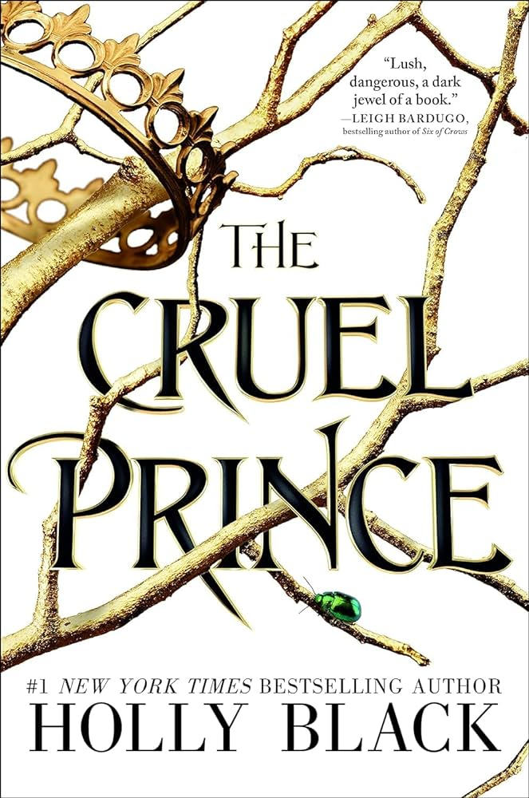

About the Author:
https://blackholly.com/
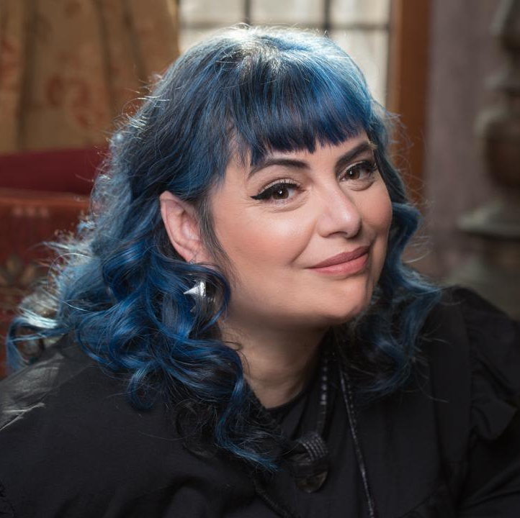
Source: https://blackholly.com/about/
Black grew up in New Jersey and graduated with a B.A. in English with consideration in becoming a librarian before writing drew her away. She has since written a series of children’s fantasy books and several young adult novels, but is best known for bestselling young adult Folk of the Air series. The series, however, is not her first foray into the land of Faerie, which belongs to her debut young adult trilogy that is officially called Modern Faerie Tales. She currently lives in New England in a house with a secret library door.

Summary of the Novel:
After Jude, her twin Taryn, and their older sister Vivi’s parents are killed when Jude is seven, they are stolen away to Faerieland by their parents’ murderer and are raised under his wing and treated as Gentry. Vivi, being his only blood daughter instead of just simply his late wife’s children like Jude and Taryn are, vows she will always hate him and makes every decision that will infuriate him the most. Jude and Taryn, despite their older sister’s efforts to join her in pissing off their placeholder of a father, try their best to adapt and fit in as humans in a world that despises them, but most of all especially by Prince Cardan, the youngest and cruelest son of the High King. Set ten years after her swift orphanage, all Jude wants is to belong and to win a place at the Court. In trying to do so, she becomes entrenched in palace conspiracies and deceptions, and discovers her own capacity for trickery and bloodshed. When betrayal looms over the Courts of Faerie, Jude stands at the crossroads of it all while the fate of Faerie lies in her hands.

Quote 1:
"Here's why I don't like these stories: They highlight that I am vulnerable. [...] Even if, by some miracle, I could be better than them, I will never be one of them" (46).

One of the recurring themes in the book is the divide between mortals and fae, one that colors every action and thought that Jude makes. She believes that because she is human, she is weak, and this is a sentiment that is mirrored throughout Faerie — one of the recurring lines in the book is even "being born mortal is like being born already dead" which gets thrown back in Jude’s face several times throughout the book. The three stories Jude has never told anyone but the reader that precede this quote are all times she was subjected to fae cruelty simply because she had been human and been susceptible to it. The other fae at the school often treat Jude and Taryn as lesser, and mock them with never being able to reach the standard of perfection and beauty that fae so easily hold; one of them even mocks her by asking Jude that if she wore a golden hair pin so she could be like them, to which Jude internally replies that of course she does because all the fae are just so divinely beautiful. Because she is human, she is automatically singled out — because she is human, she is no better than the dirt the fae walk on — because she is human, she has no natural safeguards against faerie magic — because she is human, she has to fight twice as hard to be average — because she is human, she will die of age — because she is human, she is different, and she will never belong.

Quote 2:
“He slams a dagger down Madoc’s desk. [...] My eyes on him, I slam the knife into my hand” (196).

With the coronation of the next High King steadily approaching, Prince Dain approaches Jude to be his spy because she can blend in with human servants and has the ability to lie; she accepts in return for a geas where no one can enchant her, except for whoever bestowed it upon her. Between that conversation and this one, Dain is made aware of Jude stabbing Valerian, a classmate of hers and someone who had tried to glamour her into killing herself by jumping off the tower had she not been in possession of Dain’s geas, and tells her that her decision in doing so was selfish and put her needs above his own, especially because she had showed her hand in revealing she could not be glamoured. In the test of loyalty, she grapples with what this all means to her—having to prove her fealty by willingly stabbing through her hand—and ultimately twists her fear into a weapon she can bear against her enemies. Even in the moments that lead up to her show of loyalty, the recurring divide between mortal and fae is apparent; the only difference is that she finally is no longer deluding herself that she can fit in, and decides that no matter what it takes to have power—even as just a spy to the next High King—she will go to the ends of the world to grasp it.

Quote 3:
““Surrender,” he tells me, sword pointed toward my throat. [...] I look deep into his eyes as I sheathe my sword. “Father, I am what you made me. I've become your daughter after all”” (353).

Family is a very large theme in the novel, especially for Jude whose actions are followed and influenced by family at practically each and every step. Madoc is Vivi’s father, and the stand-in paternal figure for Jude and Taryn when they grow up in Faerie—this also makes him their parents’ murderer. Despite their beginnings, he spends a decade raising them with love and respect and instructs everyone to treat them as Gentry, which is an honor that has never been bestowed upon humans. At this point in the novel, she has spent more time under his care and guidance than she has with her biological father. As the High King’s General, Madoc has a taste for bloodshed and war (and power) that will never be fully quenched, which is the root of what sparks their fight. When Jude is on the ground, held by swordpoint, her deception is finally revealed to both reader and Madoc, using a strategy only Madoc would have taught her—a strategy she only could have used because of what he made her to be. This scene goes to show the double-edged sword that is family, for it is why she is fighting Madoc and is also why she gains the upper hand—it is only because she is his daughter that she is able to betray him. Despite the love they have for each other, neither of them can change who they are.

Classroom Use
If I were to use this book in a classroom setting, I would use it to teach about the understanding of faerie folklore since it is the defining basis for the novel. I would pair this novel with The Dark Artifices and poems about faerie folklore/myths to understand where some tropes align and where they might contrast, which could similarly be paired with activities for visual guides. This can also foster discussion on how if certain tropes were subverted in The Cruel Prince then were they done to the satisfaction of the reader, and if certain elements of faerie folklore/myth could be used to elevate the narrative. This would help students think critically about worldbuilding and when elements of a fantasy world already built for you on folklore and myth can work for you and when you need to rework it.
I would also instruct that students write a rough draft to analyze Jude before instructing them to write an essay fit to analyze a different character when they’ve found their character analyzing footing. Because Jude is both the narrator and main character of the novel, it’s easier to color her motives and pick out exactly why she is the way she is and is the easy choice in analyzing any character of choice; by having every student analyze her before having to choose someone else, they can use what they learned as a class when analyzing her before moving onto a different character with more trained eyes.
For fun or as a warm-up exercise, I would have students write what they would have done if they were Sophie, the human servant girl whom Jude saved from Hollow Hall; would they have chosen the same fate as her, or would they have tried to grasp at their second chance at life?

Why should you give this book to teens?
The theme of power can particularly resonate with teens, especially when (like Jude) you have never had it before in your life and have spent the better part of it fighting twice as hard as you need to just to meet where everyone else is already at. Jude is seventeen when the prologue is over, meaning teen readers will be able to empathize with some of her more internal struggles, especially when she shows how much anger and hatred she has had to temper over the years because she was never given time to process certain events without the looming dread feeling as if it’d crash in on her. Because it is of a fantasy genre, young adult readers might have an easier time immersing themselves into the world where magic and whimsy are apparent in every page. The fae of Faerie follow certain rules, as well, that fall in line with the original faerie folklore that may entice readers that are both new and familiar to its myths, drawing consistencies that follow not just the length of the novel, but through centuries old poems as well. Even despite its fantasy genre, The Cruel Prince still touches on important topics such as family, status, truth, and what it really means to have power in a way that can still resonate with readers as it shows and magnifies the imperfections of each character, even amongst the divine perfection of fae.

How it fits best in Chapters 4-8 in Adolescents in the Search for Meaning
Chapter 4: Books about Real-Life Experiences
  - Despite its fantasy elements, Jude’s family life is a very real portrayal of dysfunctionality.
    - Between herself, Taryn, and Vivi, there is always someone who is on the outside.
  - Being discriminated against for a reason outside of your control.
  - Cardan is abused by his oldest brother, and the flippancy of which his family regards him with colors many of his actions against Jude.
Chapter 5: Books about Facing Death and Loss
  - Jude watches both her parents die in front of her when she is seven, before she loses all that she’s ever known to be stolen away to a foreign world by her parents’ murderer.
  - Cardan’s entire family (apart from himself) is killed by the hands of his oldest brother Balekin, who dies so Balekin could not usurp the throne.
Chapter 6: Books about Identity, Discrimination, and Struggles with Decisions
  - Being able to lie (and unable to lie) shape many of the actions and decisions each character takes.
  - Jude and Taryn are prejudiced simply for being human amongst fae.
    - Even despite this, other humans notably have it worse; they are often subject to their memories being wiped and compelled into unwilling servitude. This is most notably seen in Balekin’s estate.
  - Jude discovers her capacity for cruelty and grapples with what that means for her and her humanity, especially when Vivi asks her to leave Faerie and come to Earth with her.
  - Jude and Taryn struggle with fitting in and go about it in different ways; Taryn wants to marry into Court, and Jude wants to become a Knight. Jude refuses to grovel at the other fae for the chance to fit in, and Taryn keeps her head down and berates Jude when she rears her head; this difference of personality causes the twins to struggle in deciding whether family matters over fitting in, or if it’s the other way around.
  - When Jude becomes the bearer of important information, she has the power to decide who becomes king should she play her cards right, but it is not a decision she finds the least bit easy.
Chapter 7: Books about Courage and Survival
  - When Jude becomes a spy for the Crown Prince prior to his coronation, she has to fight through her own fear to do things she’d never thought she’d have to.
  - Jude poisons herself every night to build a tolerance as a survival tactic.
Chapter 8: Books on Allegory, Fantasy, Myth, and Parable
  - There are important ties to faerie folklore and myth which are brought up and are used in plot points.
  - The novel largely takes place in Faerieland, which is a world of fantasy and magical species.

Quantitative:
Word Count: 107,319
Page Count: 370
Lexile: Age: 14 - 17, 660L
AR: ATOS Book level 5.3, Interest level: Upper Grades 9-12, AR points: 16.0
Dale-Chall: 5-6 grade level, Readability: ages 10-11
Flesch-Kincaid: 6th grade
I would recommend The Cruel Prince to 9th graders and/or 10th graders because of its more mature and violent themes.
Qualitative:
- Structure
  - There are two acts of the book that are separated by “Book One” and “Book Two” accordingly and are each prefaced with a poem about faerie folklore.
    - “Book One” is prefaced with “I'd Love To Be A Fairy's Child” by Robert Graves, and “Book Two” is prefaced with “The Hosting of the Sidhe” by W. B. Yeats.
  - Told in first-person POV, apart from the prologue which is told in third person POV, but all still from the account of Jude.
  - Told mostly chronologically, apart from Chapter 6 where Jude has an aside with the reader to tell them three stories of what it meant to be a human child growing up in Faerie and how it shaped her.
- Levels of Meaning
    - The overarching themes of power, family, and belonging follow the novel from start to finish.
      - The theme of power is most significant as it exchanges hands from person to person and what each person does with it.
    - Though Faerie is a world in which its people can’t lie, the reader still must parse through deceit and deception and conspiracy alongside the characters.
- Language Conventionality and Clarity
  - The word choice is easy to understand, as well as the dialogue between characters.
    - Its vocabulary is on par with other fantasy novels, meaning there are instances where the reader might have to look up definitions for words found in the book with some examples being: lark, panoply, obeisance, redolent, countenance, and riposte.
  - The main literary devices are symbolism, metaphors, allegories, similes, parallelism, and imagery.
- Knowledge Demands
  - Though not necessary, basic knowledge of faerie folklore would help elevate the enjoyment and understanding of The Cruel Prince, but much/all of the world is explained when in use.

