Patrick Cardenas
ENGL 122B Sec 01
Dr. Warner
9 October 2023
Me and Earl and the Dying Girl
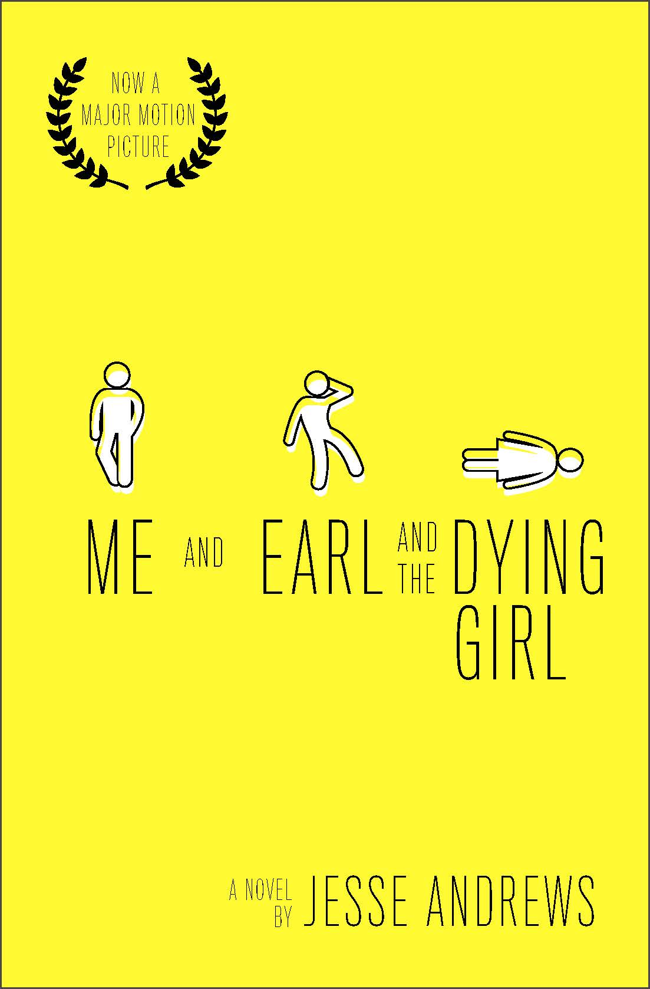
Author Information/Biography
http://www.jesseandrews.com/
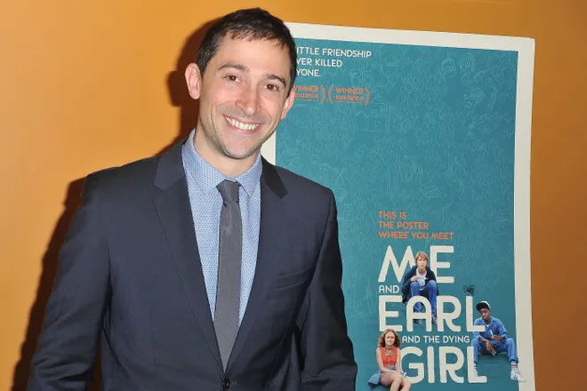
Source: https://haa.fas.harvard.edu/people/jesse-andrews
Jesse Andrews is an American novelist and screenwriter born in Pittsburgh, Pennsylvania. He is a college graduate from Harvard University, graduating with a degree in History of Art and Architecture in 2004. He spent the next six years working minimal paying jobs and singing and playing in various bands. The most successful of these bands is called The Young Dads. Andrews’ first Major novel, that being Me and Earl and the Dying Girl, was his third attempt at writing a successful novel, after his first two attempts were unsuccessful.
Summary:
Greg S. Gaines is an unremarkable and average socially inept high school loser with barely any social life. Greg is perfectly content to be on his own and not feed into the social hierarchy of his school and keep to himself. His only real friend being Earl, his best friend that he makes terrible homemade films with. His regular life of high school mediocrity is turned on its head when a girl he knew when he was younger, Rachel, gets diagnosed with cancer. His Mom, after hearing of this news, then forces the normally reserved and awkward Greg to befriend Rachel and rekindle their friendship before the inevitable comes. This situation puts Greg in an uncomfortable position as he has put aside his reluctance to befriend others in order to follow his Mom’s orders to care about someone who he never cared about up to that point.
Quote 1:
"I am extremely pale and somewhat overweight. I have kind of a rat face, and my mediocre vision makes me squint a lot" (Andrews 21).
This quote perfectly encapsulates the nature of Greg as a protagonist and his self-deprecating nature. He does not have a lot of confidence in himself and is constantly making readers aware of how much of a loser he perceives himself to be. Greg's Mom seems to think that he is just the right person who is supposed to cheer up and be friends with a girl who is dying. Based on passages like this, we see that Greg does not believe himself capable of helping others when he can't even care for himself. Greg’s dynamic with the other characters in the book is the heart of the story, as his introverted nature is tested for the sake of Rachel.
Quote 2:
“We stood there, motionless. How the hell were we supposed to greet each other? I took a step forward with my arms out, for hugging purposes, but that just made me feel like a zombie. She took a step backward, frightened. At that point I had to go with it” (Andrews 70).
The relationship between Greg and “the dying girl” is very complicated, but is integral for Greg’s character development throughout the story. The readers get to experience what Greg is feeling at all times and how he awkwardly fumbles his way back into Rachel’s life, despite not even wanting to. Countless times throughout this book we notice how Greg constantly uses humor to diffuse situations that make him uncomfortable. Greg is not a selfless hero who is going out of his way to help a poor, sick girl. He is forced to visit Rachel because of his Mom and is not given a choice. He is actively trying to avoid the situation because he does not want to deal with the awkward tension of both rekindling a relationship with a girl he has been actively ignoring, but also the real possibility that she may be dead soon.
Quote 3:
“Rachel looked better than most of the other kids, but she was totally bald. That really took a lot of getting used to. Every couple of minutes or so I would look at her head, or even just think about her bald head while trying not to look at it, and my skin would get all hot and prickly. As Earl pointed out, it looked a lot like Darth Vader’s head when they took off his mask. It was insanely white, like it had been boiled, and sort of veiny and lumpy” (Andrews 176).
Greg’s inner monologues that document how he is feeling about any given situation are the foundation of this story. Greg’s inability to take anything seriously is applied to every aspect of his life. The first quote shoes how he does not take himself seriously, and in this quote, we see how he applied this trait applied to Rachel. He is taken aback by Rachel’s condition and immediately comments on how uncomfortable she makes him, and compares her face to that of a near-death Darth Vader. When he comes face to face with someone that he knows who is now dying, he is so out of his element that it makes his body physically react in a negative way. It is uncomfortable situations like these that he is actively avoiding throughout his entire life. Seeing Rachel in a hospital so weak and dying causes an intense amount of discomfort for him.
Why should this book be taught?
Despite this book being banned for some of its more taboo content, I think that it is something that should be taught in schools. This book juxtaposes humor and tragedy in a way that students can relate to. Many books that are taught in schools are too concerned with being something overly formal or some type of classic work. What this book offers kids is a simple, enduring, humorous and impactful story that has characters that could easily exist in the real world. Hiding kids from serious subject matter is not a good way to prepare them for the future, I personally think that this is a lousy reason to ban a book. Greg is a relatable and normal kid in pretty much every way possible. He is not some type of handsome role model, he is deeply flawed, has self-confidence issues and does not have a lot of friends. There are plenty of kids who may relate to Greg in one way or even many others. I could see them resonating with the way Greg diffuses tension with humor or how he is constantly planning ways to navigate the social hierarchy of high school. The high school setting only adds further to the relatablility of the story. For many kids, high school is one of the most daunting periods of their lives. There are so many other kids who may be their new best friend, or their biggest bully, and on top of this, they have to start worrying about the future. I’d imagine that many kids would be just as awkward as Greg if they had to shoulder an old friends life as they battle leukemia.
How to teach this book
I think that this book would give teachers an important opportunity to base a unit on mental health or on bullying. We see how Rachel and her situation deeply impacts the life of Greg and Earl. There are other books who similarly deal with a teen going through a traumatizing event in their life. One book we have read this semester was Speak by Laurie Halse Anderson which dealt with a teen learning to cope with her experience of sexual assault. I think these two books pair very well together as they both tackle the experience of a high school student trying to navigate a space while dealing with trauma. The pairing of these two books could shed a lot of light on the handling of traume in pop culture. Students can see how trauma manifests in different ways between the two protagonists of each novel. Is Greg a bad person for the way he uses humor to combat trauma? How are Greg’s and Melinda’s responses to trauma different? How are they the same? I think it would be really eye opening if students could analyze how mental health is portrayed in media like TV shows, movies, and books and share their thoughts with their peers. Each student would have a different perspective and I would love to explore and hear about it in writing.
How does this apply to chapters 4-8 in Adolescents and the Search for Meaning
Chapter 4: Books about Real--Life Experiences
This book is is about as real as a narrative can get. There are no fairy tales or happy endings here. As explained earlier in the quotes, Greg S. Gaines is a normal and ordinary kid who has to confront the real possibility that someone he used to know may soon be dead. This is a lot for a younger kid to deal with, and it is something that could happen to anyone. Greg’s flaws throughout the story are highlighted and serve to humanize him. He is not a perfect person who always knows exactly what to say in any given situation. He is often fumbling through high school, his relationship with Earl and Rachel. To Greg, his life is so unbelievably mundane, but in reality, he has been given the short end of the stick in a lot of ways.
Chapter 5: Books about facing Death and Loss
The concept of death is embedded in the title of the book itself. Rachel’s name is not given in the title, and instead she is referred to as “The Dying Girl”. Greg never wanted to intervene and insert himself into Rachels life. His Mom is the only reason that he feels the need to reach out to Rachel. Greg is highly uncomfortable with the idea behind human mortality. Things that seem like big deals to a teenager such as fitting in with students and keeping up grades all become miniscule when someone is at death’s door. Rachel can’t even think about going to college or anything after high school because cancer has become her whole life. Greg witnesses as her physical state deteriorates and she succumbs to her condition and he is front and center. Despite all of his attempts to stay hidden from the things that he wishes to avoid, he still eventually has to confront the things that he is afraid of.
Chapter 6: Books about Identity, Discrimination, and Struggles with Decisions
Throughout the whole story, Greg is dealing with his own issues as he also has to shoulder the life of Rachel on his back. Greg sees himself as an outcast, he does not have many friends and thinks he is an unattractive and undesirable person. He talks about he is chubby, and constantly has boogers and because of this, he has made it his goal in high school to not associate with any groups. His only friend is Earl, an African American classmate who comes from a broken family. These two, despite their differences, come together and become friends because of their similar interests. One of Greg’s biggest insecurities are the homemade films that he and Earl make. He believes that they are so badly produced that no one should see them. By the end of the story, A vast amount of the school have seen a film made by the two boys, and they are hated because of it. The one fan of their films that they have is Rachel, who unironically enjoys their work without making fun of it. Greg’s reluctance to show his passion projects to others in fear of discrimination are relatable, and this makes Rachels appreciation of them that much more impactful.
Quantitative
Lexile: Age: 14-17, 820L
AR: ATOS Book level 5.2, Interest level: UG 9-12, AR points: 8.0
Dale-Chall: 5-6 grade
Qualitative
- Structure
  - First-person Point of View: The narrative is told by Greg and is from his point of view
  - Linear Plot
    - Few instances in the book where Greg will reflect on his childhood experiences.
    - We see Rachel’s condition worsen as the story goes on

- Language Conventions and Clarity
  - Language and vocabulary are simple and not hard to understand
  - Greg speaks and behaves like a high schooler, injecting a lot of humor into his dialogue
  - Earl utilizes a different dialect of English at times, that is more associated with the African American community
  - Vulgar and explicit language is sometimes used

- Knowledge Demands
  - Very little knowledge required for this book
  - Very beginner friendly to non-avid readers
  - Some knowledge of mental health
  - Some knowledge of cancer the the physical toll it takes on those who are afflicted

- Levels of Meaning
  - Surface-level meaning: A boy and his best friend learn to befriend and embrace the life of a girl that they know is actively dying as each passing day goes by
  - The protagonist learns about the importance of valuing the life that he is lucky to be able to say that he has. Death discriminates against no one, and Greg acknowledges this and begins to accept his passion as a filmmaker, thanks to Rachel’s encouragement.

