Victoria Pong
ENGL 112B
Professor Warner
1 October 2023
Never Fall Down
By Patricia McCormick
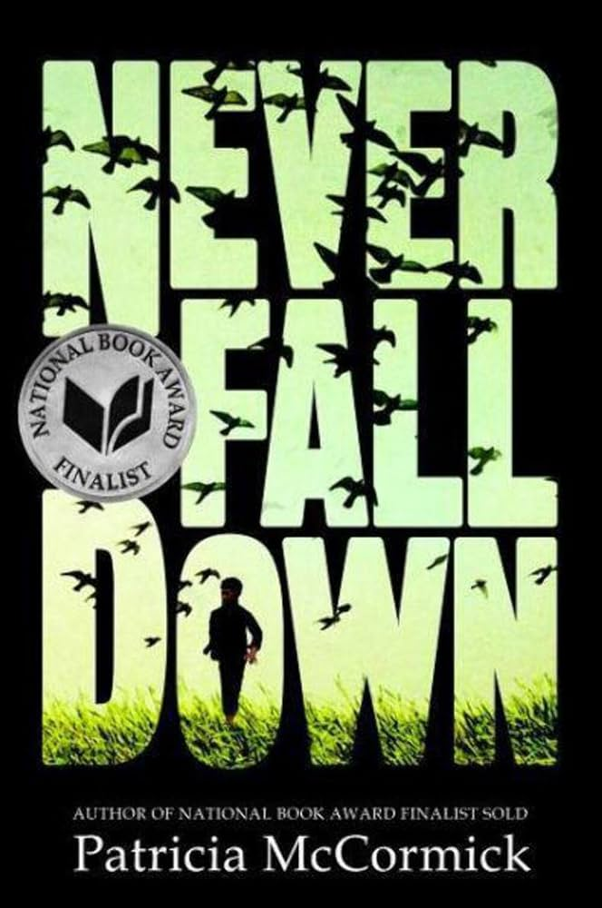
About the Author:
https://www.patriciamccormick.com/
Image Source: https://www.ncwlibraries.org/mccormick/
McCormick grew up in Pennsylvania and studied journalism at Columbia. She decided to become a writer to tell experiences that are not spoken about. With her writing she hopes to bring awareness about issues that people might not know about and change their perspectives and attitudes on the issues. Other novels by McCormick include Sold and The Plot to Kill Hitler.
- Inspired by real life incidents.
- The novel is a National Book Award Finalist
Summary:
Never Fall Down is set during the rule of the Khmer Rouge. It is about a young boy named Arn Chan who is adjusting to his new life as low class after the death of his parents. He lives with his aunt and siblings as he skips lessons from the temple to gamble instead. In April of 1975 his and the life of many turns upside down once the Khmer Rouge, a communist regime, take over Cambodia. Arn is separated from his family and forced to work in concentration camps, working in fields and entertaining to the Khmer Rouge soldiers. The fear of death and wishes to reunite with his family is what pushes him to bend to the will of the solider, doing everything they ask in hopes to live another day.
Quote #1:
“It’s a long wooden building where we sleep…Death is just my daily life now” (40-45).
The Khmer Rouge claims to be a group where all are equal, there is no rich or poor, there are no educated and uneducated, but the hypocrisy lies in the way the Cambodian citizens are being treated. In this section the Khmer Rouge are establishing their power and fear onto the common people. Those who are educated are killed, those who are rich are killed, only the poor and low class are spared, only momentarily until the Khmer Rouge finds another reason to kill off. It gives insight to understand just how horrid the event was and why Arn was so determined to do as the soldiers said. Arn’s external character changes drastically from a goofy, outgoing, and confident person into a more submissive and emotionless person.
Quote #2:
“Soup is almost ready…And I say, “Now I know you are still living, I will live, too” (125-129).
Arn is now forced to join the Khmer Rouge as a soldier to have any chance of survival. The risk is great but better than dying without trying. Arn is put into a unit with a soldier named Sombo, someone he felt he had gotten closer to almost like an older brother, and with other child soldiers to act as bait against the Vietnamese. At this point of the story Arn doesn’t even feel like he’s alive and running out of will to continue on and fight. That is until he is briefly reunited with his younger sister Sophea. Seeing her, the reality of the effects of the Khmer Rouge hit harder. He’s now more aware looking at this sister’s almost skeletal body, he looks at his own. This quote gives Arn the courage and motivation to never fall down, to continue on with this war and try to make it through so that he can once again be reunited with his family.
Quote #3:
“One teacher here in short pant; he teach the kid to play game…And I jump up and run out the door into the dark” (197-201).
This is an important part of the novel because it incorporates the reality of survivor’s guilt. Although Arn is doing his absolute best to adjust to high school in America, in the back of his mind he can’t help but feel bad that he’s given this opportunity in life while he has left so many back in Cambodia. Sojeat, Arn’s adoptive brother, is the only other one in the household that knows the truth of Arn’s past being a Khmer Rouge soldier. It haunts him and no matter how much he tries to move forward he’s constantly reminded. It poses the issue of refugees from Cambodia dealing with the guilt of living a better life while having the thoughts of leaving family and friends behind and the bad and immoral things they have done to survive during the Khmer Rouge.
Classroom Use
To present the novel to the class I would try grabbing the classes attention by finding and playing the song that Arn mentions in the novel, the Cambodian love song. Then I would do a vocabulary activity and background of what genocide is and why the Khmer Rouge started and their purpose. The novel would be read together in class because I know it is difficult for all students in a high school setting to read this text outside of class. We would go over and discuss symbolism and the author’s writing style together as a class. I would try to do daily activities such as free writing at the end of the class session to write down thoughts and feelings about the passage we read. I would also try to incorporate some fun activities such as word searches with key words to the novel. After finishing the novel, I would like to show interview clips of the author, Patricia McCormick, and Arn, the person in the story. As the final assignment for the class students can have the choice to do an analytical approach or a creative approach. For the analytical approach students would be expected to discuss the author’s style helps to portray the meaning of the book and the relation of issues the book has that are still relevant to the modern society we live in. The more creative approach would be to write a formal letter to the author or speaker in the story that is relevant to the book.
Why should teens read this book?
Teens should read this book because it tells a part of history in a way that is engaging and emotional. Rather than learning about the Khmer Rouge through a textbook, reading the raw emotions and events that Arn had to go through connects the readers in a more intimate way. It’s written in a first-person narrative as if the reader is looking at a diary of Arn. Though students might not be able to directly relate to Arn in the role as a soldier, they might relate to living in America with English not being the first language or being looked at as an outcast at school and having to deal with discrimination and bullies. It also carries a message for students to learn that a person should not be judged by their outside appearance because it’s impossible to know their story just by looking at them.
Other Reasons:
- Because the Khmer Rouge isn’t typically in high school curriculum, but it’s a very important event that should be known.
- Because the story can be a source of motivation for students to determined and hard working towards the goals they place for themselves
How it fits best in Chapters 4-8 in Adolescents in the Search for Meaning:
Chapter 4: Books about Real-Life Experiences:
- The novel is based on the real-life experiences of Arn-Chorn Pond during the Khmer Rouge
- Students in the class might have relatives, or family of friends who were affected by the Khmer Rouge and are immigrants to America as refugees of the war.
Chapter 5: Books about Facing Death and Loss:
- Arn is forced to witness many deaths and murder during the Khmer Rouge making him feel as though death was a daily part of his life.
- Arn experiences the loss of not only family members and friends, but also culture. During the Khmer Rouge even his culture was stripped away from him.
Chapter 6: Books about identity, Discrimination, and Struggles with Decisions:
- All the Cambodian civilians were being discriminated against whether it be by class, education, skin color, or gender.
- Arn was feeling confused and guilty about his identity. First, he was like the other kids being pushed around by the Khmer Rouge, only to later become one of them all for the name of survival.
- Arn had to make many difficult decisions during his time in Cambodia. Every action that he did was a risk, but it was either die from starvation or die trying.
Chapter 7: Books about Courage and Survival
- Arn showed a courageous character that had to fight against the horrid events of the Khmer Rouge. Such has the terrible working and living conditions, and the fear of death.
- All Arn’s actions were calculated towards his survival, regardless of the actions being negative, positive, or immoral.
Quantitative
Lexile: 710L
AR: 4.5, Interest level: 9-12, AR points: 7.0
Readability: Easy, Age Range 9-10
Dale-Chall: Grade Level: 4th Grade
Flesch-Kincaid: 6th grade
Qualitative
- Structure
  - First-Person POV
  - Linear plot
    - There are a few reminiscent parts of the novel when Arn thinks back on his family.
    - Time skips at the very end of the novel.
- Language Conventions and Clarity
  - Word choice and vocabulary are simple.
    - Some sentences are not standard English or grammatically correct and it gives the real voice of Arn, adds intimacy.
  - Imagery is a major literary device used in the book.
- Knowledge Demands
  - Though not needed, having some background information on the role of American and Vietnam prior and during the Khmer Rouge regime.
    - America’s bombing of Cambodia during the Vietnam war
      - Why the Cambodians were convinced by Khmer Rouge that the American were coming to attack.
    - Vietnam’s intervention with the Khmer Rouge, trying to take of Cambodia during the chaos.
      - Khmer Rouge forcing commoners and children to become soldiers to fight the Vietnamese forces.
- Levels of Meaning
  - Two levels of meaning
    - The surface level-meaning: A young boy’s hair raising and emotional journey that involves risk and quick decision making to survive.
    - A young boy learns to fend for himself and adapt to the changes in his environment and continues to grow and learn as a person.
    - The purpose is for its readers to learn more about the Khmer Rouge and the effects it had on Cambodian civilians as understand the effects of discrimination and judgment towards groups of people.

