Kristen Yabes
Mary Warner
ENGL 112B
October 23, 2023
Ain’t Burned All the Bright
by Jason Reynolds

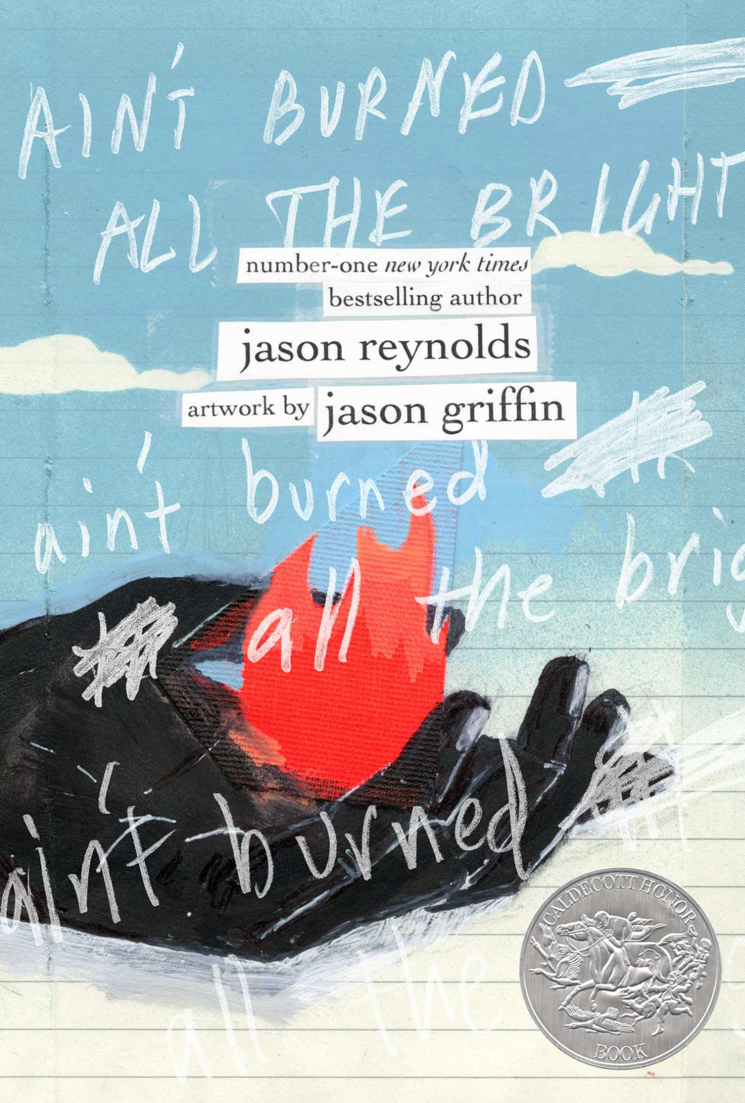

About the Author:
https://www.jasonwritesbooks.com/
Source:
https://www.npr.org/2022/12/13/1142418939/jason-reynolds-literature-ambassador-young-people

Reynolds was born in Washington D.C. and grew up in Oxon Hill, Maryland and attended the University of Maryland. Reynolds collaborated with artist Jason Griffin to create Ain’t Burned All the Bright. He received the Newbery Honor, Printz Honor and the NAACP Image Award. He was also deemed the 2020-2022 National Ambassador for Young People’s Literature. Reynolds has received public recognition and appeared on multiple shows and media outlets such as, The Daily Show with Trevor Noah, Late Night with Seth Meyers and Good Morning America.

Summary:
Ain’t Burned All the Bright is a story from the perspective of a young African American boy and his family living through the COVID-19 pandemic and the Black Lives Matters Movement. The book is composed of only three long sentences which are split up into three parts; “Breathe One, Breathe Two, Breath Three”. The poetic writing of Reynolds is also accompanied by art work on every page done by Jason Griffin. Each page consists of anywhere from no lines, or several lines. Each section of the book focuses on a different aspect of what it meant to live through and exist during 2020. The thoughts expressed by Reynolds not only hold true solely for the voice of the narrator, but there is something to resonate with for every person impacted during the pandemic.
Quote 1:
“Breathe one”:
“And he just groans and ignores me and don’t even look up…pulling back and pushing forward and back and back and forward and forward and back and back and back and forward and forward and forward.

In this first section of the book, the narrator is at home with his family when begins to notice the news and hears about the violence and brutality of men, women and kids. He starts to question what his mother thinks of it all, as they both start to see more news coverage about the protests. This quote shows the perspective of what it is like to see all of these events happening on the news, and what it is like to process these events happening. It is important to keep in mind that the reader does not know the author’s age or anything personal about him or the family. So his perspective on the topic shows the insight and perspective of being able to articulate pain and suffering poetically. Reynolds uses short “and” sentences and repeating words more than twice is impactful for the reader's ability to flow with the narration.
Quote 2:
“Breath two”:

“And I’m sitting here wondering why my mother won’t turn the channel …to get through his good-bad jokes without the punchline getting stuck in his throat jabbing and hooking”

At this point of the second section of the story, the narrator talks about his dad, and describes him being sick. It is not explicitly stated that he has COVID-19, but it is implied in the details. Once again, the reader can see the perspective of the narrator, who is listening and seeing everything going on in his household with his family. He journals his observations of his dad, and not so much his personal feelings about what it’s like to see his dad sick. But he is able to convey his thoughts in a way that temporarily distracts from the severity of it. At the end of the quote, his dad tells him to give him reassurance that he will eventually be better and he will be back to normal in just a couple of weeks.

Quote 3:
“Breath three”:

“And my sister who is ready to break out and raise her voice outside won’t leave until she breaks it up and my mother raises her voice inside and tells us all to sit down and my father yells from the other room…I still can’t help but ask if anyone’s seen the remote in through the nose out through the mouth”

In this last section of the story, the narrator describes a restlessness and impatience that he and his siblings and mom are all feeling. At this time, it is implied that his dad is no longer sick as he says he is “clear of cough”. This quote also shows how it feels to be close in proximity for this long. The narrator repeats the same format of a piece of the passage, “wondering why my mother won’t change the channel”. For many ongoing months, houses across the country relied on the news for updates. It became a part of the daily routine, and from the perspective of the narrator, it became repetitive.
Classroom use:
I would teach this book in a poetry unit to begin to teach about the different forms of poetry and writing can take. This book is an example of what it looks like to not have strict formatting in literature. Specifically, I would intertwine the idea of poetry and perspective and show the different ways perspective can be impactful for readers of any age. Since a big part of this book is the artwork component, I would pose a question to the class, asking how different the book would be without the artwork and what their favorite piece of artwork was, and what worked and maybe did not work for them, visually.
After having students read this book, as one activity, I would make them choose a different character in the book and write a poem from that character’s perspective and to share and explain why or why not they chose to include or not include artwork. Through this exercise, it gives students the opportunity to give thought into different perspectives about the same situation everyone is experiencing, in a creative format. Another activity I would have them do, is write from their own perspective at the age they were during the pandemic.
Why give this book to teens?
- This book can give teens an example of how to creatively express themselves when real life problems arise, and can be turned into art.
- It is a very easy book to read, and having the art component added to it makes it intriguing for young readers to immerse themselves in.
- It’s not an intimidating read, and is inviting to readers of all ages - they can share the book with peers and family.
- Since the book has been published very recently, it’s relatable to all teens now, and will still be relevant for all readers who will remember living through the pandemic in the years to come.

How it fits best in Chapters 4-8 in Adolescents in the Search for Meaning:
Chapter 4: Books about Real-Life Experiences:
- This book is written about the real life experiences of 2020. The timing is very recent and is relevant to teens now and in the future.
- The COVID-19 pandemic affected many families the way the narrator’s family was affected.
- The Black Lives Matter movement is a very important part of the events that transpired, it’s important to see that inequality and brutality is still very alive.
Chapter 5: Books about Facing Death and Loss:
- The narrator talks about what he consistently sees happening in the news in the community which sparks the Black Lives Matters movement.
- Many teenagers and their families have experienced the loss of loved ones during the pandemic, and can sympathize/empathize with experiencing seeing their loved ones sick, and losing them to COVID-19.
Chapter 6: Books about Identity, Discrimination, and Struggles with Decisions:
- In the first section of the book, the narrator talks about what he’s seeing in the news and sees the discrimination happening.
- Students are able to see this book as an outlet during a difficult time, at a very pivotal point of their lives in high school, trying to find their identity, but being unable to with how their education and social life has been affected.
Chapter 7: “Books about Courage and Survival”
- This book takes place in the narrator’s home, this journal is his token of courage and survival during a difficult time, especially a young boy.
- The meaning of survival for the narrator is different than surviving in a traditional sense, but in terms of experiencing a global pandemic.
Chapter 8: Books on Allegory, Fantasy, Myth, and Parable
- This book does not have any mythical aspects to it.

Quantitative

Lexile: 1010L - 1200L
AR:
-Book Level: 6.70
-AR Points: 0.50
-Word Count: 2106
Dale-Chall:
-Score: 57
-Grade level: fourth grade
-Age range: 9-10
Flesch-Kincaid: 3rd-4th grade

