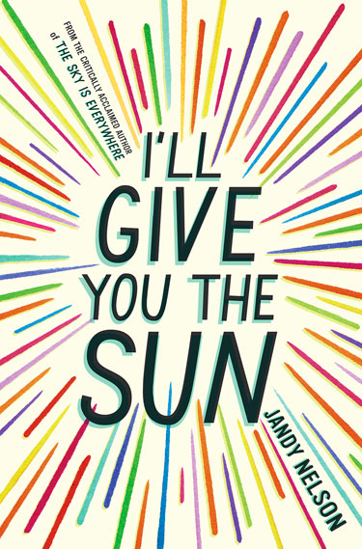
I’ll Give You the Sun

https://jandynelson.com

By Jandy Nelson
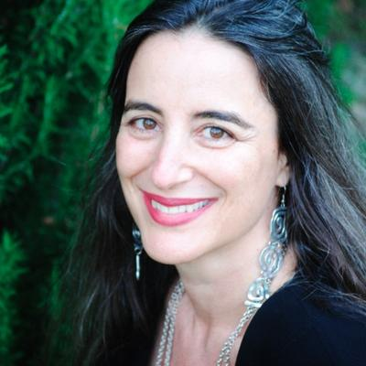
About the Author

- Completed her B.A. degree at Cornell and has two M.F.A. degrees.

- She is superstitious.

- She resides in San Francisco and adores Northern California.

- Some Y.A./middle-grade novels she considers having “changed” her life include Speak by Laurie Halse Anderson, Looking for Alaska by John Green, and Walk Two Moons by Sharon Creech.
https://twitter.com/jandynelson
Favorite Quotes
“I believe in nothing but the holiness of the heart’s affections and the truth of imagination” –John Keats
“Where there is great love, there are always miracles” –Willa Cather
“It takes courage to grow up and become who you really are” –ee cummings

Summary
Jandy Nelson’s novel titled I’ll Give You the Sun covers an entire spectrum of coming-of-age conflicts, including sexual orientation, self-esteem, social norms, and young love, taking place on the California coast. The novel is told alternatively between the perspectives of fraternal twins, ages 13 to 16 – Noah (a homosexual boy) and Jude (a heterosexual girl), both of which are extremely gifted artists with equally gifted parents, who are accomplished professors in art and science. However, despite how perfect the few of their childhood reflections seem, Noah and Jude experience a majority of their epiphanies surrounding the death of their mother in the midst of an inevitable separation from their father. Thus, although NoahandJude were inseparable as children, they still find themselves despising each other for all the wrong reasons throughout the bulk of their story, especially when it comes to their understanding of love. Nevertheless, despite the incessant heartbreak that unfolds, wholeness is restored through the piecing together of each other’s “split-aparts” by the end of this amazing, spellbinding story.

Top Three Passages
#1 There’s NoahandJude spray-painted from behind, shoulder to shoulder, our hair braided together into a river of light and dark that wraps around the whole mural. There’s Brian in the sky opening up a suitcase full of stars. There’s Mom and Guillermo kissing into a tornado of color at The Wooden Bird. There’s Dad emerging from the ocean like a sun god and morphing into a body made of ashes. There’s me in my invisibility uniform blending into a wall. There’s Noah crouched in a tiny space inside his own body. There’s Mom’s car bursting into flames as it busts through the sky. There’s Heather and Noah riding a giraffe. There’s Noah and Brian climbing a ladder that goes on forever. There are buckets and buckets and buckets of light pouring over two shirtless boys kissing. There’s Noah swinging a baseball bat at Brian who shatters into pieces. There’s Noah and Dad under a big bright red umbrella waiting out a storm. There’s Noah and me walking along the path the sun makes on the ocean but in opposite directions. There’s Noah being held midair in the palm of a giant and that giant is Mom. There’s already me surrounded by Guillermo’s stone giants working on NoahandJude.
There is the world, remade.
(pp.350-51)

Importance: This passage is significant because it is the moment where everything chaotic in Noah and Jude’s lives finally amounts to something marvelous and enlightening. Specifically, this is just after Noah and Jude reveal every ounce of truth to one another that they possibly can in order to clear out any remnant of falsehood within their relationship. What is described here is the mural that Noah creates throughout the entire course of their hardships, incorporating even some of the “self-portraits” he envisions during the experiences he depicts along the way. The beautiful thing about this moment in the novel is the fact that Noah is able to create an amazing work of art out of all of the pain and suffering within their lives.

#2 I think about how Mom told Noah it was his responsibility to be true to his heart. Neither of us has been. Why is it so hard? Why is it so hard to know what the truth is?
…
“I feel like I’m undercover.”
“Me too.” I pick up a stick, start digging with it. “Or maybe a person is just made up of a lot of people,” I say. “Maybe we’re accumulating these new selves all the time.” Hauling them in as we make choices, good and bad, as we screw up, step up, lose our minds, find our minds, fall apart, fall in love, as we grieve, grow, retreat from the world, dive into the world, as we make things, as we break things.
(p.354)

Importance: I love this passage because it illustrates an understanding that I have personally grown throughout the course of my own life. We are born as clean slates/products of our mother and father, but as we grow older, we pick up an array of external traits and ideas from people who are much unlike our innate selves. My heart swelled as I read this passage because of how much Noah and Jude’s epiphany in this moment so nearly reflected that of my own when I was a child. The most important thing in life is to understand who you are as an individual and remain true to yourself, which is also a critical message conveyed throughout this novel.

#3 Because who knows? Who knows anything? Who knows who’s pulling the strings? Or what is? Or how? Who knows if destiny is just how you tell yourself the story of your life? Another son might not have heard his mother’s last words as a prophecy but as drug-induced gibberish, forgotten soon after. Another girl might not have told herself a love story about a drawing her brother made. Who knows if Grandma really thought the first daffodils of spring were lucky or if she just wanted to go on walks with me through the woods? Who knows if she even believed in her bible at all or if she just preferred a world where hope and creativity and faith trump reason? Who knows if there are ghosts (sorry, Grandma) or just the living, breathing memories of your loved ones inside you, speaking to you, trying to get your attention by any means necessary? Who knows where the hell Ralph is? (Sorry, Oscar) No one knows.
(p.369)
Importance: Destiny as an explanation of the chaotic course of our lives is such an eye-opening perspective to have, so it makes complete sense that Jude says this passage near the close of her and Noah’s story. Accepting that there is a portion of our lives intended to remain unknown is a great way to start living and stop worrying. Although there were so many moments in this novel that either made me get really excited, laugh aloud, or cry quietly, I chose these three passages because of how deeply they resonated with that epiphanies I had within my own life. I, too, believe that the world comprises billions of scattered “split-aparts,” in which only a few people are lucky enough to find their better halves. I also accept that love makes miracles visible and that there is that must be left unknown about our lives. Thus, it is Noah and Jude’s articulation of realizations such as these that really made me fall in love with this entire novel.

Teaching Methods
- Why should teens read this book?
I believe this novel is great for teens because of how beautifully it illustrates together such profound issues as sexual orientation, self-esteem and identity, divorce, and true love. Jandy Nelson does such a great job using highly illustrative and artful descriptions in the weaving of her outstanding plot that I had a hard time putting the book down myself. Her language is contemporary and familiar, so I know students would really enjoy reading this story.

- Applying Adolescents in the Search for Meaning
…the following chapters can help deepen lessons using this novel:
  - Chapter 5 “Books About Facing Death and Loss,” since Noah and Jude not only have to endure the onset of a divorce between their parents but also the sudden death of their mother. Grievance plays a major role in Noah and Jude’s discovery of their individual selves, and this novel provides a remarkable understanding of death and loss.
  - Chapter 6 “Books About Identity, Discrimination, and Struggles with Decisions,” since Noah must come to terms with his homosexuality while Jude must flee from objectification by staying true to themselves.
  - Chapter 7 “Books About Courage and Survival,” considering that Jude loses her virginity at a very young age with someone she does not really love. Despite her constantly carrying the burden of feeling as though she has become “that girl,” Jude ultimately churns this remark from her mother into a label of empowerment and self-love.
  - Chapter 8 “Books on Allegory, Fantasy, Myth, and Parable” could even be an eye-opening resource to turn to, since Jude believes in the superstitions of Grandma Sweetwine, memorizes the Sweetwine bible, and turns to Ouija boards and The Oracle (aka “Google”) for answers in their times of need.

- If I were to teach this novel in a class, I would do the following activities:
  - Have students paint self-portraits that demonstrate their personalities and identities, just like Noah imagines throughout his narratives.
  - Have students come up with their own superstitions/charms for good luck, just like Jude adopts some from Grandma Sweetwine and creates others by herself.
  - Have students make predictions about where the characters may end up in life by writing their own endings to tack onto the novel.
I would also be sure to carry in-class discussions throughout our reading of the text to allow for any clarification of confusing and/or uncertain events, since this story is quite unique.

Text Complexity
Lexile Level: Ages 14 to 17 / Score: HL740L (“High-Low,” Grades 7 and up)
ATOS Book Level: Upper Grades (9-12) / Score: 4.9
Qualitative Complexity
On a qualitative level, regarding the overarching meaning, structure, and language used, this novel best suits upper-grade children. Considering that I’ll Give You the Sun deals with intimacy, sexual orientation, divorce, and an assortment of other deeply contemporary adolescent conflicts, it makes sense why this text would not be recommended to students under the age of 14 at the least.
Quantitative Complexity
In regard to the novel’s textual lengths, vocabulary, and general word frequency, I can also see why the Lexile Level and ATOS Book Level each evaluate it as an upper-grade work, rather than lower (or, elementary) grade. For example, it is not necessarily the characters’ specialized understandings of art history and its concepts that increase the quantitative complexity of the text, but more so its reference to rather unconventional ideas, such as Noah’s defending of “circle jerks” or Jude’s losing her virginity, followed by the complicated flurry of emotions they each communicate afterward.
Reader and Task
Although this novel best suits upper-grade young adults (ages 14 to 17), this does not undermine the level of engagement and interest the overall narration is bound to ensue for its readers. Being adolescents who are looking to define and understand themselves, this novel encompasses a variety of conflicts and problems that they may undoubtedly confide in. Regardless of whether readers are homosexual, heterosexual, and/or from a broken household, anyone can find something to enjoy and relate to within this text.

