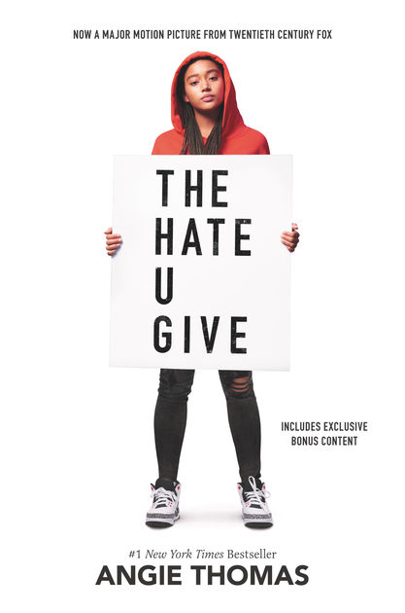
ANGIE THOMAS https://angiethomas.com/

Born and raised in Jackson, Mississippi, Angie Thomas was a former teen rapper. Thomas grew up near the home of assassinated civil rights activist Medgar Evers – her mother allegedly heard the gunshot that killed him. Thomas also witnessed a shootout at the age of six, and her mother said, “there was more to the world than what [Thomas] saw that day,” which encouraged Thomas to take up writing.

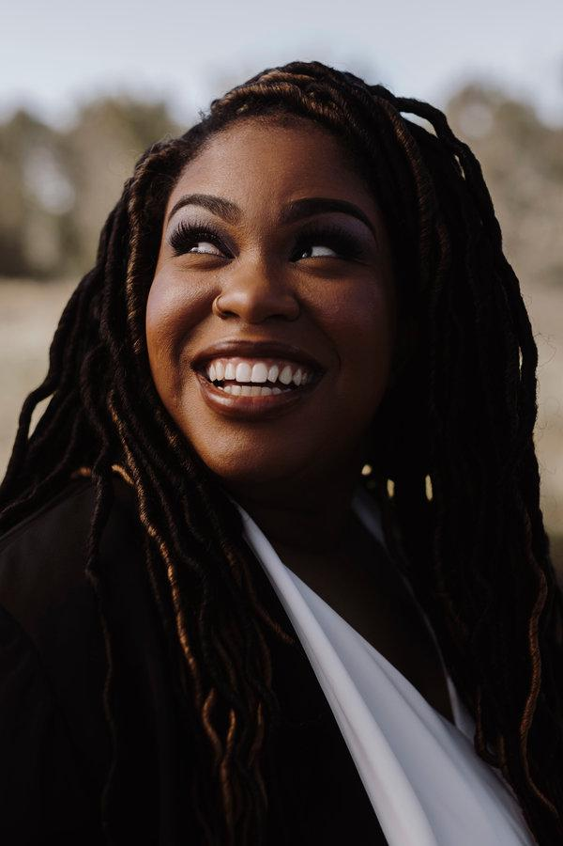
Lexile Level: HL590L
Age range: 14 – 17
ATOS Reading Level: 3.9

- I believe the reading level for this novel should be 9th-12th graders. Although the language and diction is not complex, the internal messages are controversial and thought provoking.

Summary:
The Hate U Give by Angie Thomas is an engaging young adult story that had me emotional from beginning to end. The main character, Starr, is a black sixteen-year-old who loses her childhood friend, Khalil, within the first few chapters. He is shot by a white cop who racially profiles Khalil and Starr. This would be traumatizing for anyone, let alone a young adult; however, it is much more than just Khalil’s unjust death. This novel is about racism in America and how it is very much a thing. Starr attends a private school called Williamson where she feels she must act “white” so that the other white kids don’t think she’s “ghetto.” Starr realizes that even her young colleagues are emitting hatred through racism when they abuse a protest for Khalil’s unjust death to skip class, as well as say he would’ve died anyway since he was a thug. This polarizing topic is daunting for Starr, who eventually finds her voice through Khalil’s death and promises to never forget the unwarranted murder of black people at the hands of racism and the importance of speaking up about it.

T.H.U.G. Quotes:

- “Khalil drops the brush in the door and cranks up his stereo, blasting an old rap song Daddy has played a million times. I frown. ‘Why you always listening to that old stuff?’ ‘Man, get outta here! Tupac was the truth.’ ‘Yeah, twenty years ago.’ ‘Nah, even now. Like, check this.’ He points at me, which means he’s about to go into one of his Khalil philosophical moments. ‘’Pac said Thug Life stood for ‘The Hate U Give Little Infants Fucks Everybody.’’ I raise my eyebrows. ‘What?” ‘Listen! The Hate U—the letter U—Give Little Infants Fucks Everybody. T-H-U-G-L-I-F-E. Meaning what society give us as youth, it bites them in the ass when we wild out. Get it?’ ‘Damn. Yeah.’ ‘See? Told you he was relevant.’” (14)

  - Significance: Here the title of the novel is explained. It gives one a feel for the direction Thomas is headed. Things to note here are the focus on youth and hatred. Although Tupac might be old school to some people, his message about hatred and violence is still relevant today. I believe that young black kids are taught differently based off how their elders were treated. In the end, hatred is the ultimate violence because it screws everyone over, whether that be from actual physical violence or a cynical mindset, creating a continuous cycle of hate.

- “When I was twelve, my parents had two talks with me. One was the usual birds and bees. Well, I didn’t really get the usual version. My mom, Lisa, is a registered nurse, and she told me what went where, and what didn’t need to go here, there, or any damn where till I’m grown. Back then, I doubted anything was going anywhere anyway. While all the other girls sprouted breasts between sixth and seventh grade, my chest was as flat as my back. The other talk was about what to do if a cop stopped me. Momma fussed and told Daddy I was too young for that. He argued that I wasn’t too young to get arrested or shot. ‘Starr-Starr, you do whatever they tell you to do,’ he said. ‘Keep your hands visible. Don’t make any sudden moves. Only speak when they speak to you.’ I knew it must’ve been serious. Daddy has the biggest mouth of anybody I know, and if he said to be quiet, I needed to be quiet. I hope somebody had the talk with Khalil.” (16)

  - Significance: This quote is extremely powerful because it foreshadows the next scene as well as symbolizes the whole novel. Although Starr is still extremely young, at an even younger age she was taught that cops are violent towards people of her race. Most kids Starr’s age only have one talk when they’re younger—the birds and the bees. Young black kids, however, have two talks, the other involving what to do if a cop stops you. This is a sad truth that is recognized early on in the novel and is the overall theme: it’s just not the same for white people as it is for black people.

- “Once upon a time there was a hazel-eyed boy with dimples. I called him Khalil. The World called him a thug. He lived, but not nearly long enough, and for the rest of my life I’ll remember how he died. Fairy tale? No. But I’m not giving up on a better ending. It would be easy to quit if it was just about me, Khalil, that night, and that cop. It’s about way more than that though. It’s about Seven. Sekani. Kenya. DeVante. It’s also about Oscar. Aiyana. Trayvon. Rekia. Michael. Eric. Tamir. John. Ezell. Sandra. Freddie. Alton. Philando. It’s even about that little boy in 1955 who nobody recognized at first—Emmett. The messed-up part? There are so many more. Yet I think it’ll change one day. How? I don’t know. When? I definitely don’t know. Why? Because there will always be someone ready to fight. Maybe it’s my turn. Others are fighting too, even in the Garden, where sometimes it feels like there’s not a lot worth fighting for. People are realizing and shouting and marching and demanding. They’re not forgetting. I think that’s the most important part. Khalil, I’ll never forget. I’ll never give up. I’ll never be quiet. I promise.” (241)

  - Significance: I believe this quote is of the utmost importance in this YA novel. Its significance stems further than the literary world, into the real world. The listed names are actual names of black lives taken due to racial profiling, the majority of them by cops. A slap in the face, it is a realization that this is not just a novel, it is a message about hatred and xenophobia and its relevance. Starr’s point about not knowing how or when is important because it shows that not everyone has the answers—the important part is that people are talking about it and are aware.

Adolescents in the Search for Meaning:
Chapter 5: Books about Facing Death and Loss
- Starr has lost two close childhood friends of hers: Natasha and Khalil. Young adults reading about what Starr went through can help them understand how to deal with as well as what death is in the first place. This is also helpful to adolescents because they might be dealing with loss and are unable/unsure of how to handle the pain.

Adolescents in the Search for Meaning:
Chapter 7: Books about Courage and Survival
- This novel definitely contains the story of a courageous young girl. Starr helps young adults learn how to live in peace and how to accept other races and cultures. Starr’s story is powerful and can be interpreted in many ways; however, the overall message is to abolish hatred and to be accepting of everyone.

Why Young Adults Should Read:

- Racism/Ethnicity:
  - I believe this novel would be beneficial to young adults because it would bring awareness of racism and the dangers of it at a young age.
  - P.O.C. young adults might possibly find comfort in this book because they could relate to Starr or the supporting characters.
  - Give them a new perspective on how to deal with racism.
- How to cope with losing someone and become stronger from it.

