Me and Earl and the Dying Girl

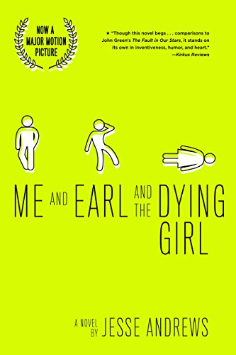
Author

Picture taken from: | Jesse Andrews was born in Pittsburgh, Pennsylvania on September 15, 1982. He currently has 3 novels published: Me and Earl and the Dying Girl, Haters, and Munmun. His latest novel Munmun was published on April of 2018. Besides being an author, he is also a screenwriter. He wrote the film adaptation for his debut novel Me and Earl and the Dying girl, while having Alfonso Gomez-Rejon direct it.
https://en.wikipedia.org/wiki/Jesse_Andrews#/media/File:Jesse_Andrews_MFF_2015.jpg
Summary

Summary

The novel begins with Greg Gains (main character) establishing himself as the author of the book. He begins by telling the audience how this novel isn’t a typical young adult novel about two friends and a girl with cancer (think the Fault in Our Stars by John Green). This theme of this novel being real life and not fiction continues throughout as Greg continues to describe his best friend Earl, his family, the first day of senior year (and why it sucks), and finally gets to describing Rachel, the girl who has cancer and is dying. The novel continues with Greg’s relationship with Rachel, and how they are not boyfriend and girlfriend, and eventually concludes with Rachel dying in the hospital. In the end Greg has a reality check when Rachel dies and expresses many emotions absent throughout most of the novel. The novel concludes with Greg realizing that he wants to makes movies for a living and decides to apply to a film school instead of a traditional four year college.

Quotes

Quote 1  “This book contains precisely zero Important Life Lessons, or Little-Known Facts About Love, or sappy tear-jerking Moments When We Knew We Had Left Our Childhood Behind for Good, or whatever. And, unlike most books in which a girl gets cancer, there are definitely no sugary paradoxical single-sentence paragraphs that you’re supposed to think are deep because they’re in italics. Do you know what I’m talking about? I’m talking about sentences like this:  The cancer had taken her eyeballs, yet she saw the world with more clarity than before.  Barf. Forget it. For me personally, things are in no way more meaningful because I got to know Rachel before she died. If anything, things are less meaningful All right? So I guess we should just start” (3) | Significance  This quote is on the third page of the novel and sets the tone for the entire book. Although from the reading the synopsis it can bear reference to works such as The Fault in Our Stars by John Green this quote immediately distinguishes this novel from anything that might bare a similarity. This quote establishes not only the tone but the perspective (it puts Greg Gaines who is the main character in the novel as the author). The novel also distinguishes itself by having the “author” of the book (The character of Greg Gaines not Jesse Andrews) talk to the audience in a form of explicit metafiction. This quote puts another perspective on death, cancer, and dealing with loss from the typical narrative and this book does it from the very beginning.

Quote 2  “So. If this was some normal fictional young-adult book, this is the part of the story where after the film, the entire high school would rise to their feet and applaud, and Earl and I would find True Acceptance and begin to Truly Believe in Ourselves, and Rachel would somehow miraculously make a recovery, or maybe she would die but we would Always Have Her to Thank for Making Us Discover Our Inner Talent, and Madison would become my girlfriend…That is why fiction sucks. None of that happened. Instead pretty much everything happened that I was afraid of, except worse.” (271) | Significance  This quote tries to relate to the reader by showing how this book isn’t a typical young-adult book. It again uses the concept of explicit metafiction to relate to its audience by stating what other young adult books do. This quote further states that those books don’t portray real life, but rather a fantasized version of life where everything resolves itself in the end. It establishes this idea of those other books being fiction and this novel as non-fiction as seen from the perspective of Greg. This idea of this book being non-fiction should give the reader more credibility as to why they should believe this story.

Quote 3  “There was just something about her dying that I had understood but not really understood, if you know what I mean. I mean you can know someone is dying on an intellectual level, but emotionally it hasn’t really hit you, and then when it does, that’s when you feel like shit. So like an idiot, I hadn’t understood until I was sitting there actually watching her physically die, when it was too late to say or do anything. I couldn’t believe it had taken me so long to understand it even a little bit. This was a human being, dying.” (277) | Significance  Although the novel presents itself as a comedy and for the most part of the novel it is, the novel doesn’t completely disregard the emotional significance that death of a friend/loved one can, and will bring. This is present in this quote and how it affects Greg Gaines, the main character. This book for a moment attempts and succeeds in relating to its audience by giving the reader a glimpse of what is going on in Greg’s mind.

Author’s other works

The haters | 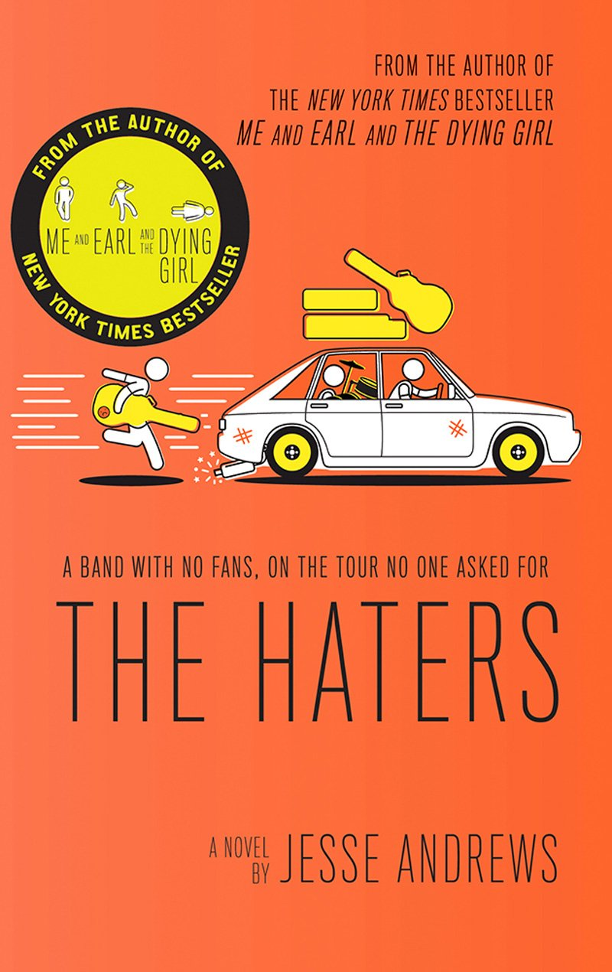 | Synopsis  This novel is based on Jesse Andrews personal experiences with road traveling bands. This book is about a group of 3 teen musicians and how they decide to go on a tour while making not so great decisions, since they are teenagers. The tour brings out the worst qualities in each of them while also bringing them closer together.
Munmun | 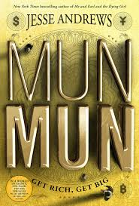 | Synopsis  This book takes place in an alternate reality where every person’s physical size is proportional to their wealt. This leads to poor people being the size of rats while the rich being the size of skyscrappers

Adolescents in the search for meaning

This novel fits two categories of books, one from chapter 4 (books about real-life experiences) and one from chapter 5 (books about facing loss and death). This novel deals with death, which is something that everyone is going to experience at some point in their life. This novel however has a different take on death by bring in humor and by making the main character aware that he is writing a book and able to communicate with the reader/ audience directly. This book however, doesn’t completely distance itself from other novels dealing with such issues since towards the end of the book Greg (main character) has an emotional response to the death of Rachel (girl with cancer), which is something that was absent throughout most of the novel. Greg also mentions throughout the novel how this book is a work of non-fiction further pushing the idea that it is about a real-life experience.

Text Complexity of me and earl and the dying girl

Atos level: 5.2
Interest level: grades 9-12
Lexile score: 820L
Overall this novel is an easy read as it is presented as more of dialogue rather than as a narrative. In many instances there are entire chapters written as a script that you would see in a movie and further ads to the ease of readability of this novel.

