Words in Deep Blue
by Cathy Crowley
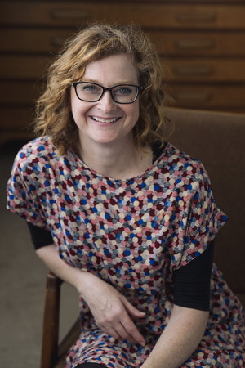
Website: https://www.cathcrowleyauthor.com/about-1

About Cathy Crowley:
- Author’s Website: https://www.cathcrowleyauthor.com/about-1

Crowley has been writing YA fiction since 2004. She wrote Take Three Girls that were cowritten by Fiona Wood and Simmone Howell, Words in Deep Blue, Graffiti Moon, Chasing Charlie Duskin and the Gracie Faltrain trilogy. She won awards such as the CBCA book of the Year award in 2018, in 2011 the Ethel Turner Prize for Young Adult Literature. Crowley also runs the Word House that her and editor and writer Alison Arnold run together that offer mentorships and professional development across Australia.

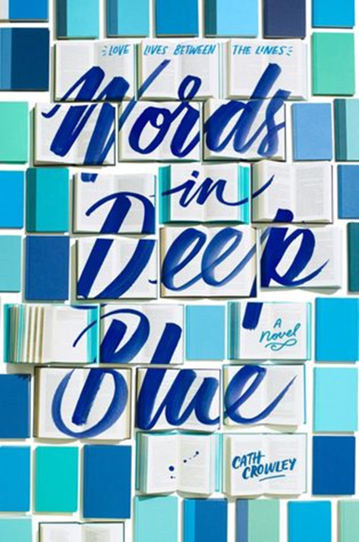

Image website: https://fab.lexile.com/book/details/9781101937655/

Synopsis of Words in Deep Blue:
Words in Deep Blue is a true love story between two childhood best friends Rachel and Henry. The story starts off with a confession letter that Rachel writes to Henry before she left for college. She tucks it away in the Letter Library at Henry’s family bookstore, but she never hears back from him. Upset and annoyed, Rachel holds this against him, even when she has to unexpectedly move back and work at his family bookstore. Yikes! Dealing with their own problems, Rachel coping with her brother’s death and working on being her old self again, and Henry learning to cope with the drastic, unavoidable changes that are happening in his life, they use this second chance at friendship to climb through each obstacle together, which could possibly lead them closer than what they have hoped.

Text Complexity:
- Lexile: HL730L Age Range: 14 to 18+
- ATOS: 4.3 Vocabulary Level 2.4
o I believe that the reading range for this novel is 14-18 because it is an easy read. I think even 12 year-olds can read this as well, but there are times when sex, and alcohol usage is discussed in this book which is why I think that this age range is perfect.

Quotes:
1. “I do a few looks of the club, looking for him. Despite my new hair, some people from school recognize me and I get caught talking to them. Emily, Aziza, and Beth want to know what I’m studying. I don’t admit to failing because that will inevitably lead to the bigger story that I don’t want to tell…’ Don’t feel you have to talk. I’m really very comfortable with the quiet,’ I tell him as we walk out of the toilets” (72-73).
A. Significance: This quote is important because it explains how Rachel is coping with her brother’s death mentally. This reflects how Rachel copes with his death by lying to others who ask about Cal, especially anything that is connected to his death. When her classmates from school ask her what she is studying for college, she doesn’t want to admit failing because it leads to the bigger story of why she failed, and she doesn’t want to tell that just yet. Because Rachel is not ready to tell anybody about her brother’s death, it reveals that she is truly pained by this experience that her way of coping is acting like everything is okay in her life, when its clear that between dealing with Henry and her losing Cal, it is obvious that she is not okay.

2.”She moves her chair back a little so some people can pass, and because I’m staring at her and I haven’t dropped the subject, she says, ‘Okay, Well you know about the guy- Joel Winter?’…’What have you lost, Rachel? Apart from your sense of humor?’”(113-114).

- Significance: This quote is told from Henry’s perspective. It is significant because it deals with the pain of losing someone. Henry and Rachel reveal how they cope with these losses differently. Henry copes with his loss of his ex-girlfriend, Amy, by talking about it non-stop. Rachel copes with her loss in this quote by suppressing it and not talking about it at all. Because they both deal with loss differently, they get frustrated and argue since they do not understand where the other is coming from. In addition, in the passage Rachel is even more irritated with Henry because his loss is small compared to her own loss. By displacing her pain onto Henry, she takes out her suppressed anger out onto him by calling him pathetic. In turn, Henry is irritated because Rachel has changed so much he does not know what she is going through at all. He tells her “What have you lost” because he truly doesn’t think she has lost anything at all to know what he is feeling. This quote shows the reality of how people deal with loss- they either talk about it, or they don’t and Rachel and Henry definitely deal with loss in different ways.

3.” What have I lost? What Have I lost? Only everything, you complete moron. I’ve lost more than you, that’s for absolutely sure. I’ve lost Cal; I’ve lost the old Mum, the old me, I’ve lost an entire ocean. That’s 71 percent of the earth, that’s 99 percent of the biosphere and you’ve lost Amy. You’ve lost a girl who, the last time I checked, dotted her I’s with tiny little self-portraits. A girl who checks her reflection in the mirror every other minute of the day. A girl who watches you fall on the floor in the front of her and doesn’t help you up” (117).

A. Significance: This is Rachel speaking in this quote. The way that Rachel has dealt with her brother’s death is by pushing it to the side and not talking to anybody about what she is going through. Rachel in this quote is responding to Henry’s comment mentally and she tells herself that she has lost everything, especially herself. This quote is important because it shows how she has completely crumbled and lost faith because she lost everything that was important to her by saying that she has lost an entire ocean which makes up a majority of the earth, and by saying this she is trying to show how her loss is more significant than Henry’s.

How might this book be used in a classroom?
- The Letter Library-
  - Have students write their own letter, something they are comfortable with other people reading. Who they are, their deepest thoughts and fears, what they are going through. They can even write to a specific person: Somebody who has passed away, a best friend etc. Have students bring in their own favorite book with a paper cover over it to keep it anonymous, and they will insert their letter in it in the beginning of class. Towards the end of class, the students will pick up a book that isn’t their own and they will respond to that letter for homework and read that book. Having students be able to participate in this action and have them put their own letters in books allows them to connect with other students in ways they didn’t expect to. I want students to work on peer relationships, a common theme that is found in this book.

Exeter Quality #7: Themes that allow the possibility of emotional and intellectual growth through engagement with personal issues.

- Rachel, Henry and George are able to grow together and get through personal issues they are experiencing by leaning on one another for help and guidance. The way these characters are learning to cope with such difficult issues in their lives can have young readers also be able to identify with the same struggling issues as well.

Seen in Adolescents in the Search for Meaning-

Chapter 4: Books About Real-Life Experiences : Making Life Choices, Facing Violence or Abuse, and Living through Family and Relationship Issues

- Through the experiences of Rachel and Henry, they share their real-life experiences with family and relationship issues to the reader with the first-person narrative and inner monologue. Similar to the example in Chapter 4, the book of Laurie Halse’s, Speak shares the power of inner monologues because the protagonist shares her painful experience and the struggles that she is going through in this way.

Chapter 5: Books about Facing Death and Loss
- Rachel’s experience of losing Cal takes a huge toll on her that she doesn’t even want to face or cope with the experience by talking about it. She keeps this bottled up because she feels like avoiding it and acting like everything is okay will eventually make her situation “okay”. In chapter five, there is an example of a novel that deals with facing death and loss by Mitch Albom, The Five People You Meet in Heaven. Giving this book to teens will be valuable to those who are struggling with losing someone who has died and learn to help a peer or a friend who is facing grief as well.

Why Young Adolescents Should Read This:

- This book obtains truth of what falling in love is like. There are uncertainties that come with your first love and everything that comes with falling in love like jealousy, butterflies, crazy thoughts that go on in their heads. I believe that adolescents can truly identify with the feeling that both Henry and Rachel and even George are feeling when talking about falling in love.
- This book is about coping with death and loss. With Rachel, the first half of the book is her learning how to cope with dealing with the loss of her brother, Cal. Being on her own, she has to learn how to be okay with the things that she can not change, and she does with thanks to Henry.
- This book is about learning to cope with changes in life. Henry is going through so many changes in his life. His family is thinking of selling the family bookstore, he is learning to be alone after his ex-girlfriend Amy broke up with him, he is even trying to figure out what he is trying to do with his life if his family were to sell the bookstore.
- This book is about bullying. Although George experiencing bullying is a minor issue in this book, it does touch on the struggles of being the one being bullied because somebody is different. George is being bullied by Shelby and it shapes how she interacts with the other characters because she is receiving this type of treatment from somebody.

