Brittney Furusho
Dr. Mary Warner
ENGL 112B
17 May 2021
Unit of Study: Mental Illness
Rationale:
Mental Health is an exceptionally essential topic of discussion following the global pandemic of COVID-19, which trapped people in their homes, many within troublesome situations, abuse, isolation, and other mentally draining situations that will undoubtedly affect generations to come. According to Standford Children’s health, “The COVID-19 pandemic has intensified the stresses of that transition for many youths” (Gray, Davia). Adolescence is already a confusing time for students and is an incurable passage of time. This too can be said with mental illness, and yet many times, teens are lost to suicide which devastates the entire world around them. In the introduction of novels that discuss mental illness and have mentally ill characters, students can begin identifying and seeking the appropriate help for their problems. Additionally, discussing mental health will allow students to analyze literature and normalize the discussion of mental illnesses.
This Unit of Study will center on One Flew Over the Cuckoo’s Nest while using other contemporary novels to support the novel’s themes. One Flew Over the Cuckoo’s Nest is by Ken Kesey and was published in 1962. The story takes place in a mental institution, and it demonstrates the severity of mental illnesses. It was vital for me to discuss and look at mental illnesses because I lost my best friend to suicide because of an untreated and misunderstood mental illness as a high school student. This unit will house music, poetry, other contemporary novels, movies, and discussions to develop a deep understanding of the severity of mental illnesses and normalize mental health conversation.

Week 1: Introduction to the Unit:
One Flew Over the Cuckoo’s Nest Ch. 1-4
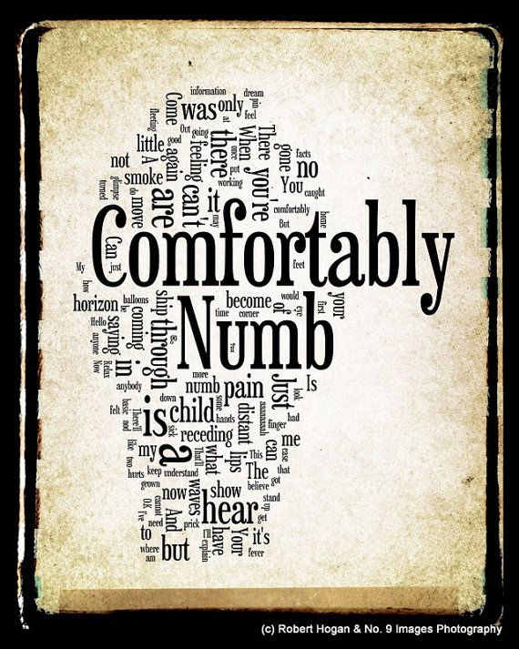
This unit will involve journaling each class session for at least 10 minutes at the beginning of class. Each class session will start with quiet journaling with different prompts on the board or write about whatever they choose. These prompts will give the students who are more apprehensive to journaling something to write about. At the same time, the students who enjoy journal can write about any aspect of their lives they wish. These prompts will include discussing three things you want other people to know about you and Writing about how you would describe yourself to a stranger. On the initial day of the unit, I will instruct the student about their journals and what we will do with them and allow them to begin their journaling in reflection on how they feel about journaling every day. After finishing their entities, we will share one word that describes their entry to another student in the class and write it at the top of their journal page. Responses could be: stupid, dumb, excited, confused, therapeutic, etc.…
After sharing their word with other students, I will then play the song “Comfortably Numb” by Pink Floyd, which is related to the text and its central theme of mental health. This song connects to the text because it is about a conversation between a patient and a doctor in which the patient is comfortably numb from the drugs given by the doctor. This song will provide students with a quick look into mental health and what the struggling person may be experiencing. After listening to the song, the class will engage in an open discussion about how the song relates to mental health and mental illness. This activity will help to increase student interest in the theme of mental illness and allow them to express what they know, ask questions, and give them a sneak peek into what will come when we begin the novel.

Weeks 2-4: ‘To The Cuckoos Nest’
One Flew Over the Cuckoo’s Nest CH. 4-29
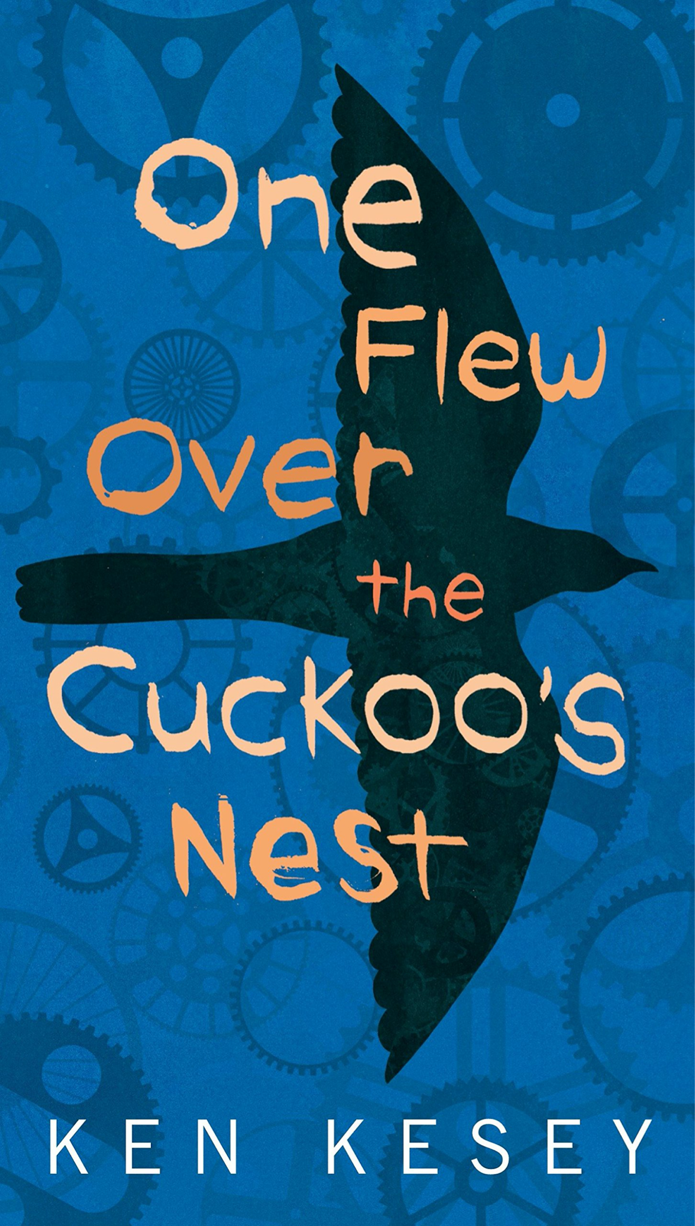
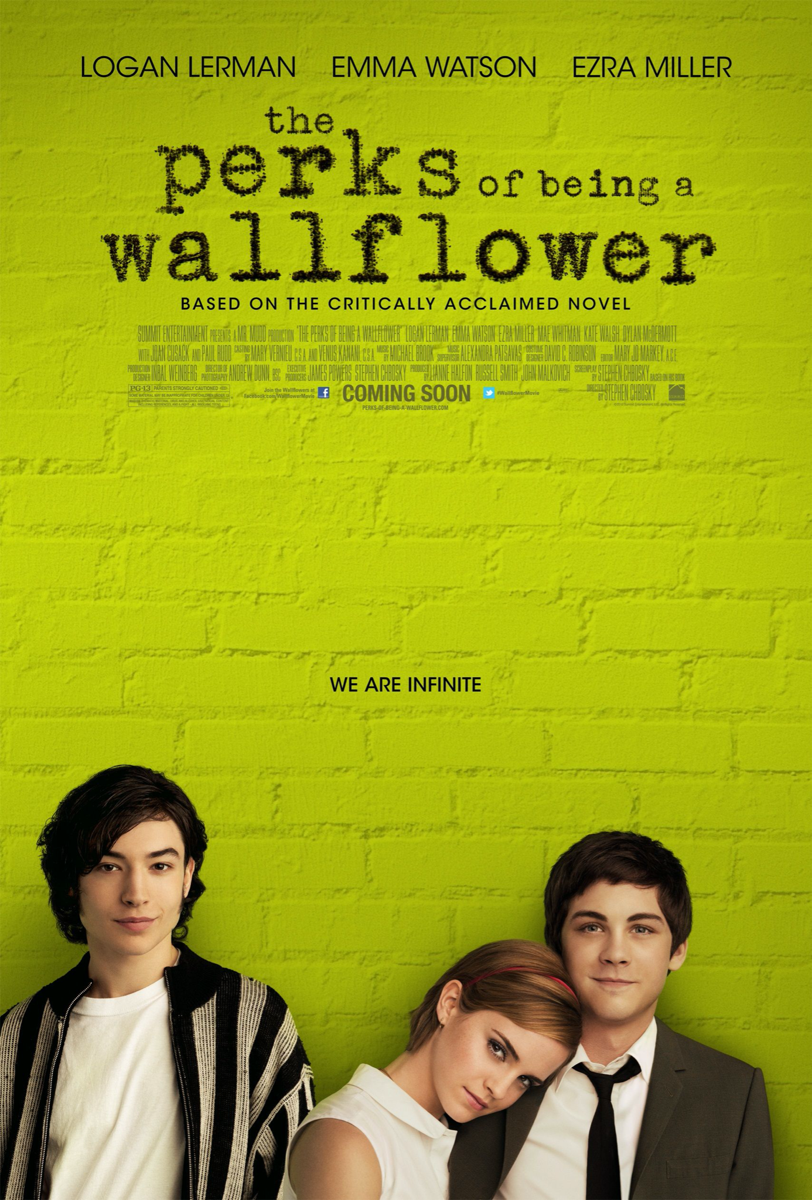
Perks of Being a Wallflower Parts 1-3

Activity 1: Fishbowl Discussion
Students will come to class having prepared a few questions about the novel, and the class will engage in a fishbowl discussion in which they will ask their questions, and another student will answer them. This discussion will help students advocate for their ideas and opinions and allow other students to gain insights from their peers. After 20 minutes of debate, I will have each student pair up and create questions to ask the group about the text regardingPerks of Being a Wallflower. The students will generate questions about themes between the two novels, how the author reflects the characters in the other novel, and how a supplementary character of either story widens the perspectives of the text. After 10 minutes of pair work, the students will return to the fishbowl discussion and ask their new questions with their partners. This type of discussion will help students engage with the text beyond lectures from the instructor. The meeting will also allow the students to work with the text in comparison and next to the complimentary text Perks of Being a Wallflower to gain comprehension of both novels and the representations of mental illness itself.

Activity 2: Brown Bag Journal Entry and Discussion
This activity will consist of the students working independently to identify two brown bag items or quotes from both novels that relate to one another and discuss how each item or selection furthers the understanding of the other. They will record these items or quotes and their analysis of each on a document submitted at the end of the class session. This activity will check for reading comprehension and ensure students are keeping up with the reading and allow students to build their ability to analyze text and use textual evidence to support their claims. After the students have finished their brown bag writing assignment, the students will share one of their brown bag items with the class and explain why they chose it and how it is essential to the central themes and ideas that have been discussed in class. This discussion will allow the students to engage critically and gain additional insights about crucial aspects of both novels and their connections.

‘In the Cuckoos Nest’ Connecting Mental Health
At this point in the unit, the students would have finished the novel One Flew Over the Cuckoo’s Nest and would be nearing the end of Perks of Being a Wallflower. As the students have the text behind them and are engaging in the complementary text, this activity will take the subject of mental health to a personal level and encourage the students to not only connect themes and context to their own lives but also begin to understand the necessity of normalizing the discussion of these topics. The students will watch the short 10 minute TED talk by Sangu Delle entitled “There’s no shame in taking care of your mental health,” which discusses how the stigma around mental health is damaging and that men (and woman) should see mental health as “important as physical health...and stop stigmatizing disease and traumatizing the afflicted”. He seeks to remove the stigma around the word “mad man” and treat mental illness like you would cancer or any other disease of the body. In viewing this TED talk, students can see other portrayals of mental illness and connect them back to their lives, either if they are struggling with mental illness or knowing someone struggling. Students will be exposed to real people with mental illnesses and hear their stories. Following the video, the students will discuss what they viewed and how their beliefs and attitudes may have changed after viewing the video.

Activity 3: Book to Film
After finishing both novels, the students will watch the film adaptation of One Flew Over the Cuckoo’s Nest, directed by Milos Forman in 1975. The students will take notes on what they notice in the film, either different or similar to the novel. Students will be able to gain more insight into the book from watching the events acted out. After viewing the movie, they will then write a Book to Film paper engaging with some argument that the movie does a better or worse job at engaging with the themes of the novel. This paper will allow for further comprehension of the story and its themes and enable the students to see another portrayal of mental illness beyond text and imagination.

“Over the Cuckoo’s Nest” Finishing the Unit:
At the end of the unit, the students will engage in a final discussion to prepare any final remarks on either novel or film. They will have an open debate to discuss any questions, concerns, or thoughts they may have about any theme or aspect of the stories.
Finally, I will have the students wrap up their journals by writing in a full circle from the beginning of the unit. I will have the students write about how they feel about journaling and continue writing in their journals after the unit. After writing I will have them tell their peers one word to describe their experience and write it on the top of their entry. Then I will allow the students to come up to the board and write both of their words down. This will wrap up the unit by showing the students how mental health gets better with time and help. The hope is that the student’s perspective on journaling has changed from the beginning of the unit, just as their perspective on mental health will have changed throughout the unit. The overarching hope for the unit is normalizing mental health and helping students find the appropriate help they need.

Extra Credit:
An extra credit opportunity for the students is to watch the film adaptation of Perks of Being a Wallflower and compare the two film adaptations to the two novels. This could either be done in an oral presentation or an essay format. This extra credit would hope to engage with both texts and film further and understand mental health. This additional credit opportunity would be offered to students who missed an activity due to illness or other reasons. Those in-class activities cannot be made up outside of class.

Beyond the Cuckoo’s Nest:
This unit focuses on the portrayals of mental illness and de-stigmatizing mental health. These novels would be encouraged to be read following the unit to further understanding and for students who are particularly interested in this topic.
-- Speak by Laurie Halse Anderson
- Melinda starts high school voiceless and a social pariah because she called the cops during a party at the end of the summer. Melinda remains voiceless throughout her first year of high school and cannot tell anyone she was raped at the party. She goes through school struggling with her mental state after the attack.
-- We Were Here by Matt de la Pena
- This novel follows three boys who escaped their group home and travel across the state to escape their actions. Each character in some way suffers from mental illness and even demonstrates suicide. The novel’s reflection through journal entries may be appealing following the unit.

Works Cited
Anderson, Laurie Halse. Speak. Square Fish, 1999.
Chbosky, Stephen. The Perks of Being a Wallflower. Pocket Books, 1999.
Delle, Sangu. “There's No Shame in Taking Care of Your Mental Health.” TED, Feb. 2017, www.ted.com/talks/sangu_delle_there_s_no_shame_in_taking_care_of_your_mental_health?referrer=playlist-the_struggle_of_mental_health.
"Comfortably Numb" Lyrics." PINK FLOYD LYRICS. Web. 17 Nov. 2012. <http://www.azlyrics.com/lyrics/pinkfloyd/comfortablynumb.html>.
Gray, Davia. “Teen Mental Health During Pandemic - Stanford Children's Health Blog.”
Healthier, Happy Lives Blog, 12 Feb. 2021.
healthier.stanfordchildrens.org/en/teen-mental-health-during-pandemic/.
Kesey, Ken. One Flew over the Cuckoo's Nest. Perfection Learning Prebound, 2009.
“One Flew Over the Cuckoo's Nest - by Ken Kesey (Paperback).” Target, www.target.com/p/one-flew-over-the-cuckoo-s-nest-reprint-paperback-ken-kesey/-/A-114
Pena, Matt de la. We Were Here. Random House Children's Books, 2009.
“The Perks of Being a Wallflower.” IMDb, IMDb.com, 20 Sept. 2012, www.imdb.com/title/tt1659337/.
“Pin by Kellie Simpson on Dark Side of the Moon: Pink Floyd Art, Pink Floyd Lyrics, Word Art.” Pinterest, www.pinterest.com/pin/75716837458337660/.

