GIVE A BOY A GUN
by Todd Strasser
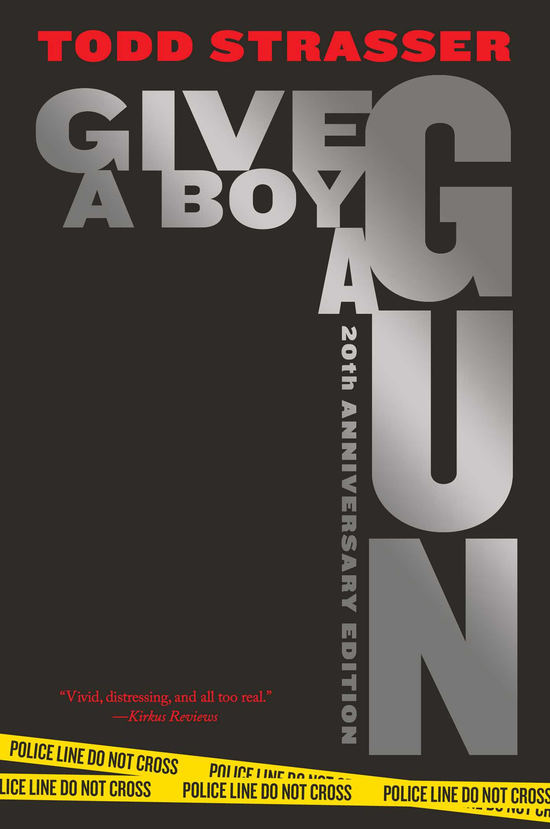

Todd Strasser
www.toddstrasser.com
is an award-winning and best-selling author who has written many critically acclaimed novels for adults, young adults, and children. He was born in New York City and raised in a nearby suburb. Early in his public education, he struggled in English because he had difficulties with spelling and grammar. He attended N.Y.U. but dropped out and lived in Europe as a street musician. Later, he returned home and studied literature and writing at Beloit College. He worked as a newspaper reporter after earning his degree and soon decided to become an author. He has written over 140 books that won awards. Several of his books are adapted for television and made into feature films. While being a writer, he contributed to television, newspapers, and magazines. His Y.A. books often talk about difficult issues that are common among teens and young adults. Despite him focusing on these topics, he feels disappointed in writing about them for young people because he has to reflect on the harsh reality that they are facing these harmful problems in their everyday lives. As he wrote a note in this novel, he tells about his concern with the gun control debate and being a proponent for stricter gun laws and restrictions on this issue that is surprisingly still relevant today. Currently, he lives with his family in a suburb of New York and continues to write books and speak at schools and libraries.
Summary
It takes place in the aftermath of a high school shooting at Middletown High School. Denise Shipley, a college journalism student, and a former student here returns home and interviews students, teachers, parents, and friends of the two suspects who committed this horrific crime. She strives to uncover the truth of the incident. In the style of it being told, each of the people interviewed shares their memories and experiences in their voices giving background and factual details that help put together the story of how this tragic event happened starting with the two suspects’ background and returning to the current aftermath. Along with each person’s recount in their perspective, the two young suspects’ notes add insight into what these troubled teens were experiencing in their lives. Brendan Lawlor and Gary Searle, who are both students at Middletown High School, are the two suspects. Their classmates and the jocks at school have bullied them for years leading up to what they did and are responsible for. Being isolated from other teens, they try to experiment with many options to ease their pain. As rage and pain ignite them, Brendan and Gary did not want to suffer any longer, so they form a plan to take revenge. They steal a small arsenal of guns from a neighbor, make bombs from reading instruction books, and take their classmates and other students hostage on the night a school dance was happening at their school. From that moment, the situation escalates in panic and fear as shots are fired and people are harmed. The tension builds and a series of events follow that end up becoming life-changing for everyone affected.

Significant Quotes
- “People talk like our school is this sick, depraved place. That’s so wrong. I talked to my mom and her friends about it, and they say it was just like this when they went to school. It must be like this at every other high school. Yes, kids can be really mean to one another, really cruel. But that’s the way it’s always been. I mean, isn’t part of growing up just learning to deal with it?” (25).
- Deirdre Bunson, a popular girl at Middletown High School
In this quote from Deirdre, Middletown High School is perceived as a bad school by the people living in Middletown because of the ongoing problem of bullying that continues to negatively impact the school environment and image. Despite bullying affects certain students at that school for a long time, other students and their parents like Deirdre and her mom are ignorant for not believing that bullying causes harmful effects on those dealing with this torment regularly. They feel it is normal to be bullied in high school because they assume every teen experiences it at least once and then learns to get over it. They view it as a learning opportunity to toughen up and mature as a young adult. Similarly, the staff members at Middletown High School express no concern about the existence of bullying in their school and fail to come up with any ideas to stop this and not reaching out to help students who are victims. They deny the truth of how serious bullying is affecting some students by remaining silent. The significance of the quote addresses how in real life, bullying should be taken seriously by schools, students, and parents and everyone needs to make an effort in helping out teens who are suffering from this problem at school because these teens have no access to get help so the responsibility lies on the schools, students, and parents for stepping in to assist them before any bad consequences might stir up.
- “Gary asked me if I would get him a gun. He’d prepared his argument very carefully. Lots of kids had guns. He’d take a safety course. It was for target practice only. I said I didn’t believe in having guns. As far as I was concerned, there was no place in our home for one. I’d be lying if I said it didn’t cross my mind that he might use it on himself.” (52-53).
- Cynthia Searle, Gary’s mother
In this quote from Gary’s mother, Gary carries a suspicious desire for owning a gun that he asks his mom, Cynthia, if she would buy him one. He seems very eager to get one that he has all the reasons why to convince his mom that she should buy it for him. She is concerned about this because she commonly sees kids having guns, but if she would buy a gun for Gary, then he needs to take a safety course first before using it only for target practice and nothing else. Gary’s mother is not against the possession of guns, but she questions what is the purpose of owning a gun in their home and what outcomes does it bring. She does not feel shocked if she would buy a gun for Gary, then he would use the gun on himself. The significance of the quote reveals how the decision of purchasing guns plays an important role in the events that follow after the firearm is in the sole possession of an individual especially a teen which is illegal by law. In reality, teens having guns raise major red flags because they might set out and start committing school shootings just like Brendan and Gary plan on doing in part of the novel or teens might decide to turn the guns on themselves to commit suicide. Basically, the quote conveys in order to prevent guns from being used by teens for the wrong reasons, it is crucial to stop these harmful acts from happening by not buying guns at all. Guns lead these students at school to be in harm’s way, and stopping the accessibility of guns from teens is critical.
- “Gary wanted to talk. Brendan said there was nothing to talk about. They’d chosen their path. So Gary goes, ‘Things have changed.’ The rest of us just lay there listening to it. Here were these two crazy boys discussing whether we’d live or not. Our lives were totally in their hands.” (114).
- Chelsea Baker, a transfer student at Middletown High School
In this quote from Chelsea, the most suspenseful moments in the novel happens here with Brendan and Gary holding the students who attended the school dance as hostages after their planned attack is going well so far. In the intense moment, Gary wants to tell Brendan something but Brendan refuses to listen since their objective is to take revenge on those in this school who have bullied them for so long. Brendan does not want Gary to lose focus on the path they have set themselves already because they have suffered a lot from bullying and now they should only continue committing violence. But Gary seems to change as he tells Brendan and they get into a verbal altercation with each other as they determine if they would kill all that are held hostage or not. Brendan and Gary’s classmates along with other students attending their school are on the verge of their lives being taken away or remain untouched. The significance of the quote implies that teens who decide to become active shooters are not bad people, but they are just people who are psychologically sick and silently calling out for help from people like us who should be open to listen and understand the stress they are dealing with. But it is disheartening that we fail to reach out to help these bullied teens escape from their struggles, and allow these sick young people to decide for themselves that gun violence is the only option that can ease their pain. In their eyes, they have waited long enough and felt that it is the best choice. For us, it is a bad choice that they are making because the lives of innocent people are taken away in a hurtful manner. So it is important to stop school shootings before they ever happen beginning with schools helping bullied student victims and educating about anti-bullying.

Why Teens Should Read This Book
By using some Exeter qualities of good YA novels, these provide some reasons as to why teens should read this YA novel.
- Exeter Quality #1: The novel’s plot is imaginative and well-structured that goes beyond simple chronologies since there are time shifts occurring in the novel with the present and the past. Denise hearing the people she interviews retelling the events of the past in the current aftermath put the past and the present in focus. Also, there are differing perspectives with the students, teachers, parents, and friends of the two suspects that Denise interviews sharing the memories and experiences in their voices.

- Exeter Quality #4: As Brendan and Gary are both characters who go beyond typical life experiences because they decide to commit a high school shooting, teen readers can take advantage of these fictional life experiences to learn that violence should not be the definite solution to solve the personal issues of mental pain and distress coming from bullying. Teens and young adults must avoid doing this when they are tempted by this decision in their own lives.

- Exeter Quality #6: With the novel covering major real-world themes, teen readers can tackle and be informed about difficult and challenging issues that relate to the immediate interests and global concerns especially here in the United States with gun control and gun violence are highlighted in this text.

- Exeter Quality #7: The novel conveys themes that allow teens especially those suffering from bullying, cyberbullying, depression, isolation, and loneliness the possibility of undergoing emotional and intellectual growth through engagement with personal issues in personal conversations, group discussions, talks, lectures, therapy, etc.

Using This Novel for Future Teaching in the Classroom
Socratic Seminar
- Students engage in a 30-minute Socratic seminar inside a classroom setting with this novel as the main focal point since this type of discussion allows students to help one another understand the ideas, issues, themes, topics, and values reflected in this text such as gun control, gun violence, and bullying. They are also responsible for contributing meaningful points to the conversation. The students should be prepared with this novel read, write down any open-ended questions they might want to ask during the seminar, develop major points prompted from the text that they want to use when speaking with textual evidence, and conduct their own research on things like current events or statistics that might connect to topics of gun control, gun violence, or bullying being emphasized in the novel. The teacher is not responsible for facilitating the conversation as the students take ownership of keeping the conversation going without any pauses. During the seminar, students participate in the discussion with the material they have prepared beforehand that they should be ready to speak without hesitation. They are expected to use academic language when speaking and apply good listening skills during the activity. Afterward, they individually write a reflection to evaluate their own performance in the seminar, notice what things they need to improve on when participating in future discussions, and also record what things they learned from other students that they want to remember moving forward when working with this novel.
Multimodal Public Awareness Campaign Group Project
- Students work in their assigned groups to produce a multimodal public awareness campaign project regarding issues that are highlighted in the novel such as gun control, gun violence, mental health, bullying, depression, loneliness, suicide, social identity. Each group decides to choose one issue they want to focus on from the options above and let the teacher know for no overlaps. Creativity is encouraged and these students should research information from credible sources to help them aid with getting their message across in a multimodal platform that they decide works best for them. Multimodal platforms they can use for this project include such as video, PowerPoint presentation, poster, infographic, advertisement, storyboard, brochure, etc. These students are responsible for cooperating in their groups and communicate inside and outside the class if necessary. The groups have time in class to work on this project and progress should be made each day. Once the groups are complete with their multimodal project, each student group will present their work in front of the class on a designated day to inform their fellow peers on the issue they are bringing awareness relating to the novel.
Dialectical Journal To Analyze Author’s Craft/Style
- Students while reading the novel should have a dialectical journal either on a word document or in a notebook to write and record specific parts of this text that they recognize can be used in analyzing the author’s craft/style. The author’s craft/style is basically how the author describes his/her ideas, events, objects, etc. that is critical for the craft of writing. The students are required to notice the ways that the author uses words such as diction, sentence structure, figurative language, sentence arrangement, mood, imagery, etc. Once they observe these elements while reading, they should pause and write down those specific examples which can range in length from possibly a paragraph to small details like words. From there, they should add their own comments relating to what the author is trying to do with what they had just noted As they finish reading the novel, the dialectical journal should consist of many of these entries and give the student a better understanding of the author’s craft/style.

For Those Not Planning on Teaching
(The writer’s style, craft, endurability, or related topics to the author and/or author’s writings.)
- Todd Strasser talking about his writer’s style and craft
Lombardi, Kate Stone. “For Best-Selling Author, What's in a Name?” The New York Times, The New York Times, 12 Oct. 1997, www.nytimes.com/1997/10/12/nyregion/for-best-selling-author-what-s-in-a-name.html.
- Todd Strasser’s Blog Post About His Letter to Young People Regarding Gun Control
https://www.toddstrasser.com/post/a-letter-to-young-people-regarding-gun-control

Category of Books from Adolescents in the Search For Meaning
Chapter 4: Books about Real-Life Experiences
Chapter 5: Books about Facing Death and Loss
Chapter 6: Books about Identity, Discrimination, and Struggles with Decisions

Text Complexity
- Dale-Call Readability Test
- Raw score 2.0288
- Adjusted Score: 3.6365 + 2.0288
- Final Score: 5.7
- Readability Grade Level: 5th - 6th grade

- Lexile Range Test
- 610L - 800L
With the text complexity results, the Dale-Chall Readibility Test gives the readibilty grade level for this novel to be 5th-6th grade and the Lexile Range Test gives this novel a 610L-800L. But overall, the age group that is predetermined and best suitable for reading this novel are teenagers starting 12 years and older who are in the middle school level and above. I truly agree with this because, during this stage in life when young children are growing up as teenagers, the specific topics, issues, and themes portrayed in this novel are at least appropriate enough to talk about with this specific age group who can handle with some level of maturity and understanding. Since some serious topics in the novel are hard to process in young children, it is best advised that this book should only be reserved for teens and young adults.
For qualitative complexity, the vocabulary is not too advanced that stirs confusion or inhibits reading comprehension along with the sentence structures not being complicated at all. The sentence length is a normal typical length that appears conversational which makes it a novel that is easy to understand and process information about important disturbing topics and subjects that revolve around this age range and grade levels with teenagers such as gun violence, bullying, mental health, depression, isolation, loneliness, murder, death, and suicide.
For “reader-task” consideration, it is significant to know that this novel is contemporary realistic fiction. With this type of genre, students especially in the middle school grade levels and above will very likely be motivated to read this text because the subjects and topics that are touched upon are age-appropriate and relevant which appeals to these young readers. Students tend to enjoy reading books that connect to the present and how they can relate to the specific topics and themes that exist in our current society. The students’ life experiences do match up to the text because they are often exposed to the reality that they are vulnerable to face school shootings or any type of gun violence anywhere and at any time. It is so common now that these students hear this very often in the news and all platforms of media. Their likely native knowledge prepares them to read the text because they are living and being exposed to the reality of gun violence, school shootings, and gun control as they are constantly being brought up almost every day. Also, schools often educate students about shootings in schools and teaching how to act properly when an active shooter is on school grounds by making barricades that protect them from harm’s way. So, their native knowledge already prepares them to be ready in reading this text.
When looking into implicit complexity, it is important to recognize the themes that are apparent in this novel since they touch upon disturbing issues usually with gun violence, gun control, bullying, mental health, loneliness, isolation, death, and suicide. The two prominent characters, Brendan and Gary, are experiencing most of these themes and the novel conveys it in a way that exposes readers to understand these themes and how to handle them properly. To note, the novel does not promote doing any act of gun violence at all. But it is more about investigating the reality of how incidents of gun violence occur and how the results of these tragedies impact the lives of people who are affected and their loved ones. The novel searches for these details and brings awareness to these types of incidents.

Other Books by Todd Strasser to Consider Reading
- Can’t Get There from Here
- Boot Camp
- If I Grow Up
- Famous
- How I Created My Perfect Prom Date
- The Wave
*Check out more of his YA titles under on https://www.toddstrasser.com/copy-of-books
A Short Summary of Can’t Get There from Here
Her street name is Maybe. Thrown out by her abusive mom, she lives with a tribe of homeless teens — runaways and throwaways, kids who have no place to go other than the cold city streets, and no family except for one another. Abused, abandoned, and forgotten, they struggle against the cold, hunger, and constant danger.
(https://www.toddstrasser.com/copy-of-books)
