Sarah Dairokuno
Dr. Warner
English 112B Sec 01
10 May 2021

Queerness in Young Adult Fiction
Young adult novels in my mind have always occupied a unique space in literature. These books can exist in various sub-genres and highlight more diverse stories. In recent years, more gay and queer young adult novels have been finding great success. Queer young adult literature tends focus on identity, though it does branch out to various other topics. This seems to be the result of the specific need for gay and queer youth to feel included in media. In these cases, a more diverse cast of characters are allowed time to explore who they are. Queer representation seems to be most prominent in young adult literature as it feeds into a demographic that must address who they are as people, but also complicated matters like sexuality and gender identity. As a young queer person, I have always found queer young adult literature to be quite exciting. I did not have many queer people to look up to so instead I turned to media to find someone like me. Even as an adult now in my early twenties I find queer young adult literature to have a more impactful look on life as a queer person compared to other books.
It should also be acknowledged that not all these books in the sub-genre focus too heavily on sexuality and gender. While such characteristics are important and meaningful to young people there are queer books where in their sexuality and gender are not the primary focus of the narrative.
In young adult literature it is especially important to have diverse characters that can be reflected on by readers. The more diverse cast also shows a progression in what is deemed more socially acceptable for the time. In turn, the wave of queer young adult literature that focus on identity shows a favorable shift in how gender, sex, and growing up are treated in fiction.

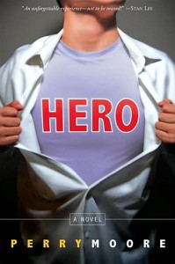
https://www.goodreads.com/book/show/1251032.Hero (read prior)
Moore, Perry. Hero. Little Brown Books for Young Readers, 2007.
Fantasy, Science Fiction, Coming-of-Age, Romance
Hero follows Thom Creed a son of a now retired superhero. Thom’s father is an angry man that now detests everything about superheroes as they kicked him out of the renowned superhero league. Thom finds himself developing budding superpowers and a crush on a local boy in their area. Both circumstances, leave Thom confused on who he thinks he is and what he wants to do with his life. In deciding to join the superhero league as an apprentice, Thom navigates the complicated world of superheroes, romance, and the tenuous relationship with his father. All the while, Thom feels as if something is wrong with the league and the mysterious boy he has fallen for.
Hero by Perry Moore is a notably older young adult novel that attempted to connect the confusing feelings of hiding in the closet with the metaphor of being a superhero with a secret identity. Throughout the novel, Thom goes through typically teenage dilemmas, at the same time trying to discover if he can be a hero and gay, which are his father’s two most hated things. Despite his worries Thom manages to find himself despite the chaotic life of a superhero.

https://www.goodreads.com/book/show/52380340-the-extraordinariesn and (Lily’s Book Talk)
Klune, T.J. The Extraordinaries. Tor Teen, 2020.
Fantasy, Science Fiction, Coming-of-Age, Romance
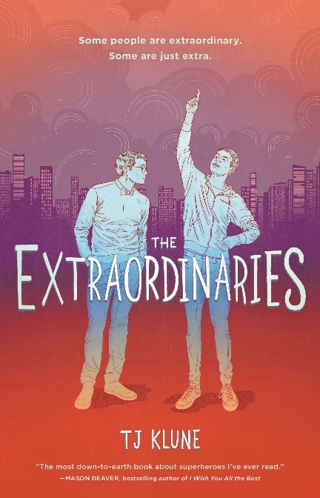
Nick Bell is like an ordinary teenager. He writes fanfiction for the Extraordinaries fandom and has a crush on Shadow Star their city’s top hero. After meeting Shadow Star, Nick decides he wants to become extraordinary. With the help of his best friend Seth Gray, Nick tries to gain superpowers. In all the rush to get superpowers, Nick might just fall in love along the way.
The Extraordinaires by T.J. Klune is a fun and funny look at how a modern teen would take superheroes and learning who he is. In being a book primarily about one’s identity it is notable that Nick must tackle budding feelings for his friend Seth, while on the search for powers. The Extraordinaires is also worth mentioning as it dives into aspects of modern teen culture like fandom and fanfiction. Klune’s take on queer romance is cute and heartwarming in that Nick’s sexuality is just a small factor in his life and does not seem to cause him much distress. This reinforces the idea that being gay is alright and only just a facet of your life.
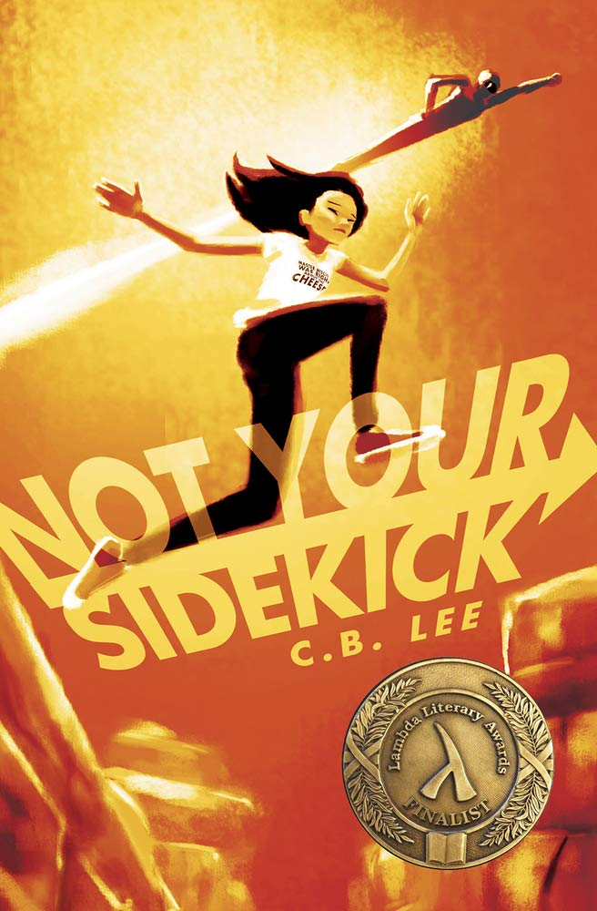
https://www.goodreads.com/book/show/52380340-the-extraordinariesn
Lee, C.B. Not Your Sidekick. Duet Books, 2016.
Fantasy, Science Fiction, Coming-of-Age, Romance
Jessica Tran just wanted to boost her college applications when she found a cool internship. The only issues is that it is to intern for the town supervillain. To her superhero parent’s dismay, she gets the internship and starts working. This does not phase the powerless Jessica at all. She gets to work with her crush and starts to have feelings for the other mysterious intern that works there as well. Jessica was only looking for a cool internship to add to her application, but she just might uncover a larger plot than all the heroics and villainy that usually affects their town of Andover.
Not Your Sidekick by C.B. Lee is another notable young adult work that takes being queer in stride. Yes, Jessica like girls but that is not the main focus. The focus is on the plot that Jessica is unfolding. In making Jessica as normal as possible Lee reinforces that being queer is no big deal. This leaves an exciting and fun book that just happens to be more diverse as it includes a gay protagonist.

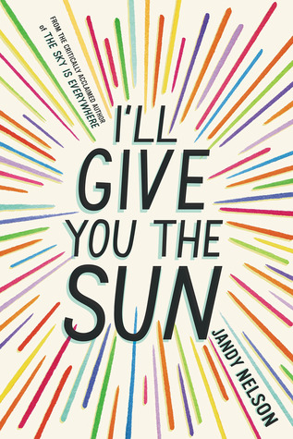
https://www.goodreads.com/book/show/20820994-i-ll-give-you-the-sun?from_search=true&from_srp=true&qid=XtmbxafwUx&rank=1 (read prior)
Nelson, Jandy. I’ll Give You the Sun. Dial Books, 2014.
Coming-of-Age, Romance, Contemporary Fiction
Twins Jude and Noah used to be inseparable. Noah is a silent artist who is falling in love with the boy nest door. Jude is talkative and daring enough for the both of them. Despite this initial closeness years down the road the two never speak to teach other. All the while both twins navigate how relationships can affect your life even years down the line. Noah tells his story through the past with his art and love life the central narrative. Jude tells the story of the twin’s present.
I’ll Give You the Sun by Jandy Nelson is about identity and relationships with family members. Noah explores his budding feelings for the boy next door. While Jude evaluates why she and her brother are no longer close. I’ll Give You the Sun is about family and love. The main narrative is primarily focused on art and family. However, the romantic and soul-searching subplot remain a tale of how unexpected and beautiful life can be.
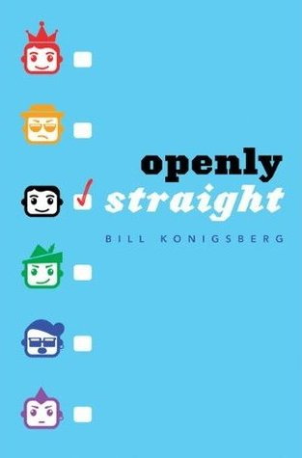
https://www.goodreads.com/book/show/52380340-the-extraordinariesn
Konigsberg, Bill. Openly Straight. Arthur A. Levine Books, 2013.
Romance, Contemporary Fiction, Realistic Fiction
Rafe has been out of the closet as gay since he was in eighth grade. Now that he is older and attending an all-boys school Rafe decides it is time to keep his sexuality a secret. Rafe just wants to be treated like one of the guys. He does not want to be known as the “the gay guy” to his new peers. At this new school Rafe is given the assignment of writing his own story. Meanwhile, Rafe seems to be falling for Ben, a boy in his classes.
Openly Straight by Bill Konigsberg is primarily about identity and how people perceive others. The focus of Openly Straight like other queer and gay young adult narratives the feelings of being different from others, wanting to fit in, and how to find oneself in their adolescence. In challenging the notion of a coming out narrative being the only viable gay narrative Konigsberg
argues that one’s sexuality does not define them entirely. Instead, Konigsberg allows Rafe to build his own character from the ground up regardless of the notion that being gay is the sole defining factor of his young life.
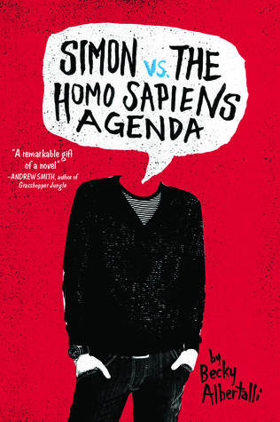
https://www.goodreads.com/book/show/19547856-simon-vs-the-homo-sapiens-agenda (currently reading)
Albertalli, Becky. Simon vs. the Homo Sapiens Agenda. Balzer + Bray, 2015.
Romance, Contemporary Fiction, Realistic Fiction
Simon is sixteen and being blackmailed by a classmate. Simon’s email to the anonymous Blue is being held over his head. Martin just wants Simon to be his wingman or Simon and Blue’s private business will become the talk of the whole school. As his troubles grow, Simon’s friend group starts to fall apart at the seams. The longer the school year goes on Simon realizes he needs to leave his comfort zone before he is forcibly outed. Simultaneously, Simon juggles his love for blue, friend group, and finding himself all in the same school year.
Simon vs. the Homo Sapiens Agenda by Becky Albertalli is primarily about one’s identity and coming into your own skin. It is important as it addresses the struggle of being outed and fear of coming out. Unfortunately, such stories are not uncommon to queer youth. It is important to acknowledge that such situations can occur and that someone can make their way through it.

https://www.goodreads.com/book/show/32797600-the-dangerous-art-of-blending-in (currently reading)
Surmelis, Angelo. The Dangerous Art of Blending In. Balzer + Bray, 2018.
Romance, Contemporary Fiction, Realistic Fiction, Mental Health
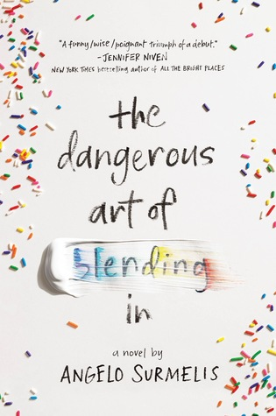
Evan Panos likes avoiding attention under any circumstances. He does not fit in anywhere. It does not help that his mother finds him to be a disappointment. Evan is terribly lonely and often finds himself alone drawing in an abandoned church. Henry is Evan’s best friend, and he wants to be more than that. As his relationship with Henry becomes more serious the abuse from his mother escalates. Evan needs to learn how to find himself before his mom’s abuse escalates even further.
The Dangerous Art of Blending In by Angelo Surmelis is important as it discusses the difficulty in coming of age as a queer kid. In this case what it is like trying to find oneself and establish an identity when facing abuse and little support. As a primarily identity-based story Surmelis’ life experiences. It is a sadder and more pessimistic take on growing up gay in a poor environment. This can give young people a story to emphasize and relate to as unfortunately there is still a lot of negativity toward queer youth in some environments. It is important as it recognizes the unfortunate situations young people can go through.
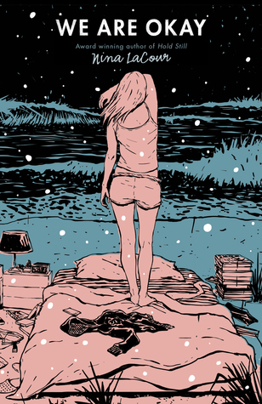
https://www.goodreads.com/book/show/28243032-we-are-okay
LaCour, Nina. We Are Okay. Dutton Books for Young Readers, 2017.
Romance, Contemporary Fiction, Realistic Fiction, Mental Health
Marin has left everything behind. She has not even contacted her best friend, Mabel. Now waiting in an empty dorm in New York, Marin feels incredibly sad and alone. Mabel is coming to visit Marin. Once Mabel shows up Marin will have to confront the loneliness she feels on a daily basis and all the things she has left unsaid. Marin pushed everyone away following the passing of her grandfather. Ow that Mabel is here Marin is not sure what she wants or what exactly she feels.
We Are Okay by Nina LaCour is primarily a book about relationships and emotions. Being queer in We Are Okay is a factor but not the main focus of the narrative. The book revolves around being oneself and the grief of one’s past. LaCour suggests that being queer is a lonely experience that can factor into one’s life choices and relationships with others. Grief is the primary motivator of the narrative and is the main thing Marin experiences throughout.

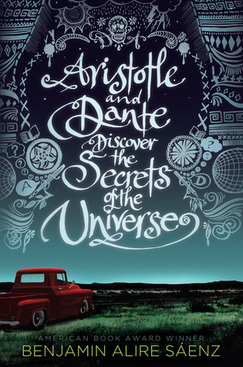
https://www.goodreads.com/book/show/12000020-aristotle-and-dante-discover-the-secrets-of-the-universe?ac=1&from_search=true&qid=QqueEZDZDr&rank=1
Alire Sáenz, Benjamin. Aristotle and Dante Discover the Secrets of the Universe. Simon
& Schuster Books for Young Readers, 2012.
Romance, Contemporary Fiction, Realistic Fiction
As two loners Aristotle and Dante start spending time together, they make a special friendship that neither were expecting. Despite having virtually nothing in common the budding relationship the two form proves to be special. Through this new friendship Dante and Aristotle will learn more about themselves and who they want to be.
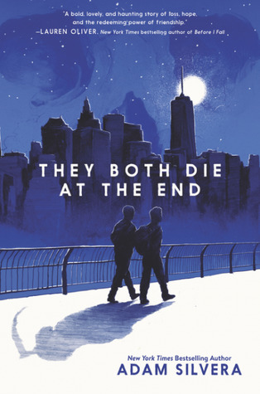
Aristotle and Dante Discover the Secrets of the Universe by Benjamin Alire Sáenz is primarily about finding identity and feeling emotions. The book focuses on how opening to new people can give someone new perspectives. It is a coming-of-age tale that gets more layered as it progresses. It is also dedicated by the author saying, “to all the boys who’ve had to learn to play by different rules.” This gives a better look at who exactly the book was written for. It is a book written for young queer kids trying to find themselves.
https://www.goodreads.com/book/show/33385229-they-both-die-at-the-end?from_search=true&from_srp=true&qid=B4gwjNBdUC&rank=1
Silvera, Adam. They Both Die at the End. Quill Tree Books, 2017.
Romance, Contemporary Fiction, Science Fiction, Fantasy
Mateo Torrez and Rufus Emeterio are going to die today. They are total strangers but looking for companionship on their final day. They meet through an app called Last Friend and plan to hang out on their last day. They meet up and try to have an adventure of a lifetime on their last day on earth.
They Both Die at the End by Adam Silvera is best described as a book about death and life that just happens to revolve around queer people. They both die at the end has an interesting take on life and how people should live it. It argues that death is a necessary and inevitable part of people’s lives and therefore people should live life to the fullest. In terms of queer young adult literature, the novel is a reminder that young queer people have lives to live. Gay and queer youth have lives to live and they can live them to the absolute fullest.

