Sherwin Aguilar
5/9/21
ENGL112B
Professor Warner
Field Experience Paper: https://docs.google.com/document/d/1P3B_FrvpNmJOr5mtkg4bIK0wsuzE3yNxThF6IcwE_wA/edit
Unit of Study: How Science fiction has inspired real life

Rationale:
Despite the name of the genre, science fiction still has a big basis in the entire idea of science as a whole. Looking closely at it, you would actually discover that science fiction has so much to it than on the surface. It is more than laser swords and giant robots or alien spaceships. Science fiction has actually led to the influence and discovery of things one wouldn’t normally find in science rationally. The discovery of the appliances of artificial limbs and the creation of cybernetic companions has truly created and ushered in a new age of living for the people of earth as a whole. In fact, when you really look at some of the modern inventions we have today, a good chunk of them were actually not possible without the inspiration given to the scientists who made them. All of these inspiring sci-fi stories were the very things that helped change the world's history as we know it, in some of the most inspiring ways, and most terrifyingly, some of the most destructive ways one could ever think.
The main story that the Unit of Study would focus on in order to prove this point would be the story of H.G. Wells “The world set free” written in 1913 and published in 1914. The purpose behind this book is to show that despite how much fake stuff one would find in sci-fi, there can also be a haunting amount of real life to be found in said stories. After all, “The world set free” sets the precedent for one of the most upsetting predictions in all of sci-fi. The story shows the potential benefits and all the dangers that would come from the ability to harness atomic power. When H.G. Wells created this plot line for his story, he had the thought that this power would either utterly and completely destroy society, or it would end up forcing mankind to stop their fighting and finally achieve world peace. This very book would be the very thing to inspire the scientist Leo Szilard, the man who went and figured out how to harness atomic energy in real life. Which ended up leading to the invention of the atom bomb, as I said before, despite how much of a positive inspiration sci-fi brought to our world, it has also changed it completely in some of the more destructive and darker ways than one person would ever expect it to.
This unit of study will be able to show and help people understand the reasoning behind why science-fiction is actually the most influential and helpful genre’s in YA novels. It is the very thing that can lead to the foundation of some of the greatest pieces of technology humanity have ever seen and help benefit people. The goal of this unit for me is show that through each of these YA novels you will end up seeing that, despite how poorly aged some of the plot lines in these stories are, and how some of them actually ended up predicting the future in the strangest ways possible, it can also lead to the discovery that lead to the creations that humanity could not ever find themselves ever living without. And by the end of the unit, students can see beyond the pop culture influence that sci-fi has had, to see past the toys, and nerd culture it has created and realize that sci-fi is already coming to life all around us. And that perhaps the fiction, in science fiction, isn’t so fake after all.

Introduction to Unit: https://youtu.be/IAZAIdLwhGw
This video shows that science fiction and science innovation has actually more basis in reality than one would believe. Science fiction and science reality is much more possible than one would believe. This all started during the 19th century thanks to many of the steel mills and factories around the world, producing all sorts of items at an alarming rate that people were not used to at the time.
I would be having students analyze the various pieces of technology that was brought up in this video and have them write down notes on everything being noted. Showing that even during the 1700’s and 1800’s that one would find that science actually has a basis in fiction, with scientists, as shown in the video using electricity to figure out the various effects it would have on corpses. This would end up involving the inspiration of Mary Shelly to create one of fiction's most influential stories, Frankenstein. This very story is actually what ended up inspiring the creation of the defibrillator we all know of today, the very first one being created in 1957. And with this huge creation, one has to ask, what else has sci-fi inspired that ended up leading to some of the biggest changes the world has ever seen? What stories would have giant monsters or flying around the rings of Saturn at light-speed do for us as a species?
During the our first class, I will hand an assignment to the students and ask them a set of 3 questions that I want them to answer thoroughly
- What pieces of technology have you seen in science fiction have you noticed actually exists in modern day?
- Do you believe that science fiction can lead to even more scientific advancements? Or is it doing more harm than good? Please explain.
- What sci-fi stories, whether it be a novel or a movie or even a series have you seen that has technology that hasn’t been invented yet?
The reason why I would have this be their very first assignment is due to the fact that I want these students to actually discover how much all the items that are around them, their watches, the t.v.’s, the airplanes, everything they see in the world around them is actually because the people who created them in the first place were inspired by Science fiction. And even when they were to find out that some of the technology we have today, like credit cards, wasn’t actually created because the person who invented it read a sci-fi story, this assignment would also have the student realize that the pieces of technology and a lot of what one would see, like self driving cars, AI’s helping us in our modern life and more, would actually be predicted from all the way back in the 1900’s sci-fi stories, showing one of the more surprisingly terrifying aspects that can come from sci-fi stories.

Centerpiece of study:
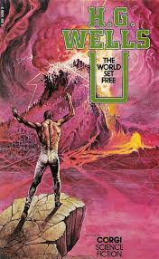 The World Set Free in my opinion is the most important story in all of science fiction due to the fact that it was this story that created the most dangerous and deadliest weapon in all of human history. I want for the next few weeks for the students to analyze from top to bottom everything that this story presents to the people. What basis of reality can we see this story that H.G. Wells created having a basis in our everyday life, after all, the creation of atomic energy and the ability to harness it is mainly so there would be something that would help the world finally be able to come to terms with one another. The main story is a haunting one that actually comes to reflect the ways humanity has acted in our modern day in terms of the way it seems like there is so much hostility between our fellow man, but I believe that is the point. The story is trying to get you to focus on the big reflection that this story is trying to put upon its reader. I want more than to just show how science fiction can lead to changes in our world, I also want to show my students and those who would read this book, how much of our world we can actually find in these fantastical stories. See and understand what it is about them that could lead to the inspiration of the scientists and possibly see them become inspired as well.
We’re also going to do thorough analysis of the quotes, such as “The power of destruction which had once been the ultimate privilege of government was now the only power left in the world--and it was everywhere.” And ask what it ultimately means, doing an in-class assignment where I have students partner up to try and figure out what they believe this quote ultimately means. And find out each viewpoint a student would have over such a heavy quote and what it could mean for us as people.
Through the unit:
I’ll be assigning daily journals for the students to write, I want them to make sure that they’re paying attention to the most important parts being taught in the class about what parts of history, what stories, and what pieces of technology are all be ing used. The most important thing for these students I want them to take away is the various themes in the stories, I want them to see what it is these novels contain. Have them figure out what it is that’s in them that leads to some of the surprisingly accurate predictions and creations that we have today. I’ll also make sure to assign a quiz at least every 2-3 weeks to really test them on whether they’re paying attention or not and make sure to use specific questions that would make sure to see whether or not they’re really reading the text.
If we’re online or in person, I also want to do various group activities, the most of which is going to be a group discussion on the book we are going to be reading. I want them to throw out various viewpoints and see what answers they come up with. I’m going to ask them questions like:
- What is it about this story that grabs you the most?
- What part of this story scares you and if it doesn’t, why is that?
- Do you believe this is truly accurate of our times or just some story?
- If you were to put yourself in the positions of these characters, where would you find yourself being?
I also want this to be a group project, I want the students to find a sci-fi story, something they can all agree on that has the potential and practicality to lead to something we could actually find today. I know it doesn’t sound like a lot, but this’ll really test their thinking ability, because we already have so much technology that comes from sci-fi that it’s gonna have them really wrap their brains around what it is that could be used. And I want it to be a presentation where each of them are participating, each person with an assigned role that way we can see what each person will discover and help contribute to the bigger picture. Sort of showing that scientists couldn’t really do a lot of their biggest experiments alone, and they’ll need help and approval in order to go through with some of their bigger ideas.
Outside of the main unit:
The main focus of the unit is to make sure to explore the possibility that sci-fi is one of the most influential genres ever created. To prove to the students that all these sci-fi stories can end up creating the next big invention that could truly change the world as we know it. And to also prove that all these inventions had to start somewhere, and what better way to do that than to use more stories that would end up leading to some of the biggest inventions our modern world has ever seen
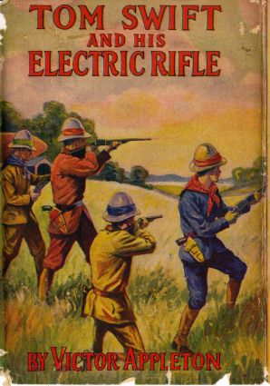
- Tom Swift was a YA series from the early 1900’s about a teen genius and the various adventures that he and his friends went on. The series contained over 100 novels, in which the main character had invented, as the title implies, his electric rifle. While the plot line of the story has not aged well considering it has to do with an extremely racist safari, this novel did end up inspiring NASA Researcher Jack Cover to invent the real version of the electric rifle, aka, what we know today as the taser.
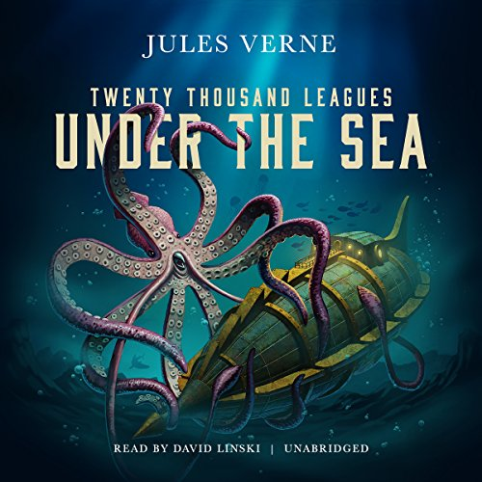
- American Inventor Simon Lake became completely enamored by the idea of the undersea travels after reading all about Captain Nemo’s adventures. And while the story of 20,000 leagues under the sea is more about them traveling twenty thousand leagues WHILE under the sea, rather than them traveling DEEP into the sea. This didn’t stop Simon Lake for it was in 1898 where he finally completed the Argonaut, the world's first successful open-water submarine. The writer, Jules Verne even wrote him a congratulatory note.
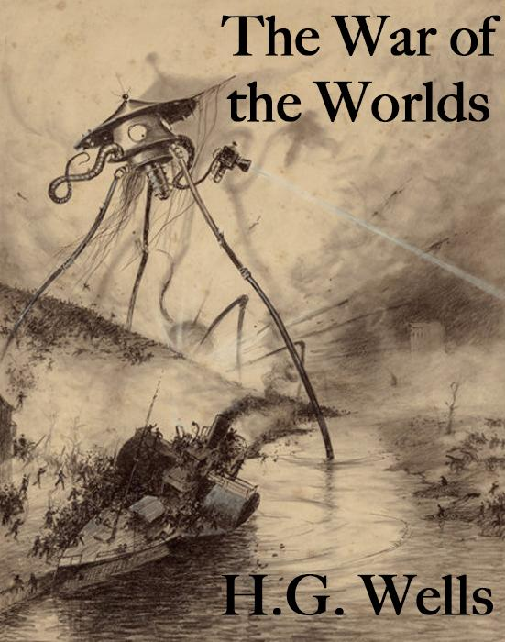
- It was the classic and one of the most famous sci-fi novels ever written, War of the Worlds that helped pioneer one of the inventions that would eventually lead to the people of earth wanting to explore the stars. The story about Martians invading earth ended up being the jumping point for the scientist Robert H. Goddard needed in order for him to come up with a new invention, a new mode of transportation. This mode of transportation was the Liquid Fueled rocket, inspired by Wells Martian’s interplanetary ships.
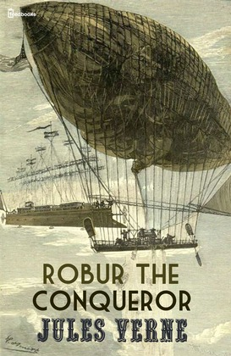
- H.G. Wells created stories that were all about destroying the world and yet also found ways to inspire the people to create devices like the rocket. Jules Verne was all about writing overly specific, hard sci-fi stories and was all about waiting for someone else to come along and make it into reality. Igor Sikorsky read the Verne Novel, Robur the Conqueror and lil Igor was so taken aback with the idea of a flyin, lighter than air transportation, that he grew up to invent his very own flying machine. That flying machine is what we know today as the helicopter.

Ending the Unit:
As we end the unit I want to do one final presentation involving the students, I want them to choose a sci-fi story that they personally have loved the most. And do a slideshow and video presentation or live presentation if given the chance to talk about what pieces of technology in this story have inspired them. I know not all students are set out to become scientists, but I want to see which of them actually felt that spark of creation, that moment of realization that these very famous scientists have had, and see which among them can show that they could also have that moment as well. I want to walk out of this class knowing that I truly have lead to the inspiration of some of the future inventors and innovators of the future.

Citations:
- ArXiv, E. (2020, April 02). When science fiction inspires real technology. Retrieved May 10, 2021, from https://www.technologyreview.com/2018/04/05/67057/when-science-fiction-inspires-real-technology/
- Cavendish, L., &amp; Magazine, A. (2020, March 25). Welcome to the future: 11 ideas that went from science fiction to reality. Retrieved May 10, 2021, from https://www.space.com/science-fiction-turned-reality.html
- Electropages. (n.d.). How sci-fi Influences real-world tech and innovation. Retrieved May 10, 2021, from https://www.electropages.com/blog/2020/01/how-sci-fi-influences-real-world-tech-and-innovation
- Fussell, J. (2013, October 22). Science fiction inspires innovation in real world. Retrieved May 10, 2021, from https://phys.org/news/2013-10-science-fiction-real-world.html
- Zabiegalski, R. (2019, March 11). These 15 tech inventions were totally inspired by sci-fi movies. Retrieved May 10, 2021, from https://thetempest.co/2017/04/25/now-beyond/tech-money/tech-inspired-by-science-fiction/
- Zuin, L. (2021, March 26). How science fiction still inspires real technological innovation. Retrieved May 10, 2021, from https://www.syfy.com/syfywire/how-science-fiction-still-inspires-real-technological-innovation

