Emrick Palmero
Dr. Mary Warner
ENGL 112B
19 April 2021
Realized Growth and Retrospective Gazes: Examining the Structure and Effects of the Bildungsroman in YA Literature
Rationale:
The bildungsroman: a story that chronicles the coming-of-age of a young protagonist, pertinently a child, as they eventually become an adult (or young adult). While the label generally attaches itself to more classic novels, the structure of the bildungsroman is synonymous in effect to literature, and in particular, it has become an integral part of young adult literature, or as the textbook Literature for Today’s Young Adults puts it: “as new realism or as problem novels” (chapter 4). As teens and young adults experience what is arguably the most turbulent changes of their lives, the structure of the bildungsroman offers a mirror for readers to view their lives’ recent events and distant memories, illustrating the growth of how one might have become who they are today. With various novels and stories featuring protagonists who grow physically and mentally from their childhoods and eventually onto adulthood, the aspect of their characters’ development also underscores the shifts of their socioeconomic standing, although it does not necessarily need to be attached to who the characters become in the end as they look back to their childhood past. Offering the bildungsroman, alternatively known as problem novels or stories that involve a coming-of-age, in the classroom not only allows students to come upon the same or similar realizations of character building and growth, but also allows them to peer into how different social backgrounds in life also impact the initial and ensuing character.
In this unit of study, the centerpiece work is a canonical and exemplary work of a bildungsroman: Charles Dickens’ Great Expectations. In addition to this work, students are also interacting with other coming-of-age works that are also considered young adult literature, with significant examples such as The Outsiders and The House on Mango Street. While the protagonists of these two novels, Ponyboy and Esperanza respectively, reflect upon their adolescence while they are still young, the fact that they come to grow, or have grown, from their experiences as they narrate and write them shares a close link to the evocative experiences of Pip in Great Expectations, who also reflects upon his life albeit presently in the novel as a narrating adult. Prior to tackling these stories.
Part 1 – The Start of the Unit
The unit of study starts with considering the definition of the bildungsroman, and how its application connects to the literary works of today, particularly young adult literature. The inquiry evolves into a discussion of the defining characteristics of the bildungsroman, hopefully lengthening to a good half of the time spent in the class. Regardless of the result, the discussion will lead onto a brief listen of the Beatles’ song “In My Life” from the Rubber Soul album, having the students at least pay some attention to the lyrics that are sung. Afterwards, the discussion of the bildungsroman will resume again, but this time identifying parts of the lyrics (a handout with the song’s lyrics) for brief annotations that aim to reveal similarities to previously identified bildungsroman characteristics. The song will be played again for the sake of reviewing these identified characteristics, which will still be in view through a visual format (a whiteboard perhaps) so that students are able to refer back to them as they listen to the song again.
Figure 1: blank timeline chart
If the time allows or for another class period, there will also be another assignment introduced that involves a blank timeline chart (see above). Students will work on understanding the structure of the bildungsroman by applying it to their own lives, mapping out the important events that they can remember (if they wish to share them!) from their childhood and up to now. What constitutes importance will root from what the class agreed upon in what defines the bildungsroman, but any justifications given to a regarded memory are also welcome. In this same assignment, I will allow students to share the one memory they deem as the most important or the most life-changing, and have them share their reasons for choosing the memory in order to see if it aligns with the class’s agreed definitions for the bildungsroman. Of course, these characteristics are continuously open to change, so any new findings are added to the list when the class approves of them.
Part 2 – Reading Charles Dickens’ Great Expectations
It is at this point when I will introduce the centerpiece work for this unit: Great Expectations. To maintain the mirroring experiences of reflection and reminiscence, students will also begin keeping writing journals to coincide with the novel, and after that, for the rest of the unit. The reading of the novel will be done mostly out of class, but in-class writings will be important as discussions of the novel will take place. For example, upon reading the first two chapters, students will explore the world-building described so far by the narrating Pip, particularly to his attention of his impoverished and troubled home life as a child. In the same vein of looking back to their own lives, students will share, if evident and willing to share, any parallels of struggles in their lives in a similar fashion to Pip’s troubled home life. In order to ensure that students are reading the novel, there will be two types of assignments that will continuously emerge throughout this part of the unit: milestone quizzes and quotation logs. The milestone quizzes serve a pause in the unit to discuss the plot of the novel as it shifts in events through the course of Pip’s growth in childhood and in his teen years, allowing me to gauge if the class is able to interact with the text smoothly or if clarity is needed. If the latter becomes necessary, the quotation logs will assist in reviewing what may have caught the attention of some students in what they have read so far from the novel. In reviewing these quotes, and perhaps even showing the class some review videos, such as Wisecrack’s summary video or TED-Ed’s overview video of Charles Dickens and his literary works, I am aiming to keep the class’s understanding of the bildungsroman relevant to how they view them, solidifying them as they see them in action through Great Expectations. In addition, quotation logs, as they build up, will also become useful for a brief (2-3 page MLA format) reflective/summary essay on Great Expectations at the end of this unit.
To further engage the students with Great Expectations, there will be some minor activities that are assigned along the way. In the following text below, I will list some examples of what could be done:
- Draw My Life: Inspired by the same trend of videos that show the course of someone’s life as they draw them, students will practice the reflection aspect of the bildungsroman by drawing out the life of Pip as it is chronicled so far in the novel. The format is not required to be animated as videos of “Draw My Life” are like, but can instead be done in different visual formats: hand-drawn, digital illustrations, cut-outs from physical images (like magazines) or online images. The specifications to this assignment, in effect, are broad, so long as the students accomplish the goal of conveying the life of Pip in some visual format. Again, I want to emphasize that it is not required to be animated or in video format, as this is meant to be a small assignment.
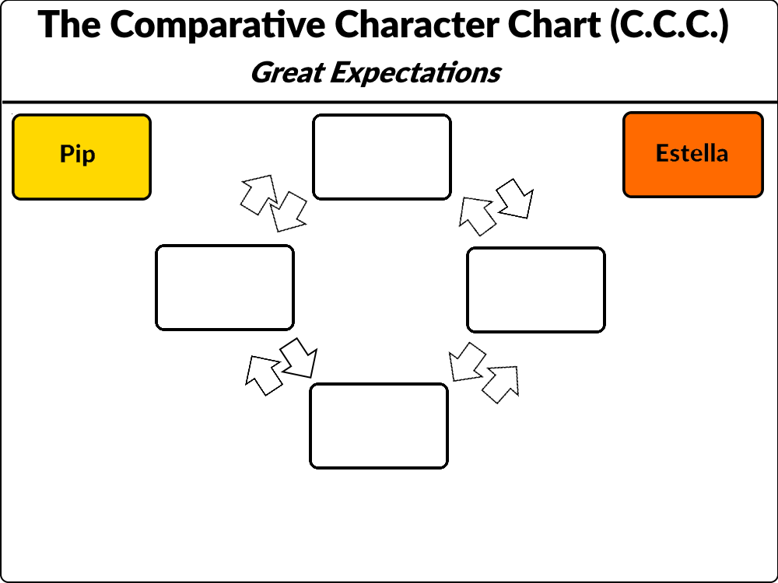
- Comparative Character Chart (the C.C.C.): A handout will be given near the end of reading Great Expectations, serving as a precursor to the extended unit project in the next section. For this initial part of the assignment, students will track down instances of character growth or realizations from Pip as he mentally grows as an individual, reflected upon in the form of quotations and inclusions of brief contextual summary with those quotations. Looking at the handout below, the arrows will indicate the transitions of those changes in which students will explain how they have come to fruition in the context of Pip. As these arrows are interchangeable in transition, the boxes in the chart should be connected in the sense of Pip’s life, noted by how the context of his narration comes from reflection. Notice also that Estella, a secondary character in the novel, is also included. Estella, like Pip, is a young character in the novel who grows and changes as a person, both physically and mentally. While she does not appear as much as Pip does (as it is obviously evident through Pip being the narrator), she still serves as an essential example of the bildungsroman’s effect in structure.
Figure 2: a mock-up of what the C.C.C. for Great Expectations might look like
  - The handout has some color coding to further distinguish which explanations and quotations correspond to whom, encouraging the use of colored pencils or other color-coding methods.
  - At the back of the handout, names of protagonists from choice young adult novels are included, which will come into use for the extended unit project. Notice also there is a sole blank box to the right, which will serve as a custom choice for a young adult novel that a student may wish to request for the final project, which I will have to approve upon verifying that the novel of choice fits the coming-of-age or bildungsroman genre. Students will have to create their own structure for how the changes of the character that they are studying are exhibited through their respective novels, so custom drawn or illustrated boxes must be made in the chart as well as their own arrows connecting those attributes.
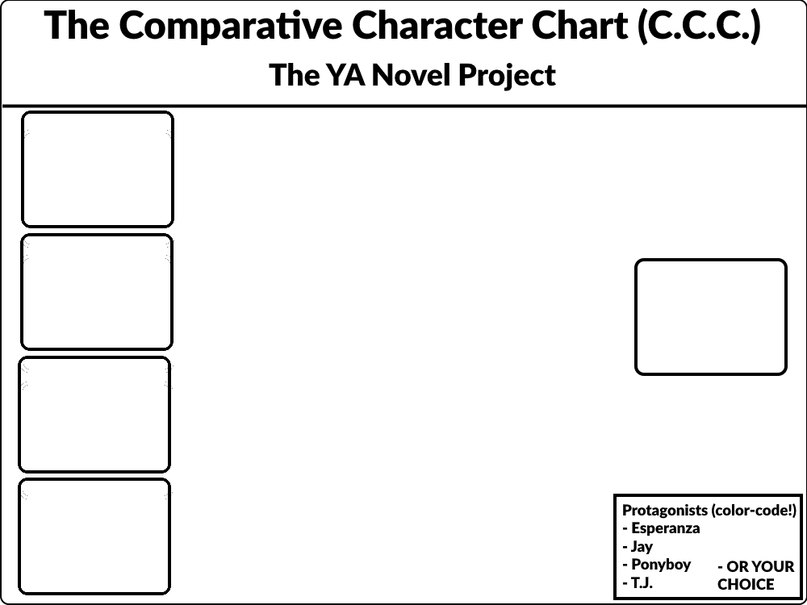
Part 3 – Extending the Unit: the class’s final unit project
As I noted before, the final project for this unit will transition to a study of individual students’ choices of a young adult novel. These young adult novels will come from four choices (among them being two novels that are commonly taught in schools):
- The House on Mango Street by Sandra Cisneros
  - A novella centering on a young Latina adolescent named Esperanza, who details a year of her life through brief chapters known as vignettes, becoming glimpses of her past experiences in the span of a year as she and her family live on Mango Street, an impoverished part of a neighborhood in Chicago.
- Patron Saints of Nothing by Randy Ribay
  - Told in the perspective of a Filipino-American teen named Jay, Jay discovers that Jun, his cousin and who was once his best friend, had died to causes left unknown to him by his parents and Jun’s family. Determined to find out what happened to Jun, Jay travels to the Philippines and searches for answers among Jun’s family.
- The Outsiders by S.E. Hinton
  - The Outsiders consists of the written experiences of young American teen and greaser Ponyboy Curtis, tasked to write about what he has experienced in roughly the past couple of months as part of a writing assignment. In these reflections of his past, Ponyboy remarks upon his life in living among his mix of surrogate and real band of brothers and their troubles against the Socs, a rival group of similarly-aged teens and young adults of richer status.
- Whale Talk by Chris Crutcher
  - Taking place at a fictional town in Washington state, Whale Talk assumes the perspective of mixed-race teen T.J., a brash yet assertive high schooler. With the help of a friend and English teacher John Simet, T.J. sets upon the goal to expose his town’s high school’s biased championing of its bullies by forming a swim team consisting of other teens who have been bullied and have been casted as pariahs by their school.
The list does not restrict itself to just these four. An option for a requested novel is available to students, only requiring that it meets the conditions for a bildungsroman or a problem novel that involves a protagonist’s coming-of-age experience as well as being classified as a young adult novel. The custom choice elucidates that the bildungsroman’s structure is not encompassing of all literature, hence the looser formats of the novels from the list. In addition, the list serves as a foundation for students to also base their choices from if they are looking for a young adult novel of their choice.
In regards to the final project’s instructions, the project will also consist of another visual product, instead being of various multimedia to represent the stories of whichever novel that a student chose for this project. The parameters for this project is broad, but it has some baseline requirements:
- The visual product should have something to convey the plot structure of the novel (effectively a summary in visual form)
- The visual product should feature some important commentary (at least three quotations) said by the protagonist in regards to a realized change of their character or a conveyed observation
  - I understand that this instruction is still broad and can be prone to change from the list of books. As long as the quotes are relevant to some form of character change exhibited by the protagonist, they are valid for use.
- The visual product should not be any plain written format—i.e. it has to have a main visual component
  - e.g. video/performed skit(s), music video/song, comic
The students will use what they have learned from understanding the bildungsroman and its applications from Great Expectations on this final project. In terms of its due date, the students will have a month or approximately four weeks to work on this project, giving them time to read their respective novels as well as to do the two parts that come with the project.
At the end of this unit, I hope that students will have adopted the idea of the bildungsroman and how its structure has been translated in more recent years in the form of problem novels or coming-of-age novels through young adult literature. On an amusing note, the final days for the unit will involve a vote for a possible movie adaptation viewing by students, though this will be limited to more popular adaptations as not all novels will have them (e.g. Francis Ford Coppola’s adaptation of The Outsiders).

Works Cited
Cisneros, Sandra. The House on Mango Street. Vintage Books, 2009.
Crutcher, Chris. Whale Talk. HarperCollins, 2001.
Hinton, S.E. The Outsiders. Viking Press, 1967.
Ribay, Randy. Patron Saints of Nothing. Penguin Books, 2019.
The Beatles. “In My Life.” Rubber Soul, Apple Records, 1965.
“Chapter 4: Contemporary Realistic Fiction: From Tragedies to Romances.” Literature for Today's Young Adults, by Alleen Pace Nilsen et al., Pearson, 2014.

