Emily Greulich
Dr. Mary Warner
ENGL 112B
10 May 2021
Unit of Study: Gender Roles of Women
Rationale:
According to a study of the reported issues that teens face in Adolescents in the Search for Meaning: Tapping the Powerful Resource of Story, “the search for identity is a primary focus” (Warner 9). My Unit of Study explores identity and gender roles of women. During adolescence, many teens struggle to find their identity in all different areas. Navigating gender can create very real obstacles for students to overcome as they try to find themselves. Many stories that teens absorb, either through media or literature, have a very limited or stereotypical portrayal of women. Women are often depicted in stories as supplemental characters, mothers, or romantic interests without agency or identity. Teaching literature that women are given a real voice is critical to establishing identity, not just for female students but males as well. Through studying a historical range of works by women about women, the class can also discuss intersectionality, describing the means in which race, gender, and class work independentally to create layers of privilege or discrimination.
My canonical “centerpiece” of this unit is the 19th Century Victorian novel Jane Eyre by Charlotte Brontë (1847), paired with the Young Adult Mexican-American novel The House on Mango Street by Sandra Cisneros (1984). Although written 140 years apart, layers of marginalization are portrayed through the combination of gender and class for both Jane and Esperanza. As a supplemental piece to Jane Eyre, I use the strong imagery of a male-dominated society and its dangerous consequences for women in the Gothic short story The Yellow Wallpaper by Charlotte Perkins-Gilman (1892) to introduce the unit. All of these texts have one commonality: the desire for freedom from societally-imposed restrictions. I use YA to depict the universality of these themes in Jane Eyre, establishing its relevance for my students today. By pairing this novel with The House on Mango Street, students gain a modern perspective of the same kind of themes. I first read this novel in middle school, and even though my life reflected many of the images Cisneros portrayed of women, I wasn’t able to fully appreciate or analyze what it meant until I reread it in high school. Like Jane Eyre, Esperanza also seeks freedom from the imposition of roles upon her, especially through emphasizing the unfair circumstances that women in her neighborhood become trapped with because of their gender. Our unit begins with a day of The Yellow Wallpaper, then transitions into Jane Eyre, and concludes with The House on Mango Street.
Additionally, students work best when the content appears relevant to them, so this 5-Week Unit of Study ideally will take place in October/November to increase student interest in the Gothic genre of Jane Eyre. Student reading comprehension will be measured through journal writing, and these entries can be later used to expand on a larger essay.

Part 1A: “Into” Activities - Week 1
Reading The Yellow Wallpaper; Jane Eyre pg. 1-62
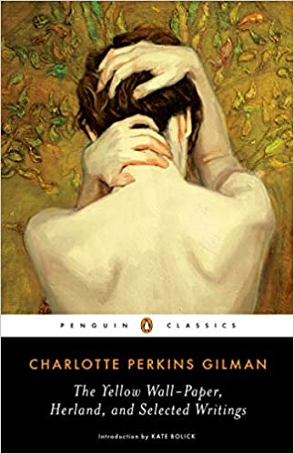  https://www.amazon.com/Wall-Paper-Herland-Selected-Writings-Classics/dp/014310585X | To begin this unit, students will come to class having read the complementary text The Yellow Wallpaper by Charlotte Perkins-Gilman (1892). This short horror story is a great way to lead into the unit because: it quickly introduces the major theme of gender and societal expectations in the Victorian Era of women found in the centerpiece Jane Eyre; it introduces the Gothic genre in an exciting way via psychosis and mental illness; and it is another important work of (American) literature from a 19th Century female author. For accessibility, I would provide this text as a PDF on Google Classroom:  https://www.nlm.nih.gov/exhibition/theliteratureofprescription/exhibitionAssets/digitalDocs/The-Yellow-Wall-Paper.pdf

Inspired by my field-experience observation hours on ATLAS, I would also include in the conversation a short historical overview of the Victorian Era (rigid class structures and evolving gender expectations). These things are building the foundation to introduce the Centerpiece text.
- Activity #1: Internal/External - What is the narrator’s “identity?”
To begin a conversation about intersectionality and time period for women, I would have two handouts with an outline of “the narrator:” one is left blank inside the outline, and one is left blank outside the outline. In small groups, students will work together to compile quotes that reflect internal forces (the narrator’s thoughts and feelings) on the inside of the outline, and quotes that reflect external forces (other characters, societal expectations) on the outside of the outline. For example:
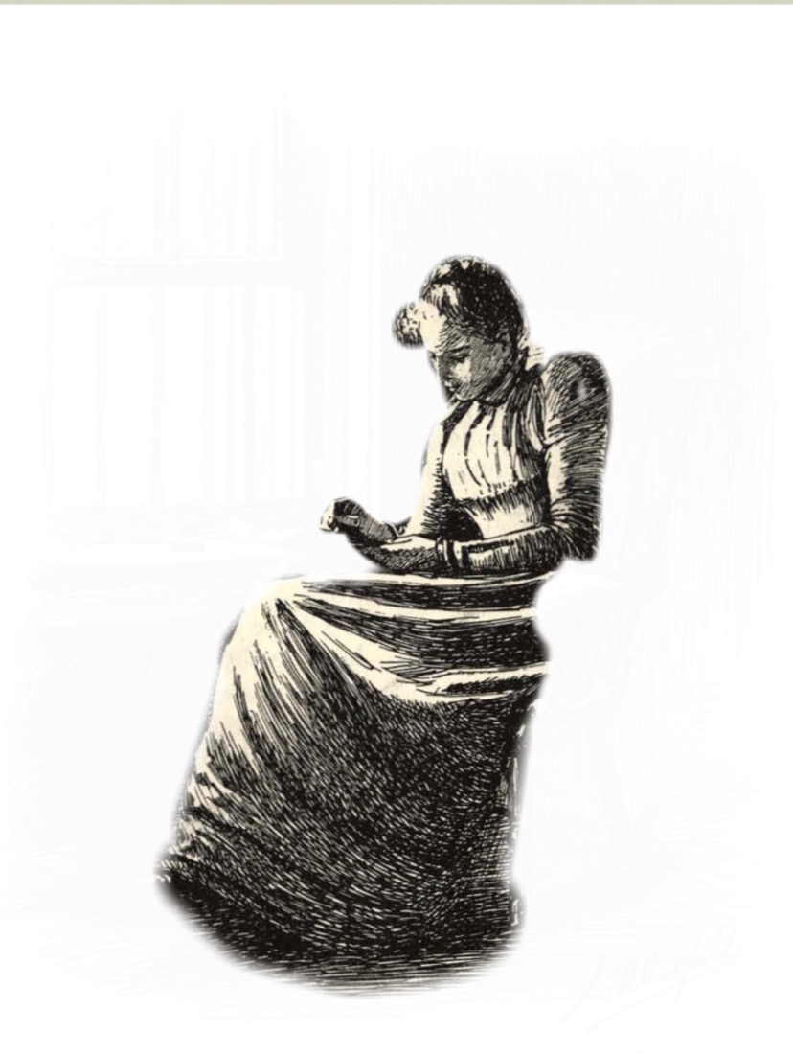  External:  “If a physician of high standing, and one’s own husband, assures friends and relatives that there is nothing the matter with one but the temporary nervous depression - what is one to do? / My brother is also a physician...and he says the same thing.” (Gilman 2). | 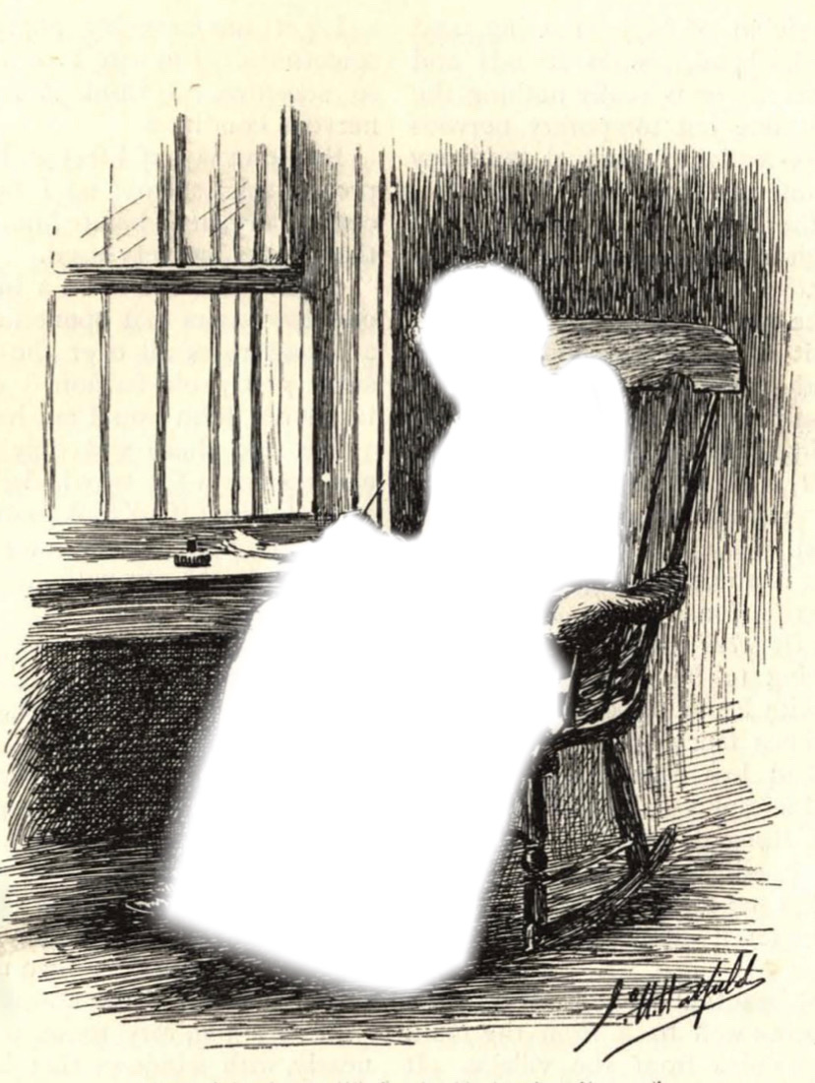  Internal:  “The faint figure behind seemed to shake the pattern, just as if she wanted to get out” (Gilman 6); or “It is the same woman, I know, for she is always creeping, and most women do not creep by daylight” (Gilman 8).

Via small-group, whole-group, or socratic seminar, I will facilitate class discussion of The Yellow Wallpaper, prompting themes, quotes, and characters as needed. I might prompt: what does this story say about the role of women in the Victorian Era? What was wrong with the narrator? What does this say about women’s access to healthcare? What does this say about women’s voice?
Journaling:
For in-class writing/homework, students will demonstrate engagement with themes through a reflection journal activity of their choice. Students are able to select the prompt that is most interesting to them, encouraging more enthusiastic writing. Each prompt will correlate with the themes to be introduced in the Centerpiece, Jane Eyre:
- POV - Gilman uses First-Person Point of View to write the narrator’s personal account. Write a journal entry from the POV of a different character, such as John, Jennie, or the nanny Mary. What would they think about the narrator’s actions? How much would the narrator’s story be changed with a different perspective?
- Add another journal entry - Doubling is a common motif found in Gothic literature. As the narrator, write a journal entry explaining who is the woman in the wallpaper? Is she a former inhabitant of the room? A reflection of the narrator in some way? What does she symbolize? Include a drawing of the woman in the wallpaper.
- Extra, Extra! Write an Article - As a top 19th Century journalist dedicated to uncovering the truth, you must write a newspaper article reporting on what happened here. Who is the narrator? Of what social class was she? What happens to the narrator after the story ends? Who’s fault was it?
Part 1B: “Into” Activities Continued
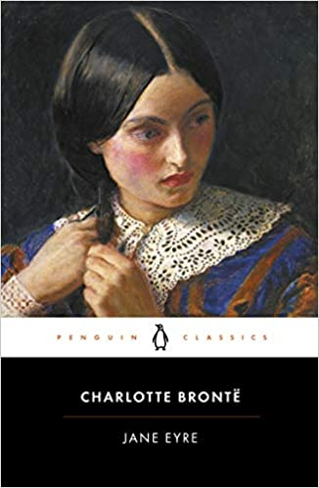  https://www.amazon.com/Jane-Penguin-Classics-Charlotte-Bront%C3%AB/dp/0141441143 | 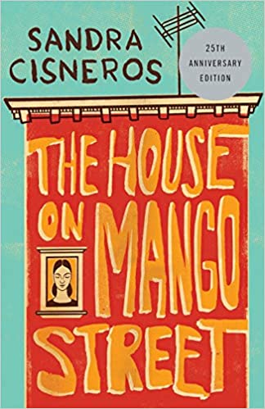  https://www.amazon.com/House-Mango-Street-Sandra-Cisneros/dp/0679734775/ref=sr_1_1?dchild=1&keywords=the+house+on+mango+street&qid=1620541929&s=books&sr=1-1
Before we begin to read Jane Eyre and The House on Mango Street, we will do a Book Pass / Blind Date with the books. Before we begin reading each novel, students will fill out a journal entry about the following parts: “Title, Cover, Back Cover, First Page.”
Students will look at the copies of their book and fill out their “take” on these sections, with our discussion from the previous text in mind. This activity makes it so that students feel their opinion matters as much as mine. Students share their “takes” with small group discussion.

Part 2: “Through” Activities - Weeks 2, 3, 4, & 5
Jane Eyre pg. 63-517; The House on Mango Street pg. 1-103
Rather than using pop quizzes to test comprehension, students will use journaling to write “through” their understanding of the novel while enhancing their comfort with writing. Students share their writing with their groups.
Journal Prompts for Reading Comprehension:
- “Brown Bag” - Inspired by Dr. Warner’s “Brown Bag” activity, students choose an item, character, or important quote from the section they’ve read about to include in the brown bag of the novel. (For Jane Eyre, these symbols could be The Red Room, the presence of fire and ice...); (For The House on Mango Street, this can be shoes, characters…)
- “Mystery Prompt” - Trade! For this day, students will reach into a jar and pull out a slip of paper with either a setting, an item, or important quote that their classmates put into the brown bag. Students will then write on the significance of the item they’ve pulled for fifteen minutes.
- Compare and Contrast - Students will make a creative chart comparing the traits of Jane in Jane Eyre and Esperanza in The House on Mango Street. How do these female characters adhere to gender roles, and where do they oppose them? Keep track throughout the reading and update regularly. *When reading through Jane Eyre, this prompt should also be used for Jane and Bertha: what makes Bertha less of a woman?
- “High Heels” - Identity. In The House on Mango Street, Esperanza gets in trouble for wearing adult shoes because it implies a woman’s sexuality, and this means something different for the men around her - write a poem about a physical thing you own (an article of clothing, an item in your room, a pin on your backpack) and what perception it gives off about you. Is there ever a place where you don’t feel comfortable wearing/showing off your item? What do people think about your item? What do you think about your item?
  - Activity: “I Am Poems” : From Dr. Warner’s class, writing about who you are using the I Am Poem template. This will help students to work with the concept of identity, and how external factors can be a very real influence on our lives.
https://www.sjsu.edu/faculty/mary.warner/Engl112B_handouts/I%20Am%20Poem%20template%20&%20What%20Jimmy.doc

Additional Reading for the Unit: Supplemental Poems
- Poetry Packets - Students will also read and reflect upon thematic poems throughout the unit by female authors. Each of the poems are relevant to young adults because they act as pairings for the novels, and prompt questions of identity:
1.Emily Dickinson (445) “They Shut Me Up in Prose” - Dickinson writes in the same time period as Jane Eyre about little girls being told to be seen and not heard. Who is the bird in this poem? How does the imagery of a bird escaping capture compare with the freedom sought by Jane and Esperanza?
https://www.poetryfoundation.org/poems/52196/they-shut-me-up-in-prose-445
2.Sylvia Plath “The Applicant” - How does this poem add to the meaning of women’s roles? What imagery does it use to speak about marriage and gender stereotypes?
https://www.poetryfoundation.org/poems/57419/the-applicant
3.Audre Lorde “A Woman Speaks” - This poem introduces the concept of intersectionality, what it means to be woman and Black. How can this poem apply to the texts we have read? How does Jane Eyre portray Bertha Mason (hysterical, demonic, savage) and why? What challenges does Esperanza face because of her gender and ethnicity?
https://www.poetryfoundation.org/poems/42583/a-woman-speaks
*Extra Credit: Film Critic! Movie Review
Watch a modern film (within the last 10 years) and write a movie review about the portrayal of female characters. Do they align with female gender expectations or not? How do the female characters act similarly or differently to characters in Jane Eyre or The House on Mango Street? Suggestions: “Hidden Figures” (2017), “Star Wars: The Last Jedi” (2017), “Birds of Prey” (2020). The point is to make the topic of this unit universal.

Part 3: “Moving Beyond” & Final Project - Week 6
After finishing the reading, students will write an essay about Jane Eyre in relation The House on Mango Street. Students have the option of choosing at least two characters (major or minor) to write about the themes of gender roles across these two texts. Students have the option of incorporating additional readings, such as The Yellow Wallpaper or poems we read in class or a YA Pairing of their choosing. I want students to have lots of room for choice of what they are going to write about because this lets young adults choose something they are actually interested in.
*YA Lit / Out of Class Readings:
These are the texts that I would suggest for my students to enhance their connection with this unit and further adolescent literacy:
1.Speak by Laurie Halse Anderson (1999) is YA story with a female protagonist who must make come to terms with her sexual assault. This is a good pairing for the texts of this unit because it talks about the struggles of young women in a modern setting.
2.Whale Talk by Chris Crutcher (2001). Focus on female characters. This YA story does not have a female protagonist but is a good pairing for this unit because it portrays its secondary female characters dealing with gender-based trauma (abusive boyfriends, abusive father…) in a realistic way.
3.Wide Sargasso Sea by Jean Rhys (1966). This novel is best fit for junior or senior students because of its text complexity, but the novel is only approximately 100 pages long. This is a great example of how different perspectives can change a story, and gives agency to Jane Eyre’s Bertha Mason. This text also serves as a great compliment to this unit because it helps to explain intersectional feminism and colonialism when read after Jane Eyre.

Citations
Anderson, Laurie Halse. Speak. Square Fish, 1999.
Brontë, Charlotte. Jane Eyre. Penguin Books, 2003, 1847.
Cisneros, Sandra. The House on Mango Street. Arte Público Press, 1983.
Crutcher, Chris. Whale Talk. HarperCollins, 2001.
Dickinson, Emily. “(445)They Shut Me Up in Prose.” 1862, Poetry Foundation,
https://www.poetryfoundation.org/poems/52196/they-shut-me-up-in-prose-445. Accessed 06 May 2021.
Gilman, Charlotte Perkins. The Yellow Wallpaper, 1892. Accessed online 01 May 2021:
https://www.nlm.nih.gov/exhibition/theliteratureofprescription/exhibitionAssets/digitalDocs/The-Yellow-Wall-Paper.pdf
Lorde, Audre. “A Woman Speaks.” 1993. Poetry Foundation,
https://www.poetryfoundation.org/poems/42583/a-woman-speaks. Accessed online 06 May 2021.
Plath, Sylvia. “The Applicant.” 1963. Poetry Foundation,
https://www.poetryfoundation.org/poems/57419/the-applicant. Accessed online 06 May 2021.
Rhys, Jean. Wide Sargasso Sea. W.W. Norton & Company, Inc., 2016, 1966.

