Guadalupe Cazarez
December 4, 2018
English 112B
Professor Mary Warner

Fantasy: Female empowerment in a magical fantastical world

Rationale:
According to the dictionary, fantasy is “the faculty or activity of imagining things, especially things that are impossible or improbable.” Fantasy books include fantastical characters living different lives than ours, falling into situations we can only dream of. Most fantasy books include mix and match of magic, extraordinary creatures, interesting objects, weapons. The main characters usually also experience the awe of these worlds with us. One of the most famous fantasy books is the Harry Potter series, which features a boy who learns he’s a wizard who goes to a magical school where he makes friends, sees beautiful and weird creatures, and fights spiders, snakes and an evil being named Voldemort. We are never going to be wizards or ride broomsticks, and yet we can empathize with these characters and what they’re going through.
I’ve loved fantasy for as long as I can remember, both in books and video games. There’s something about reading of a magical school or playing in a game where you learn magic and can decide to terrorize people or make them respect you. Fantasy isn’t just a way to escape my life (though there’s also that), but a way to exercise my mind. Fantasy is a strong tree with roots in our world and the branches swaying in the magical imaginative worlds writers create. These books also incorporate real life problems like violence, racism, choices, classism.
There’s a video game I wanted to mention, though not exactly fantasy it does have fantasy elements. It’s bioshock infinite. It’s about a man named Booker and his journey begins with the sentence “bring us the girl and wipe away the debt” and soon his life changes. The video game takes place in Colombia, a flying city, where Booker is joined by Elizabeth. Booker can use powers called vigors (like shooting lightning or making enemies levitate). Bioshock’s setting, like in a lot of fantasy and even dystopia books, is beautiful but hiding a lot of problems. There’s racism, politics, kidnapping, and other things. The video game delves into these subjects while showing Booker and Elizabeth’s relationship. One theme was choices. There was a few times in the game where you are given choices and the games makes it seem like they are very important but they end up doing little to nothing. It made me think how in life we put too much pressure in our choices but sometimes they aren’t as important as we think they are.
The biggest reason I wanted to talk about Bioshock was because of the character of Elizabeth. I loved how Elizabeth wasn’t the usual damsel in distress like in other games and some books. While she does get taken by Songbird a few times, she helps the character by throwing bullets and other things they might need. As a female person of color, I’ve wanted to see myself in the books and video games I consume and I don’t have too much in common with white guys who are usually the heroes. And even more, female characters who are empowered in a magical world make me happier.
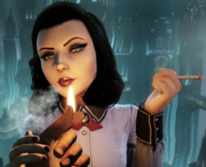
https://en.wikipedia.org/wiki/Elizabeth_(BioShock)#/media/File:Elizabeth_in_Burial_at_Sea.png

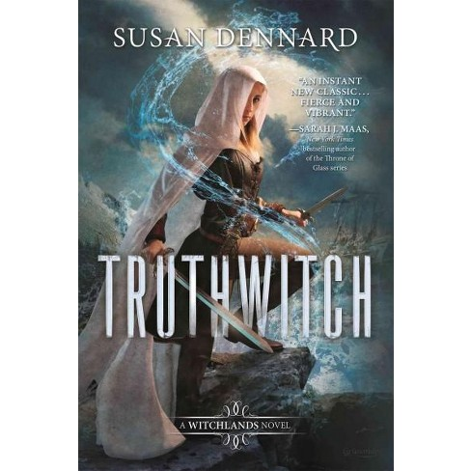
https://www.target.com/p/truthwitch-hardcover-susan-dennard/-/A-50159138#
Truthwitch is a story about two witches Safyia and Iseult, who end up in the middle of a war. Safi has to find the fact that she’s a rare Truthwitch, which means she could tell when someone is lying. Getting found out would mean getting used in this war she wants no part of. (Summary written by me).
Dennard, Susan. Truthwitch. Tor, 2017.
I loved the magic system in this book. It was explained very well. The highlight for me was the female friendship between Safyia and Iseult. There’re not many female friends I read about in books that beautiful and not toxic. This book is a perfect example of a good fantasy book with the magic class, the setting with its own rules, ideas.
(Readthis book)

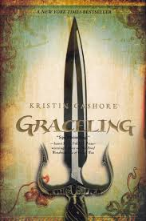https://goo.gl/images/w5CJnY
Graceling: “Katsa has been able to kill a man with her bare hands since she was eight—she’s a Graceling, one of the rare people in her land born with an extreme skill. As niece of the king, she should be able to live a life of privilege, but Graced as she is with killing, she is forced to work as the king’s thug…She never expects to learn the truth behind her Grace—or the terrible secret that lies hidden far away . . . a secret that could destroy all seven kingdoms with words alone.” (Summary from Goodreads. Source: https://www.goodreads.com/book/show/3236307-graceling?ac=1&from_search=true)
Cashore, Kristin. Graceling. Gollancz, 2018.
This was a fun book full of magic powers, adventure, and love.
(Read this book)

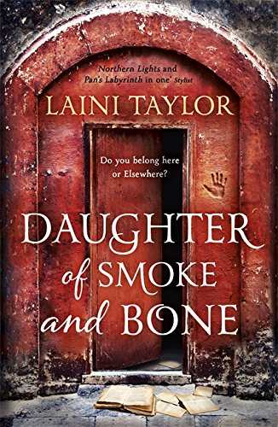 http://ecx.images-amazon.com/images/I/61czWGfS9PL.jpg
Daughter of Smoke and Bone: “Around the world, black hand prints are appearing on doorways, scorched there by winged strangers who have crept through a slit in the sky.In a dark and dusty shop, a devil’s supply of human teeth grows dangerously low.And in the tangled lanes of Prague, a young art student is about to be caught up in a brutal otherworldly war.” (Summary from Goodreads. Source:https://www.goodreads.com/book/show/8490112-daughter-of-smoke-bone)
Taylor, Laini. Daughter of Smoke and Bone. Hodder, 2012.
This was a beautiful world full of angels. Felt like Harry Potter in the way that the beginning felt like our world and the rest takes place in the magical world. Karou actually goes between going to “human” school and being with the magical creatures.
(Read this book)

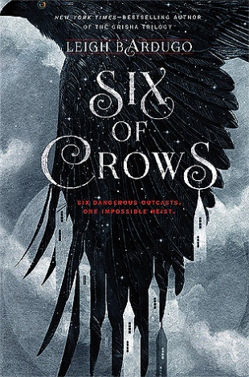https://images.gr-assets.com/books/1459349344l/23437156.jpg
Six of Crows: “Six dangerous outcasts. One impossible heist. Kaz’s crew is the only thing that might stand between the world and destruction—if they don’t kill each other first.” (Summary from Goodreads. Source: https://www.goodreads.com/book/show/23437156-six-of-crows).
Bardugo, Leigh. Six of Crows. Square Fish/Henry Holt, 2018.
This book follows six different perspectives, each from one of the group in the heist: Inej, Kaz, Jesper, Nina, Matthias, and Wylan. I loved how you really got to know the characters and understand what they went through to get to this point. I also the relationships between Inej and Kaz and the interactions between Inej and Nina. It is fast paced and I left reading to see what was going to happen.
(Read this book)

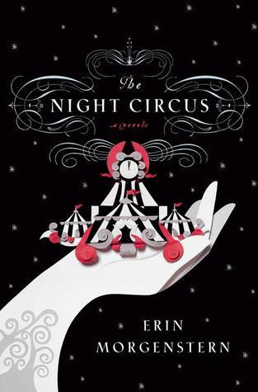https://images.gr-assets.com/books/1387124618l/9361589.jpg
The Night Circus: “The circus arrives without warning. No announcements precede it. It is simply there, when yesterday it was not. Within the black-and-white striped canvas tents is an utterly unique experience full of breathtaking amazements…behind the scenes, a fierce competition is underway—a duel between two young magicians, Celia and Marco, who have been trained since childhood expressly for this purpose by their mercurial instructors. Unbeknownst to them, this is a game in which only one can be left standing, and the circus is but the stage for a remarkable battle of imagination and will.” (Summary from Goodreads Source: https://www.goodreads.com/book/show/9361589-the-night-circus)
Morgenstern, Erin. The Night Circus. Vintage, 2016.
I would argue that the biggest character in this book is the circus itself. Erin Morgenstern spends a lot of the book describing the circus to the reader, with beautiful words and through different perspectives. The circus isn’t just a place but living and breathing. Celia and Marco’s love story is woven in with the circus giving it a different feel to it.
(read this book)

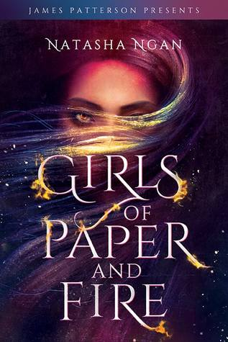https://images.grassets.com/books/1518109125l/34433755.jpg
Girls of Paper and Fire: “In this lush fantasy, Lei is a member of the Paper caste, the lowest and most oppressed class in Ikhara. She lives in a remote village with her father, where the decade-old trauma of watching her mother snatched by royal guards still haunts her. Now, the guards are back, and this time it's Lei they're after--the girl whose golden eyes have piqued the king's interest.” (Summary from Goodreads Source: https://www.goodreads.com/book/show/34433755-girls-of-paper-and-fire)
Ngan, Natasha. Girls of Paper and Fire. Hodder & Stoughton., 2018.

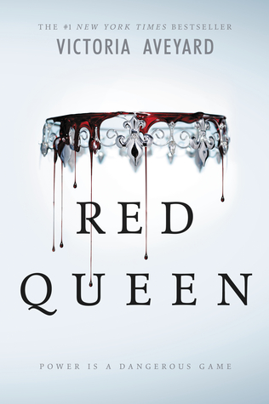https://images.gr-assets.com/books/1449778912l/22328546.jpg
Red Queen: “This is a world divided by blood - red or silver. The Reds are commoners, ruled by a Silver elite in possession of god-like superpowers. And to Mare Barrow, a seventeen-year-old Red girl from the poverty-stricken Stilts, it seems like nothing will ever change. That is until she finds herself working in the Silver Palace. Here, surrounded by the people she hates the most, Mare discovers that, despite her red blood, she possesses a deadly power of her own. One that threatens to destroy the balance of power.” (Summary from Goodreads. Source: https://www.goodreads.com/book/show/22328546-red-queen)
Aveyard, Victoria. Red Queen. Orion Books, 2015.
I didn’t like this book but I thought I would add it to the list. It felt bleh. It had so many tropes and things that I saw coming. But just because I didn’t like it doesn’t mean someone else can’t.
(Read this book)

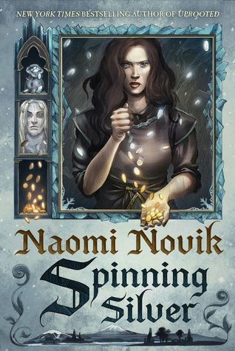https://images.grassets.com/books/1513872748l/36896898.jpg
Spinning silver: “Miryem is the daughter and granddaughter of moneylenders... but her father isn't a very good one. Free to lend and reluctant to collect, he has loaned out most of his wife's dowry and left the family on the edge of poverty--until Miryem steps in. Hardening her heart against her fellow villagers' pleas, she sets out to collect what is owed--and finds herself more than up to the task. When her grandfather loans her a pouch of silver pennies, she brings it back full of gold.” (Summary from Goodreads, Source: https://www.goodreads.com/book/show/36896898-spinning-silver?ac=1&from_search=true)
Novik, Naomi, and Nicolas Delort. Spinning Silver. Del Rey, 2018.
This book was so great. It read like a fairytale and had these magical elements that seemed to just fit in. There were different perspectives in this book and each one had a distinct voice. I also loved when Miryem and Wanda helped each other.
(Read this book)
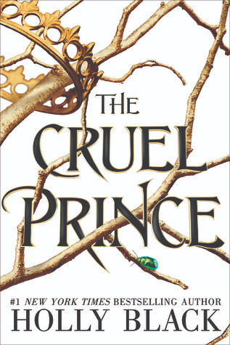https://images.gr-assets.com/books/1493047153l/26032825.jpg
The Cruel Prince: “Jude was seven when her parents were murdered and she and her two sisters were stolen away to live in the treacherous High Court of Faerie. Ten years later, Jude wants nothing more than to belong there, despite her mortality. But many of the fey despise humans. Especially Prince Cardan, the youngest and wickedest son of the High King.To win a place at the Court, she must defy him–and face the consequences.” (Source: Goodreads, Source: https://www.goodreads.com/book/show/26032825-the-cruel-prince?ac=1&from_search=true)
Black, Holly. The Cruel Prince. Little, Brown and Company, 2018.
This book have fae in it so from the very beginning you are magically transported to a magical world.
(Read this book)

