Aaron Cao
ENGL 112b
Warner

Unit of Study- Racial Discrimination
Racism is an experience that various minorities or ethic groups have experienced in their lives. Such discrimination begins from the time they were children and follows for most of their lives. It is prominent in various facets of society such as the justice system or within the workplace. As a result, it is not uncommon for students that are part of a certain minority or ethnic group will experience some form of racial discrimination in their lives.
To Kill a Mockingbird by Harper Lee is a canonical text that examines the injustice of racism within Tom Robinson’s trial. The trial is one of the most pivotal moments of the story as Tom is faced with a trial for a crime he did not commit, and shows how an authority unfairly ruled against him due to racial discrimination despite evidence otherwise. Although many students will most likely not experience racism first hand within a court of law, racial discrimination is a prevalent issue that is trending across America, especially with the rise of the Black Lives Matter movement. Additionally due to the news coverage and other media, students may already be familiar to a certain extent with the issue. Because this novel shows how unfairly Tom is judged, it serves to inform students of racial discrimination and encourages them to take a stand.
This unit of study examines the various aspects of racism, such as racial profiling which is prominent within the justice system, In addition, stereotypes and objectification are other aspects that students may relate to in their lives. Through young adult literature, one can learn about racial discrimination as well as become more prepared to deal with it in their daily lives. The goal of the unit is that students would acknowledge differences and embrace each other’s identities, cultural history, and experiences, bridging the divide between racial tensions in America. At the conclusion of this unit, students will be able to recognize and become more aware of this issue in America as well as become more prepared to deal with experiences regarding this issue.

Introducing the Text: https://www.youtube.com/watch?v=Nma-y59bV5A
This clip from Get Out shows the more subtle nature of racism that students may be able to relate to. In the clip, Chris is shown to be objectified and stereotyped by the people at the party in various ways. In fact, one of the participants at the party even says that “Black is in fashion,” viewing being Black as a popular trend. This is evident in postmodern America as well, as pop culture which often involves Black speech and culture results in other ethnicities adopting slang words such as “fam” or “bruh.” The movie shows the assimilation that is undergoing in America with a literal take; the members of the Armitage community subjugate and take control of the Black characters in the movie.
First, I would have students analyze the clip of the party shown, directing their attention to the statements of various participants. Students will then dissect the clip and discuss the various statements which objectify and stereotype the main character. This discussion may lead into students being able to share personal experiences similar to that in the video, depending on if they are comfortable. The discussion and activity engages the students and prepares them for the centerpiece work because it shows the negative stereotyping that affects many minorities today, some of which have been experienced by students. This would result in students becoming more connected with Tom’s trial in To Kill a Mockingbird since they would relate to Tom’s experience of discrimination.
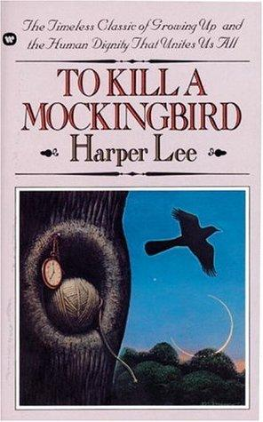
Centerpiece Work:
The Unit of Study’s centerpiece work is To Kill a Mockingbird, which is a canonical text that deals with themes such as loss of innocence and racial inequality. The story follows Scout, a young girl whose father is tasked with defending a Black man named Tom Robinson. Due to Scout’s innocence and naive point of view, the novel offers a unique perspective because she does not understand fully the different aspects of society, such as race. As a result, Scout is able to serve as an observer without bias in the novel. When students read Scout’s perspective, they would be able to examine various themes of the novel in an objective way and learn along with her.
The main focus of the novel is Tom Robinson’s trial which shows the institutionalized racism that affects Blacks. The class will examine the trial in addition to how it relates to current events such as police brutality, informing students about a problem that affects present-day America. In addition, although Tom Robinson may have most of the focus within the Unit of Study, Atticus’s role within the novel deserves noteworthy mention. Atticus exhibits bravery when he takes a stand against racial injustice despite the scrutiny of others, fighting alone for what he believes is just. This stand towards injustice may inspire the 9-10th grade readers who read the novel.

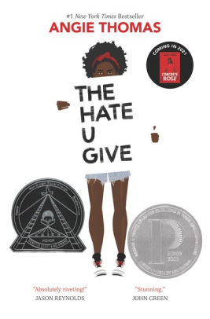
Companion Works:
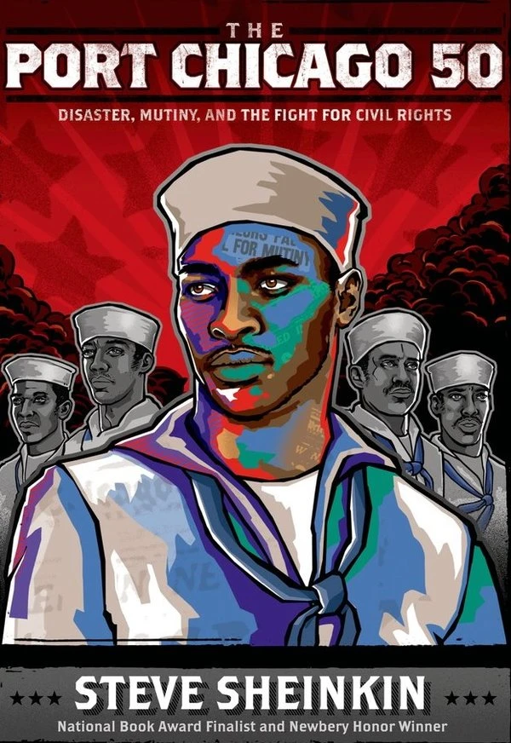
The Hate U Give is a novel by Angie Thomas that pairs very well with To Kill a Mockingbird. The protagonist, Starr Carter, witnesses her best friend Khalil get murdered by a police officer. Throughout the novel, Starr tries to find her voice inorder to take a stand against racial injustice. Her friend Khalil is racially profiled as a drug dealer and Starr deals with various struggles in school such as stereotypes from her friend Hailey and code-switching, when Starr switches from her language at home to one in school that is less confrontational. This novel pairs well with To Kill a Mockingbird because it shows the various struggles that Blacks face in present-day society and encourages readers to take a stand. Infact, the pop culture references serve as an advantage for students to relate to the novel, as Drake or Nae-Nae are mentioned.

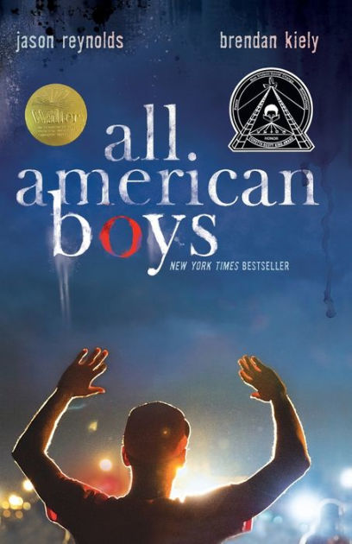
The Port Chicago 50 by Steven Sheinkin is a novel that details the historic struggles of African Americans in the navy. The novel uses research and interviews from historian Robert Allen to show the inadequate training of enlisted African Americans to handle dangerous work involving bombs and ammunition. The resulting explosion killed hundreds, while the remaining survivors protested against the unsafe conditions. The men who mutinied were sentenced to jail for decades and some were even executed. This novel pairs well with To Kill a Mockingbird because it teachers readers how to fight against injustice, as well as how change happens. Change is gradual, as shown in their fight for justice.

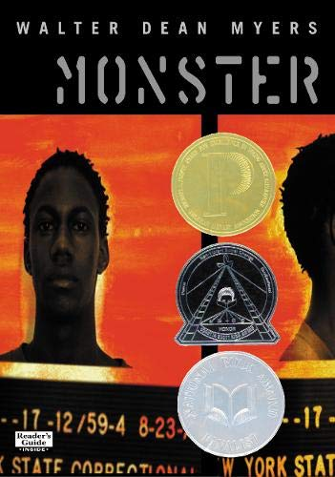
All American Boys is a novel by Jason Reynolds and Brendan Kiely that was written after the Zimmerman case. The main focuses of the novel are racial profiling and police brutality as the perspectives of the novel shift between a Black teen and a White teen. As the Black teen is beaten at the store by a police officer who thought he was shoplifting, the White teen who was raised by the very officer refuses to believe that his father figure could be guilty. Eventually their school begins to take sides as the town divides itself over the incident. This novel engages the harsh realities of To Kill a Mockingbird in a contemporary and more relatable way, similar to The Hate U Give.

Monster is a novel by Walter Dean Myers that tells the story of a 16 year old Black teen named Steve Harmon, who awaits his trial for murder. Throughout the trial, Steve faces racial profiling such as in the opening statement of the prosecutor, he and other accused are labeled as “monsters.” This novel shows the negative effects of racial profiling, not only through the biased justice system as the detective investigates with a confirmation bias; he immediately assumed that Steve was guilty, but also how it affects Steve himself. While the trial is occuring, Steve is haunted by the question of whether he is indeed a monster they see him as. The twist comes at the end of the novel, when Steve tries to hug his attorney, who simply turns away, possibly even doubting his innocence.

Through Activities:
Text-to-Text Connections: One activity while reading the novel is Text-To-Text Connections. Students will find a passage from each chapter and use Text-to-Text, Text-to-Self, and Text-to-World connections. Through Text-to-Text, students will find connections from To Kill a Mockingbird to other novels they have read. With Text-To-Self, students find a passage from the novel that relates to them personally, and using Text-to-World, students apply the lessons from To Kill a Mockingbird to the world. The purpose of this activity is to help students develop connections while reading, allowing them to develop ideas from the text and apply them.

Debate:
Three answers will be posted in each corner of the classroom: Agree, Disagree, I Don’t Know. A phrase will be posted on the board, and students will choose to stand in whichever corner that they resonate with regarding the statement. The students will then debate or discuss various statements regarding racism. Although at the beginning phrases will be less debatable and more obvious such as “Racism is bad,” or “Racism ended in the 60s,” they will get progressively harder. Difficult phrases that are more debatable will include “I don’t see color.” The goal of this activity is to engage students in critical thinking and explore various ideas of different groups in contemporary America.

Socratic Seminar Discussion
For this in-class activity, students will discuss and analyze Tom Robinson’s trial.
Several topics to focus on include: the trial itself, how Tom Robinson is unfairly discriminated against, and Atticus’s bravery in standing up alone against the group that intends to lynch Tom Robinson and in the courthouse. Continuing, students can apply Atticus’s stand against racial injustice to the Black Lives Matter movement. The video (https://www.youtube.com/watch?v=YG8GjlLbbvs) serves as an introduction and explains the movement for those that may have heard the phrase through the media but do not know what it means. The purpose of this discussion is to apply the themes from the novel to current events, particularly racial injustice. In addition, Atticus’s stand could even inspire students to take a stand against injustice as well.

Closing the Unit:
In order for me to see the student’s understanding of the novel and its concepts, I would want my students to answer this prompt: “What have you learned from Scout's point of view or Atticus's stand against racism in To Kill a Mockingbird? How do the actions of the characters within the novel apply to present-day society?” In addition, I added the second part inorder to apply what they’ve learned from the novel to the present day. This is because many students do not understand why a novel is being read, especially when it seems so distant compared to their own lives.

Works Cited
Lee, Harper. To Kill a Mockingbird . Lippincott, 1960.
Myers, Walter Dean. Monster. Amistad, 2001.
Reynolds, Jason, and Brendan Kiely. All American Boys. Atheneum/Caitlyn Dlouhy Books, 2015.
Sheinkin, Steve. The Port Chicago 50: Disaster, Mutiny, and The Fight for Civil Rights. Square Fish/Roaring Brook Press, 2017.
Thomas, Angie. The Hate U Give. HarperCollins, 2017.

