Carlos Alonzo Gonzalez
Dr. Warner
ENGL 112B
25 November 2022
Bildungsroman: The Coming of Age Genre
Rationale
When raising children, it is generally vital that they are sheltered, or at least they should be to some aspect. Parents or Guardians often shelter their children from the violence, lying, and cruelty of the world. Sadly, no matter how good a parent is at sheltering their kids, children and young adults will eventually succumb to some form of trauma. As unfortunate as this may be, it allows a lot of us to grow. Though trauma and challenges are not specific to any age group, I believe that the group that can benefit most from hearing these kinds of stories is none other than young adults. There comes a time in everyone’s lives when the rose-tinted glasses have to come off. The world is not a perfect place and that can be a very depressing realization for a lot of people.
I chose the coming-of-age genre (as well as loss of innocence) because of how empowering they can be. Coming of age is the process of becoming an adult, yet many coming-of-age tales don't address the subject in that way. In truth, the main characters in the majority of these stories will have to mature in some mental capacity at some point within the story. In this genre, characters are put through challenging situations or events that, in the long run, will improve their disposition. Inherently, with the introduction of these challenges there comes a loss of innocence. However, these stories maintain their optimism by teaching their characters a lesson or by having them simply overcome their problem.
Growing up, and even now I have a lot of appreciation for this genre. I like how applicable it is. These stories are very relatable and engaging with how personal they can feel. I hope that through this unit students can identify with the characters as they (the characters) are forced into new/different scenarios that they may have never experienced. I’m hoping that as this unit develops, students will be able to have fun and most importantly, grow with the characters. This genre presents the often worst of the world but it also shows the indomitable human spirit. It shows how bad things can happen to us, but with resilience, we can often find a better place. If I can get students interested in this genre I will see it as a success and anything they learn along the way is just a bonus!
Introduction to the Unit
Ⅰ. Developing a Claim
To begin this Unit of Study, students will be asked to read the lyrics to Paramore’s “Ain’t It Fun”. I will call on students to read lines from the song, specifically the first two verses and the chorus. 3-4 students would end up having to speak aloud during this introduction to the activity. Afterward, I will play the song for the students and kindly ask them to listen. After listening, I look to develop students’ comprehension of the text through an in-general class discussion of what they noticed about the lyrics.
-What stands out?
-Anything in particular they find interesting?
-What’s the message being presented here?
-Who liked the song?
I want to start small, these kinds of lessons are the ones I found most engaging in high school. I think it's important to ask who liked the song so students can develop some sort of personal connection with a piece of literature whether they like it or not. Students should feel comfortable not liking specific texts. Overall, the main goal of introducing this unit with a discussion like this is so students are able to comprehend the steps it takes to form a claim. By the end of the discussion, I want students to be able to gather evidence in order to form a claim of what the author’s overall message was. Ultimately, this lesson will warm students up for future essay assignments. Following this discussion, I will examine the song with students and discuss with them why this song is classified as a coming-of-age or bildungsroman text. I will briefly review the general tropes of coming-of-age stories via a quick google search on the projector. Finally, I will end the discussion by asking students what coming-of-age stories they’ve heard/seen/read in their lives.
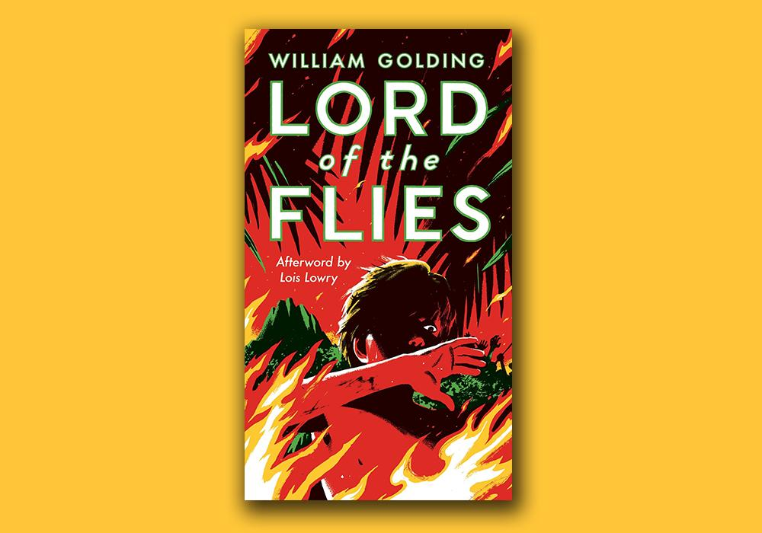
Centerpiece: William Golding’s Lord of the Flies
Lord of the Flies is a novel about a group of young boys who get stranded on a deserted island. I chose this novel because of its excellent usage of symbolism. I’m sure students would also appreciate the novel's connection to history as it was inspired by the atrocities seen during the Second World War. This novel is also a bildungsroman tale! The book is a coming-of-age story for Jack as he experiences various physical challenges which affect his mental and emotional state (study.com).
Ⅰ. Setting Up the Novel (Prologue)
Were there better choices for a coming-of-age novel? Maybe, but they weren’t as fun. At this point in the classroom, I would have already established the four types of conflict in literature. For the sake of time and consistency, this all happened at the start of the semester. After that lesson, I proceeded to teach my students about symbolism. This was on one of those Wednesdays where we’re all just trying to get through the week, but the point is it happened.
Ⅱ. Setting Up The Novel
This takes place right after the Paramore discussion. Immediately I introduce the novel, Lord of the Flies by William Golding. Simply put, this is a novel about a group of kids who get stranded on a deserted island. After I briefly mention the novel, I’ll give a bit of history on William Golding and when he wrote Lord of the Flies (after World War Ⅱ). This will be a lecture kind of presentation told through various well-designed slides on a PowerPoint. At the end of the slides, I will have a link to youtube where I will show students a clip from the hit Adventure/Drama Cast Away, starring Tom Hanks. During the video, I will interrupt and ask the students what kind of conflict this movie presents. They will respond “Person vs Nature” and I will say it with them.
Ⅲ. The Reading
The audiobook for Lord of the Flies on audible is about six hours long if the speed is not changed. The book is 12 chapters long and throughout the course of two weeks, I will read the book with the students. As the audiobook plays, I will pause at random pages and ask a student what event just transpired. This simple action will encourage students to pay attention. Every other day we will have brief quizzes with about 4-7 questions about the previous chapter(s) we just read. Each quiz will end with a question asking students what they do or what they don’t enjoy about the novel so far. These quizzes will have general questions about the book, but I will also integrate questions about symbolism such as: What do Piggy’s glasses represent? At the end of the novel, students will be given a small quiz on the story. We will likely be done with the book ahead of schedule and I will tell students to pat themselves on the back for being so productive. I should mention that during the emotional scenes (specifically the end of the novel), I will play Space Song by Beach House. Some will laugh, many will cry.
Ⅳ. Reviewing the Text
After the text, the classroom and I will engage in a discussion over the text where I will ask if students enjoyed the novel. This discussion will be very brief. Next, I will tell students to take a moment and write as much as they can about the novel in about 5-10 minutes. I will encourage students with writing prompts on the whiteboard that looks like the following: Which character did you connect with the most? What is the author’s message in this novel? What did you like/dislike about the novel? What other examples of symbolism di did you notice in the book? What are the themes of the novel? Is this novel a coming-of-age story? After students write I will ask students to share what they wrote or just anything thought they’d like to share regarding the novel. I’d want to lead the students to start thinking about an overall claim for them to be able to write an effective argumentative essay on the novel for the end of the unit. As the discussion continues, I would write possible topics the students may want to write about on the whiteboard.
The overall goals of this unit include the following:
-Students will be able to show an understanding of the novel as well as its themes
-Students will be able to use the author's background and the symbolism in the novel to make a claim.
-Students will be able to identify what kind of conflict is occurring in a particular text.
-Students will be able to identify the coming-of-age genre in different mediums of literature.
Outside Readings
Sticking to the bildungsroman genre, I would want to provide students with other works of literature that deal with the protagonist experiencing a great deal of mental change specifically in their formative years. Coming-of-Age is a broad genre and often takes place in different parts and periods of the world and I think that through this category students can often find themselves learning about other parts of history.
- Weep Not, Child by Ngūgī Wa Thiong’o
In this book, a young boy attempts to pursue an education in Kenya amidst the Mau Mau Uprising. This novel deals with a lot of issues involving Colonialism and with heavy themes of violence but also hope and progress. This historical-fiction piece perfectly illustrates the rising tensions amidst the Mau Mau Uprising in Kenya. I think many students, especially first-generation students will be able to identify with the book’s main character as his family supports him in his education in the hope that he will one day be able to lead them out of poverty. The main character goes through a lot of mental change throughout the novel landing it in the coming-of-age genre.
- The Catcher in the Rye by J. D. Salinger
The original coming-of-age story, about an observant boy dealing with getting kicked out of prep school. Holden, the protagonist, is an observant person and narrates the story in an engaging, snarky tone. Besides the prep school aspect, I think many adolescents would be able to identify with Holden, particularly his view of adults. This novel explores the relationships we make as young adults. Of course, it wouldn’t be a coming-of-age tale without rich emotional development and we do get that. This book has such a sweet ending that is guaranteed to make even the most indifferent reader feel something.
- The Perks of Being a Wallflower by Stephen Chbosky
Another story about an observant, quiet child, but with a lot fewer snarky comments. This book follows an adolescent and his struggle with mental illness. The main character is in high school and is faced with coping with his best friend’s death. He meets a lot of supportive characters along the way that help him cope with the loss. This book also perfectly captures the atmosphere of what it’s like to be an adolescent. Chobosky makes it easy to connect with his characters in this fun, yet extremely emotional novel.
- To Kill a Mocking Bird by Harper Lee
To Kill a Mocking Bird is a classic novel by Harper Lee. This book deals with the heavy themes of racial discrimination and sexual assault. The initial reception this story received was highly divisive, and to this day this book is a huge target of censorship in the United States. Taking place in the South, Jean “Scout” Finch describes the world around her including the events of a trial that takes place and other similar events in her family’s life. Lee tells the story over the course of a couple of years creating another classic bildungsroman tale. This is a historical fiction text and it does a great job of maintaining the audience’s attention with its critical themes and occasional humor.
- The Poet X by Elizabeth Acevedo
A more-recent bildungsroman story that follows an adolescent girl in Harlem and her relationship with poetry. This book carries heavy themes of religion and sexuality. It's another tale told during high school through the eyes of a teen, yet Acevedo does a great job at keeping her story fresh and engaging with modern teenage struggles that seem to often be overlooked in other books. Of course, this is a bildungsroman, so we stick with the character and watch them undergo some sort of emotional development.
Coming-of-Age Films
Films are another medium of literature made more accessible to general audiences. As a once-adolescent myself, I can say that I was way more interested in movies than I was in books. Movies are ultimately what got me interested in literature and I hope they can do the same for others. There are many different ways to spread wisdom and ideas and I think movies are the most appealing in our vast array of choices. I would probably end a semester or the school year by showing students a movie as I believe they can be both fun and insightful.
- Boy (2010) Directed by Taika Waititi
If I had to recommend two coming-of-age stories, this would be one of them. The film follows a boy in New Zealand who has been separated from his father. Boy imagines his father as a heroic, charming figure. As a matter of fact, a huge detail in the story is that he sees his father as Michael Jackson. Boy deals with the issue of coming to terms with having bad parents. The film has many comedic elements and is very endearing, but it's also heartbreaking. Of course, it's a bildungsroman so it tackles a lot of heavy issues through the eyes of a child.
- Diary of a Wimpy Kid (2010) Directed by Thor Freudenthal
This movie follows Greg Heffley on his journey through middle school as he tries to become popular. I think young adults will enjoy this film as it is full of comedy and most importantly emotional sequences. I’m almost a thousand percent certain that young adults will get emotional during the scene where Rowley confronts Greg for not being a good friend. I think it's an amazing coming-of-age movie that would fit perfectly at the end of a school year.
- Perks of Being a Wallflower (2012) Directed by Stephen Chbosky
This film will pair wonderfully with a reading of the book. All the love and care that went into making this project is noticeable given the final product. Having the original book's author be the director of the film adaptation definitely came a long way in this scenario. This movie stays true to the book’s original story.
Ending the Unit (Activity & Essay)
Ⅰ. Essay Assignment
I will be ending this unit with an essay to be able to understand what knowledge the students retained through this unit of study. I would provide the following prompts, but I would allow students to come up with their own as long as they check in with me first. I make time for students to be able to write their thesis and then send them on their own and have them write the rest of the essay at home.
Possible Prompts:
✻ How does symbolism contribute to the telling of the novel? Would the story be as effective without it?
✻ Who is a better leader, Ralph or Jack?
✻ Bildungsroman: Is Lord of the Flies a coming-of-age story? What change is seen in Ralph?

Works Cited
“5 Simple Tips for Your Lord of the Flies Introduction Lesson.” Visual Thinking Classroom, 22 Oct. 2022, https://visualthinkingclassroom.com/5-tips-lord-of-the-flies-introduction-lesson/. Accessed 28 Nov 2022.
Acevedo, Elizabeth. The Poet X. First edition. New York, NY, HarperTeen, an imprint of HarperCollinsPublishers, 2018
Admin. “Elizabeth Acevedo, ‘The Poet x.’” The Banned Books Project, 20 Dec. 2021, https://bannedbooks.library.cmu.edu/elizabeth-acevedo-the-poet-x/#:~:text=Trading%20prose%20for%20poetry%2C%20Elizabeth,as%20she%20begins%20tenth%20grade. Accessed 28 Nov 2022.
Chbosky, Stephen. The Perks of Being a Wallflower. New York: Pocket Books, 1999.
Chbosky, Stephen, director. The Perks of Being a Wallflower, Summit Entertainment, 2012, https://www.amazon.com/gp/video/detail/amzn1.dv.gti.52a9f7c7-6b12-b9fc-c634-3e262a45f330?autoplay=0&ref_=atv_cf_strg_wb. Accessed 28 Nov. 2022.
Golding, William, 1911-1993. Lord of the Flies. New York :Perigee, 1954.
Jacobson, Nina, et al. Diary of a Wimpy Kid. Diary of a Wimpy Kid, Fox 2000 Pictures, https://www.hulu.com/watch/1595c669-c7d5-4edd-b6d5-3aafefc22b29. Accessed 28 Nov. 2022.
Lee, Harper. To Kill a Mockingbird. New York: Harper Perennial Modern Classics, 2006.
LitCharts. “Weep Not, Child Themes.” LitCharts, https://www.litcharts.com/lit/weep-not-child/themes. Accessed 28 Nov 2022.
“Lord of the Flies Essay Examples (Prompts and Topics) - Free Argumentative Essays and Research Papers.” PapersOwl.com, https://papersowl.com/examples/lord-of-the-flies/. Accessed 28 Nov 2022.
Ngugi wa' Thiongo. Weep Not, Child. New York: Penguin Classics, 2012.
Salinger, J. D. The Catcher in the Rye. Little, Brown and Company, 1991.
Strauss, Darin. “The 'Lord of the Flies' Family Book Club.” The Paris Review, 6 May 2020, https://www.theparisreview.org/blog/2020/05/06/the-lord-of-the-flies-family-book-club/. Accessed 28 Nov 2022.
“Take Online Courses. Earn College Credit. Research Schools, Degrees & Careers.” Study.com | Take Online Courses. Earn College Credit. Research Schools, Degrees & Careers, https://study.com/academy/lesson/lord-of-the-flies-genre.html#:~:text=Lord%20of%20the%20Flies%20can,mark%20their%20transition%20into%20adulthood. Accessed 28 Nov 2022.
“The Perks of Being a Wallflower Summary.” Sparknotes, SparkNotes, https://www.sparknotes.com/lit/the-perks-of-being-a-wallflower/summary/. Accessed 28 Nov 2022.
“To Kill a Mockingbird.” Wikipedia, Wikimedia Foundation, 15 Oct. 2022, https://en.wikipedia.org/wiki/To_Kill_a_Mockingbird. Accessed 28 Nov 2022.
Waititi, Taika, director. Boy, Whenua Films, 2010, https://www.vudu.com/content/movies/details/Boy/496898. Accessed 28 Nov. 2022.
“Why Are Coming of Age Films so Important to Us?” Edinburgh International Film Festival, https://www.edfilmfest.org.uk/latest/why-are-coming-age-films-so-important-us. Accessed 28 Nov 2022.
Zemeckis, Robert. Cast Away. Twentieth Century Fox, 2000.

