Carola Figueroa
Dr. Mary Warner
English 112B
December 4, 2023

Annotated Bibliography Rationale
Young Adult literature books help young adults to better understand their world. If you add a Latin voice to it, the Latin teens who read these books are going to identify with the characters and feel recognized, and they will realize that they also have a voice because someone who is like them, and who experienced the same problems and wonders as every other teenager while growing up, is writing books they can relate to. The novels that I chose for this annotated bibliography fall under “Chapter 5: Books about Facing Death and Loss,” “Chapter 6: Books about Identity, Discrimination, and Struggles with Decisions,” and “Chapter 7: Books about Courage and Survival” in Adolescents in the Search for Meaning: Tapping the Powerful Resource of Story. As covered in these chapters, the novels show themes of identity, discrimination, family issues, loss, life experiences, courage, and decisions as a Latin young adult.
In these novels, one of the main themes is self-identity. The characters try to find themselves in a world full of people who discriminate against others for reasons such as race. The characters belong to a Latin ethnicity and struggle deeply to be seen as people and not only as Latin. The prejudice and rejection they experience from other people makes them stronger and able to be happy and proud of their origins. These novels, even though they are fiction, are written by Latin writers, who are obtaining a big Latin audience because they are showing in a very realistic way the problems that come with belonging to a different race and culture in a country that can be very welcoming but also difficult to integrate sometimes because of these differences. Another important theme in these novels is courage. The characters, who go through many family issues, show that they are able to overcome every obstacle in order to be happy.

Annotated Bibliography: The Power of Latin Voices
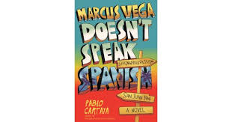
Read in 2023.
Cartaya, Pablo. Marcus Vega Doesn’t Speak Spanish. Puffin Books, 2018
ISBN: 9781101997284
Marcus, a kid born in Puerto Rico and raised in the US, is helpful, smart, loves his mom and down syndrome brother, but misses his father who left his mother 10 years ago and went back to Puerto Rico. After punching a kid who was making fun of his brother at school, his mother decides to take him and his brother on a trip to Puerto Rico to reconnect with family and friends. Yet, Marcus sees this trip as a journey to find his idealized father. They have an amazing time and Marcus sees his father but he feels disappointed once he sees him because Marcus realizes that the person in the picture he wants to see everyday is not the same person in front of him because they no longer know anything about each other. After this, he values his mother more and heals that part of him which was so curious about his unknown father.
Through Marcus, the main character, the book shows the reader themes of identity, bullying, race, discrimination, decision making, and family issues. It is a book I recommend because it teaches the values of family and friendship and how brave a 14 year old can be. Through a realistic dynamic, the book shows different environments such as middle school, a family house in the US and in Puerto Rico, and different situations such as a brother defending his brother and younger friends from bullying, and a kid telling his father that he does not want him to be part of his life. The book is powerful and shows different types of characters, cheerful, sad, funny, serious, but mostly, entertaining. The Exeter Qualities shown in this novel are, 4 (characters who go to beyond typical experiences such as Marcus seeing his father after 10 years), 7 (themes that allow emotional and intellectual growth such as Marcus learning to value his mother more and to be better at school).

Read in 2023.
Maldonado, Crystal. Fat Chance Charlie Vega. Holiday House, 2021.
ISBN: 9780823451319
Charlie, a 16 year old overweight girl, who is great at writing, dreams of how her first kiss will be some day, while she hangs out with her best friend Amelia, who is beautiful and has not only her boyfriend but every boy in school wanting to be with her. Charlie’s mother has lost weight and has many men wanting to date her (Charlie’s father is dead). Charlie wishes she could be more like Amelia or her mother, beautiful and thin, until one day she meets Brian, who falls in love with her. Charlie learns that everyone is beautiful in their own way and finds a way to heal her resentment towards her best friend and her mother.
The themes presented in this novel are discrimination, race, bullying, family relationships, friendship, love, disappointment, and identity. Charlie’s confidence struggles because people make fun of her in school and because her best friend and mother are beautiful and are told all the time they are beautiful while no one tells Charlie this. Charlie is witty, smart, funny, and a good friend. This book teaches young adults to love themselves and to value their friends and parents. It also teaches about the experience of first love and how wonderful this one can be. Through Charlie, the reader can learn that bullying and discrimination can be used as a tool to obtain strength. Charlie feels sorry for herself in the beginning when no one looks at her and only makes fun of her; but, later on in the novel, she becomes stronger and once she is in a good place with herself, she finds love which completes her growth from a sad teen to a content young woman. Charlie no longer wants to be considered beautiful, nor does she want to be thin anymore, and instead wants to be herself because now she finds real value in it. Some of the Exeter Qualities shown in this novel are, 3 (Characters who reflect experiences of teen readers), 6 (themes that inform about the wider world such as what bullying can do to a person), 7 (themes that allow the possibility of emotional and intellectual growth such as when Charlie grows as a person).
Read in 2023.
Chavez Macias, Anette. Too Soon For Adios. Montlake, 2023.
ISBN: 9781542039307
Gabby, a Mexican-American girl who dreams of being a sous chef in Los Angeles, has to quit her job to take care of her ill mother. Her mother dies and Gabby finds out who her biological father is through her aunts who are her mother’s close friends. He invites her to come see him in another town because he has a house for her that belonged to her grandmother. Gabby accepts his invitation only to repair the house and sell it. Things change when Gabby moves to Sonrisa, New Mexico. Her father owns a restaurant, Gabby’s love for food makes her enjoy the restaurant and the little town. She finds her dream job as a chef and love in his father’s friend, Diego.
The themes presented in this novel are grief, family secrets, identity, love, deception, sexism, and tradition. Gabby has to deal with men objectifying her while she works in restaurants. Men assume they can take advantage of her for being a woman who wants to grow professionally. Gabby refuses and rebels against these types of people. Gabby’s loss makes her find her father and a whole different world, where she discovers her real identity. At first, she rejects this small town she moves into, but later on, she finds that tradition and being close to her heritage are the things that she was needing the most. The Exeter Qualities shown in this novel are, 2 (exciting plots that include secrecy, surprise, and tension), 7 (themes that allow the possibility of emotional and intellectual growth).
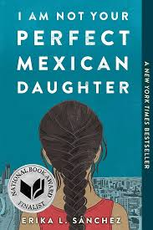
Read in 2023.
Sanchez, Erika L. I Am Not Your Perfect Mexican Daughter. Penguin Random House LLC, 2017.
ISBN: 9781524700485
This young adult novel set in contemporary Chicago, follows the lives of Julia Reyes, a 16 year old girl, who is a daughter of Mexican immigrants, and her sister, Olga. She calls her parents ama and apa. Olga dies in the beginning of the story and we see how Julia struggles with her parents' idealization of her dead sister while they are, especially her mom, hard on her and very judgmental about how different, in a bad way, she is from her sister. Her sister was an apparently very well behaved 22 year old girl who went to college and during her free time, helped her mother cleaning houses and spent time at home with her parents, mostly. Julia is different; she is opinionated, questions the world, loud, and wants to go to New York City to become a writer. Throughout the novel, Julia’s mother keeps telling Julia how she is so different from her sister, implying her sister was better than Julia. Julia finds items that suggest that her sister had a secret life while Julia is going through depression from her sister’s death and her parents not being supportive.
This novel shows the themes of love, disappointment, family issues, friendship, loss, and identity. Julia is trying to find herself while dealing with her parents expectations after her sister dies. Julia has good friends and finds love. She also finds joy in her Mexican heritage before she goes to pursue her dream of becoming a writer in New York City. But things do not come easily for Julia and she struggles and goes through depression and a suicide attempt before finding happiness in her life. This novel shows the Exeter Qualities of 2 (exciting plots that include secrecy, surprise, and tension), 6 (themes that inform truthfully about the wider world in order to make the reader identify with the story and to acknowledge strong issues), 7 (themes that allow the reader to grow in different ways, intellectually and emotionally).
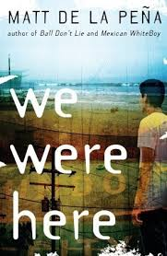
Read in 2023.
De La Pena, Matt. We Were Here. Random House Inc, 2009.
ISBN: 9780385736701
This novel follows the journey of Miguel, a teen from Stockton, California. He kills his brother without intention; yet, he is sent to a juvenile hall. From this place, Miguel escapes with two other boys, Rondell and Mong. They want to go to Mexico and on their journey they have many adventures while Miguel is mourning his brother’s death and finding friendship and his love for literature. However, Mong dies, after which Miguel and Rondell come back to the juvenile hall to make things right. Miguel is now certain that he loves books and that he wants to work to return the money he stole to escape.
This novel shows the themes of loss, identity, friendship, adventure, and deception. Miguel’s grief is a constant theme in the book, he blames himself for what happened to his brother, even though he did not mean it to happen. His escape with the other boys helps him find friendship and their adventures create a strong bond among them. A girl steals the money they stole, teaching him a lesson of not trusting too much in someone whom he had just met. The Exeter Qualities in this book are, 1 (imaginative and well structured plots going beyond simple chronologies to include time shifts and different perspectives), 6 (themes that allow the possibility of intellectual and emotional growth).
Read in 2023.
Chavez Macias, Annette. Big Chicas Don’t Cry. Montlake, 2022.
ISBN: 9781542039291
This novel follows the story of four cousins, Mari, Erica, Selena, and Gracie, from childhood to adulthood. They are family and best friends who have different experiences in life which make them sometimes not as close to each other as they wished; yet, their love for their grandmother is what always brings them back together. Mari moves away when she is a teeneger and the dynamic changes among them, but when their grandmother dies, they decide to not ever be separated from each other again.
This book explores the themes of loss, friendship, family, secrets, love, disappointment, and tradition. Through Mary, the book explores the themes of love, tradition, and secrets. She is married to a man who does not want her to work and she hides the fact that she is not happy because she wants to work as a caterer doing what she enjoys the most: baking. Erica’s boyfriend breaks up with her, leaving her disappointed from love, which is going to change once she falls in love with her boss. Selena does not want to commit to anyone; yet, she meets a good man who makes her change her mind and who helps her find her dream job in New York City. Gracie is a Catholic teacher who is sweet and innocent; she gets pregnant from a guy she trusted; yet, the guy leaves her after finding out she wants to keep the baby. The Exeter Qualities in this book are, 2 (exciting plot including secrecy, tension, and surprise), 7 (themes that allow the possibility of emotional and intellectual growth).
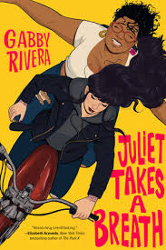
Readi in 2023.
Rivera, Gabby. Juliet Takes A Breath. Penguin Random House LLC, 2019.
ISBN: 9780593108192
This novel follows the journey of Juliet, a teenager from Puerto Rico, who lives in the Bronx. She obtains an internship to work for a feminist author in Portland. Before she leaves for her trip, she tells all of her family during her farewell dinner party that she is lesbian and that she has a relationship with a woman. Her family supports her, except her mother who is in real shock after the news. Juliet leaves for Portland and her journey to understand her family and who she is as a person begins.
This novel explores themes of identity, discrimination, family, friendship, love, and disappointment. Juliet navigates through a different world when she arrives in Oregon; she begins to understand what her pronouns are and who she is as a powerful Latin lesbian woman, who wants to be independent but also wants to always be near her loving family. The Exeter Qualities of this book are, 6 (themes that inform truthfully about the wider world in order to allow readers to engage with challenging issues), 7 (themes that allow the possibility of emotional and intellectual growth).
Read in 2023.
Mendez, Yamile Saied. Algonquin Young Readers 2020.
ISBN: 9781643751894
This novel tells the story of Camila, a young girl who loves playing soccer and is part of a soccer team. Yet, Camila keeps this hobby as a secret from her parents because in her country, Argentina, soccer should be played only by men. Camila pursues her dream to go to the United States with a scholarship and finally be able to play soccer in a professional field. Camila is also in love with her childhood crush, Diego. Diego is a professional soccer player in Italy and they find the way, after struggling long distance, to stay together.
This novel shows the themes of discrimination, love, friendship, dreams, and family. Camila’s parents do not want her to play soccer because they are afraid that if she plays soccer she will be considered homosexual by everyone in the neighborhood. Camila’s boyfriend wants her to go with him to Italy, not considering she wants to go to the US to become a soccer player. Camila shows her parents and her boyfriend that making her dreams happen is possible. The Exeter Qualities shown in this book are, 2 (exciting plots that include secrecy, tension, and surprise), 7 (themes that allow the possibility of emotional and intellectual growth).
Read in 2023.
Cisneros, Sandra. Penguin Random House, 2022.
ISBN: 9781644734285
This novel follows the experiences of Esperanza, a Mexican American child. These experiences include stories of her family, her neighbors, and friends in a Latinx community in Chicago while growing up.
The novel includes the themes of identity, discrimination, poverty, tradition, family, and sexism. The Exeter Qualities in this book are, 2 (exciting plots that include tension, surprise, and secrecy), 7 (themes that allow emotional and intellectual growth).
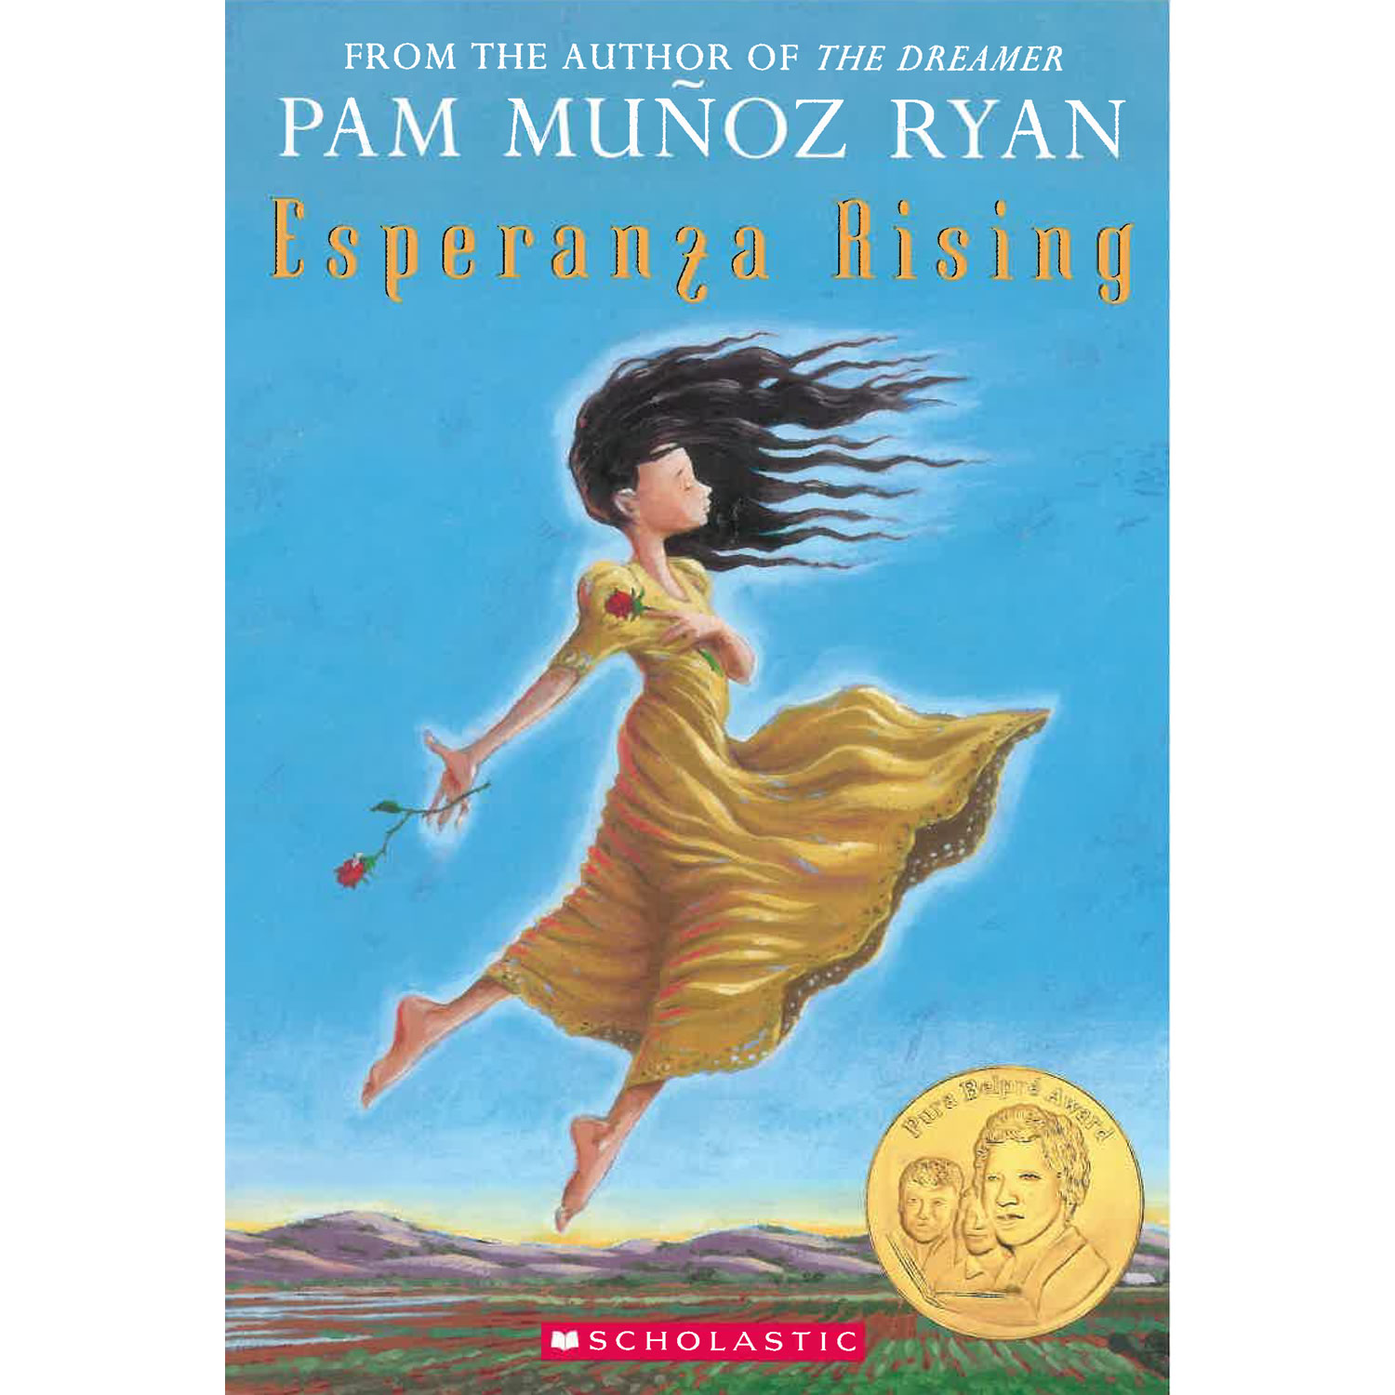
Read in 2023.
Munoz Ryan, Pam. Esperanza Rising. Scholastic Inc 2018.
ISBN: 9780439120425.
This novel tells the story of Esperanza, who is a very wealthy Mexican child living in Mexico. Her father is killed and her mother decides to go with her to the US because Esperanza’s uncle wants to marry her mother and he burns the house that Esperanza lives in in order to convince her mother to give him access to what he wants. Esperanza’s mother is scared so she escapes with Esperanza and some of her servants to the US. In the US Esperanza’s servants are not servants anymore, but equals, as she, her mother and they are working in agriculture and trying to survive without the luxurious life Esperanza and her mother are used to.
The themes shown in this novel are courage, discrimination, adjustment, family, change, social and economic hierarchy. Esperanza does not understand in the beginning of the story that not having money can mean also being happy. She had a happy wealthy life and she misses this but her mother and her own experiences teach Esperanza different values in life. Esperanza learns that in a different country she and the people she used to call servants are the same and that it is better to be unified with everyone and not be separated by race or economic power. The Exeter Qualities are 3 (characters who reflect experiences of teen readers, especially when it comes to strong female protagonists), 7 (themes that allow intellectual and emotional growth).

Final Word
As a Latin person who comes from a different country, and even though I am not a teenager but an adult, reading these novels now made me wish that I could have read these novels when I was younger. I did not come to the US until I was in my twenties and I did not know that there was a whole world of literature describing Latin immigrants’ experiences in America. Most of the characters in these novels are very self-conscious, sometimes embarrassed, sometimes proud, but always conscious of their ethnicity, of being different in a country that can make you feel rejected if you are different. This consciousness of ethnicity is something that I identified with, and I appreciate these books because it is one thing is to experience discrimination when you are older, but when someone is young, they may not know how to handle it. In such circumstances, these novels become very relevant because teens who read them can feel that there is hope against discrimination and that they should be only proud of their ethnicity.
Works Cited
Cartaya, Pablo. Marcus Vega Doesn’t Speak Spanish. Puffin Books, 2018
Maldonado, Crystal. Fat Chance Charlie Vega. Holiday House, 2021.
Chavez Macias, Anette. Too Soon For Adios. Montlake, 2023
Sanchez, Erika L. I Am Not Your Perfect Mexican Daughter. Penguin Random House LLC, 2017.
De La Pena, Matt. We Were Here. Random House Inc, 2009.
Chavez Macias, Annette. Big Chicas Don’t Cry. Montlake, 2022.
Rivera, Gabby. Juliet Takes A Breath. Penguin Random House LLC, 2019.
Mendez, Yamile Saied. Furia. Algonquin Young Readers 2020.
Cisneros, Sandra. La Casa en Mango Street. Penguin Random House, 2022.
Munoz Ryan, Pam. Esperanza Rising. Scholastic Inc 2018.
Warner, Mary. Adolescents in the Search for Meaning: Tapping the Powerful Resource of Story. Scarecrow Press, 2006.

