Victoria Pong
Dr. Mary Warner
ENGL-112B
27 November 2023
Annotated Bibliography Rationale
Oftentimes, young adult literature is thought to be tailored only towards a younger audience because of its clique and overexaggerated stories. Themes of dramatic romances and high school drama can seem redundant and tiring to read. However, there is more to young adult literature than drama. In Literature for Today's Young Adults, chapter four focuses on contemporary realistic fiction from tragedies to romances. The novels that I choose fall under this category with a concentration of living through family and relationship issues as well as struggling with identity and discrimination. It’s important for students to be able to make connects with stories and characters to help them make judgments and decisions for themselves regarding similar situations. The books that I chose consists of traditional novel structure but also some that are graphic novels. The novels in question are mostly centered around coming of age stories where the protagonists must tackle the struggles of generational differences between their families and encounter obstacles that help them discover their identity as individuals.
The exeter qualities that these realistic novels presents are, “Characters who reflect experiences of teen readers, something that is not found in much of the literary canon, especially when it comes to strong female protagonists.” (exeter quality class handout). Many of the books I have listed have female protagonists that have to face the struggles of discrimination whether it be because of their gender, racial or cultural background. In these stories, the female protagonists go about different ways to solve their problems of finding their true self and what they stand for. It’s important to have diversity in the books that are being read, which is why having female representation presented to students is good in that it reaches a wider audience about real-life situations that girls have to challenge rather than hiding the reality of the world away from them.
This adds on to another exeter quality of these text, “Themes that inform truthfully about the wider world so as to allow readers to engage with difficult and challenging issues relating to immediate interests and global concern” (exter quality class handout). Living through family and relationship issues is relatable to teenagers especially because of the sensitive age range they are in. Generational differences and age gapes can bring up topics of arguments when trying to decide what is the best path to choose to be successful and happy. This is a theme and topic that is worth reading and learning about because it allows for students and teenagers to use their similar issues at home to connect with the stories. It allows students to learn from the lessons and actions of the characters from their reading and relate it to their own world to solve and go about identity. In terms of identity, people are always learning about themselves, but struggling with identity during the teenage years can be extremely tough when the most important thing might feel like to fit in with everyone. These novels share the importance of accepting oneself and come to terms with identity rather than reject it. Many of the books listed share how teens overcome being part of a multicultural background, having a health condition, and not fitting as minorities. These are all great exeter qualities that make the themes and moral of these stories beneficial for teens to read and learn from as they tackle real life issues that teenagers are facing and struggling with.

Annotated Bibliography: Relationships and Identity in Contemporary Realistic Fiction
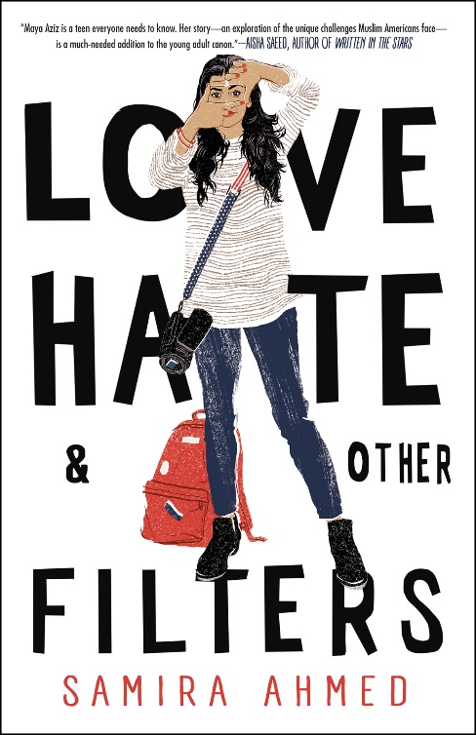
Love Hate and Other Filters by Samira Ahmed
I have not read this novel; Summary is adapted from Goodreads.
Ahmed, Samira. Love, Hate and Other Filters. Soho Teen, 2018
ISBN: 9781616958473
The story follows Maya Aziz, an American-born seventeen-year-old, who must deal with the conflict of identity. Maya dreams of pursuing her studies at film school in New York City and deepening her relationship with a boy she’s known since grade school. However, she’s pressured with the ideals her parents have for her to be a perfect Indian daughter. She’s expected to attended college near Chicago, where they live, and arranged to be with an older Muslim boy. While dealing with the expectations of her parents and trying to reach towards her goal in life, Maya also faces discrimination of Islamophobia due to a terrorist attack that makes her journey more challenging. (Love Hate and Other Filters, GoodReads).
Love Hate and Other Filters combines the high expectations of traditional family values as well as the outside world’s religious discrimination against a group of people because of an uncontrollable act of terrorism. The books brings attention to Islamophobia and by teaching students about the reality of this, it brings change to generations to become more open of accepting people regardless of their racial, cultural, or religious background.
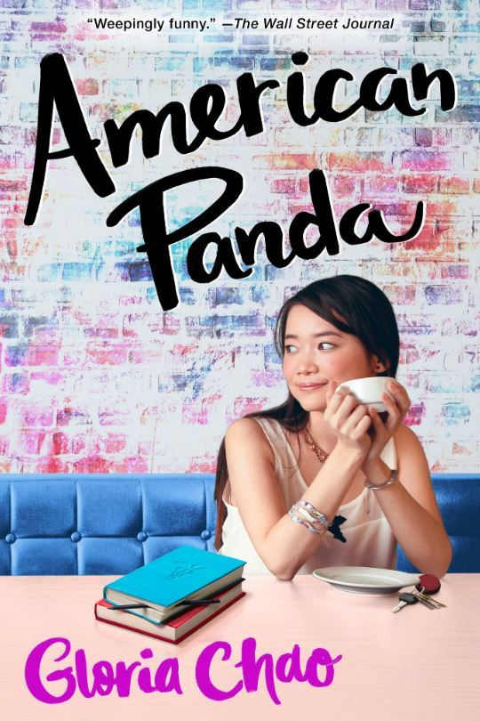
American Panda by Gloria Chao
I have not read this novel; Summary is adapted from Goodreads.
Chao, Gloria. American Panda. S&S Books for Young Readers, 2019
ISBN: 9781481499118
Mei, a seventeen-year-old Taiwanese American, was forced to skip the fourth grade by her parents to quickly reach their expectations of quickly becoming a doctor. She is now a freshman at MIT and is supposed to prepare to marry a Taiwanese Ivy leaguer and expected to have children. However, Mei faces the challenge of how she’s going to tell them she’s a germaphobe, fall asleep in biology lectures, and has a crush on her Japanese classmate Darren Takashi, someone not Taiwanese. During this period of conflict, she reconnects with her estranged brother, Xing, who was outcasted because he did not date a woman of Taiwanese descent. (American Panda, GoodReads).
A common issue today is trying to fit in when coming from a multicultural background. Mei’s parents are more on the traditional side in the sense that they expect her to be a doctor, marry into a Taiwanese family, and mother plenty of children. Mei’s character goes against the wishes of her family because of what she truly wants. The age and generational gap are what families today must deal with as well, making it relatable to teenagers who have high expectations placed on them to follow family footsteps. This makes it harder for them to carve their own path and find themselves and individuals. Reading this book follows the exeter qualities mentioned before that help teens learn how to deal with similar issues in their own personal lives.

We Are Not Free by Traci Chee
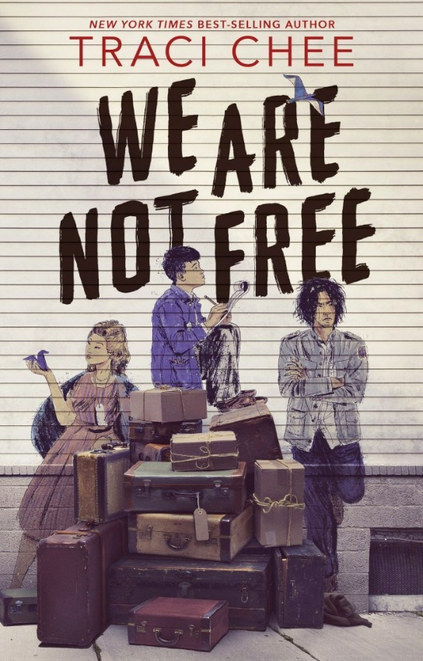
I have not read this novel; Summary is adapted from Goodreads and BookTalk from Franklin Trinh.
Chee, Traci. We Are Not Free. HMH Books for Young Readers, 2020.
ISBN: 9780358131434
The stories in We Are Not Free follow the experience of fourteen second generation Japanese Americans teens who were put into incarceration camps during the World War II. These teens who grew up together in Japan town, San Franscisco formed a community as they deal with the discrimination and violence tailored at them and their community simply because of their ancestral background. (We Are Not Free, GoodReads & BookTalk from Franklin Trinh).
While schools teach about World War II and briefly explain the incarceration camps of Japanese Americans, these stories presented in this novel brings forth the reality of the world. While students may not be able to directly relate to the incarceration camps, they can relate to the bigger issue at hand, discrimination. Unfortunately, racial discrimination is still an issue that people must face. By reading these stories, hopefully teens will understand the severity of what happened historically but also learn how to build communities with one another that support each other.
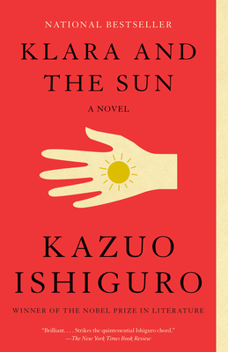
Klara and The Sun by Kazuo Ishiguro
Read in 2022
Ishiguro, Kazuo. Klara and The Sun. Vintage International, 2021
ISBN: 9780593311295
Klara, an Artificial Friend, is bought by a young girl named Josie and her family. In this society all children are expected to have an artificial friend as guidance to be successful in making a societal debut. Although Klara’s personality differs from the other artificial friends because of her outstanding observational skills and desire to do anything to make Josie happy. The story takes a twist as Klara has trouble figuring out what she needs to do to help her owner, Josie, recover from her illness. The story follows Klara’s growth as a person even though she is not human. Her desires conflict with the wants of Josie’s family as she realizes that she isn’t exactly welcomed as part of the family. Klara struggles to meet up to the expectation of Josie’s parents and her sense of morality is challenged as people try to influence her thought process to benefit their ideas on what would be best for Josie.
Klara and The Sun follows a different way of presenting the idea of identity. Unlike the other books I’ve chosen, the main character in the story is an artificial intelligent friend, meaning she’s not human. However, Klara is still able to showcase many human emotions in a way that shows the complexity of what goes on in people’s mind. This allows for readers to see the and understand why fitting in is such a crucial issue for teenagers and challenges issues of identity in a rather unique way.
A Mango Shaped Space by Wendy Mass
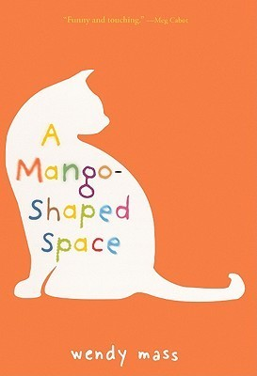
I have not read this novel; Summary is adapted from Goodreads.
Mass, Wendy. A Mango Shaped Space. Little, Brown and Company,2005.
ISBN: 9780316058254
Mia Winchell is a thirteen-year-old girl who is diagnosed with synesthesia, which is a neurological condition that mixes her senses at the same time. Her condition allows her to see colors when she hears sounds. In this coming-of-age story, Mia needs to learn how to accept herself and fit into school with her condition. (A Mango Shaped Space, GoodReads).
This novel brings forth health conditions that can make people feel unable to fit in. Again, this is a big issue that connects with the struggles of identity. It is hard to accept oneself and most of the time teenagers with try to reject parts of themselves because it is not part of the social norms. Not only does this novel bring awareness to synesthesia, the condition that Mia is diagnosed with, but it also helps students to change their action on how they view and treat themselves and others. It follows the exeter qualities of experiences that are not in much literary canon as well as informing the truth about how health conditions can negatively affect the mind space when put in a school setting.
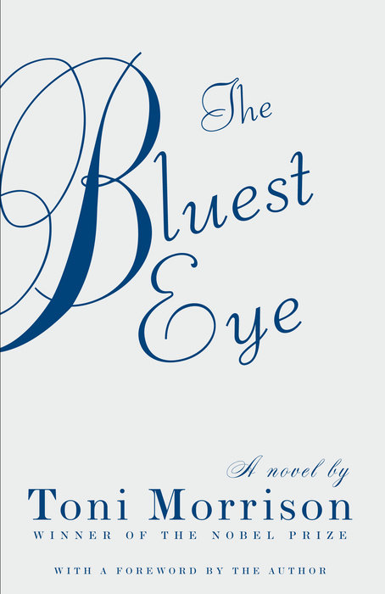
The Bluest Eye by Toni Morrison
Read in 2022
Morrison, Toni. The Bluest Eye. Vintage International, 2007.
ISBN: 9780307278449
The story is told with one of the characters, Claudia, as the narrator. Claudia, Frieda, and Pecola must face discrimination and colorism as young black girls. The story captures the strikingly realistic hardships that people in the black community have faced. Pecola, who struggles not only with forming relationships with peers but also with her own family, is pushed onto the idea that the reason for her misfortune comes from her physical appearance. She does not believe she is beautiful and that having blue eyes and blond will be the solution. Her obsession with having White features starts early as she is seen heavily admiring the Shirley Temple cup handed to her. Pecola’s life takes a twisted turn after an incident with her family that outcasted her from her family and all of society.
Although the book is banned, I believe that it brings awareness to issues of discrimination against females and the severity of rape. While people may believe that rape is a touchy issue that teenagers should not be reading about, it sheds light on the reality of what happens to not only young girls but also boys. There are many lessons to learn from this novel that show the rude awakening of what dangers and issues people are often fighting behind the scenes.

Persepolis: The Story of a Childhood by Marjane Satrapi
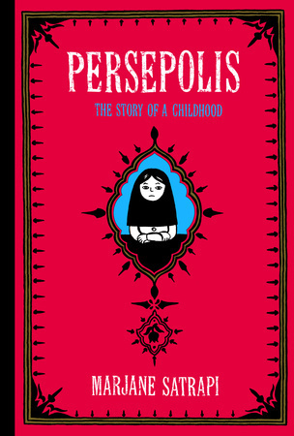
Read in 2021
Satrapi, Marjane. Persepolis. Pantheon, 2004.
ISBN: 9780375714573
This graphic novel focuses on the story of Satrapi’s life as she witnesses the overthrow of the Shah’s regime and moves away from her parents given the opportunity to study away from the war with Iraq. During her time, she journeys on a discovery to find herself which differs from the cultural expectations that were held of her back at home. She must come to terms with her identity and where she if from despite how she wanted to fit in with her peers at school.
This book isn’t necessarily realistic fiction because if follows the life of the author, but I still thought it followed the subgenres of living through family and relationship issues as well as tackling identity and discrimination. The graphic novel not only presents political issues that happened but also the hardships of Satrapi’s background and how it affected the way that she went about rejecting her cultural background to fit in. It is relatable in the sense that trying to experiment with identity often leads to straying away from the expectations of traditional family views. This allows for a different view on how people deal with the struggles of identity that can be learned from to apply to one’s own life.

She is a Haunting by Trang Thanh Tran
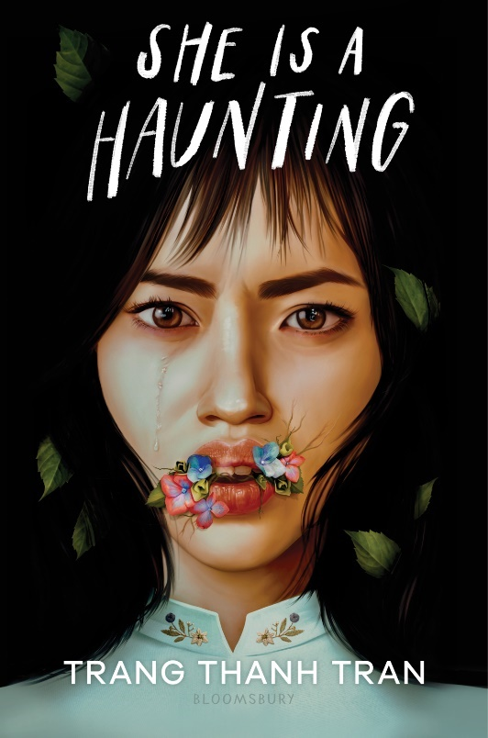
I have not read this novel; Summary is adapted from Goodreads.
Tran, Trang Thanh. She is a Haunting. Bloomsbury YA, 2023.
ISBN: 9781547610815
Jade Nguyen visits her estranged father in Vietnam in hopes of getting the money she needs to complete college. Her father promises her the money as long as she visits, but it is implied that she must meet the cultural expectations of her Vietnamese heritage in order to satisfy him. However, during her time at her father’s house she gets an eerie feeling every night. Not only does Jade need to overcome the family drama but also needs to find out who she is to save her family. (She is a Haunting, GoodReads).
Family’s where parents or siblings are estranged are not uncommon and many teens and students can relate to only having one parent and the struggles of not being able to pursue a high education due to financial reasons. This story brings forth not only the tensions of children and their parents but also the unrealistic expectations of following very traditional values instead of embracing oneself. In the story Jade struggles with her family issues, as well as her cultural and sexual identity. The topic of sexual identity is also something that teens struggle with as well and having text that openly talk about the struggles can make it easier for them to progress through their journey of discovering who they are.
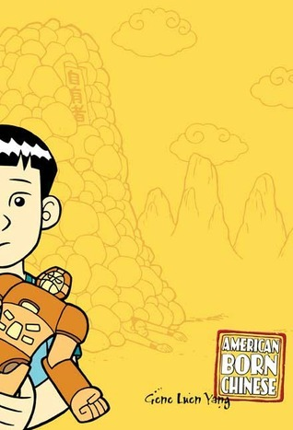
American born Chinese by Gene Luen Yang
Read in 2022
Yang, Gene Luen. American Born Chinese. First Second, 2006.
ISBN: 9781596431522
This graphic novel follows the main character Jin Wang as he tries to fit in his predominantly white school. The story combines both Chinese folklore and stereotypes to showcase how Jin is ashamed of his culture and wants to be White to be liked. His fear of missing out and being outcasted is what pushes him to discriminate against his immigrant friend Wei Chen Sun. His actions towards Wei Chen reflect his rejection for his Chinese culture as he tries to completely adapt his American culture. The novel has three different perspectives and stories that intertwine to connect the struggles of being Asian-American and not being accepted into society.
The novel does an amazing job at showcasing the struggles of growing up as a minority in a predominantly white community. The struggles of wanting to reject culture because of fear of not fitting in, is something that many multicultural children must deal with. Awhile some stereotypes are exaggerated, it shows the harsh reality of how Asians were treated before trends made them more accepted into society. Teens can learn about how it is important to accept yourself for who you are and that it is okay to be different because there will always be a crowd out there that they will fit in.

Frankly in Love by David Yoon
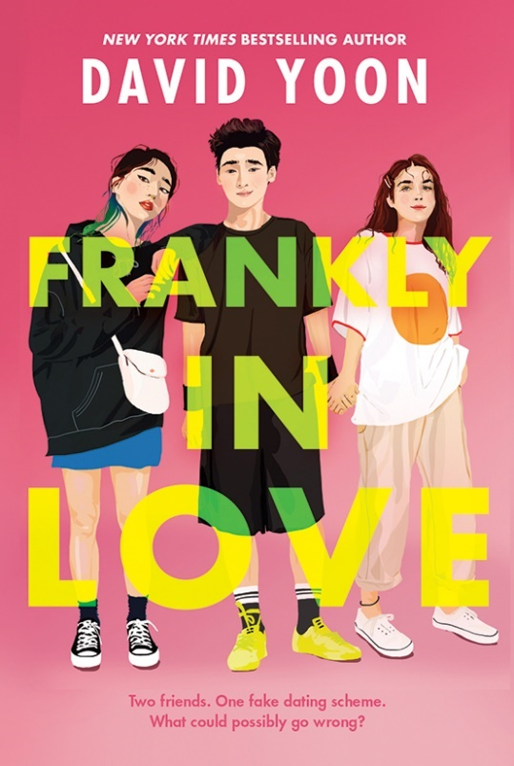
I have not read this novel; Summary is adapted from Goodreads.
Yoon, David. Frankly in Love. G.P Putnam’s Sons Books for Young Readers, 2020.
ISBN: 9781984812223
Frank Li is a Korean American born and raised in Southern California. Although he is Korean, he barely speaking Korean but that does not stop his parents from expecting him to fate and marry a Korean girl. Frank, however, does not want to adhere to his parents’ ideals and wishes because he wants to forge a path of his own. The person he is in love with isn’t Korean but White, which is not what his parents want of him. Frank works with a friend named Joy Song so that they can both get away from the unrealistic expectations held upon them.
Frankly in Love is another novel where the protagonists have to deal with the conflicts between family expectations and the struggle of chasing personal goals. Family expectations happen regardless of gender, racial, and cultural background. There are times where people are not fortunate enough to be able to fight those expectations and achieve goals that they personally want. However, having strong protagonists who believe in the right to be able to express themselves is what teens and students need to fight motivation to chase their own goals and make decisions for what they want to do. It brings the lesson that it is okay to have your own path that you want to walk instead of walking on that was planned and paved for you.

Final Words
I didn’t read many novels as a teenager because it was hard for me to relate and find something that I thought was interesting. That’s because most of the literal canon were not something I personally related to. That’s why I believe that it’s important to have diversity in readings that deal with real life situations that teens can understand and make connections to. It will not only encourage to read more but also help them to make decisions regarding similar issues in their own life. Had I read some of the books listed, I would have had an easier time adapting in school as a minority where I was afraid of my own identity because of my racial and cultural background. I was embarrassed of how different I was from others and of not fitting in. These books bring awareness on how to deal such issues and how to come to terms with the different cultures whether it be multiracial or simple being the mix between American culture and family heritage and culture.
Works Cited
Ahmed, Samira. Love, Hate and Other Filters. Soho Teen, 2018. https://www.goodreads.com/en/book/show/31207017
Chao, Gloria. American Panda. S&S Books for Young Readers, 2019
https://www.goodreads.com/book/show/42201385-american-panda
Chee, Traci. We Are Not Free. HMH Books for Young Readers, 2020.
https://www.goodreads.com/en/book/show/49934666
Ishiguro, Kazuo. Klara and The Sun. Vintage International, 2021
Mass, Wendy. A Mango Shaped Space. Little, Brown and Company,2005.
https://www.goodreads.com/en/book/show/171020
Morrison, Toni. The Bluest Eye. Vintage International, 2007.
https://www.goodreads.com/book/show/292327.The_Bluest_Eye
Nilsen, Alleen Pace, and Kenneth L. Donelson. “Chapter 4 Contemporary Realistic Fiction: from tragedies to romances”, Literature for Today's Young Adults. Harper Collins College Publishers, 1993. pp 111-162.
Satrapi, Marjane. Persepolis. Pantheon, 2004.
Tran, Trang Thanh. She is a Haunting. Bloomsbury YA, 2023.
https://www.goodreads.com/en/book/show/60784841
Yang, Gene Luen. American Born Chinese. First Second, 2006.
Yoon, David. Frankly in Love. G.P Putnam’s Sons Books for Young Readers, 2020.
https://www.goodreads.com/book/show/50690074-frankly-in-love
Warner, Mary. “Exeter Study Qualities.” Engl112Handouts, https://www.sjsu.edu/faculty/mary.warner/Engl112B_handouts/Exeter%20Study%20Qualities.docx

