Kendall Story
Dr. Mary Warner
ENGL 112B
6 December 2021
Annotated Bibliography Rationale
Growing up and holding on into my early adult years, I have never been a strong or passionate reader. I always found difficulty finding connections or relating to aspects of a novel and have struggled to stay incapsulated and content while reading. It wasn’t until my immediate world was expanded and my general experiences had broadened when I really began to see the relations that many genres in literature attempt to portray. Young adult literature is often misunderstood and believed to lack depth and real connections to reality, but in actuality, young adult literature exposes it readers to differentiating perspectives that many novels fail to mark upon. Young adult literature, especially novels that fall within the genre of contemporary realistic fiction, offer teenagers, adolescents, and even adults a safe space that continuously features themes riddled with important messages and real-life struggles, but portrayed with perspectives that allow the reader to understand the vast complexity of aspects that influence life.
The novels that I chose to include within my annotated bibliography fall under Chapter 4 of Literature for Today’s Young Adults and have a significant focus on the realism that follows romance, tragedy, and relationships. I chose this as my “centerpiece” because of the year 2020. Many people were forced to face times of utter uncertainty, grief and death, issues in relationships with family and friends, and young adult literature offers an escape from all of the loneliness that has recently been caused. Young adult literature touches on many of the complex points that life unfortunately offers us all at varying points in our life. The novels I chose generally focus on grief after losing a loved one, finding and not losing onto yourself, and the importance that others around you hold.
Chapters four through six from Adolescents in the Search for Meaning: Tapping the Powerful Resource of Story feature the main subgenres or issues that I chose to focus on: Books about Real-Life Experiences, Facing Death and Loss, and Identity, Discrimination, and Struggles with Decisions. I personally believe that these are key components that many young adults face with little to no preparation for how to handle themselves or others within these situations. Novels such as The Lines we Cross, Thirteen Reasons Why, and The Outsiders offer differentiating perspectives that allow the reader to see opposing sides of issues where many are censored from the full truth. They offer themes surrounding determining your own identity and struggles with finding or securing a personal identity, coping with loss, and the importance and the influence that friendships may hold.
Covid-19 was an experience that no one was prepared for and, while I do not believe there would have been any possible way to prepare the world for global disaster, I feel that novels such as the ones I have included offer important lessons when it comes to defining and maintaining your genuine individuality. Novels such as Looking for Alaska, Before Goodbye, and The Fault in our Stars carry heavy themes surrounding death and loss of a loved one with values of inspiration and perseverance to avoid losing the person you are. Whereas novels like Thirteen Reasons Why and All the Bright Places offer the heavier alternate versions of reality that many are too scared to accept.
These are all very strong examples of the Strong Problem novels we discussed in chapter four of Literature for Today’s Young Adults that focus of the true realities that many young adults are forced to face.
Annotated Bibliography: Strong Problem Novels in Realistic Fiction.
1. The Lines We Cross by Randa Abdel-Fattah
– I have read this novel. –
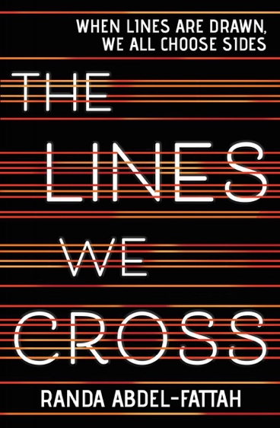
Abdel-Fattah, Randa. The Lines We Cross. Scholastic Incorporated, 2018.
The Lines We Cross is written by Australian writer named Randa Abdel-Fattah. This story follows an extremely intelligent high school student named Mina after receiving a full scholarship to Victoria College, a very prestigious school in Australia, where she meets another student named Michael. Readers are given both of the perspectives from these two students by alternating their narratives each chapter. This novel expose’s specific themes surrounding real-life experiences regarding major life choices, facing discrimination, violence, or abuse, and struggling with family relationship issues. Mina is an Afghani-Australian refugee whose family had escaped Afghanistan and traveled by boat to Australia and Michael was raised into a conservative family that opposes allowing Muslim immigrants settle in Australia. The two students quickly learn about their opposing political viewpoints, but their similar taste in music is what initially brings them closer together. Mina is eventually able to teach Michael about racism, basic human morality, and how to form an opinion of his own after opening up his mind by explaining her experiences leaving Afghanistan, family history, and the tragedies she had experienced.
Michael’s character goes through many different developmental phases within the novel, but ultimately, because of his budding relationship with Mina, he goes through a positive change in mentality. Initially, Michael is very stubborn politically when topics arise and stray from his family’s beliefs. Michael’s father is the leader of an organization called Aussie Values that actively promote their beliefs. As Michael and Mina grow closer within the novel, Michael is able to realize that the entire world doesn’t function in the same ways that Australia does and he is able to open his mind, especially when it comes down to the humanity and morality behind the subject at hand. This novel touches on moving forward after death or loss of a loved one, as well as circling around themes involving identity, discrimination, struggles with decisions, and developing a personal sense of courage and strength.
2. Thirteen Reasons Why by Jay Asher
– I have read not this novel, but I have watched the Netflix series. –
Asher, Jay. Thirteen Reasons Why. Klett Sprachen, 2010.
“Thirteen Reasons Why: Plot Overview.” Sparknotes, SparkNotes, https://www.sparknotes.com/lit/thirteen-reasons-why/summary/.
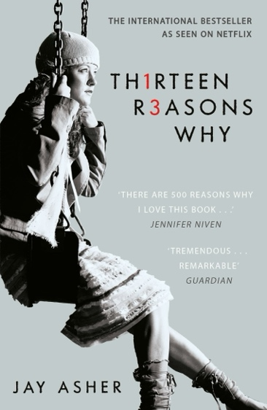
Thirteen Reasons Why is written by Jay Asher and follows the life of a student named Clay Jensen after he finds a shoe box filled with seven double-sided cassette tapes labeled “A” and “B” in sequential order on his front porch. Readers quickly find out that these tapes were recorded by a student named Hannah Baker right before taking her own life. Each of these cassette tapes that Hannah Baker had recorded explains each reason for why she ultimately decided to go through with the decision of killing herself. Clay confusingly travels around the town with the help of a map the Hannah had made as he listens through the tapes and delivers them to the individuals that Hannah personally held responsible for her overall decision. Eventually, Clay realizes that his position in Hannah’s life was a lot more important than he had realized.
This novel exposes its readers to themes of mental health, suicide, depression, and many of the other factors that typically result in teenage suicide. Many reviewers of this novel are disappointed that Hannah put the blame of her suicide onto thirteen of her classmates, but this novel offers an extremely realistic situations of how many teenage students treat each other and gives the opportunity for readers to take an inside look to change the person in the mirror first. This novel also touches on the importance of checking in on your loved ones because you never truly know if they are fighting silent demons. By using specific real-life experiences, this novel is able to expose some variations of violence, bullying, teenage suicide, relational issues, struggling to fit in, and facing death or loss that many young adults are not encouraged enough to push through during (but not limited to) their high school years.
3. Before Goodbye by Mimi Cross
– I have not read this novel. –
“Before Goodbye by Mimi Cross.” Goodreads, Goodreads, 1 Jan. 2016, https://www.goodreads.com/book/show/27406254-before-goodbye.
Cross, Mimi. Before Goodbye. Skyscape, 2016.
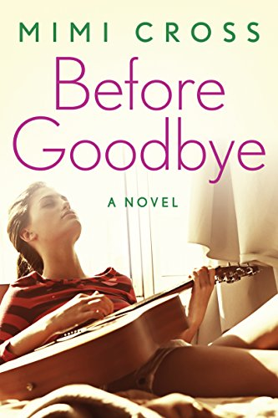
This book was introduced to me because of Christopher Molina’s book talk presentation. Before Goodbye is written by Canadian author, Mimi Cross. Similar to The Lines We Cross; this novel is also given in a two-person alternating narrative style. Cate Reese is a young musician who falls in love with her long-term friend and partner guitar player named Cal before he is accidentally killed in a car accident. David Bennet is the second perspective that readers are given within this novel and is a close friend of Cate and also struggles with survivor’s guilt after his brother’s suicide. The pair grow closer over the duration of the novel, eventually helping each other heal from their losses.
Cate and David both do not have parents that are actively involved within their lives, they struggle trying to fit in at school, and are both forced to face dealing with grief and loss at such a young age. This novel exposes its readers to hardships such as death and offers on opportunity for relatability and exposes the concept that many people may look like their mentally stable and have their lives put together yet are still constantly battle the silent or hidden demons they may be facing. David struggles with his own identity when it comes to living up to his father’s expectations and meeting his standards and the pair both struggles with finding their identities while they cope with the loss of a loved one. While focusing on real-life representation, this book communicates situations involving tragedies, facing death and loss, and struggling with identity.
4. We Were Here by Matt De la Peña
– I have read this novel. –
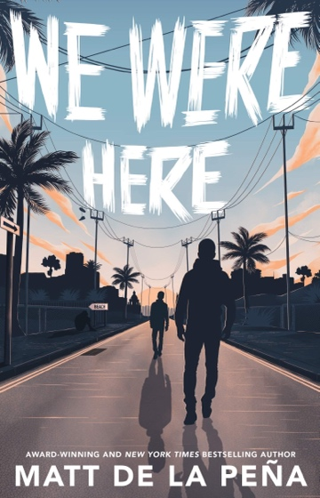
De la Peña, Matt. We Were Here. Ember, an Imprint of Random House Children's Books, 2019.
We Were Here is written by Matt De la Peña in a journalistic or diary-entry style. This story follows the day-by-day activities of Miguel Castaneda after he was appointed by a judge to stay in a group home and keep record in his journal. The journal that the readers are given is contingent with Miguel’s sentencing as the judge feels that this journal will better help the adults in his life understand him and help him control his actions. Miguel initially isolated himself from everyone else that is in the group home until one evening when him and two other group members are able to escape. Miguel eventually learns concepts of acceptance while dealing with the consequences of his own actions, how to own up to his mistakes and grow from them, and personal self-worth.
This novel uses more real-life experiences to show the challenges that many teens face when they feel “unseen” or “unworthy.” This novel amplifies the importance behind learning from your mistakes, giving permission for those to feel grief or remorse after a wrong term, and building a personal sense of self-esteem. Miguel is able to find acceptance with what has happened between him and his brother, understand that he cannot change what has already happened, but also come to terms with the fact that it was an accident with no ill intent and still has humanistic value.
5. I Have Lost My Way by Gayle Forman
– I have not read this novel. –
Chen, Sandie Angulo. “I Have Lost My Way - Book Review.” Common Sense Media: Ratings, Reviews, and Advice, Common Sense Media, 27 Mar. 2018, https://www.commonsensemedia.org/book-reviews/i-have-lost-my-way.
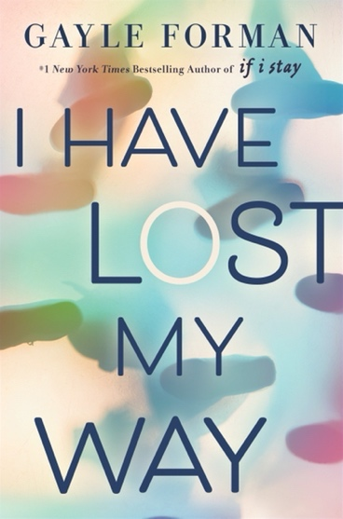
Forman, Gayle. I Have Lost My Way. Penguin Books, 2019.
This novel follows three young adults, who are complete strangers to each other and each struggling with their own personal crisis, over the span on one day. This story has multiple narrators and switches between their viewpoints within the chapters. Although this story only takes place over a day, the readers are given specific flashbacks in order to fully piece together the entire narrative. One of the main characters, Freya is a young singer who struggles with the relationship she holds with her family before losing her voice. The second character the novel follows is a young man named Nathaniel, a survivor of abuse and neglect. Finally, there is Harun, a Pakistani American Muslim who ended his relationship with his first true love because he is ashamed for being gay.
This novel follows the realistic events that occur to these three drastically different individuals with discussions involving family relationships, sexual orientation, and mental health. Each of their personal experiences, issues, and insecurities are what bring these three together in order to work on their healing processes. All three characters within this novel face situations involving death or loss that can be relatable by many different audiences while also highlighting the importance that those around you may hold.
6. The Fault in our Stars by John Green
– I have read this novel and watched the movie. –
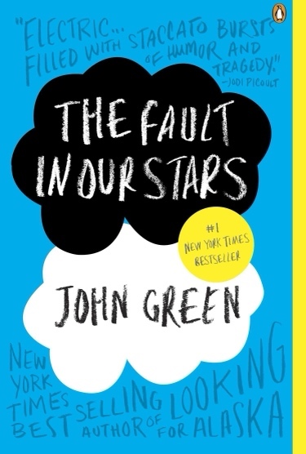
Green, John. The Fault in Our Stars. Dutton Books, 2018.
The Fault in our Stars is written by John Green and follows alongside seventeen-year-old Hazel Grace Lancaster while attending a cancer patients’ support group. Hazel grace has stage four lung cancer and because of this she must use an oxygen tank in order to breathe properly at all times. Hazel quickly meets another young cancer patient named Gus who is currently in remission when the readers are first introduced to him. Hazel is initially reluctant to get to know Gus, but after some words of encouragement from her best friend and parents (also his persistence for life) eventually convinces her to test out new some new waters (that’s a pun because his full name is Augustus Waters.) Gus and Hazel explore many new ventures between the couple and this novel overall exposes the true meaning of “for better or for worse” when it comes to any relationship.
While Gus is in remission for a decent portion of the novel, his cancer returns and takes his life before the end of the book. This novel deals with a version of death that an individual and their loved ones are actively preparing for. Hazel Graces character specifically does an extraordinary job at portraying the genuine feelings that many young adults experience. This novel focuses on the ideals behind true love, loss, anger, depression, grief, and offers a notion to not take your own life or a loved one’s for granted because at any point it could be gone. Green’s decision in combining Gus’s death into the story shows the reader’s that the typical “fairytale happy ending” is not always the realistic version of life.
7. Looking for Alaska by John Green
– I have not read this novel. –
Green, John. Looking for Alaska. Harper Collins Children's Books, 2019.
“Looking for Alaska: Full Book Summary.” Sparknotes, SparkNotes, https://www.sparknotes.com/lit/looking-for-alaska/summary/.
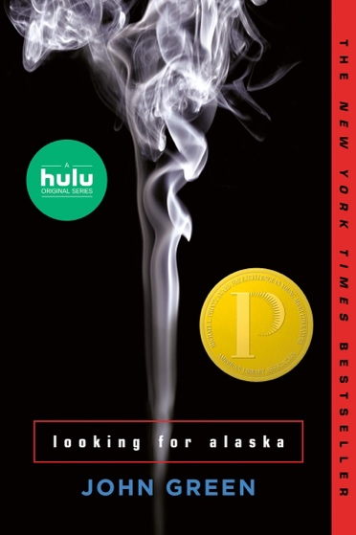
Looking for Alaska is also written by John Green and tells the story of a high school junior named Miles “Pudge” Halter after experiencing a life changing event that isn’t revealed to the readers until the later sections of the novel. Miles’s parents are worried for him to attend Culver Creek boarding school because they think his reasoning is that he does not have friends at his current school, but the truth is that he was influenced by the last words of poet François Rabelais concerning “seeking the Great Perhaps.” This story follows Miles as he moves to Alabama, befriends his roommate, and starts to fall for another student named Alaska who is killed after driving head on into a police cruiser with their lights on, she was presumed to be intoxicated.
Green’s novel follows Miles and his roommate’s investigation into the real reason for Alaska’s death after the boys find a note in her bedroom with that said “straight and fast” was the way out of the labyrinth. This novel not only focuses on issues revolving suicide and choosing to persevere instead “running” from your problems instead, but significantly highlights the importance and influence that a good friendship holds. Overall, Miles takes in the information he had learned about loving and losing his friend into motivation for “seeking the Great Perhaps.” This novel expresses many moments of genuine realism that teens and young adult experience (like acts of smoking, drinking, and sexual explorations) while placing a special emphasis on the importance and value behind true friendships.
8. The Outsiders by S.E. Hinton
– I have read this novel. –
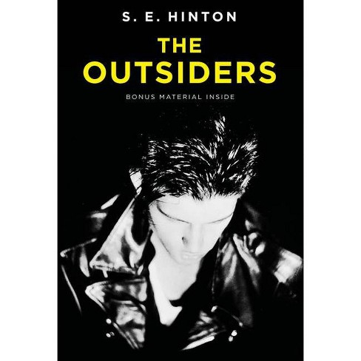
Hinton, S. E. The Outsiders. Viking, 2021.
The Outsiders is set in the 1960’s and was written by S.E. Hinton. The main character, Ponyboy, believes that there are only two types of people in this world: the socials (or socs) and the greasers. The socials have money, they can get themselves into anything they want and pay their ways back out. Greasers, on the other hand are viewed as the outcasts, the troublemakers, but are extremely loyal to each other. Over the course of the novel, Ponyboy distinguishes the differences between right and wrong within his society and learns great values while understanding what diversity is.
Although this story is set back in the 1960’s, it still marks very important topics such as accepting the differences within a society. S.E. Hinton was only 15 years old when she wrote a novel that highlighting an internal struggle with general feelings of acceptance and full understanding the concept of “cliques.” The Outsiders offers its readers a sense of personal understanding and to see that their feelings are valid and that they are not alone. This novel focuses on the idea of becoming your own individual and not subsiding to everyone else’s standards while also providing a powerful message that focuses on embracing the diversity and the differences within a society.
9. To Kill a Mockingbird by Harper Lee
– I have read this novel. –
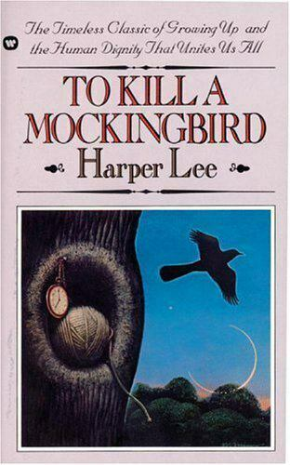
Lee, Harper. To Kill a Mockingbird. New York: Harper Perennial Modern Classics, 2006.
To Kill a Mockingbird was one of my favorite novels introduced to me during high school. This story is about a young girl named Scout Finch that lives with her brother and widowed father. This novel is set during the Great Depression and the little town of Maycomb, Alabama that this family resides in is currently suffering greatly. Luckily, Atticus, the children’s father, is a very prominent lawyer and their family is financially secure, especially in comparison to the rest of their community. Atticus confronts the judicial system and their racist tendencies from the Depression-Era and its many other incidents like this that force Scout to confront her genuine beliefs and distinguish good versus evil.
Scout and her brother, Jem, are transformed as they transition away from their childhood innocence and learn some of the true natures that the world offers. This novel also emphasizes the existence of societal inequalities, general racism and prejudices, and the importance behind understanding human morality. Scout does not attend typical public school prior to the novel but expresses how she has learned the same information except algebra. This simple note expresses Atticus’s education for his children revolves around the information that will help them become the most productive and beneficial members to society, instead of memorizing information they may never use again. This story realistically dictates the unfortunate transition out of your childhood where you learn the worlds true colors.
10. All the Bright Places by Jennifer Niven
– I have not read this novel. –
“All the Bright Places: Plot Overview.” Sparknotes, SparkNotes, https://www.sparknotes.com/lit/all-the-bright-places/summary/.
Niven, Jennifer. All the Bright Places. Random House Children’s Books, 2020.
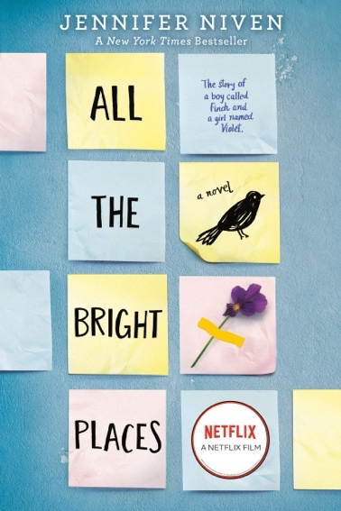
All the Bright Places is the combination between the first-person narratives of Theodore Finch and Violet Markey as the two’s “unlikely friendship and love” saves them after a devastating loss. This story begins with Theodore (also known as Finch within the story) and Violet six stories up at the very top of the Bartlett High School bell tower where Finch is contemplating suicide. Violet is able to convince him to step down from the ledge as some of the students below are urging for him to jump. Finch is fascinated by death and is constantly thinking of different possible ways to die, but every single time there is something (no matter how small) that stops him. Through the couple’s adventures leading up to Theodore death, Violet is able to learn how to live.
This novel focuses on themes revolving the stigma behind mental health and suicide, highlighting the importance of community and support, and determining your own individuality and identity. Finch cycles through different phases for how he expresses his physical appearance, going from ideas such as “80s Finch,” “Badass Finch,” or even “Dirtbag Finch,” shows readers greater versions of relatability and the difficulties one can face while trying to “fit in.” I believe this novel is important for young adults because in the end, Finch loses his battle with depression and amplifies on of the more common side effects from mental health being suicide.

