Taylor von Kugelgen
Dr. Warner
Engl 112B
28 November 2017

Diversity in Graphic Novels
Working at a bookstore, I have become very familiar with the kind of books that are written for and marketed to children and teenagers. Much of it is the same, following trends and conventions to guarantee sales. Some of it is new and exciting and original. With the popularity of superhero movies and increasing number of independent comic presses, more graphic novels are hitting the shelves, providing a fresh and creative medium for stories that teach, entertain, and affect. No longer does the word “comic” refer only to superhero adventures or newspaper strips; artists and writers are creating nuanced, emotionally rich, and diverse stories in a visual way. While compiling a list of my favorite young adult and middle grade graphic novels, I discovered two surprising characteristics: all the titles on my list have been published within the past five years, and their authors all belong to one minority group or another. These are stories told by people who have historically been excluded from telling stories in English-speaking societies. And so, I have chosen to focus on graphic novels written by marginalized authors. Some are women, some are people of color, some belong to the LGBTQ+ community, and some believe in religions other than Christianity.
It is important to have diversity in literature, especially young adult literature. Adolescents learn about the world through television, books, and the internet, so the kinds of stories that they encounter can greatly impact their understanding and empathy. However, it is not just a matter of making sure that there are diverse characters on the page; there should be diversity among the people telling the stories. To encourage diverse voices in literature is to encourage diverse stories, and the comics industry is at the forefront. In many of the works I have chosen, the authors have included characters and experiences that reflect their own identities with an air of authenticity and sincerity. All of them share a wider perspective on growing up and adolescence. Adolescents can benefit from that wider perspective and its complex, thoughtful approach to many real-life issues with the added accessibility and emotional intelligence of a visual medium.

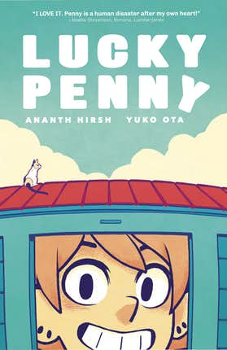
https://www.cbr.com/lucky-penny/
Hirsh, Ananth, and Yuko Ota. Lucky Penny. Oni Press, 2016.
Realistic Fiction, Humor, Slice-of-Life, Coming-of-Age.
After losing her job and her apartment, Penny finds herself homeless, jobless, and as unlucky as ever. But when she moves into her friend’s storage unit, gets hired by the world’s surliest eleven-year-old laundromat manager, and meets the guy of her dreams, it looks like her luck might change.
Penny deals with many issues of newfound independence: poverty, vulnerability, and isolation. Though she meets her challenges with perseverance and casual determination, she struggles with lack of life security, loneliness, and the consequences of an impulsive, immature personality. She perseveres, however, and is finally able to find a place for herself – a resolution that many young adults struggling to find their footing will appreciate.

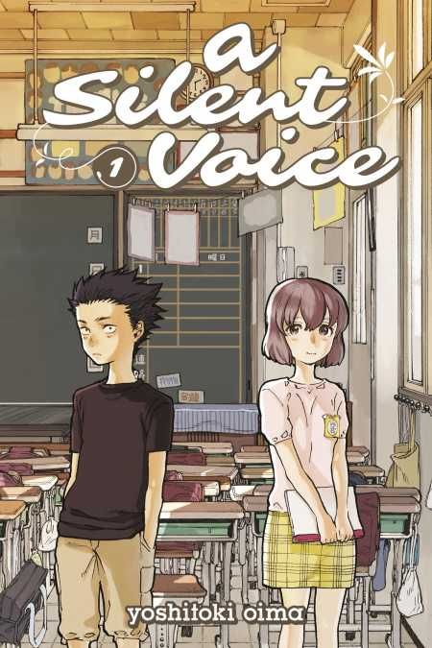
https://kodanshacomics.com/volume/a-silent-voice-1/
Oima, Yoshitoki. A Silent Voice, vol. 1. Kodansha Comics, 2015.
Realistic Fiction, Slice-of-Life, Drama, Translated.
In elementary school, Shoya bullied his deaf classmate Shoko so mercilessly that she transferred to a new school. Now a high school student, Shoya finds himself depressed and isolated. When he encounters Shoko again one day, he realizes the consequences of his past actions, and sets out to repair the lives that he hurt.
A Silent Voice is a story about social and emotional isolation and ostracization and tackles a variety of issues such as bullying, prejudice, racism, and suicide. Japanese society is often described by the idiom “the nail that sticks out gets hammered down,” and here a number of characters are “hammered down”: Shoko is bullied for her deafness, Shoya’s niece is discriminated against for being mixed race, among others. It is not easy or gentle, but together they learn how to move past societal prejudice and find the courage to heal.

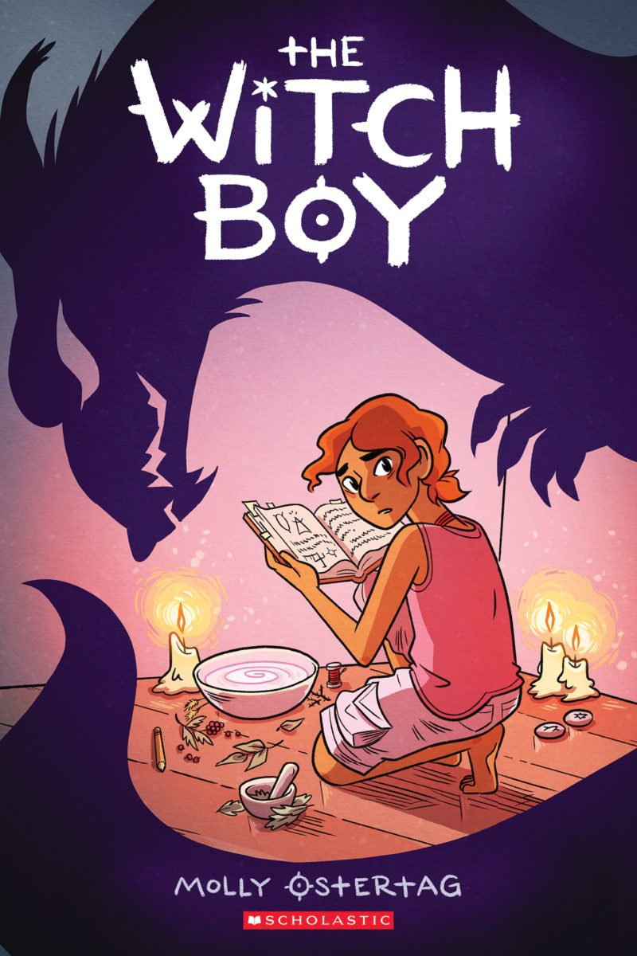
https://www.scholastic.com/teachers/books/the-witch-boy-by-molly-ostertag/
Ostertag, Molly Knox. The Witch Boy. Graphix, 2017.
Fantasy, Coming-of-Age.
In Aster’s family, girls become witches and boys become shapeshifters, and anyone who attempts to cross those lines is exiled. At thirteen, Aster has yet to learn how to shapeshift, and finds himself increasingly drawn to witchcraft. When the boys in his family begin to disappear, he knows he is the one to save them — but only as a witch.
A middle grade work, The Witch Boy is a simple story about accepting the truth of one’s self despite social and familial pressures, but it is a clear metaphor for coming out as gay or transgender. The final scene, when Aster is accepted as a witch with a loving embrace from his mother, is a positive depiction of coming out, one that is important for LGBTQ teenagers to encounter in literature. Other young people can benefit from the easy-to-understand analogy as well.

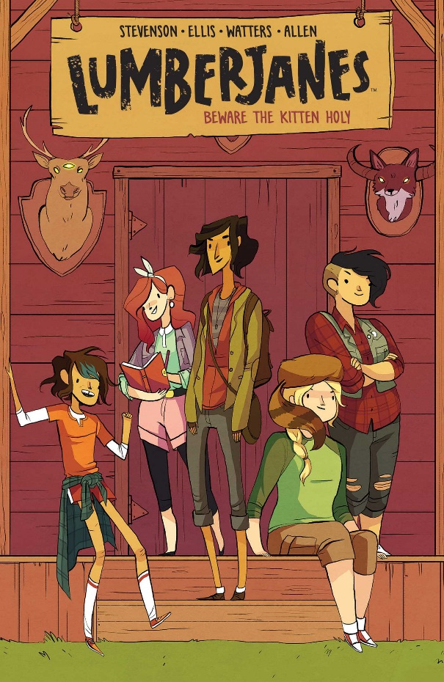
http://www.simonandschuster.com/books/Lumberjanes-Vol-1/Noelle-Stevenson/Lumberjanes/9781608866878
Stevenson, Noelle, et al. Lumberjanes Vol. 1: Beware the Kitten Holy. BOOM! Box, 2015.
Fantasy, Humor, Adventure.
At Miss Qiunzella Thiskwin Penniquiqul Thistle Crumpet's Camp for Hardcore Lady Types, five scouts sneak from their cabin at night and are attacked by a pack of three-eyed foxes. So begins their supernatural adventures as they attempt to solve the mysteries surrounding the camp — and maybe earn some badges in the process.
What begins as a supernatural romp quickly turns into a celebration of girls of all kinds. References to notable female figures are peppered throughout as scout badges or exclamations, and the strictly female cast members can explore their femininity safely and without judgment or expectations. Make-up, athleticism, intelligence, and bravery all coexist naturally, and the inclusion of a chaste same-sex romance as well as a transgender character, provide representation that fantasy-adventure stories often lack.

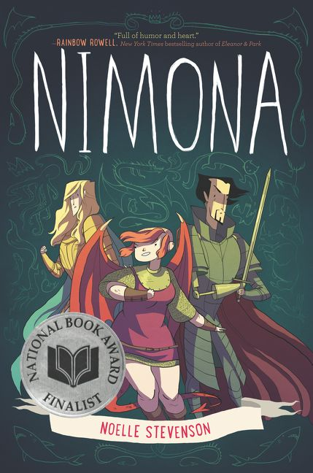
https://www.harpercollins.com/9780062278234/nimona
Stevenson, Noelle. Nimona. HarperTeen, 2015.
Fantasy, Adventure, Science Fiction.
Supervillain Lord Ballister Blackheart doesn’t really want a sidekick, he just wants to focus on bringing down his nemesis, Sir Ambrosius Goldenloin, and the rest of the Institution of Law Enforcement and Heroics. But when the dynamic shapeshifter Nimona announces herself his sidekick, his plans get a little more chaotic and explosive than he bargained for… and darker than he ever expected.
Though Nimona begins as a comedic play on sci-fi/fantasy tropes, it quickly turns into a complex look into the difference between “good” and “evil.” Blackheart is not the villain that he claims to be, nor is the Institution a beacon of hope and goodness, and as lines blur, characters must make important choices about goodness, sacrifice, and forgiveness. Stevenson’s own struggles with depression manifest in Nimona’s self-destructiveness, resulting in a raw emotional journey that many young adults can understand.

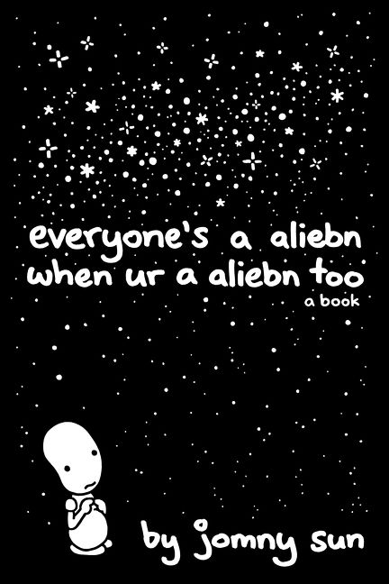
https://www.harpercollins.com/9780062569028/everyones-a-aliebn-when-ur-a-aliebn-too
Sun, Jomny. everyone’s a aliebn when ur a aliebn too. HarperPerennial, 2017.
Humor.
An alien arrives on Earth to learn what it is to be human. Over the years, he studies a number of creatures ranging from bees and yetis and trees and rocks to nothingness itself, and listens to what they have to say about life, love, the good things, and the bad.
Sun got his start on Twitter.com and so everyone’s an aliebn reads like a series of tweets: words are intentionally misspelled, grammar is taken lightly, and the narrative is little more than a series of vignettes connected by the “aliebn” protagonist. It is an instance of comics-meet-poetry, a celebration of life and loneliness and all of the feelings and emotions that make us human. Adolescents are learning to look at the world in new, more complex ways, and Sun’s work is a perfect exercise in humanity.

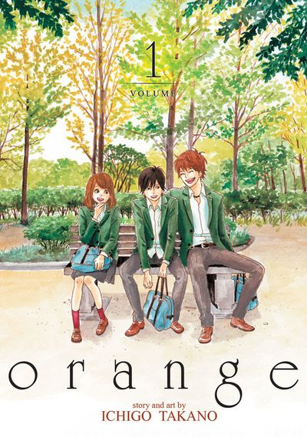
https://global.bookwalker.jp/deac66a393-ee41-4492-9de0-70a491c16de2/
Takano, Ichigo. Orange: The Complete Collection 1. Seven Seas Entertainment, LLC, 2016.
Realistic Fiction, Drama, Romance, Translated.
When sixteen-year-old Naho receives a letter from herself ten years in the future, she thinks it’s all an elaborate prank. But her best friends have received letters from their adult selves as well, letters saying the same thing: make different decisions, or the new transfer student will die.
Orange explores consequence and choice in a very personal and relatable way for teenage readers. Naho is kind but shy, and though it initially seems that a lack of assertiveness would only hinder herself, she discovers that her timidity has greater ramifications that she could ever know. Many young adults will sympathize with her journey to find love and self-confidence. It also deals with more intense issues such as suicide and depression.

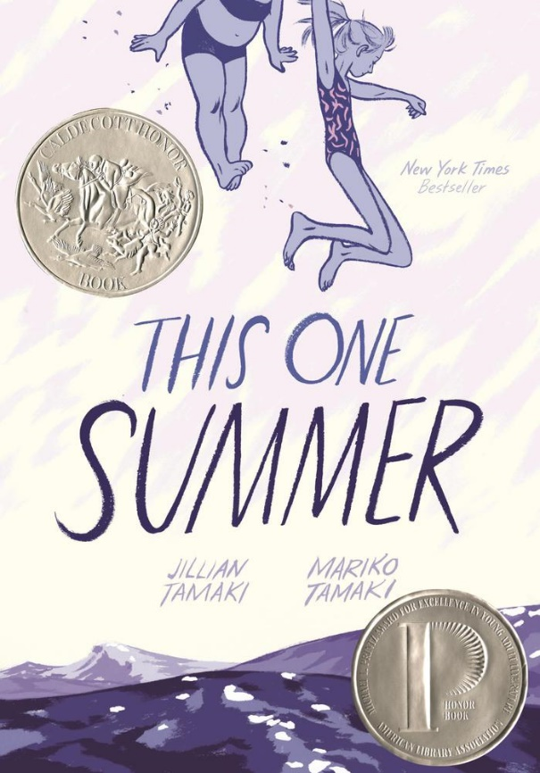
https://us.macmillan.com/thisonesummer/jilliantamaki/9781596437746/
Tamaki, Jillian, and Mariko Tamaki. This One Summer. First Second, 2014.
Realistic Fiction, Drama, Coming-of-Age.
Rose has been coming to her family’s vacation home in Awago every summer for as long as she can remember, and so has her summer friend, Windy. But this one summer is different, her friendship with Windy is changing, and she finds herself noticing things about Awago itself that she has never noticed before.
Rose is still a preteen, but she is on the cusp of adolescence and finds herself entranced by the social drama arising between the older teenage residents of Awago. It is a perfect representation of the transition from child to teenager, as her worldview broadens and she catches a glimpse of some of the harsh realities of adolescence. Interspersed in Rose’s own coming-of-age story are the more mature struggles of the teenagers and adults around her. Tamaki and Tamaki tackle issues like teenage pregnancy, miscarriage, depression, and sexuality, all through the eyes of their young protagonist as she explores the world of adulthood for the first time.

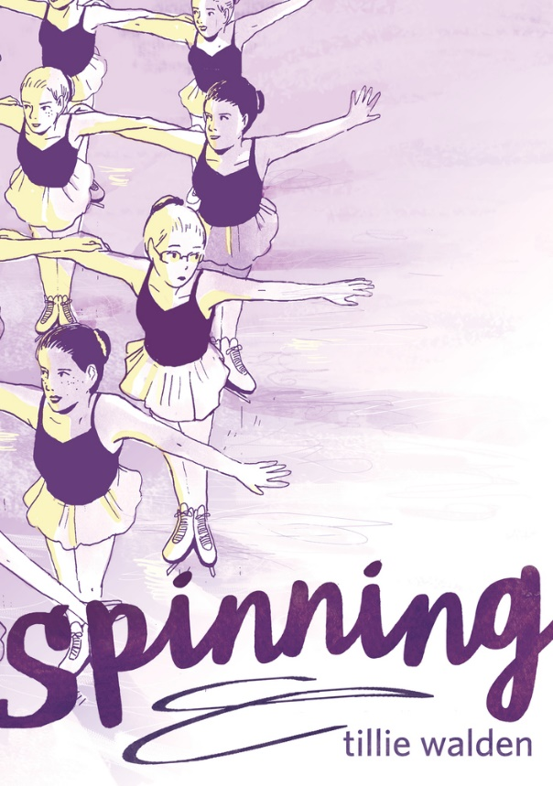
https://us.macmillan.com/spinning/tilliewalden/9781626729407/
Walden, Tillie. Spinning. First Second, 2017.
Memoir, Non-fiction, Coming-of-Age.
When Tillie’s family moves to Texas, she not only has to adjust to a new town and a new school, but a new competitive ice skating team as well. As she gets older, she forges new friendships and discovers first love, but also must deal with harassment and assault, and struggles with the sport that has dominated her life for as long as she can remember.
Walden looks back on her years as figure skater, from childhood to the cusp of adulthood. Her life revolves around skating, and with it comes a variety of trials and issues: abusive coaches, bullies, cliquish teammates. As she gets older, skating gradually becomes more and more of a negative influence on her life. It is also a story of her coming out experience as a gay teenager in a conservative part of the country.

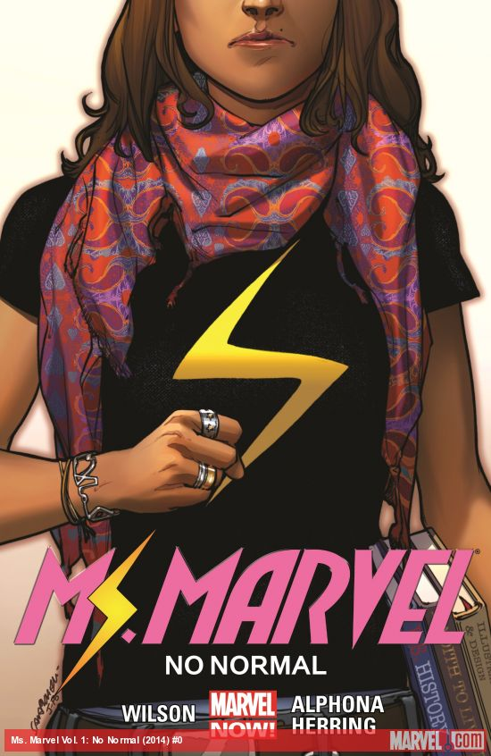
http://marvel.com/comics/collection/48987/ms_marvel_vol_1_no_normal_trade_paperback
Wilson, G. Willow, and Adrian Alphona. Ms. Marvel, Vol. 1: No Normal. Marvel, 2014.
Superheroes, Action.
Jersey City teenager Kamala Khan finds herself the next Ms. Marvel, but she doesn’t want to be the same old blonde superhero that everyone knows and loves. As she struggles to master her new superpowers, she also must learn how to reconcile her new superhero role with her identity as a Pakistani-American teenager.
Though Ms. Marvel is a superhero comic, it focuses more on Kamala Khan than her new identity as the eponymous Ms. Marvel. Rather than struggling to overcome some powerful supervillain, her primary struggles in this first volume are deeply personal. She must balance her new body-morphing powers with her desire to retain an individual identity; she explores her newfound freedom and priorities while also respecting her religion and responsibility to her family. She is an ordinary teenager and so her problems reflect those that many teenagers today face: rebellion, self-image, family relationships, and the consequences of increased independence. At the beginning, Kamala wishes to be like her hero, Captain Marvel, but when her wish comes true, she quickly realizes that there is more to like about Kamala Khan than she expected. Writer Wilson is Muslim herself, and she represents a warm, supportive Muslim family – an image that is, sadly, largely absent in today’s media.

