Miguel Lomeli
Dr. Warner
ENGL 112 B
1 May 2018
Gemini: The American Dream
Growing up, I never had any pieces of literature that told the story from a similar point of view as mine. The Harry Potter series was booming but it still was a miss and anything we did read of minority literature had the characters experiencing problems elsewhere in the world. Themes of drugs, gangs and alcohol were missing along with the idea of double consciousness where one has one foot in one society and another in their culture. Many teachers that teach in the east side of San Jose are only doing so to pay off their teach grant it seems as the staff constantly evolves and teaching jobs are always popping up. However, when I began teaching these “lost causes” at an after-school program, I already knew what had to be done to make the connection for these future success stories to keep on reading.
In chapter one of Literature For Today’s Young Adults, by Alleen Pace Nilsen and Kenneth L. Donelson, the main focus of characteristics for honor books lies on the relatability to young readers. If they are willing to keep turning the pages voluntarily, then the job of the author is met. Every part of town is going to be different from an economic status that often links to ethnicity, which then leads to lack of resources in impoverished areas that then leads to a lack of excitement towards education and reading. When the same language is used in books that talk about a similar struggle while educating the youth of that particular characters past, present and future. Then a beautiful site occurs of that child continuing to read and want more of it. Within my sister’s friends I saw the change of attitude for reading. From hating life because they had to do book reports to wanting to research and dive into the world of literature all because of an author named Sherman Alexie all in a two-year span. The Absolute Diary of A Part Time Indian by Alexie was their gateway book. Having all the characteristics of an honor book, from language to the absence of parents and dealing with adversity and identity in a discriminating world, this book had these kids feeling all the emotions and excitement to talk about the literature the next day. Something I wish I had during my years of schooling and something that is still lacking in most of these schools.
The reason being for my choosing of the canonical piece, The Great Gatsby by F. Scott Fitzgerald, is mostly due to having most canonical pieces of literature in high school are the old dead white guys. Completely unrelatable to the youth in my area at first glance. However, I have come to dissect the novel numerous times to extract the themes to relate to the young adult emotions and at the same time compare it to the reality of their dreams and ambitions. Comparing the American dream and questioning the privilege Gatsby has in obtaining it towards the other pieces of minority literature we will see and read.
The future is brighter for these kids when they have a hand raised in the air during discussion on the next day of class. My goal is to do what I can to spark that fire to help them succeed and ask the questions that challenge or compliment the text. Too many times have I seen friends and family members drop those hands and eventually drop out. Join the falsely advertised quick way to get rich which leads them locked up or dead. I am one of four from our original twelve-member team who is still alive. I don’t want anymore statistics, I want change.

Opening the Unit

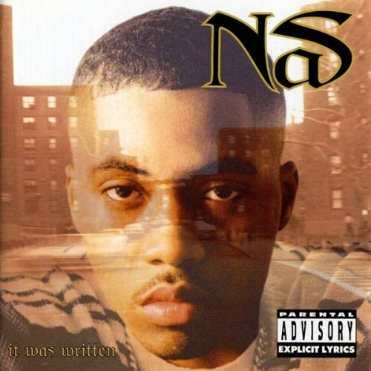
I would introduce the unit with the use of songs as poetry that would gain the students attention and set the tone of dreams and aspirations. Opening with “XO TOUR Lif3 Remix” by LiL Uzi Vert featuring 2pac and having students guess what 2pac was saying about not going to sleep. Then transfer to “Wrote My Way Out” by Nas, Dave East, Lin-Manuel Miranda and Aloe Blacc and allow students to lead discussion on what the message of this song is. Finally ending with “I Can” by Nas and the poem “The Rose That Grew From Concrete” by Tupac Shakur. A note of positivity but still highlighting the facts of possibilities to pursue. The main topic I would discuss is the power of reading that is held over these artists. All these lyrics were crafted by influence from other authors and dissected into a lyric that relates to their situations within their neighborhoods or self.
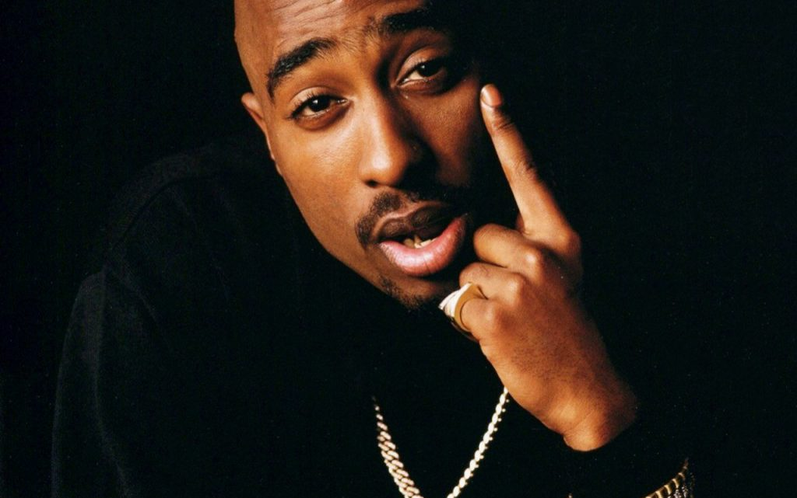
The lyrics within these songs and poems are not only powerful and positive, they are also what most of the kids from impoverished areas hear daily. Hearing it in class will finally allow them to begin listening to the music. “The Rose That Grew From Concrete” by Tupac has already so much imagery and meaning behind it. One can envision the struggle for a rose to grow from such a place. One would marvel at the idea of a rose growing from such circumstances, however when compared to the poor hood kids, the same feeling isn’t felt. Once ideas begin flowing on the themes of poverty and perseverance with the American dream, then the transition to the main text would be made.
Main Text
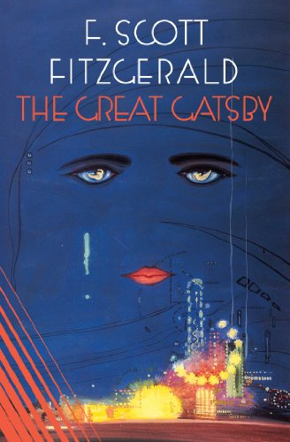

Starting the main text, I plan on having each student keep a daily journal. The opening journal passage for them to write on would be about their dreams and aspirations along with a question. How hard does achieving their dream seem to be and what obstacles are in their way? Continuing every day, students would begin class by writing in their journal on topics about the main novel or their read at home novel. How does the read at home novel compare with the in class? How do they relate to your own life? Etc.…
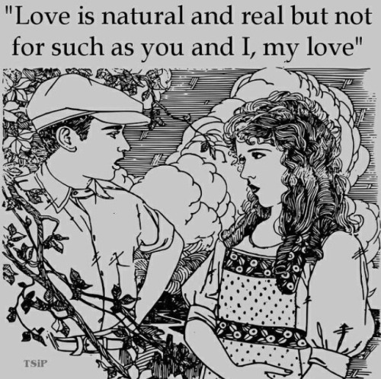
Topics of SSW would also include lists of 5 pertaining to characters in the in-class novel and/or with their out of class text. While reading, I will continuously incorporate music to relate to the themes of the story. Such as “I know It’s Over” by The Smiths, especially towards end of the novel where Gatsby gets rejected by Daisy or when Myrtle’s life comes to an end. The whole idea of love and what true love is and what it means to be in love. A linking theme to the modern day adolescent because this is a time where feelings of love begin to emerge. Scenes in the novel when characters are all together would incorporate a type of theater reading to engage in the text.
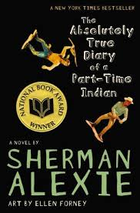
The assignment for this novel would be to transfer the overall summary of the novel, incorporating characters dreams and ambitions along with themes that stick out and incorporate it into a rap or thug note-esque video. If students do not wish to choose this option, they can also make a “true” trailer of what the book is about in groups with a write up portion detailing what themes, dreams, and scenes they wanted to capture from the novel. The final option for neither of the two above would be just a standard essay comparing The Great Gatsby to the outside of class novel which in my case would be The Absolute True Diary of a Part Time Indian by Sherman Alexie. A book that has all the qualities of an honor book and is overall fun to read for a student who would mainly get the original, plain and overly dense sentences from authors who are dead white dudes.

Linking Texts
The other comparison towards the novel would be to do a comparison piece with the film adaptation of the play written by Luis Valdez titled, Zoot Suit. Valdez illustrates the discrimination Latinos face and offers a view into their life during World War I. The theme of hardships and racial discrimination tie into Alexie and give view point in the other side of the American dream. Dreams and ambitions of just wearing a piece of clothing without being associated or linked to hoodlum. Many relevant to today’s news and media on how cops are targeting the minorities based in articles of clothing as they did back in the 20’s. Generational and systematical as well to take into consideration for some silent sustained writing or comparing to the life of Alexie's character and to Gatsby who comes back from the same war.
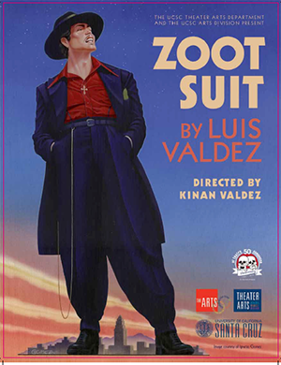

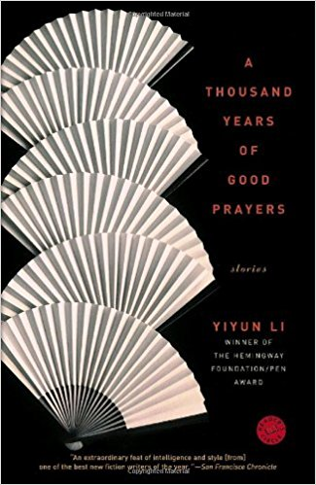

A Thousand Years of Good Prayer by Yiyun Li
A collection of short stories from a Chinese American child who has trouble knowing who she is in this world and if she belongs. Not knowing what to do, she digs deep into her roots and uncovers her background and embrace’s her ethnicity to understand the struggles of her immigrant family. The troubles and hardship of discrimination along with the little money and opportunities her family has been given by this Government are what Sparks her Li's renaissance of discovering herself. The hammer of discrimination hits all nails of ethnicity except the one with the white head. While the hammer swings maliciously, she is the fierce warrior that pushes herself out of the hole.
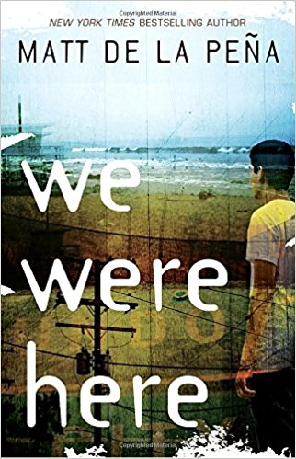
We Were Here by Matt De La Pena
A solid third option to have read outside of the class that brings three different ethnic backgrounds in similar situations coming together. Discussing dreams and ambitions yet acknowledging the obstacles that come into play with obtaining that goal. The struggle and extraordinary circumstances Rondell, Mong and Miguel face is drastic change of scenery from Gatsby as well as the other two texts mentioned. Teenagers trying to find their place in the world if the world would give them such a chance.

Media
“Thug Notes” by Wisecrack
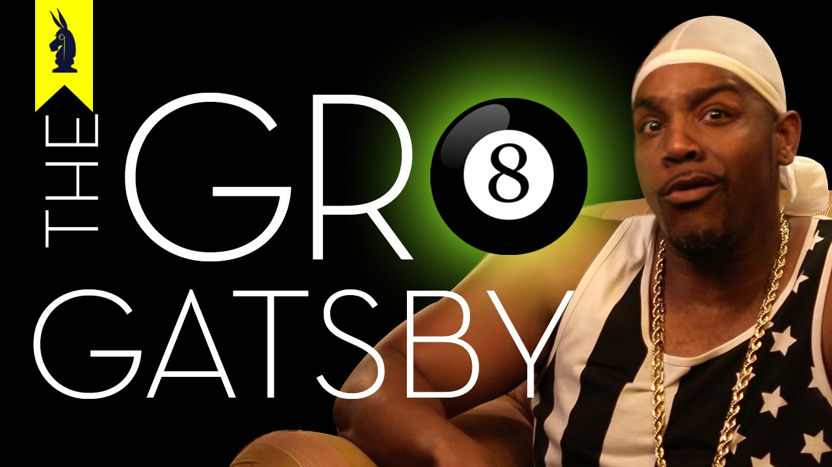
The inspiration behind one of the one of the choices for my assignment. Here, the youtuber reads the novels and does a summary and analysis of the characters in a “hood” style. Merging the two worlds into one while having fun and providing the viewer knowledge of the literature with street terminology. A great way to inspire the students and keep them focused on the assignment, getting them to think outside the box for an understanding, rather than the usual essay check.

“Zoot Suit” by Luis Valdez
The film adaptation of the play written by Valdez is a wonderful companion piece to Gatsby. Highlighting the opposite of what goes on in the other side of the world, meaning the ethnic spectrum. Where Gatsby focus’ on the white privilege aspects, this film shows the minorities point of view of how they were treated for wearing clothes. Could very well be link to modern day topics such as the black hooded sweater with hood up attire that was the reasoning for someone to shoot a Black male boy.

“Stand and Deliver” Directed by Ramon Menendez
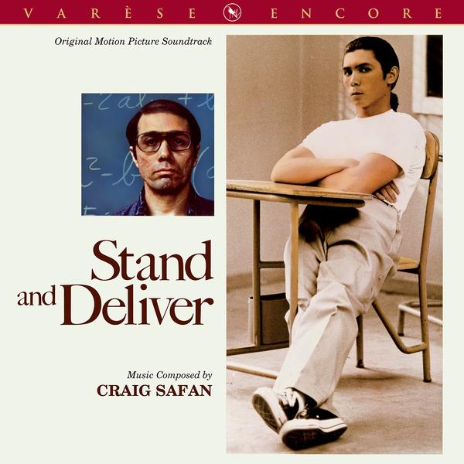
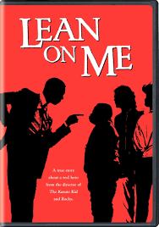
“Lean on Me” Directed by John G. Avildsen

“Freedom Writers” Directed by Richard LaGravenese
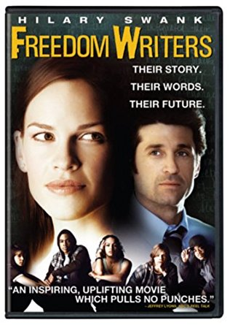
“Coach Carter” Directed by Thomas Carter
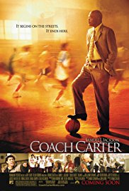
All these films have the same underlying meaning of at risk teens seeing no hope for them. They have no one who believes in them and no one who can give them guidance. All it takes is one professor to change that attitude and structured way of thinking in order to inspire one to fill in the steps to make their dreams become a reality.
Questions to think about for students:
What do you notice about the schools/setting/environment surrounding the kids?
Do you see this in your community?
How does it relate to Alexie, Li, De La Pena, and Valdez?
Can you compare it to these text?
How do these films relate to Gatsby?
How do they relate to the poems?
How do they relate to the Songs?

Poems/Music
“The Headmaster’s Ritual” by The Smiths
Shows the effects of bullying by portraying how the bully can be manifested into a variety of different things. From another student to a teacher or principal to even an ailing sickness not wanting to let the individual grow and flourish. Bullying is the topic of the song and shows the listener how this way of life restricts the person to be their best. Giving them a negative view on life and lowering their self-esteem, leaving them with no confidence and nothing to live for. Fueling the depression that was once a small problem to grow into an abyss. Topics relatable for teens and how many of the minority writers and characters felt in their respected novels.

“If I Ruled the World” by Nas and Lauryn Hill
A song that includes how one person’s wishes would be in order to free their people of the white dominant society we live in. Balancing the scale of who holds the power and mistreatment of those who have color in their skin.

“Changes” by 2Pac and Talent
A beautiful harmonious tune highlighting the negatives of this government and world. Discussing how we need to remain focus as one, as humans and yet we fail to recognize that we need to heal and love each other. “Instead of a war on poverty, they got a war on drugs so the police can bother me.” The pain and suffering of those outside the realm of Gatsby has says a lot more than problems of will she ever leave him for me?

“Dreams” & “Let America Be America Again” by Langston Hughes
Two beautiful poems showing the idea of the American dream being only to one side however one must still have a dream. The importance of holding onto one’s dream is what keeps one going in life. Uplifting and relevant not only to the texts but of todays time as well.

These poems and songs are what really hits the youth. Sometimes the old, dead white guy is not relatable and a voice coming from the same streets or circumstances is what inspires the youth. They hear the songs being played, and like the beat but the adolescents are slowly starting to listen to the lyrics. When you get a powerful message behind a catchy tune, then a lightbulb begins to flicker and the spark has been ignited. The concept of poetry is bizarre and odd and boring to many young adults and adults beginning many generations ago. However, when introduced to a new light and cared for in order to relate the importance, it can be what catches the eye. Gang violence and activity are what are high concerns for at risk teens, sometime cops and people of higher status and privilege never give the light of day to someone from the ebad parts of town. These poems and words tell the story of those that came through and she’d light on their dreams for their future, with guidance and support that pushes their mind to good use.

Works Cited
“Nas.” Nas [New York, New York, New York], 2001.
Alexie, Sherman. The Absolutely True Diary of a Part-Time Indian. Cornelsen, 2011.
Carter, Thomas, director. “Coach Carter”.
Fitzgerald, F.Scott. The Great Gatsby. Penguin Books, 1950.
Erin Gruwell. “Freedom Writers”. 2007
Hughes, Langston, et al. Selected Letters of Langston Hughes. Alfred A. Knopf, 2015.
Michael Schiffer. “Lean On Me.” Performance by Morgan Freeman.
Li, Yiyun. A THOUSAND YEARS OF GOOD PRAYERS. Magnolia Pictures, 2008.
Tupac Shakur. “Lil Uzi Vert Remix.” XO TOUR LIF3 Remix [Los Angeles, CA], 2017.
Peña Matt de la. We Were Here. Ember, 2011.
Shakur, Tupac. The Rose That Grew from Concrete. MTV Books, 2009.
Morrissey. “Speedway, The Headmaster's Ritual, I Know It's Over.” Louder than Bombs, Best of Morrissey [Manchester, England], BBC, 1986. “Stand and Deliver.”
Valdez, Luis. Zoot Suit. American Theatre Press, 1979.
Thugnotes. “Wisecrack.” YouTube, YouTube, www.youtube.com/user/thugnotes.
Valdez, Luis. “Zoot Suit”. 1981.

