
The Global Leadership Advancement Center and Leadership Forum for Social Innovation present:

Solution Discovery Series: Is Education the

Great Equalizer in Silicon Valley?

Global diversity, ethnicity, language, education, income, citizenship, and family support affect the level of education attainable by children in in our communities.
What can we do to close the achievement gap?
Join members of the Silicon Valley public and private sector communities to hear distinguished educators Dr. Jeffrey Ashe and Manny Barbara discuss the challenges – and benefits – of making education opportunity and equity possible on a large scale.
Following the presentations, the speakers will lead a workshop-style discussion with attendees focused on identifying innovative, yet achievable cross-sector solutions aimed to balance and align educational opportunities in Silicon Valley. One key discussion topic is financial inclusion. Savings Circles help parents save for college and set expectations for their children. What other ways can mini-financial institutions help increase economic securities? Come share your thoughts and experience!

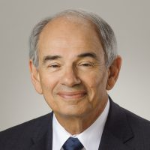
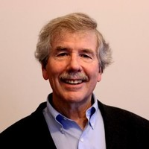
Speakers

Jeffrey Ashe
Professor of International and Public Affairs, Columbia University, NY

Dr. Ashe is a frequent presenter for the Sustainable Microenterprise and Development Program and helped produce the Arusha Savings Groups Summit, the first global gathering of Savings Groups practitioners in 2011. He led Saving for Change at Oxfam America, which now has 600,000 savings group members in Mali, Senegal, Cambodia, El Salvador, and Guatemala. Dr. Ashe has consulted to microfinance projects in more than 30 countries. He authored the book, “In Their Own Hands: How Savings Groups are Revolutionizing Development”.
Manny Barbara
SCC Office of Education Advisory Board Member, VP, Silicon Valley Education Foundation
Mr. Barbara is VP of Advocacy and Thought Leadership at the ALearn Silicon Valley Education Foundation. Until his retirement in 2009, he served in various leadership roles for 36 years in the Oak Grove School District, including 10 years as Superintendent. During his tenure he received the Hank Hutchins Award from the Santa Clara County of School Black Educators, was selected four times as the Administrator of the Year by ACSA Region 8, and was honored as Educator of the Year by 100 Black Men of Santa Clara County in 2008.

Wednesday, October 3, 2018 - 8:30 - 11:30 am
$25 registration fee includes continental breakfast
San Jose State University’s - Lucas Business Complex
2933 Bunker Hill Lane, Suite 120 | Santa Clara, CA
Seats are limited and tickets must be purchased online prior to the event. To view the agenda and purchase tickets, please go the registration website. If you are unable to attend but would like to make a donation to support the Leadership Forum, please go to the donation website.

