SJSU HRI
Pitch Paragraph and Project Summary
2019-20 AY
Last Edited: 12/04/19

--------------------

SJSU HRI Pitch Paragraph:

Whether to address climate change, the housing crisis, immigrant or refugee rights, criminal justice reform, or racism and white nationalism, the San José State University Human Rights Institute [SJSU HRI] provides research, policy design, and reporting necessary to confront our most pressing collective challenges. Institute faculty include award winning authors, educators, and journalists who partner with one of the most diverse student bodies in the country and some of the most impressive organizations in the region to inform policy and practice according to international human rights law, standards, and scholarship. Every contribution to the SJSU HRI—anonymously or to leave a deliberate legacy—is a sound investment in this desperately needed work and in distinguishing SJSU as a center for world class human rights scholarship.

--------------------

RECENT ACHIEVEMENTS AND PRODUCTS (not exhaustive)

Reforming California and Federal Law to Meet International Human Rights Standards on Police Use of Deadly force: CA AB 392 and the PEACE Act.

The faculty and students of the SJSU HRI are working hard to address the nearly 1000 fatal police shootings a year in the U.S.—the highest rate in the developed world. This police violence is targeted overwhelmingly at people of color, the poor and dispossessed, LGBTQ populations, and those struggling with mental illness. Though this work continues, the HRI collaborated with community organizations and policy makers to establish significant policy solutions at the state and federal level.

- Institute faculty and students participated in the statewide coalition to draft and successfully pass CA AB 392, the California Act to Save Lives.* AB 392 brings CA police use of deadly force standards in line with international law and standards that prioritize the human (and Constitutional) rights to life and due process. Specifically, the HRI provided documentation and information on international standards on police use of deadly force. As a result, California now has one of the strictest use of force standards in the country (along with Washington state).

*Signed into law on 08/19/19.

See an article documenting some of this work from the HRI Director:

Armaline, W. T. (02/26/19). Challenging lethal policing in California. The North

Star. Retrieved on 02/26/19 from: https://thenorthstar.com/articles/challenging-lethal-policing-in-california.

- Institute faculty then worked with Congressman Ro Khanna to research and help to draft the PEACE Act, a bill that brings the law defining police use of force in line with international standards for all federal law enforcement and provides necessary incentives for states to revise their laws in kind. The PEACE Act represents an enormous opportunity to scale policy reform up to the federal level and bring this reform to other states. Please see the SJSU HRI Director and many other policy experts quoted in the press release of the bill here: https://khanna.house.gov/media/press-releases/release-reps-khanna-clay-announce-landmark-police-brutality-bill-raise.

Improving the Human Rights of Immigrants and Migrant Workers: Ending the 50-Mile Rule

Immigrant, migrant worker, and refugee rights have long been an area of expertise for Institute faculty and Human Rights Minor Program students. In addition to working for 2.5 years with the DALE Coalition in Santa Clara County to provide DACA/DAPA assistance to thousands of families in need, Institute faculty and students organized with Human Agenda and other partners to make sure the thousands of migrant children in the state have access to public education.

- After many years of organizing with Human Agenda and other partners, the California legislature effectively ended the “50-mile rule” that prevented many children of migrant workers from attending public schools without constant interruption.

Informing the Transition from Criminal Prohibition to a Regulated Market: Cannabis Equity Programs and Cannabis Record Clearance

The Institute Director and other HR Working Group faculty provided policy reporting to the City and County of San Francisco on racism and the war on drugs in partnership with California Criminal and Juvenile Justice [CJCJ] since 2009. On the reputation of this work, when cannabis legalization passed in 2016, Institute faculty and students were asked by City Councils and State government (Sacramento) to help inform California’s transition from failed cannabis prohibition to legal, regulated sale. Institute faculty then worked with policy makers and industry professionals around the state to design “Cannabis Equity Programs” (diverting opportunity and revenues from the recreational market to heal communities harmed by the failed drug war) and push for universal cannabis record clearance for all qualified charges under the Adult Use of Marijuana Act [AUMA].

- Institute faculty consulted on the Equity Program Ordinance in San Francisco, Statewide policy in Sacramento, and authored the San Jose Cannabis Equity Assistance Program Ordinance (01/10/19). Phase II of this program will be considered, along with permanent funding options, in the February (mid-fiscal year) city budget revisions. Institute faculty, Students Against Mass Incarceration [SAMI], and the San Jose Cannabis Equity Working Group [SJCEWG] continue their work to achieve universal, automatic cannabis record clearance in Santa Clara County as announced in San Francisco and Los Angeles Counties.

New Report: Analysis of Policing Data in Wethersfield, CT (2013-18)

- This new report reveals significant racial disparities in policing and support for the hypothesis that local police target Black and Latinx non-residents for stops and citations. The report was commissioned pro bono by the Community Party (Hartford, CT), and was completed in partnership with Silicon Valley DeBug.

Student UPR Reports, Fall 2019

- On 12/04/19 student groups from the Human Rights Minor Program (JS 179 and 171) presented their human rights reporting projects presented as local shadow reports for the international UPR process. This was our “beta testing” event for what will become a regular process that will later include actual submission to the civil society review process for the U.S. The event, held in partnership with MOSAIC, was well attended and featured presentations on topics including CEDAW/women’s rights, homelessness, and undocumented immigrant rights.

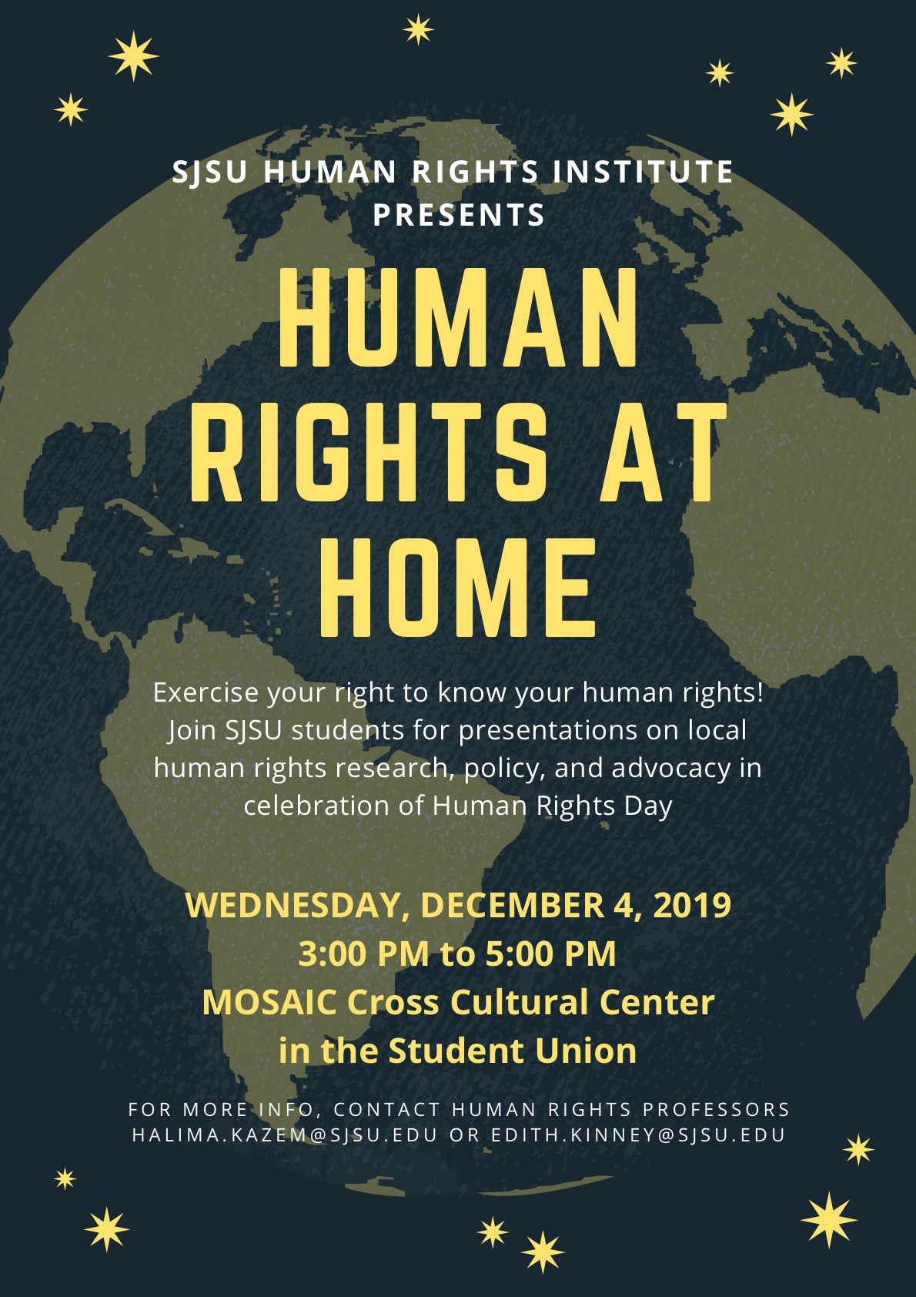

SAMPLE PROJECTS FOR 2019-20 (not exhaustive)

Confronting the Rise of Right Wing Extremism and their Infiltration of Law Enforcement Agencies: The California Law Enforcement Accountability [CLEAR] Act.

Lead Contact: W. Armaline

Following countless reporting from journalists and federal agencies on the infiltration of law enforcement agencies and threat of mass terror now clearly posed by right wing extremist organizations, the SJSU HRI is aggressively pursuing meaningful policy solutions. Confronting white nationalism, fascism(s), and other forms of “right wing extremism” will be a central area of focus for HRI policy and research activity in the 2019-20 and 2020-21 AYs.

Institute faculty are working with state and federal lawmakers, relevant legal scholars, and community organizations to research and design the California Law Enforcement Accountability [CLEAR] Act policy proposal and draft bill. The CLEAR Act is designed to effectively prohibit anyone with membership in or significant affiliation with right wing extremist organizations from serving in any CA law enforcement agency. The proposal is complete and public hearings will be scheduled for 2020.

Faculty Led Program [FLP] on Human Rights Reporting: Geneva, Amsterdam, and New York City

Lead Contact: H. Kazem-Stojonovic

This summer Human Rights News Network [HRNN] Coordinator, Halima Kazem-Stojonovic will lead an FLP to the major centers of international law in Geneva (UN High Commissioner for Human Rights), Amsterdam (The Hague and International Criminal Court), and New York City (U.N.). This is one of many FLP programs designed for students to engage in national and international human rights research and reporting while producing meaningful, relevant content for dissemination through the HRNN.

Launch Event: Annual Human Rights Lecture Event (spring 2020)

Lead Contact: W. Armaline

Look out for promotional materials and a save the date notice for the official SJSU HRI launch in spring 2020. To mark the occasion, the launch will include the first Annual Human Rights Lecture Series event since 2016. The Lecture Series will feature an incredible speaker and highlight some of our most successful work. The launch event will provide the opportunity to learn about Institute projects, engage with Institute faculty/students, and invest in the Institute’s future.

Building a Re-Entry Support and Student Success Center at SJSU

Lead Contact: E. Kinney

Given the history and expertise of Institute and Minor Program Faculty in criminal justice reform and incarceration in the U.S., the SJSU HRI will work with close partners (such as the Record Clearance Project) to develop a pipeline for formerly incarcerated community members to complete their undergraduate degree at SJSU. Providing opportunity and support for the formerly incarcerated can help to reduce recidivism and associated local social problems such as homelessness. This project will come together under the leadership of Legal Action Coordinator Edith Kinney (JS), and will include two initial components:

- Develop an admission pipeline and support infrastructure at SJSU, appropriate partnered community colleges, and local county jail system (Main Jail and Elmwood).
- Develop and propose a Re-Entry Student Success Center at SJSU as is done for other at-risk student populations.

To fund this project, we are applying for State Community Reinvestment grants in partnership with the Record Clearance Project (Director: Peggy Stevenson). The reinvestment grants are funded by the state cannabis tax and are meant for organizations working in the broad area of restorative justice. Specifically, we will apply to fund an expansion of the RCP’s direct legal services and mentorship program and to fund the creation of a Re-Entry Support and Student Success Center.

Dr. Kinney is already in contact with formerly incarcerated students and will begin outreach for a student organization (as the organized engine and demonstration of need) shortly.

Cannabis Policy Reform in San José and Santa Clara County: Equity Program Phase II and Universal Cannabis Record Clearance

Lead Contact: W. Armaline

Meetings are currently underway with SJ City Council Members and city staff to design Phase II of the San José Cannabis Equity Assistance Program. Phase II will cover the opening of retail licensing in SJ (delivery and retail storefront) for equity and general applicants. Phase II will also necessarily include determining the permanent funding stream for cannabis equity assistance and incubation programs (we propose a percentage of the cannabis sales tax) and expansion of the “green zone” available for cannabis retail.

Fortunately, Drs. Kinney and Armaline worked with city staff to secure over $500K in funding for building and implementing both phases of the equity program. Specifically, the SJSU HRI will work with the city on the following, immediate steps:
- Put forward a budget to produce a San José Equity Report that details the people and neighborhoods most adversely affected by criminal prohibition. This budget will be submitted before year’s end. If accepted, funded research is likely to begin in spring 2020.
- Work with city staff to organize a one-stop-shop equity job fair (job incubation). This job fair will be an excellent opportunity for equity populations to meet and apply for living wage employment in the cannabis and various ancillary industries. The fair will also feature free background checks necessary for employment in legal CA cannabis businesses.
- Work with city staff to design the parameters of Phase II (above).

In the arena of cannabis record clearance, we’ve now received an official response from DA Rosen’s office on their progress toward universal, automatic cannabis record clearance in Santa Clara County. Though they are still somewhat resistant, they claim to be working toward a “highway” for cannabis and other forms of record clearance in SCC. We will be meeting with our student group (SAMI), organizational partners, and the offices of Supervisor Cortese and Congressman Khanna before following up with Assistant DA D. Angel in early December. We are very hopeful about our ability to encourage and work with the DA’s office to complete this work by summer of 2020.

Research on the Public Health Implications of Vaping (Tobacco and Cannabis)

Lead Contact: M. Worthen

Dr. Worthen is constructing a research grant proposal examining the public health effects of vaping (tobacco and cannabis) on various communities in the Bay Area. Specifically, the research will look for disparities in use and exposure across race, class, neighborhood (geography), and so forth. The proposal is being designed and submitted to the Tobacco-Related Disease Research Program Rapid Response Research Award, and will provide opportunities for student research.

Partnered Workshop w/ MOSAIC on Anti-Racism, Anti-Fascism, and Constitutional and Human Rights to Speech and Expression

Lead Contact: E. Kinney

Following verified reports of right wing extremist organizations distributing propaganda (Identity Evropa) and organizing events (Turning Point USA / Praeger University) on campus in Fall 2019, and in line with our general focus on anti-racism and anti-fascism and current policy projects (CLEAR Act), we will offer a workshop on recent debates over the constitutional and strategic legitimacy of modern anti-racist/anti-fascist organizing in spring 2020. We will discuss current efforts by fascist and/or white nationalist organizing on campuses across the U.S. and offer an analysis of a variety of strategies employed to resist their infiltration of universities and other public institutions including but not limited to law enforcement.

Discussions and planning for this event are underway--time/date/location TBA with materials to follow.

