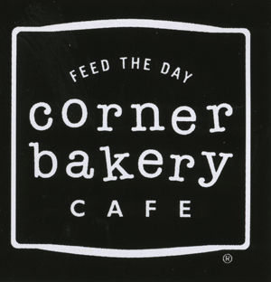
MENU
Focusing on innovative, flavorful offerings and delicious desserts, the Corner Bakery Cafe menu features:
• Specialty breads
• Hot breakfasts
• Made-to-order salads, sandwiches, panini and pastas
• Seasonal soups
• Freshly baked sweets
• Hand-roasted coffee by Java City and gourmet teas by Mighty Leaf

Signature menu items include: Chicken Pomodori Panini, The Trio Salad and our famous Cinnamon Creme Cake.
Corner Bakery Cafe Catering is an industry-recognized program, which represents 20% of total sales.

AMBIENCE
Casual neighborhood gathering place where people can relax, meet up with friends and enjoy great food any time of day.
SERVICE STYLE
Fast-paced and efficient in-line ordering with the luxury of table service delivery and self-serve beverage refills.
PRICE POINT
$0.99 - $8.29
HOURS
Hours vary, but stores are typically open from 6:30 a.m. – 9:00 p.m.
EXECUTIVE LEADERSHIP
Mike Hislop, Chief Executive Officer
Gary Price, President
Richard Peabody, Chief Financial Officer
Diana Hovey, Chief Marketing Officer
Blake Bernet, Senior Vice President of Development and General Counsel
Ric Scicchitano, Senior Vice President of Food & Beverage
Bob Hartmann, Vice President of Real Estate Development
Denise Clemens, Senior Vice President of Human Resources
HISTORY
1991 – Founded by Chicago’s Lettuce Entertain You Enterprises (LEYE)
1995 – Purchased by Brinker International
2006 – Purchased by Il Fornaio and equity investment firm Bruckman, Rosser, Sherrill & Co. LLC
2007 – Brand begins aggressive franchise strategy that brings new ownership partners to individual stores and markets
2011 – Purchased by Roark Capital Group, an Atlanta-based private equity firm

We are currently hiring for all positions in the café: cashier, service attendant, expo, line cooks, dishwasher/bake, and catering.

We are hiring for the Palo Alto location at this time, and Foster City location next month. Please call us at 650-843-0676 to schedule an interview AND please apply online at www.work4pcandf.com!

