B. S. in Industrial & Systems Engineering

Student Guide

San José State University

Department of Industrial and Systems Engineering

- General Information
- Rules and Policies
- Requirements for B. S. degree
- Flow Diagram of Required Courses
- Sample Four-year Plan
- Course Descriptions
- General Education Check List
- Major Form
- Major Advising Form
10.Transfer Evaluation Form
11. Approved List of Technical Electives

General Information

Office Location
Engineering Building, corner of San Fernando & 7th Streets,
San Jose, 4th floor - Room 485

Office Hours
8:00 a.m. to 12.00 p.m. and 1:00 p.m. to 5:00 p.m.

Telephone
(408) 924 - 3301
Fax
(408) 924 - 4040

Email Address
industrialsystems-dept@sjsu.edu

Web Site Address
http://ise.sjsu.edu/

Chair
Dr. Yasser Dessouky

Program Director and Major Advisor
Dr. Yasser Dessouky

Area Advisors

Dr. Yasser Dessouky
Production Systems and Simulation

Dr. Louis Freund
Dr. Dan Nathan-Roberts
Dr. Anil Kumar
Ergonomics and Human Factor Engineering

Dr. Minnie Patel
Dr. Jacob Tsao
Dr. Ayca Erdogan
Dr. Hongrui Liu
Operations Research Applications and Applied Statistics

Mission Statement

To serve society, with emphasis on the manufacturing and service sectors by

Providing undergraduate and graduate industrial and systems engineering education that prepares students to effectively apply engineering knowledge to the evaluation, design, and operation of complex industrial, service, and governmental systems comprised of people, equipment, and supplies through the application of modeling, measurement, and economic methods.

Contributing to the enrichment of the profession and to the development of knowledge through faculty leadership, scholarship and professional practice.

Meeting the needs of working professionals for continuing education in the fields of operations research, advanced statistical methods, ergonomics and human factors, production planning and control and related topics.

Program Educational Objectives

1 | Function effectively as an ISE professional designing or improving and implementing business processes.
2 | Identify and use methodologies to formulate and develop solutions for problems encountered in their organizations.
3. | Use computational skills to analyze and interpret data to solve systems problems.
4. | Evaluate impact of their solutions in the broader context of the organization or society.
5. | Effectively communicate using written, oral and visual media to articulate problems, findings and their proposed solutions.
6. | Engage in life-long learning and growth within their chosen profession.

Program Description

The BS - Industrial and Systems Engineering program prepares engineers for a broad scope of systems analysis and design challenges that deal with improving the overall performance of an organization or system. ISE’s focus is on productivity improvement, with concern for the human aspects of work as well as with finding the right combination of resources to ensure that the organization performs at its best. Using the latest computer-based analytical and modeling technologies, ISE bridges the gap between management and operations, applying organizational development, continuous improvement, Total Quality Management, ergonomics and production systems expertise. The goal of ISE is to assure that the organization’s systems are efficient, productive, safe and will not lead to cumulative injury, and that they incorporate the right tools and equipment. An industrial and systems engineer may be employed in almost any type of industry, business or institution, from retail establishments to manufacturing plants to government agencies to hospitals. The program prepares students to enter the profession immediately or to go on to graduate school. The undergraduate curriculum is accredited by the Accreditation Board of Engineering Technology (A.B.E.T.)

Rules and Policies

Major Advisor
A Major Advisor is a representative of the program who can assist you in selecting courses and
develop a plan for fulfilling the SJSU and major requirements. You must consult your Major
Advisor at least once each semester.

Writing Skill Test (WST) and Engr 100W
You must pass the WST and have upper division standing, in order to register for any Advanced
General Education course (including Engr 100W). Engr 100W is a prerequisite for all Industrial and Systems Engineering senior courses. You are urged to take the WST as early as possible.

Placement Examinations
All undergraduate students must take the Entry Level Mathematics (ELM) Exam or be exempted from
it before placement in the appropriate university mathematics coursework. All students who wish
to enroll in the following courses are required to take the corresponding placement examinations.

* Engl 1A requires English Placement Test,
* Math 30 requires Calculus Placement Examination,

Drop Procedure
A student may petition to drop a course after the third week of instruction only for serious and compelling reasons. Poor performance in a class is not considered a serious and compelling reason for late-drop. Verification and meeting with the University office responsible for late drop are necessary.

Prerequisites and Corequisites

You can take an ISE course only if 1.) you have completed all prerequisites of the course before taking it, and 2.) you are taking all corerequisites at the same time or have taken all corerequisites before taking the course. A student taking a course without satisfying either of the above conditions will either be dropped by the instructor or get a failure grade.

Course Load
You should adjust your course load based on your scholastic records, working hours, and other factors. You should discuss your individual situation with your Major Advisor. Students will not be allowed to register for more than 18 units per semester without prior approval from the Department Chair with the Petition for Excess Units form.

Technical Electives
6 semester units of upper-division technical electives are required. You can select the technical electives from the approved list, however two technical electives must be selected from upper-level engineering courses. The choice of technical electives must be made in order to complete the Major Form. You need your Major Advisor’s approval (on the Major Form) to take any elective course that is not on the approved list. A “C-” or better is required.

General Education
Questions on GE requirements should be directed to the Major Advisor who will refer the student to the student
ESSC, located in the Engr 334, if further clarification is needed
Major Form

An approved Major Form on file is required before taking any senior level ISE courses. A sample of the Major Form is included in this package. A major form must be submitted one (1) year prior to your anticipated date of graduation. In addition, the department office will contact you if there are any questions regarding your major form prior to approval. The following is the process to complete your Major Form. A major form can be downloaded as a word document from the department website: http://ise.sjsu.edu/content/forms.

- You must see your advisor and submit your Major Form and the complete documents for the approval and signature.

- The department will then check your grades and submit your Major Form and the documents to the department’s Chair for the signature.

- Upon department verification and approval, your Major Form and the documents will be taken to the Dean’s office for further verification. If the packet is complete, it will be forwarded to Admissions and Records.

Documents to Attach to Major Form:

- Major form checklist/cover page
- Graduation application
- General education checklist (official or copy signed by GE assessment advisor or stamped by Advising Center )
- College of engineering General Education checklist
- Graduation courses not completed for the baccalaureate degree
- SJSU transcripts (will be printed by ISE department staff
- Other college/university transcript(s) (copies are acceptable)
- Articulation agreement(s) printed from www.assist.org or equivalency form(s) for all course works that appear on your major form but were not completed at SJSU.

Reminder:

- Any changes to a student’s approved major form must be documented by a “Changes of Course(s) on Major Form” form.
- Don’t forget to submit copies of the transcript(s) to the department for course(s) with a “Blank grade” that will be taken at another college/university (Be sure that an OFFICIAL copy goes to the office of Admission s and Records )

Transfer Evaluation
Before enrolling in ISE 102 or ISE 130, you must see your Major Advisor to review credit for Mathematics, Physics, Chemistry, and Engineering coursework taken elsewhere.

Online course equivalents from other colleges can reached on the Internet via WWW with the URL, http://artic.sjsu.edu/ or www.assist.org. Theses web sites offer information on which courses can be transferred from the 131 colleges and universities holding articulation agreements with San Jose State University.

The following steps are required for a transfer credit evaluation:

- Obtain a set of unofficial transcripts showing all the Mathematics, Physics, Chemistry, and Engineering courses taken elsewhere that you consider equivalent to the corresponding SJSU courses. Note that the Admissions Office does not make transcripts available to the ISE Department.

- If applicable, obtain copies of catalog descriptions of pertinent courses that were taken at schools other than California community colleges. SJSU Library normally has copies of catalogs for most U.S. colleges.

- If applicable, attach catalog descriptions, and submit to the appropriate SJSU departments the Equivalency Evaluation forms for those courses taken at schools other than California community colleges. The U.S. college forms can be obtained from the ISE Office, while the foreign college forms are processed through the Admissions and Records Office. Following review, these forms should be returned to the ISE Department.

- Complete the worksheet included in the Transfer Evaluation Packet in ink. A list of course equivalencies between California community colleges and SJSU is included. Courses not found in this list require the completion of Equivalency Evaluation forms by the pertinent department to complete the evaluation.

- If all your pertinent transfer coursework was done at California community colleges, attach the set of transcripts to the completed worksheet and submit to your Major Advisor. Within a week or so, unless there are problems, your official transfer evaluation should be complete and placed in your file with the ISE department.

- If part (or all) of your pertinent transfer coursework was taken at schools other than California community colleges, attach the set of transcripts and copies of the signed Equivalency Evaluation forms to the completed worksheet and submit in person to your Major Advisor. Once processed, your official Transfer Evaluation will be signed by your Major Advisor and placed in your file with the ISE Department.

Requirements for B.S. Degree

(Total Minimum 120 Semester Units)

General Education....................................................……………………..…….……………….27 units

Preparation for the Major.......................................………………...………...…....….……… 26 units

MATH 30, 31, 32, 123 ........................................……………...………………...…….……….13 units
PHYS 50/51 ......................................................………………......……………….……………..…8 units
CHEM 1A...................................................………………...................……………………………..5 units

Engineering Common Core ..............................………………................………… ………….11 units

CMPE 30, ENGR 10, ME 20, MATE 25

Required Courses in Engineering and Science......................………......………. …………....50 units

ISE 102, 105, 115, 120,130, 131, 135, 140, 142, 151, 155, 167, 170, 194, 195A, 195B;
CmpE 131, ENGR 100W

Approved Upper Division Electives....................................……………..……….. …………...6 units

120 units

Sample Four-Year Program
(Total minimum units required for degree is 120)

FRESHMAN YEAR: 28 units

Fall Units Spring Units
Math 30 3 Math 31 4
Chem 1A 5 Phys 50 4
Engr 10* 3 Oral Communication 3
Engl 1A 3 Engl 1B 3
14 14

SOPHOMORE YEAR: 30 units

Fall Units Spring Units
Math 32 3 MatE 25 3
Phys 51 4 ME 20 2
American Studies 1A 6 Math 123 3
CmpE 30 3 American Studies 1B 6
16 14

Passing Writing Skills Test (WST) is required before taking Engr 100W

JUNIOR YEAR: 30 units

Fall Units Spring Units
ISE 102 3 ISE 131 3
Approved Technical Elective 3 ISE 120 3
ISE 130 3 ISE 142 3
Engr 100W 3 ISE 105 3
ISE 151 3 Approved Technical Elective 3
15 15

All ISE senior courses require the completion of Engr 100W and Major Form on file

SENIOR YEAR: 32 units

Fall Units Spring Units
CmpE 131 3 ISE 115 3
ISE 135 3 ISE 155 3
ISE 140 3 ISE 195B 3
ISE 167 3 GE Area S or V 3
ISE 195A 1 ISE 170 3
GE Area S or V 3 ISE 194 1
16 16

* Transfer upper-division students may substitute an engineering science course for Engr 10.

ISE Course Descriptions

ISE 102. Engineering Economic Systems
Systems analysis applied to economic decisions in engineering; comparison of alternatives based on cost breakdown structure and time value of money; system life-cycle process; life-cycle economic concepts, costing methodology and applications. Corequisite: Math 31 & Engr 10 or equivalent. 3 units

ISE 103. Life Cycle Engineering
Life cycle analysis of products focused on the contexts of reducing energy and the carbon footprint. Methods to analyze and evaluate the environmental impacts of engineering activities. Interdisciplinary case studies and projects related to life cycle engineering. Prerequisite: ENGR 102, ME 172, ISE 105 or METR 135, or instructor consent. 3 units

ISE 105. Introduction to Systems Engineering and Activity Costing
Techniques for integrating engineering problem solving methods with systems theory including principles of problem identification, description, modeling, solution and implementation; applying traditional and activity based cost systems to assist engineers in decision making process through the product life cycle. Prerequisites: Math 31. 3 units

ISE 110. Manufacturing Processes
Fundamentals of manufacturing processes such as machining, forming, cutting, welding and casting. Selection of materials. Production facility practices and meteorology. Geometric dimensions and tolerancing.
Prerequisite: ME 20 (C- or better). Pre/Corequisites: MATE 025. 3 units

ISE 112. Occupational Health Engineering
Legislative framework and historical perspective of work-related injuries and diseases: prevention assessments, legal and regulatory issues surrounding solutions to occupational health problems, principles of industrial hygiene and program management. Prerequisite: Junior standing in engineering. 3 units

ISE 114. Safety Engineering
Hazards, accident prevention and engineering approaches to the design of equipment, facilities and processes. Provides familiarity with system safety, system evaluation and evaluation of alternative countermeasures. Latest safety regulations and agencies responsible for their enforcement. Prerequisite: Junior standing. 3 units

ISE 115. Computer Integrated Manufacturing
Analyze, design and integrate manufacturing processes with CAD/CAM technologies including numerical control, material handling and storage, group technology and computer control. Prerequisite: Cmpe, 30, ISE 120. Misc/Lab: Lecture 2 hours/lab 3 hours. 3 units

ISE 120. Work Methods Design and Measurement
Design of efficient and effective work processes; includes process management, methods analysis and improvement and work measurement. Prerequisite: Math 032. Corequisite: ISE 130. Lecture 2 hours/lab 3 hours. 3 units.

ISE 130. Engineering Probability & Statistics
Probability theory, graphical displays of data, graphical methods of comparisons of samples and hypotheses testing. Statistical estimation and inference. Uses graphical statistical packages. Prerequisite: Math 32 or Math 71. 3 units

ISE 131. Statistical Process Control and Improvement
Statistical computations, sampling procedures, development and use of control charts and utilization of computerized statistical packages. Design of statistical quality control systems. The seven tools of quality; process capability studies. Prerequisite: ISE 130 (with a grade "C-" or better) or equivalent. 3 units

ISE 135. Design of Experiments
Tests of composite hypotheses, analysis of variance, statistical decision theory, sampling procedures, design and implementation of statistical process control systems, response surface experimental design, Taguchi experimental design, system reliability, utilization of computerized statistical packages.
Prerequisite: ISE 130 (with grade of "C-" or better) or equivalent. 3 units

ISE 140. Operations Planning and Control
Design, implementation and evaluation of manufacturing, planning and control systems. Includes MRP II, ERP, JIT. Prerequisite: ISE 102, ISE 120. 3 units

ISE 142. Service Systems Engineering and Management
Operational productivity, operational quality strategy and information technology applications in the service sector through the use of tools, techniques and case studies. Contrasts manufacturing and service sector issues related to supply chain, process quality, information systems and other topics
Prerequisite: Upper division standing. 3 units

ISE 151. Managing Engineering
Broad overview of engineering management theory and practice including: management's roles, responsibilities, skills, strategy and planning; management systems, human resource management, problem solving and decision-making; engineering ethics. Prerequisite: 100W course. 3units

ISE 155. Supply Chain Engineering
A comprehensive coverage of supply chain topics; real world applications including logistics, inventory management, risk pooling, value of information, strategic alliance, procurement and outsourcing strategies, information technology, coordinated product and supply chain design, customer value, decision support systems.
Prerequisite: ISE 140. 3units
ISE 160. Healthcare Delivery Systems
Overview and analysis of health care delivery systems in the US with emphasis on the assessment, analysis, and improvement of operational quality, efficiency, and effectiveness. Impact on primary components of health care systems: facilities, approaches to care and treatment modalities, and personnel. Quantitative and qualitative techniques and applications to improve health care systems; performance measures used to evaluate access and quality of care. Impact of healthcare policies, laws, economics, and current US health care culture on organizational performance and patient outcomes. Prerequisite: Junior Standing
ISE 161. Medical Errors Reduction and Patients Safety Engineering
Standardization of national reporting of medical errors; patient safety and high risks processes performance analysis; Safety improvements utilizing human factors techniques; information technology applications to reduce medication errors and improve patient safety; structured teams and systems to reduce clinical errors. Prerequisite: Junior Standing. 3 units.
ISE 162. Engineering Statistics and Analysis
Topics will include error analysis, probability, statistics including hypothesis testing, confidence limits and control variables, design of experiments and statistical process control as they are utilized in the chemical, materials and process engineering industries. Prerequisite: Math 133A. 2 units.

ISE 163. Healthcare Information Systems
Current and emerging use of clinical information, electronic medical records and clinical information systems. Healthcare enterprise architecture. Pre-built automation models of unified patients records. Automated decision support. Integrated interfaces, interoperable record exchange, and meta knowledge integration. Security of healthcare information. Prerequisite: Junior Standing. 3 units.
ISE 164. Computer and Human Interaction
Introduction to human/computer interaction, paradigms for interaction, human performance capabilities, computer input/output device analysis and design, pattern recognition 3D audio, 3D visualization, application to virtual reality and multimedia. Prerequisite: Junior Standing. 3 units.
ISE 166. Healthcare Financial Engineering Management
Healthcare activity costing and life-cycle, methodologies of modeling financial decisions, dynamic pricing techniques, and integrated financial analysis that spans clinical, access, and revenue functions. Financial risks assessment using statistical and stochastic methods as applied to pricing of alternative providers settings. Prerequisite: Junior Standing. 3 units.

ISE 167. System Simulation
Introduction to simulation. Monte Carlo techniques. Design and use of discrete-event computer simulation modeling techniques; theoretical and practical treatment of input to models; model validation methods and output analysis. Synchronized sampling, model comparisons.
Prerequisites: CmpE 30, ISE 130 (with grade “C-” or better). Misc: Lecture 2 hrs/Lab 3hrs. 3 units.

ISE 170. Operations Research
Development and application of mathematical models to industrial problems. Linear programming, network analysis, Markov models, game theory, queuing theory and decision analysis. Prerequisite: ISE 130 (with grade of "C-" or better). Pre/Corequisite: Math 123. 3units

ISE 180. Individual Studies
Individual work on special topics by arrangement. Prerequisite: Upper division standing and instructor consent.
Repeatable: Repeatable for credit. CR/NC 1-3units

ISE 194. Data Analytics Workshop
Application of common analytics programming languages to problems in industrial engineering. Prerequisite: CMPE 30, ISE 135, and Senior Standing. 1 unit

ISE 195A. Senior Industrial Engineering Design I.
Individual or group design projects. Proposal preparation with plans and specifications. Oral and written reports. Professional seminars. Prerequisite: ISE 105, ISE 120, Engr 100W, major form on file, and open only to seniors in good standing in the major.
Misc/Lab: Lab 3 hours. 1unit

ISE 195B. Senior Industrial Engineering Design II.
Design of a complete industrial system including quality function deployment, technology trends, financial analysis, functional specifications, process design, production capability, quality management, manufacturing resource planning, equipment requirements, human resource management, management information systems, facility design and project management. Prerequisite: ISE 140 and ISE 195A (with grade of "C" or better). Misc/Lab: Lab 9 hours. 3 units

ISE 197. Cooperative Education Project
Part or full-time on-site paid work experience based on a pre-approved project assignment in area of student's career objective. Oral presentations, written final report and evaluation by project supervisor. Approved technical elective. Prerequisite: Instructor consent. 3 units

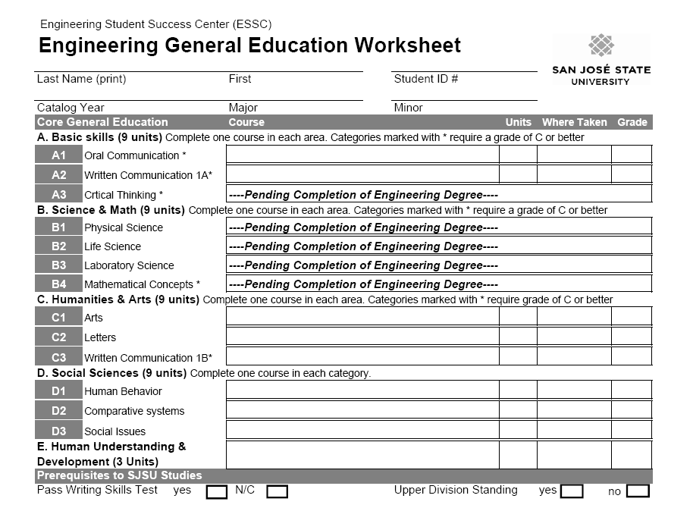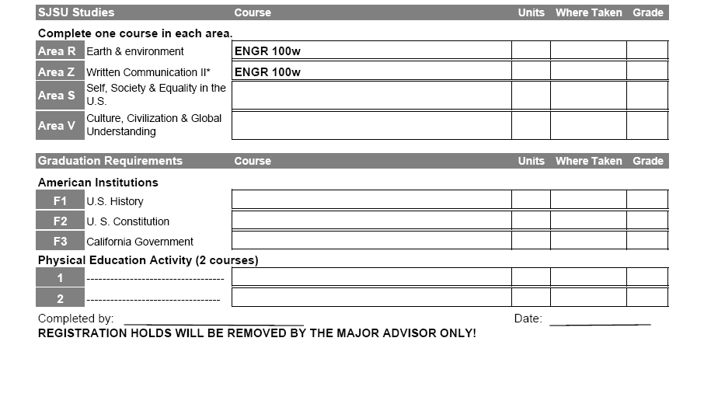

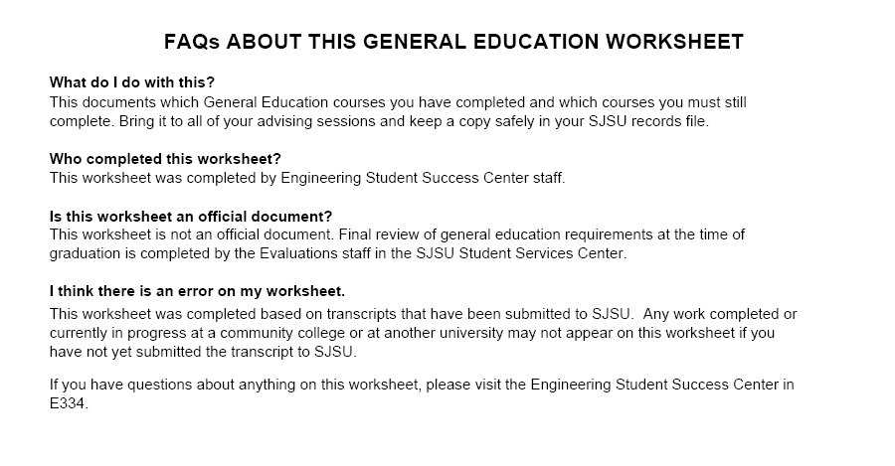

San Jose State University
College of Engineering
Department Industrial & Systems Engineering
Major Form for B. S. in Industrial & Systems Engineering

Name (Last, First M.): Student ID:

Minimum number of semester units for the degree: 120 Bulletin: ______ Proposed Semester of Graduation:

ENGINEERING COMMON CORE (minimum 11 units)
Dept | No. | Title | Unit | Grade | Dept |  |  | No. | Title | Unit | Grade
CmpE | 30 | Computer Engineering I | 3 |  | ME |  |  | 20 | Design & Graphics | 2
Engr | 10 | Engr. Process & Tools | 3 |  | MatE |  |  | 25 | Intro to Materials | 3
REQUIRED COURSES (minimum 50 units)
ISE | 102 | Engr Economic Systems | 3 |  |  | ISE | 151 |  | Managing Engineering | 3
ISE | 105 | Systems Engr & Activity Costing | 3 |  |  | ISE | 155 |  | Supply Chain Engineering | 3
ISE | 115 | Comp Integrated Manufacturing | 3 |  |  | ISE | 167 |  | System Simulation | 3
ISE | 120 | Work Methods Design & Measrmt | 3 |  |  | ISE | 170 |  | Operations Research | 3
ISE | 130 | Engineering Statistics | 3 |  |  | ISE | 194 |  | Data Analytics Workshop | 1
ISE | 131 | Statistical Process Contr. & Impvmt | 3 |  |  | ISE | 195A |  | Senior ISE Design I | 1
ISE | 135 | Design of Experiments | 3 |  |  | ISE | 195B |  | Senior ISE Design II | 3
ISE | 140 | Operation Planning & Control | 3 |  |  | Engr | 100W |  | Engineering Reports | 3
ISE | 142 | Service Systems Engr & Mgmt | 3 |  |  | CmpE | 131 |  | Software Engineering I | 3
APPROVED TECHNICAL ELECTTIVES (minimum 6 units)
Courses Required in Preparation for the Major – Mathematics, Chemistry, Physics (minimum 29 units)
Math | 30 | Calculus I | 3 |  |  | Phys | 50 |  | Mechanics | 4
Math | 31 | Calculus II | 4 |  |  | Phys | 51 |  | Electricity & Magnetism | 4
Math | 32 | Calculus III | 3 |  |  | Chem | 1A |  | General Chemistry | 5
Math | 123 | Linear Alg & Differential Equations | 3 |  |  | Engl | 1B |  | Argument and Analysis | 3

(Student's Signature)______________________________________________________________will have completed all the requirements for the Bachelor of Science in ISE after: (a) successful completion of the above work. (b) An audit of the student’s transcript of record to verify that all-appropriate data has been entered accurately. (c) A minimum 2.0 GPA in all required courses has been achieved. (d) A minimum 2.0 GPA in all required & technical electives combined has been achieved. (e) A minimum 2.0 GPA in all required courses&technical electives taken at SJSU has been achieved.

[Signed] ___________________________________________ [Signed] _____________________________________
Major Advisor. Department Chair
[Date] ___________________ [Date] _____________________

Major Advising Form for B. S. in Industrial & Systems Engineering
___________________ ________ __________ ______ ____________
Last Name First Name SID Bulletin Advisor

__________________ _______________________________________ ______________________________________________________
Telephone Email Address

 | U | Sem | Grade | Remarks |  | U | Sem | Grade | Remarks
Math  30 | 3 |  |  |  | Math  31 | 4
Chem  1A | 5 |  |  |  | Phys  50 | 4
Engr  10 | 3 |  |  |  | Oral Comm | 3
Engl  1A | 3 |  |  |  | Engl  1B | 3
CmpE 30 | 3 |  |  |  | Math 123 | 3
Math  32 | 3 |  |  |  | ME 20 | 2
Phys  51 | 4 |  |  |  | MatE 25 | 3
GE | 3 |  |  |  | GE | 3
GE | 3 |  |  |  | GE | 3
WST
ISE 102 | 3 |  |  |  | ISE  131 | 3
Tech Elec. | 3 |  |  |  | ISE  120 | 3
ISE 130 | 3 |  |  |  | ISE  142 | 3
Engr 100W | 3 |  |  |  | ISE  105 | 3
ISE 151 | 3 |  |  |  | Tech Elec. | 3
 |  |  |  |  | Major Form
CmpE 131 | 3 |  |  |  | ISE 195B | 3
ISE 135 | 3 |  |  |  | ISE  115 | 3
ISE 140 | 3 |  |  |  | ISE  155 | 3
ISE 167 | 3 |  |  |  | ISE 194 | 1
ISE 195A | 1 |  |  |  | GE S or V | 3
GE S or V | 3 |  |  |  | ISE 170 | 3

Advisor Initials: _______ _______ _______ _______ _______ _______ _______ _______

Advising Date: _______ _______ _______ _______ _______ _______ _______ _______

Flag-off Initials: _______ _______ _______ _______ _______ _______ _______ _______

Flag-off Date: _______ _______ _______ _______ _______ _______ _______ _______

Revised 03/23/2016

Transfer Evaluation Form for B.S. In Industrial & Systems Engineering

Name Last First M.I.

________________________________________ _____________ _______________
Date of Entry to SJSU SSN Previous College Work

Course at SJSU |  | Units | Course Transferred and college | Units  S/Q* | Grade | Dept  Initials
ISE | 102 | 3
ISE | 105 | 3
ISE | 115 | 3
ISE | 120 | 3
ISE | 130 | 3
ISE | 131 | 3
ISE | 135 | 3
ISE | 142 | 3
ISE | 140 | 3
ISE | 151 | 3
ISE | 155 | 3
CMPE | 131 | 3
ISE | 167 | 3
ISE | 170 | 3
ISE | 194 | 1
ISE | 195A | 1
ISE | 195B | 3
CmpE | 30 | 3
Engr | 10 | 3
ME | 20 | 2
Engr | 100W | 3
MatE | 25 | 3

________________________________________ ___________________
Major Advisor Signature Date

* Show S(semester) or Q(quarter) next to the number of units for each entry in this column.

APPROVED LIST OF TECHNICAL ELECTIVES
(Note at least two electives must be engineering course and all courses must be completed with a grade of “C” or better)

Software Systems Engineering
CmpE 120 Computer Organization and Architecture
CmpE 135 Object-Oriented Analysis and Design
CmpE 133 Software Engineering II
Engr 136 Information Engineering
CmpE 124. Digital Design I
CmpE 126 Algorithms and Data Structure Design
CmpE 130. File Processing
CmpE 138. Database Systems Design
CmpE 148. Computer Networks

SemiConductor/ Manufacturing
MatE 153 Electronic Properties of Solids
MatE 141 Materials Characterization
MatE/EE 129 Basic IC Processing
MatE 130 Characterization and Analysis of Semiconductor Devices
MatE/EE 167 Microelectronics Manufacturing Methods
MatE/ChE 166 Advanced Thin Films Processes
ME 106 Fundamentals of Mechatronics Engineering
ME 109 Heat Transfer in Electronics
ME 136 Design For Manufacturability
ME 165 CAD in Mechanical Engineering

Human Factors/Ergonomics
ISE 112 Engineering Occupation and Health
ISE 114. Safety Engineering
CE 170 Principles of Environmental Engineering
ISE 164 Computer and Human Interaction
Psyc 170 Industrial Organization Psychology
Psyc 173 Human Factors

Transportation and Traffic Management
CE 121 Transportation Engineering
CE 122 Traffic Engineering
CE 134 Project Management for Construction

Business Management
Psyc 175 Management Psychology
Bus 130 Introduction to Marketing
Bus 133A International Marketing
Bus 133B International Marketing: Pacific Rim
Bus 168 Management Issues in High Technology Firms
Bus 170 Business Finance

ISE Related
ISE 103 Life Cycle Engineering
ISE 110 Manufacturing Processes
ISE 196R Reliability Engineering
ISE 197 Cooperative Education Project
Healthcare
ISE 160 Healthcare Delivery Systems
ISE 161 Medical Errors Reduction and Patients Safety Engineering
ISE 163 Healthcare Information Systems
ISE 166 Healthcare Financial Engineering Management

