Martha Toral (Administrative Coordinator) was a first generation in college and studied here at SJSU and completed her Bachelor of Science in Biology. Following Martha Toral’s first interview I knew we had found a wonderful new addition to our office. Martha came to us from the Boys and Girls Club in East Palo Alto. She had been working there for two years. Through a friend she heard about our position and applied. We are so very glad she did. She has reorganized the entire program. She recently married the ‘friend’ who sent her to us.

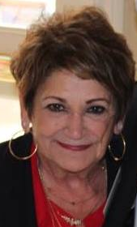 generation in college and studied Biology here at SJSU. She from the Boys and Girls Club in East Palo Alto. She had been working there for two years. Through a friend she heard about our position and applied. We are so very glad she did. She has reorganized the entire program. She graduated from SJSU with a degree in biology. She recently married the ‘friend’ who sent her to us.


