One page summary example – Please follow the format of this example as closely as possible. Do not extend beyond 1 page.
Six Degree-of-Freedom Robotic Motion Simulator
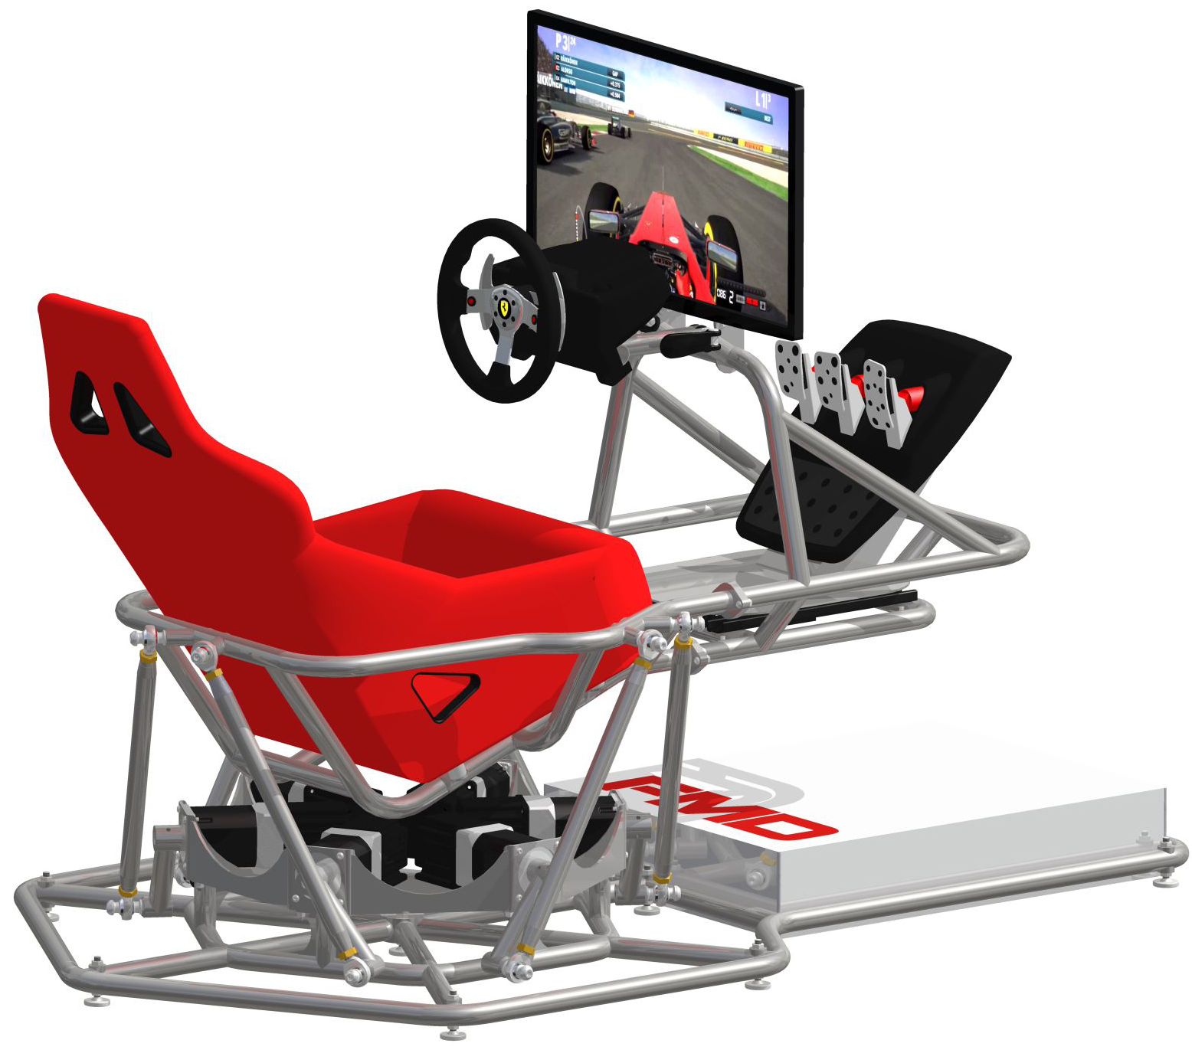
Student Team Members:
Tyler Kroymann (Team Lead)
Robert Dee

Faculty Advisor: Dr. Winncy Du

Project Scope and Objectives:
Design and build a 6-DOF parallel robot to simulate the Formula 1 racing experience.
- Derive the inverse kinematic equations for a rotary Stewart platform parallel robot.
- Design a control system to implement the inverse kinematics and establish communication between 6 rotary actuators and a racing simulation game.
- Perform an ergonomics study to determine ideal cockpit ergonomics.
- Design and build a full-size motion platform that meets the following specifications:
  - Capable of supporting a 250lb driver
  - Capable of at least +/- 20 degrees of rotation and +/- 4” of translation
  - Capable of being disassembled and transported easily by two individuals and an average pickup truck or sport utility vehicle.
  - Small enough to fit in a living room or TV room and capable of running on a typical household electrical system

Project Results:
- Successfully derived the inverse kinematics.
- Successfully designed a complete control system.
- Successfully established the ideal cockpit ergonomics with a full range of adjustability.
- Successfully designed and built a motion platform that meets (or exceeds) all of the design specifications.

Sponsors:
Moog Animatics, SJSU, TechShop, Metal Supermarkets, Olander Company Inc, Columbia River Mandrel Bending, Arrow Industrial Products, Ofensus Racing, Kickstarter backers.

