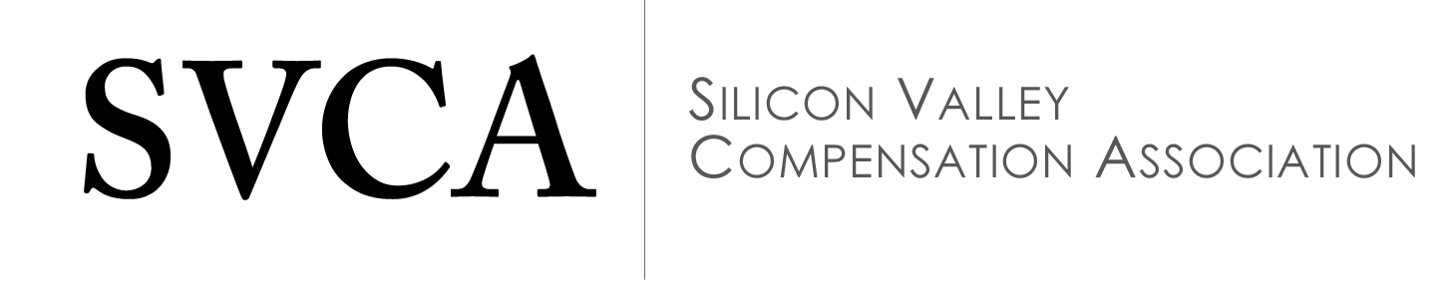

Scholarship Program

Scholarship Benefits
As an organization that is dedicated to the development of compensation professionals and growth of the professional network of compensation professionals in the Silicon Valley, the Silicon Valley Compensation Association knows the benefit of engaging and helping develop our future colleagues. The Silicon Valley Compensation Association is offering scholarships for students concentrating in Human Resources.
Recipients of the one-year scholarship will be awarded:
- Silicon Valley Compensation Association membership for one year (12 month following the scholarship grant)
- Free attendance at all Silicon Valley Compensation Association meeting and seminars for one year (12 month following the scholarship grant)
- $1,000 to contribute to the costs of your tertiary education
Eligibility Criteria
The scholarship is open to all students studying Human Resources Management who are enrolled at a San Jose State University who are in need of assistance toward professional development and certification. A minimum GPA of 3.0 is required.

Application, Review and Certification Process
Scholarship candidates must submit a complete application to be considered. Candidates will submit their application through the San Jose State University Scholarship Application Process. The scholarship application package must include the following materials:
- Completed application form
- 200-word essay
- Resume or CV
- Letter of recommendation from faculty or professional mentor
- Proof of enrollment at San Jose State University in Human Resources related field, and the minimum 3.0 GPA
- Have completed or are currently enrolled in a compensation class
The 200-word essay should describe the importance of compensation knowledge to your HR career development. This essay should include an explanation of why the scholarship is needed. The Silicon Valley Compensation Association will award scholarships based upon merit.
Scholarship recipients will be notified of their acceptance after a formal review by a committee of the SVCA Board and consultation with a faculty or university representative.
Deadline to submit scholarship application: March 31, 2016
Terms & Conditions
Scholarship Program Details
- Scholarships are open to both members and non-members of Silicon Valley Compensation Association.
- Scholarships will be offered on an ongoing basis until the Silicon Valley Compensation Association, at its sole discretion, terminates the Scholarship Program.
- The Silicon Valley Compensation Association decides the number of scholarship grants based on the following factors:
  - the number of applicants that meet the Scholarship Program Qualifications;
  - the funds and resources available for the Scholarship Program;
  - the relative merit of applicants, as determined in Silicon Valley Compensation Association’s sole discretion;
Scholarship Program Qualifications
- Scholarship recipient is an student enrolled in at San Jose State University;
- Recipient is majoring in Human Resources;
- Recipient must be a permanent resident or attend school in the San Francisco Bay Area;
- Recipient has submitted a complete scholarship application;
- Recipient fully authorizes the Silicon Valley Compensation Association (and its agents) to validate information provided in support of the scholarship application;
- Recipient’s facility member and/or professional mentor has submitted a support letter recommending the Recipient;
- Recipient has been interviewed (over the phone) by a representative of the Scholarship Program and has been deemed to have qualified for the Scholarship.
Recipient Rights and Obligations
- Recipient shall be responsible for any tax related to the receipt of the scholarship.
- Recipient will indicate his/her agreement with the scholarship terms and conditions by signing a legal agreement (application form) to that effect.
Silicon Valley Compensation Association Rights and Obligations
- The Silicon Valley Compensation Association will provide the award to the successful recipients within 90 days of receiving an agreement from the recipient.
- The Silicon Valley Compensation Association agrees to waive recipient’s Silicon Valley Compensation Association membership fees and Silicon Valley Compensation Association meeting and seminar fees for one year.
- The Silicon Valley Compensation Association reserves the right to revoke, suspend, or terminate the Recipient’s scholarship, membership or subsidized meetings at any time, within the Silicon Valley Compensation Association’s sole discretion.

2016 Scholarship Application
PLEASE TYPE OR PRINT CLEARLY ALL RESPONSES
PERSONAL INFORMATION
Name:
Address:
Home Phone:
Work Phone:
Cell Phone:
Email:

EDUCATIONAL INFORMATION
College/University: San Jose State University
Major:
Degree Expected:
GPA:
Compensation class details:
(course name & date)

REFERENCE
Reference (Name and Contact information):
________________________________________________________________________________________________________

I believe all of the above information to be true. I hereby apply for the Silicon Valley Compensation Association Scholarship, and agree to all Terms and Conditions. It is my understanding that I will be notified within 90 days if I have been selected as the recipient of an award.
Applicant Signature:
Date Signed:

Parent or Guardian Signature:
(If application is younger than 18 at time of application)
Date Signed:

I hereby grant permission for the Silicon Valley Compensation Association to use my name and photo for future scholarship announcement and advertisement. It is my understanding that this is voluntary and in no way will it affect my eligibility to be selected as a scholarship recipient.
Applicant Signature:
Date Signed:

Parent or Guardian Signature:
(If application is younger than 18 at time of application)
Date Signed:

APPLICATION CHECK LIST
- Completed, signed application form
- 200-word essay
- Resume/CV
- Letter of recommendation from faculty and/or professional mentor
- Proof of enrollment at San Jose State University in Human Resources related field (including details on compensation class)
- Proof of minimum 3.0 GPA

