1. Given the following system:
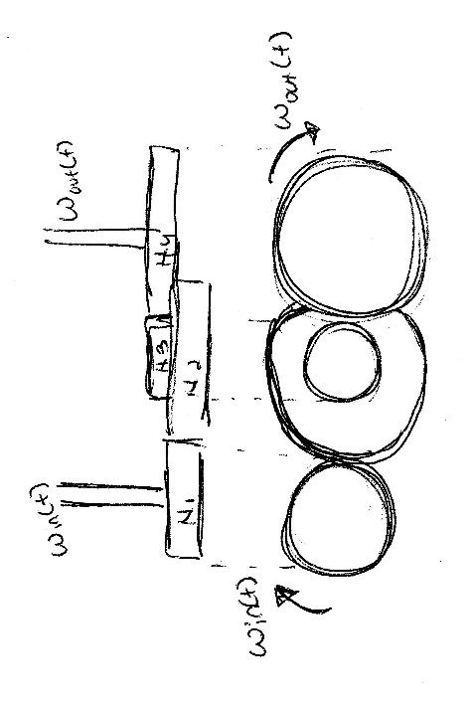
- (5 pts) Find the open loop transfer function in terms of $\frac{Ω_{out}(s)}{Ω_{in}(s)}$ where Ω(s) is the Laplace transform of ω(t) angular velocity, and N₁ – N₄ are the number of teeth on the meshing gears.
- (5 pts) Find the open loop transfer function in terms of $\frac{θ_{out}(s)}{θ_{in}(s)}$ where θ is position.
2. Given the following system:
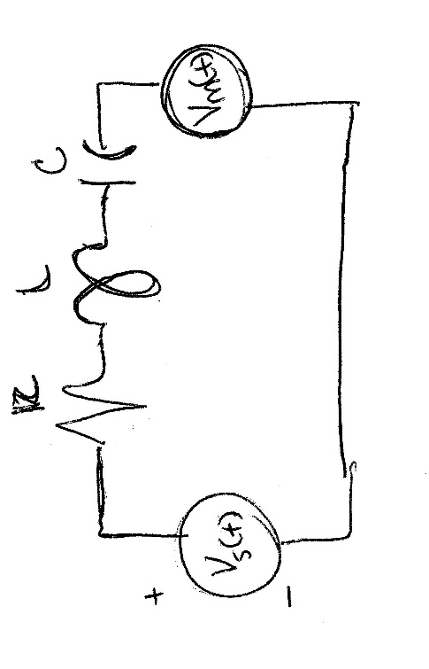
Where R = 5 Ω, L = 10 H, C = 1/10 F, k = 7, A = 17, and B = 16.
Where the voltage of the motor is given by equation 1:
$V_{m}(t)=kω(t)$ (1)
And the source voltage is given by equation 2:
$V_{s}\left(t\right)=Aθ\left(t\right)+Bω(t)$ (2)
- (5 pts) Using the diagram and equations 1 and 2, find $\frac{I(s)}{Ω(s)}$.
- (5 pts) Using equation 2, find $\frac{Ω(s)}{V_{s}(s)}$.
- (5 pts) Draw the block diagram for an open loop system where $V_{s}(t)$ is the input and I(s) is the output. Label ω(t).
- (5 pts) Using Matlab, plot the step response in the time domain.
3. (20 pts) Using the inverting operational amplifier shown below, design circuits (i.e., choose circuit components, such that the equivalent impedances (Z₁(s) and Z₂(s) for the combination of circuit elements you choose) will yield the controller transfer functions ( G_{controller} ≡ Vo(s)/Vi(s) ). Where resistors are needed in the circuit that produces Z₁, use values of 1 kΩ.
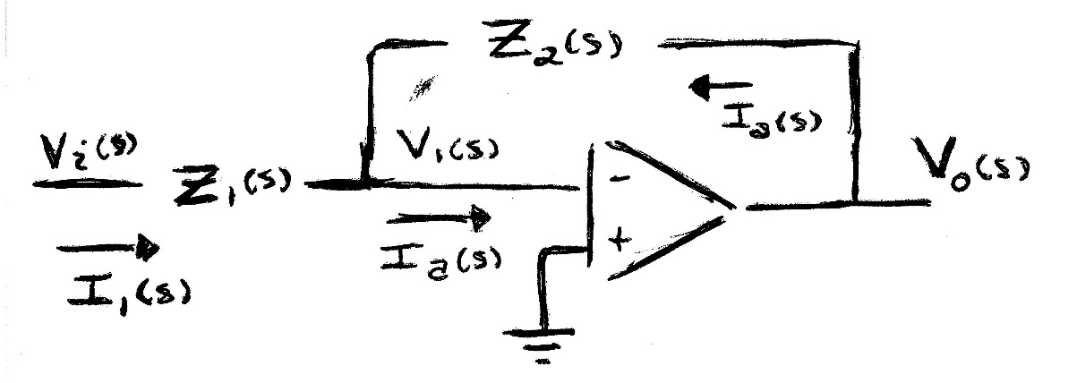
- $G_{controller}\left(s\right)=-5$
- $G_{controller}\left(s\right)=-\left[5+\frac{10}{s}\right]$
- $G_{controller}\left(s\right)=-\left[5+15s\right]$
- $G_{controller}\left(s\right)=-\left[5+\frac{10}{s}+ 0.15s\right]$
4. Given the following system:
`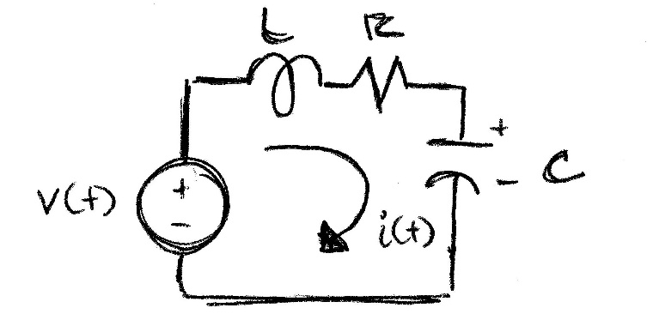
Where L = 1/4 H, R = 0.1 Ω, and C = 1 F.
- (5 pts) Find the open loop transfer function for $\frac{I(s)}{V(s)}$.
- (5 pts) Using pidTool (or pidTuner depending on your version of Matlab), design a PID controller for the closed loop system such that the maximum current never exceeds 1.1 and the final value is 1.
- (5 pts) What values does Matlab give for your controller?
- (5 pts) Using the plot from part b, what values does Matlab give for rise time, peak time, percent overshoot, and settling time?
Don’t forget to:
- Add a cover page with a summary (10 pts) about what you did and what you learned. Address in your summary your reflections on this “flipped classroom” approach (where you watched videos on your own and class time was used for problem solving and consultation with the instructor).
- Publish any Matlab code. Integrate the published code with the rest of the work on this HW.

