ME 190 Lab 1 – Matlab Refresher and Data Handling
Learning Objectives: By the end of the lab, you should be able to:
- Create, manipulate, and search arrays and matrices
- Use the Matlab command line and create scripts
- Use basic plotting commands
- Digitize analog plots
- Create reports using the ‘publish’ tool in Matlab
Pre-lab Tasks:
- Download and review the Introduction to Matlab document at the following URL:
http://www.maths.dundee.ac.uk/software/MatlabNotes.pdf
- Watch the following videos on publishing Matlab scripts and use this feature whenever you are including a script in your work:
http://www.mathworks.com/academia/matlab-examples/
- Read these plotting tips:
http://www.mathworks.com/help/matlab/ref/plot.html
http://www.mathworks.com/help/matlab/creating_plots/using-high-level-plotting-functions.html
- Watch the video on publishing MATLAB scripts, and use this feature whenever you submit work with Matlab: http://www.mathworks.com/academia/student_center/tutorials/ps_publishing/player.html
- Study the script file, dc_motor_example.m (http://www.engr.sjsu.edu/bjfurman/courses/ME190/Lab_related/dc_motor_example.m) and its published output.
- Download Plot Digitizer and read homepage description:
http://plotdigitizer.sourceforge.net/
Exercises and What to Submit
Submit one published Matlab script with the Exercises below separated by cell breaks in hardcopy and softcopy (softcopy in the corresponding Canvas Assignment). The first section of your submission must be a Summary of what you did, how you did it, and what you learned. Don’t forget your name and date in the published report.
--------------------------------------------------------------------------------------------------------------------
Exercise 1) Matrix Generation and Manipulation
--------------------------------------------------------------------------------------------------------------------
- Create a vector, B that contains all integer values between 3 and 11 using the colon operator.
- Create a vector, C that contains the same values as part 1 except in reverse order (11 to 3) using the colon operator.
- Perform an element-by-element multiplication of B and C without using a loop. Store your answer into a variable, D.
- In a variable, E, store the first three elements of B, the middle three elements of C, and the last three variables of D using indexing and concatenation.
- In a 3X3 matrix, F, store the first three elements of B in the top row, the middle three elements of C in the middle row, and the last three variables of D bottom row using indexing and concatenation.
- Using the functions linspace() and logspace(), create a matrix, G, whose top row consists of 10 evenly spaced integers from 1 to 10 and bottom row consists of 10 elements of logarithmic spacing from 1 to 10.
--------------------------------------------------------------------------------------------------------------------
Exercise 2) Simple Indexing
--------------------------------------------------------------------------------------------------------------------
In this exercise you may need one or more of the functions:
min(A)- find the minimum value in A,
max(A)- find the maximum value in A
find(A)- returns the numeric indices to TRUE (non-zero) values in A
along with the relational operators <, <=, >, >=, ==.
Let x = [-100:100];
and create a variable y = x³ + 50x² - 100
Now find the following (using the appropriate Matlab function(s))*:
- The minimum and maximum values of y
- The maximum value of y for negative values of x
- The minimum value of y for positive values of x
- and the values of x at which the results in (2b) and (2c) are obtained
- the value of x at which y first becomes positive
- The index into y at which y has values between 0 and 1000 and corresponding values of x
*Hint: create a logical index to select parts of the data meeting the required conditions, then find the value required from this subset of data.
--------------------------------------------------------------------------------------------------------------------
Exercise 3) Multiplication Table
-------------------------------------------------------------------------------------------------------------------
- Create a script that will generate a multiplication table. Your script must follow the format in Figure 1.
Hint: you may use matrix algebra or a double loop.
%% Times Table  % table size  row=5;  col=5;  ***Do math here***  % generate table and output  table=**return value here*** | 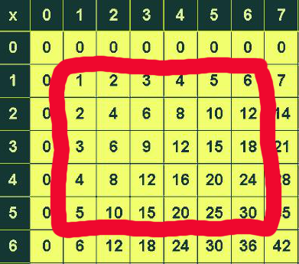
Figure 1: Times table format
- Building from 3a, have your script determine the sum of product values for those lying in the center of the table (i.e. values which do not lie along an edge of the table). Show that it works for a 6X7 multiplication table (See Figure 1).
- Modify your script from part 3a to determine the number of elements in a 10X10 multiplication table that are greater than 20 but less than 70
--------------------------------------------------------------------------------------------------------------------
Exercise 4) Plot Digitizer /Plotting
--------------------------------------------------------------------------------------------------------------------
Use Plot Digitizer collect data points belonging to the step response shown in Figure 2. To faithfully capture the curvature of the plot, use your mouse, and click along the curve in enough places that curve comes out reasonably smooth.
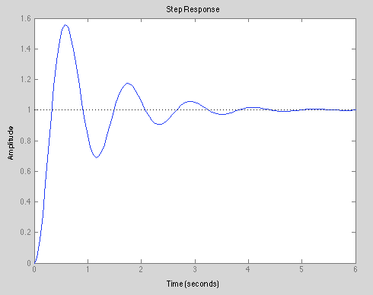
Figure 2: Step response
- Once you have completed your trace using Plot Digitizer, copy your data to an Excel spreadsheet.
- Import your data set using xlsread(). For more information on xlsread() enter type: EDU>> help xlsread
- Plot your data set in Matlab to confirm that your data looks correct.
- Download GraphingVars.mat from: http://www.engr.sjsu.edu/bjfurman/courses/ME190/Lab_related/Lab1_Matlab_refresh_related/
  - Import the .mat file to your workspace. You should see the variables t, yClean and yNoise in your workspace.
- Create a plot with your data set, yClean and yNoise all on one plot.
  - Be sure to have the plot properly titled, axis labeled, grid, and legend on.
- Now use subplots and have each data set in a separate subplot like in Figure 3.
  - Once again be sure to have the plot properly titled, axis labeled, grid, and legend on.
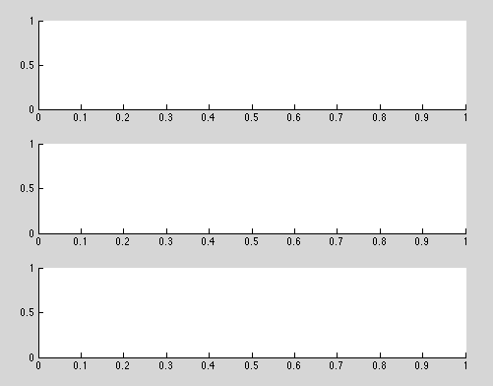
Figure 3: Subplot example
--------------------------------------------------------------------------------------------------------------------
Exercise 5) Filtering
--------------------------------------------------------------------------------------------------------------------
The filter command can be a bit overwhelming if you are not familiar with transfer functions in the frequency domain. Below is a simple form of both a high pass and low pass filter.
For a 1-pole low-pass filter,
xfilt = filter(a, [1 a-1], x);
where a = T/τ, T = the time between samples, and τ (tau) is the filter time constant.
Here's the corresponding high-pass filter:
xfilt = filter([1-a a-1],[1 a-1], x);
- Design a filter for the yNoise signal and plot the filtered and unfiltered signal on a plot. Be sure to have the plot properly titled, axis labeled, grid, and legend on. Include the code for your filter design in your report as well as a plot that compares the unfiltered and filtered data.
References
- http://www.mathworks.com/academia/student_center/tutorials/launchpad.html (extensive list of Matlab Tutorials and Learning Resources)
- Problem 2 reference: http://homepages.see.leeds.ac.uk/~lecimb/matlab/index.html
- http://math.loyola.edu/~loberbro/matlab/Publishing2013.pdf (good resource on Publishing in Matlab)

