Homework Solutions

12-8-14

**Homework #9**

Solve (6.8) – Forward velocities and accelerations only.

Solve (7.2), (7.5), (7.7), (7.10), Due 11/25. Study Examples and (7.17).

(6.8)

Link 1 ------------------









Link 2 (prismatic) ------------------













Inertial Equations

Link1 --------------



Link2 ----------------

7.2)

From Eq. 7.6,









-----------------------------------------------------------------------

(7.3)

From (7.23)

If , tb=2 seconds from (7.22) 🡪 No linear path

If , $t_{b}=2-\sqrt{3}$, then the linear path = $2\sqrt{3}$ and $\dot{θ}$ =85(2- $\sqrt{3}$)

Use Eqs. (7.15) to find the coefficients of the two cubic curves.

0 ≤ t ≤ 0.268 (1st parabolic portion)



 

0.268 < t ≤ 3.732 (linear portion)



 

3.732 ≤ t ≤ 4 (2nd parabolic portion)





 

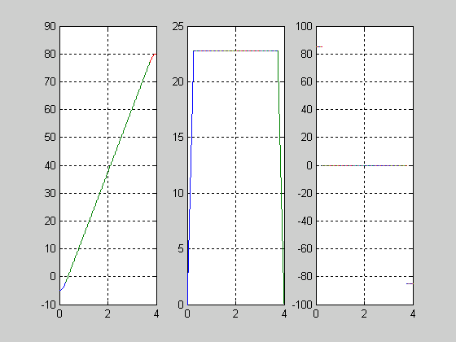

______________________________________________________

7.6)

For the first segment, 0=5, f=15, 0=5, f=17.5, tf=1

From (7.11), a0=a1=0, a2=12.5, a3=-2.5

For the second segment, 0=15, f=40, 0=17.5, f=0, tf=1

From (7.11), a0=15, a1=17.5, a2=40, a3=-32.5

Then, plot Eq. (7.3) 

-----------------------------------------------------------------

7.9)

For the first segment, 0=5, f=15, 0=0, f=0, tf=2

From (7.11), a0=5, a1=0, a2=7.5, a3=-2.5

For the second segment, 0=15, f=-10, 0=0, f=0, tf=2

From (7.11), a0=15, a1=0, a2=-75/4, a3=25/4

Then, plot Eq. (7.3) 

**-----------------------------------------------------------------------------------**

**7.10)**

For the first segment, from (7.26)

For the second segment, from (7.28)