George Bernard Shaw - Biographical

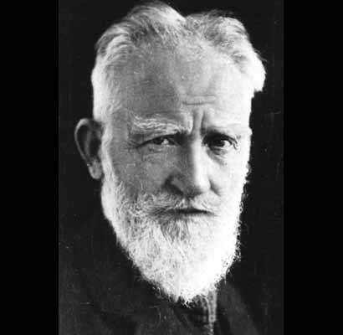
George Bernard Shaw (1856-1950) was born in Dublin, the son of [George Carr Shaw] a civil servant, [corn merchant, and alcoholic, a kindly but ineffectual person who inspired Shaw to become a lifelong teetotaler. Shaw was raised in a “shabby genteel” household, his parents hanging onto the fringes of what was still called “the Protestant Ascendency” without the fortune to maintain its pretentions.] [Shaw was an early and voracious reader, but] [h]is education was irregular, due to his dislike of any organized training. [He left school at 15 but continued to read widely and study music, which was the full-time occupation of his mother, one of his sisters, and their mysterious live-in singing master, George Vandeleur Lee.]
After working in an estate agent's office for a while he moved to London as a young man (1876), where [after a painful decade or so of poverty and hardship] he established himself as a leading music and theatre critic in the eighties and nineties and became a prominent member of the Fabian Society, for which he composed many pamphlets [and trained himself to be a devastatingly effective public speaker and debater. With some fellow Fabians he established the London School of Economics.]
He began his literary career as a novelist [doggedly writing five novels—all rejected by publishers at the time--before he turned to playwriting]; as a fervent advocate of the new theatre of Ibsen (The Quintessence of Ibsenism, 1891) he decided to write plays in order to illustrate his criticism of the English stage. His earliest dramas were called appropriately Plays Pleasant and Unpleasant (1898). Among these, Widower's Houses and Mrs. Warren's Profession [his prostitution play] savagely attack social hypocrisy, while in plays such as Arms and the Man and The Man of Destiny the criticism is less fierce. Shaw's radical rationalism, his utter disregard of conventions, his keen dialectic interest and verbal wit often turn the stage into a forum of ideas, and nowhere more openly than in the famous discourses on the Life Force, «Don Juan in Hell», the third act of the dramatization of woman's love chase of man, Man and Superman (1903).
In the plays of his later period discussion sometimes drowns the drama, in Back to Methuselah (1921), although in the same period he worked on his masterpiece Saint Joan (1923), in which he rewrites the well-known story of the French maiden and extends it from the Middle Ages to the present [This is the play for which he won the Nobel Prize.]
Other important plays by Shaw are Caesar and Cleopatra [written 1898, first staged 1901, filmed 1945], a historical play filled with allusions to modern times, and Androcles and the Lion (1912), in which he exercised a kind of retrospective history and from modern movements drew deductions for the Christian era. In Major Barbara (1905), one of Shaw's most successful «discussion» plays, the audience's attention is held by the power of the witty argumentation that man can achieve aesthetic salvation only through political activity, not as an individual. The Doctor's Dilemma (1906), facetiously classified as a tragedy by Shaw, is really a comedy the humour of which is directed at the medical profession. Candida (1898), with social attitudes toward sex relations as objects of his satire, [and more centrally about marriage, Christian socialism, and the role of the poet in society] and Pygmalion (1912), a witty study of phonetics as well as a clever treatment of middle-class morality and class distinction, proved some of Shaw's greatest successes on the stage. It is a combination of the dramatic, the comic, and the social corrective that gives Shaw's comedies their special flavour. Shaw's complete works appeared in thirty-six volumes between 1930 and 1950, the year of his death.
From Nobel Lectures, Literature 1901-1967, Editor Horst Frenz, Elsevier Publishing Company, Amsterdam, 1969. This autobiography/biography was written at the time of the award and first published in the book series Les Prix Nobel. It was later edited and republished in Nobel Lectures. To cite this document, always state the source as shown above.
Note: The profile above is from the Nobel Website, but the material in brackets was added by your professor, who felt the Nobel committee left out a lot.
For instance, Shaw’s wife, Charlotte Payne-Townsend, an Irish heiress and fellow Fabian, gets left out entirely, as does the rest of Shaw’s very extensive crowd of famous friends and enemies. In his time, he was one of the most famous and influential men in the world. Some of his most interesting works are not listed above, including Adventures of the Black Girl in Her Search for God, and Commonsense About the War, both of which made him extremely unpopular for a while. He also wrote a fun melodrama set during the American Revolution which has been filmed: The Devil’s Disciple. You’ll notice that his Irish plays, John Bull’s Other Island and O’Flaherty V.C. (the latter just a one-act play but worth reading) are also not mentioned. For more about Shaw and Ireland, see The Matter With Ireland, an anthology of Shaw’s writings on his native land, including letters to leaders of its revolution and commentary on post-independence Ireland. Though a Protestant, Shaw was a resolute Republican, meaning he was against partitioning Ireland into an independent republic in the south and a still-British-ruled Northern Ireland. He continually urged his countrymen to stick together.

