‘My Fair Lady’ and other ‘Pygmalion’ adaptations
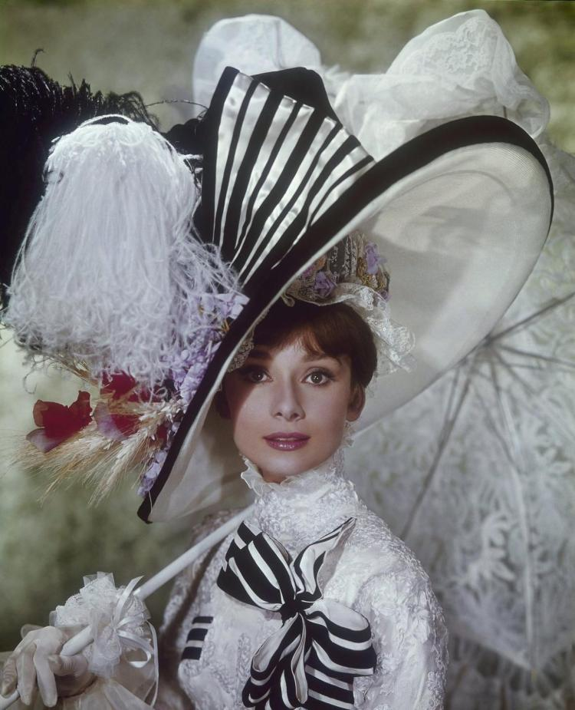

Audrey Hepburn appears as Eliza Doolittle in “My Fair Lady.”
BY Kate Feldman NEW YORK DAILY NEWS Wednesday, October 21, 2015
Fifty-one years ago Wednesday, Audrey Hepburn took center stage at the world premiere of “My Fair Lady” — the story of a snobbish professor and a Cockney flower girl.
While it’s the most popular, “My Fair Lady” isn’t the first story of a woman who’s not good enough and a man who tries to make her so.
George Bernard Shaw’s 1913 play “Pygmalion,” named after a Greek mythological character, created Eliza Doolittle, the girl from the wrong side of town who goes for elocution lessons to try to raise her status.
Here a few other “Pygmalion” adaptations:
“Pygmalion” (1938)
The first movie adaptation of Shaw’s play starred Leslie Howard as Professor Higgins and Wendy Hiller, who also starred in the stage production, as Eliza.
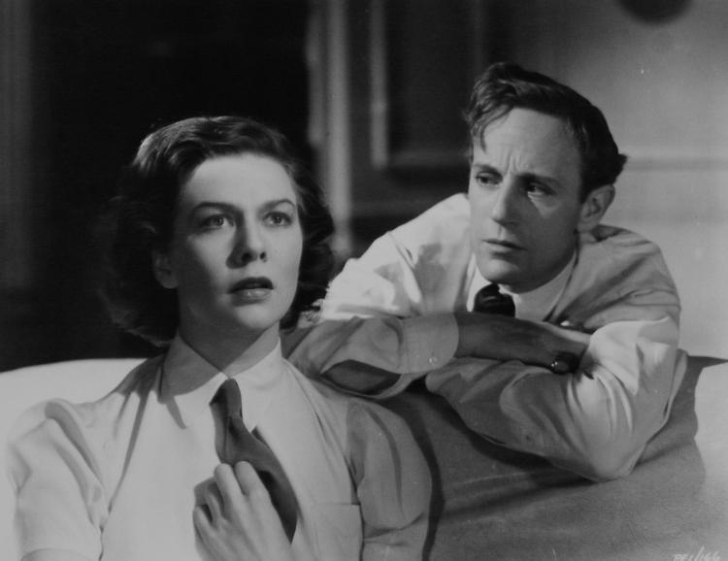

Leslie Howard and Wendy Hiller in “Pygmalion.”
(MGM) The film won the 1939 Academy Award for Writing (Adapted Screenplay) and received nominations for Best Picture, Best Actor and Actress.
“Educating Rita” (1983) One of the first film adaptations to alter Shaw’s original work, “Educating Rita” follows Liverpool hairdresser Rita (Julie Walters), who goes to English professor Frank Bryant (Michael Caine) to overcome her working-class life.
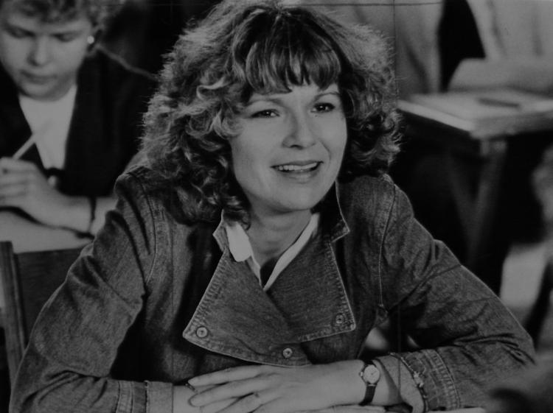

Julie Waters starred in “Educating Rita.”(Columbia Pictures)
The movie, based on Willy Russell’s stage play of the same name, won Golden Globes for Best Actor and Actress and was nominated for Academy Awards for Best Actor, Best Actress and Best Writing for Adapted Screenplay.
“Pretty Woman” (1990) The 1990 film about a businessman and a prostitute is a bit of a stretch, but its basis lies in a rich man helping a poor woman change her life.
Richard Gere helps make over Julia Roberts in “Pretty Woman.”

(SNAP/Rex/REX USA) Vivian Ward (Julia Roberts) found Edward Lewis (Richard Gere) as a client, not a professor to teach her how to speak and behave properly, but he has the same effect nonetheless.
“She's All That” (1999) By the ‘90s, makeover movies were all the rage, but “She’s All That” was the most blatant adaption of “Pygmalion.”
(Miramax) On a bet from his friends, Zack Siler (Freddie Prinze Jr.) turns Laney Boggs (Rachel Leigh Cook) from art school nerd to prom queen and, big surprise, falls in love with her in the process.
“Selfie” (2014) The short-lived ABC show was “Pygmalion” for the 21st century.
After an embarrassing video goes viral, Eliza Dooley (Karen Gillan) hires Henry Higgs (John Cho) to revamp her image.
http://www.nydailynews.com/entertainment/movies/fair-lady-pygmalion-adaptations-article-1.2405697
P.S. In class I mentioned an adaptation that starred Lindsay Lohan. It’s title is Confessions of a Teenage Drama Queen, which has its own Wikipedia page. https://en.wikipedia.org/wiki/Confessions_of_a_Teenage_Drama_Queen
Tried and Trope

Fri Oct 17 2014 9:30am

Because Nothing Says Love Like a Makeover: Top 10 Pygmalion-Style Romances
Rachel Hyland
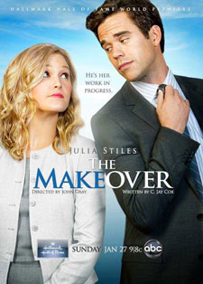
The Makeover
First performed a century ago this very year, George Bernard Shaw’s Pygmalion has long captured the public fancy. The tale of ragamuffin flower seller Eliza Doolittle learning to better herself at the hands of disdainful linguist Professor Henry Higgins in pre-WWI London, the play was named for the Roman sculptor of myth who created himself the perfect woman—though in Shaw’s lengthy postscript to the play, Eliza ends up marrying not her maker but Freddy, her respectable, but ultimately improvident suitor.
With ABC’s Selfie recently arrived on our screens, in which Karen Gillan plays social media obsessed millennial Eliza Dooley to John Cho’s disdainful marketing expert Henry Higgs, the time seems right to look at some previous attempts to bring the story, much like Galatea, to vibrant life. The “Pygmalion” trope, by the way, is vastly different to the “Ugly Duckling to Swan” trope, since it is as much the presence of the ever-so-superior teacher and his (or her) stormy relationship with the spirited student that defines it, as much as does that student’s requisite new beauty and/or ability to use the right fork.
So that being understood, I here submit my favorites...
10. The Makeover (2013)
Thank you, Hallmark, for this gender-flipped attempt, in which uptight and unlikeable politico Hannah Higgins (Julia Stiles) grooms charismatic delivery guy Elliot Doolittle (David Walton) for office—when what he believes she’s training him for is an office job. While I think we can all agree that Stiles hit her rom-com peak with 10 Things I Hate About You and that Walton’s handsome charm is the kiss of death when it comes to TV (every show he’s starred in has barely lasted a full season), nevertheless this cotton candy-light exploration of honesty in politics, embarrassing family members—Frances Fisher as Elliot’s blousy mother is a hoot—and the snobbery directed against South Boston accents is as enjoyable as it is, most surprisingly, thought-provoking. But... Doolittle for Congress? Isn’t that just a given?
9. Kitty (1945)
Hard to find unless you happen to haunt the listings of Turner Classic Movies and its ilk in search of it, this black-and-white costume drama treats with one Sir Hugh Marcy (Ray Milland), who stumbles upon pickpocket-turned-artist’s model Kitty (Paulette Goddard) and sets about making her the toast of late-middle Georgian London, his motive: revenge. Based on the 1943 novel by Rosamond Marshall (also hard to find; it’s not even available for Kindle), the costumes are lavish, especially the ballroom scenes; entirely worth the price of admission for anyone into couture porn, and the romance ultimately very rewarding, although there is one particularly harrowing scene of social mortification that may well stay with you a long, long time. Or that might just me.
8. My Fair Billionaire by Elizabeth Bevarly (2014)
Only rarely does a category romance find its way into my hands nowadays, but the title of this Harlequin Desire all but leapt at me from the shelves when it was released this past June. Telling of a one-time nerd and his “own personal” mean girl, it sees two high school enemies brought together years later when the much-humbled Ava is enlisted to teach the nouveau riche Peyton how to get along in High Society, now that he’s all rich and stuff. Bevarly’s customary sparkle is present and accounted for, the education of each by the other is as sweet as it is judiciously spicy, the dialogue is sharp and the conflicts just tense enough to keep you in that weird state of heightened tension at which this type of novel excels, given that the ultimate outcome is (obviously) never in question. Because this is category romance, and that would be lunacy!
7. Ruby Sparks (2012)
Perhaps the most literal of all these homages to the same idea, since the titular Ruby Sparks (Zoe Kazan) is actually a creation brought magically to life (as in Ovid’s original recounting), this sweet, surreal and yet somewhat sinister offering sees former wunderkind novelist Calvin (Paul Dano) inventing his perfect woman on his old-fashioned typewriter—ever notice how, in movies, Proper Writers eschew such conveniences as spell check in favor of White Out and carriage returns?—and then discovering her made manifest, all witty and nubile, in his kitchen. Also written by the quirky Kazan, this rumination on control, narcissism, self-determination and belonging is as charming as it is no little creepy, a difficult line to maintain and still, somehow, remain romantic, but which this indie darling manages handily.
6. She’s All That (1999)
Poor high school superstar Zack Siler (Freddie Prinze, Jr.). Dumped by his horrid but popular girlfriend after she hooks up with a D-grade reality star, Zack’s reputation for unassailable awesomeness is in jeopardy—so he takes on the apparently (laughably) “impossible” task of turning Rachael Leigh Cook into a Prom Queen. Cue contact lenses, raised hemlines and makeup courtesy of a precocious younger sister (Anna Paquin). Presto! Insta-babe. Now if only Zack can convince Laney to forgive him for feigning interest in her arty self, and get her to turn down the opportunity of a lifetime so that she can most probably be dumped even before he pledges the inevitable frat. (And of course he does manage it. Apparently we women just love those lying liars. And this movie!)
The Proposition by Judith Ivory
4. The Proposition by Judith Ivory (1999)
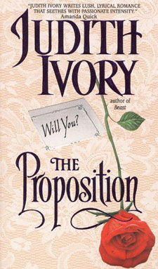
Another gender-swapped entry on the list, this Victorian-era romance sees rat-catcher Mick Tremore taken on as a student by linguist Lady Edwina Bollash, to settle a bet between two gamester brothers. Impoverished but ever-so genteel, Lady Edwina begins the mammoth task of turning this unashamed Cornishman of the lower orders into a respectable society gentleman, just as he —no less peremptorily, it must be said—teaches the insecure spinster how to rejoice in her womanly charms. The inherent sexism of both the myth and the play, in which all the power in the relationship lies with the male as he forces his hapless creation to conform to his ideal of womanhood, isn’t exactly turned on its head here; for all his lowly station, Mick is pure Alpha Male, and the bluestocking Lady Edwina is readily moulded into just his type even as he becomes... well, still himself, just with better manners. Still, it is a fun— if salacious—romp, as long as one can ignore the prude-shaming subtext.
4. La Femme Nikita (1997 - 2001)
There are several iterations of this particular story, from the 1990 French film that started it all to its American remake Point of No Return, to the CW’s more recent four-season attempt. But winner and still champion has to be the cult Canadian production La Femme Nikita, in which a statuesque vagabond of uncertain history (Peta Wilson) finds herself wrongly convicted of murder and forced to become an operative for sinister covert agency Section One. Schooled in the ways of combat by the compelling Michael (Roy Dupuis), Nikita also learns from him how to seduce and beguile—and along the way, he falls for her, which is very much against the rules. (For some reason.) It’s a fun, sexy, angst-ridden ride, and while the technology may have dated slightly – as have the fashions; and there was never an excuse for Michael’s mullet – the transformation of Nikita from street rat to superhero, and her tempestuous relationship with her mentor, will always stand up to a rewatch.
3. Pretty Woman (1990)
This one might be questionable as a Pygmalion adaptation, since there are no high stakes involved, a la Shaw, and neither does the wealthy Edward (Richard Gere) invent sex worker Vivian (Julia Roberts) out of whole cloth, a la Ovid. It does, however, adhere to most of the other themes of those venerable works, with the hooker learning proper comportment and clothing choices while teaching the uptight tycoon with daddy issues how to relax and have fun. All for the bargain rate of just $3000 per week. Aw, so sweet. (As it stands that is, anyway. Had they kept the original ending, with Viv back on the streets after her week in the lap of luxury, I’m not entirely certain it would have made it on this list, despite the spirit of the thing being rather truer to the original. Reality has no place here!)
2. These Old Shades by Georgette Heyer (1926)
Walking down a darkened street in mid-Georgian Paris, the astute and acerbic Duke of Avon is elegantly bored. An aristocratic gamester who has won and lost fortunes in his forty-plus years, he is currently possessed of great wealth and, famously, the luck of the devil. This luck soon sees him take possession of one Léon, a slight and comely young man who seems far too delicately made to have come from the hearty yeoman stock of his supposed family. First employing the impressible scamp as a page, Avon soon ships his new charge off to England to learn to be a lady (for Léon is, in fact, Léonie), and before long not only is she the instrument of his revenge upon a most distasteful enemy, she also proves to be the only woman capable of melting his cold, calculating heart. (Good thing she turned out to be of appropriately rarefied lineage though, isn’t it? Otherwise, we are given to understand, she would have been worthy of nothing except life on a farm. Because pleasing manners are genetic, of course!)
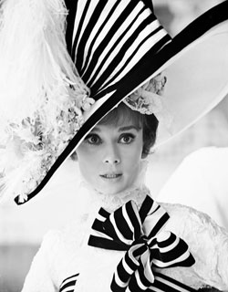
Audrey Hepburn as Eliza Doolittle
1. My Fair Lady (1964)
Oh yes, this was a stage musical first, opening to raves on Broadway in 1956 and starring Rex Harrison and Julie Andrews. But for anyone who did not have a chance to see that wonder in person—which, I imagine, is most of us; what I wouldn’t have given!—then this film version is close to the next best thing, even if Audrey Hepburn’s singing was dubbed, or whatever. Full of remarkable songs from Lerner and Lowe—try to pick a favorite! Go on, I dare you—and giving Shaw’s far bleaker work an agreeable fillip of HEA, this straight-up musical adaptation gives us gorgeous costumes, the exquisite Hepburn as Eliza and a simply masterful performance from Rex Harrison, reprising his stage role with such authority that surely Henry Higgins will never see a more iconic earthly avatar.
HONORABLE MENTIONS: Can’t Buy Me Love (1987); Drive Me Crazy (1999); the Star Trek: Voyager episode “Someone to Watch Over Me” (with Seven of Nine in the Eliza role); the 80s mystery series Remington Steele; Heaven, Texas by Susan Elizabeth Phillips, To Love a Thief by Julie Anne Long; My Fair Concubine by Jeannie Lin; and My Unfair Lady by Kathryne Kennedy. Only time will tell if Selfie will make it onto this list, as well... so far, though, I’m hopeful.Rachel Hyland is Editor in Chief of Geek Speak Magazine.
http://www.heroesandheartbreakers.com/blogs/2014/10/because-nothing-says-love-like-a-makeover-top-10-pygmalion-style-romances
Christopher Campbell
Writer and Editor for Film School Rejects, Movies.com and Nonfics. Follow him on Twitter @thefilmcynic.
Oct 21, 2014

The 5 Best ‘Pygmalion’ Movies Since ‘My Fair Lady’
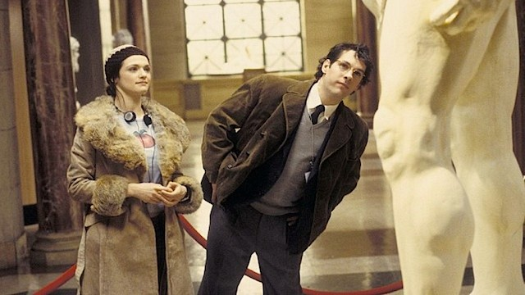
Focus Features
When the movie version of My Fair Lady premiered — 50 years ago today — it was an adaptation of a stage show that was a musical remake of a play that was loosely based on an ancient myth. Once again: “originality” is not that big a deal and never has been. Proof has continued in the legacy of all these properties in the half century since. Even now on television there is a sitcom so admittedly based on Pygmalion that the characters are named Eliza Dooley and Henry Higgs. The fact that most people call this show, Selfie, a modern take on the musical rather than George Bernard Shaw’s earlier drama is not a surprise. Different generations have their reference point. In She’s All That, for instance, Rachel Leigh Cook’s character says, “I feel just like Julia Roberts in Pretty Woman. You know, except for the whole hooker thing.” She could have said Eliza Doolittle.
There are certain movies and other media that are clearly more linked to the play and musical (i.e. Pretty Woman) involving a lower class person transformed by someone of a better social level. Then there are still those that go directly to the source (i.e. Mannequin) where someone falls in love with an initially inanimate creation. The scenario has easily been the basis for many high school movies (including She’s All That) and even some porn films (notably The Opening of Misty Beethoven) and doesn’t always have to be a romantic plot, as in the case of Shaw’s play, in which Eliza and Henry don’t get together, and Weird Science, where Lisa isn’t the boys’ object of affection. There are also many near-similar movies that I wouldn’t qualify due to the objects not really originating at the hands of the protagonist, such as the case with Lars and the Real Girl and Her.
Below are five titles I consider to be the best Pygmalion movies since My Fair Lady, some of them not exactly like the 1964 musical.

Trading Places (1983)
Complete with a bet, this comedy is a take on Shaw’s idea with even less of a romantic connection between the sculptor and his molded creation. Here Higgins and Pickering are likeminded villains, wealthy commodities trader brothers Randolph and Mortimer Duke. Eddie Murphy is their Eliza, a street bum who the fraternal duo attempt to turn into a polished businessman. There’s an added figure, though, in Dan Aykroyd’s Louis Winthorpe III. The Dukes give him the reverse shift, turning him from rich to poor with greater ease.

Can’t Buy Me Love (1987)
This teen movie has never received the amount of respect it deserves — nobody even cared when they remade the thing as Love Don’t Cost a Thing. But it’s every bit as good if not better than the most of the high-school-set social-class explorations, and it’s at least more believable than The Breakfast Club. Two years before Pretty Woman made the mentorship a monetary transaction, Can’t Buy Me Love had one of its own, in opposite order. Like a gender-swapped Eliza hiring a Henry to help her (hey, that’s the twist for Selfie), Patrick Dempsey plays a nerd who pays Amanda Peterson’s cheerleader $1000 to help make him popular. The interesting thing is that it doesn’t take much more than his being seen with her to lift his social status. We had a false sense of equality in America in the 1980s compared to England in the 1910s.

The Shape of Things (2003)
Neil LaBute adapted his own play for this messed-up movie that seems at first to be an innocent rom-com but turns out to be a drama that sort of calls out the situational gimmickry of much of that genre. Rachel Weisz is the Higgins/Pygmalion here, an art student who takes on the task of sculpting a guy so that he’s more attractive and to “change his world.” While more aligned with the myth given that Paul Rudd’s character is an art project, the nature of it being also a social experiment is not unlike the bet involved in the stage play and musical.

Project Nim (2011)
Not only is this an interesting twist on Pygmalion in that it’s a true story, but it’s also an interspecies example. In the 1970s, a chimpanzee named Nim Chimpsky was brought into a family home for a research project aimed at teaching the ape to communicate and thereby be molded to be closer to human than beast. In a way, the taming and educating was as much a success as Higgins is with Eliza, and there’s a weird sort of romantic element to Nim’s relationship with the woman who raises him. Then we see the terrible events of his basically being thrown out (as we do in Can’t Buy Me Love and The Shape of Things), only his fate is worse than if he’d just been sent back to where he’d been found.

Ruby Sparks (2012)
Zoe Kazan’s take on the rom-com genre does some similar things as The Shape of Things, though here we’re back to only our second gender-retaining version of Pygmalion on the list of five. Paul Dano is the artist, a novelist who creates his perfect Galatea in Kazan. Then she somehow comes to life and isn’t as flawless in real life as she was on the page. Fortunately, he can keep sculpting her into what he wants, through his rewriting of her character. Among the many things the film says about men and women in relationships, the main point could be that in more than 2000 years, the male ego and idealization of the female hasn’t changed much.
My Fair LadyPretty WomanRuby Sparks
•

Christopher Campbell
Writer and Editor for Film School Rejects, Movies.com and Nonfics. Follow him on Twitter @thefilmcynic.
https://filmschoolrejects.com/the-5-best-pygmalion-movies-since-my-fair-lady-41082c679893#.wplhb6ly4

