HARVARD BUSINESS SCHOOL—ALUMNI STORIES

Remembering His Roots 14 Nov 2012

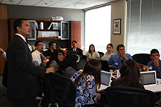
Curiel: Investing in young people who grew up as migrant farmworkers. (Photo courtesy Martin Curiel)
Martin Curiel (MBA 2004) wants you to invest in dreams.
Through the Rising Farmworkers Dream Fund (RFDF), the nonprofit he cofounded with two HBS classmates in 2004, potential donors are encouraged to invest in the educational and professional potential of men and women whose young lives were spent as migrant farm workers. Living by the cycle of fruit harvests, a basic education for these kids was often out of reach or incomplete, and dreams were deferred.
Curiel knows how hard that life is, having spent the first 16 years of his life alongside his family, moving from Mexico up and down the West Coast of the United States to harvest peaches, olives, cherries, and plums. He managed to graduate from high school in California in 1993 and later attended Cal Poly and became an engineer. But not before a tragic car accident changed the course of his life forever.
On a return trip from the cherry season in Oregon, my dad and I were in a deadly collision that took his life and the lives of four other farmworkers,” says Curiel, who was days away from starting college when the accident happened. “My life was spared, and I felt that it was my destiny to continue going forward with full force; this included completing a higher education, providing for my family, and helping my fellow farmworkers.”
Curiel wasted no time, and launched a nonprofit to help migrant students prepare for higher education opportunities. But HBS gave Curiel more effective tools. “HBS opened my eyes to the power and resources of business and the possibility that it could be harnessed for the greater good,” he says.
The Rising Farmworkers Dream Fund (www.risingfarmworkers.org) grew out of an HBS field study that Curiel performed during his second year. Classmates and cofounders Chadd Garcia and Misha Simmonds joined his effort to test that idea following graduation.
The RFDF’s “Mini MBA” program offers migrant students online courses in business and finance while fellowships help finance the application to business schools as well as some of the tuition. The RFDF Exchange, an online platform that allows students to raise money for their respective educational pursuits, is a major component.
“Each student is a stock with a starting price of $10,” explains Curiel. “Depending how much commitment they demonstrate to helping the farmworking community and themselves, the students receive ‘investments’ from a variety of sources, including the RFDF and individuals. More than 200 students are participating in the Exchange, and about 50 investors are actively donating time and financial resources. Through our Entrepreneurs program, we’ve also helped five individuals launch their own small businesses, advised them on their business plans, and helped them land their first clients.”
By day, Curiel serves as vice president of institutional business development for Matthews International Capital Management. Though the firm is worlds away from where he started, Curiel sees his success as fuel for the RFDF and its mission to help change the future for many in his community. He commits 10 percent of his time and 10 percent of his income to the cause, an idea he learned at HBS.
“With its mission of developing leaders who will change the world, HBS has given me the perspective that capitalism is, overall, a positive force,” Curiel says. “Increasing the number of migrant students who become entrepreneurs, investors, or managers will have a game-changing effect on the farmworking community.”
https://www.alumni.hbs.edu/stories/Pages/story-bulletin.aspx?num=1299
Profile from the Rising Farmworker Dream Fund website:
Martin Curiel, Co-Founder, Chairman of the Board
Martin Curiel is co-founder of the Rising Farmworker Dream Fund (RFDF). A migrant farm worker from the age of five until the age of nineteen, Martin has experienced first-hand the harsh life of a migrant and seasonal farm laborer. Alongside his family who originally came to the U.S.

as undocumented immigrants, Martin harvested peaches, cherries, olives, prunes, and many other crops. His community service mission is to leverage the principles of business and capitalism to help migrant workers and other impoverished communities.
Martin is a former engineer with a degree in Civil Engineering from Cal Poly, San Luis Obispo and an MBA degree from the Harvard Business School.
Martin is currently Principal at MYeCFO, an investment advisory firm specializing in tax strategy.

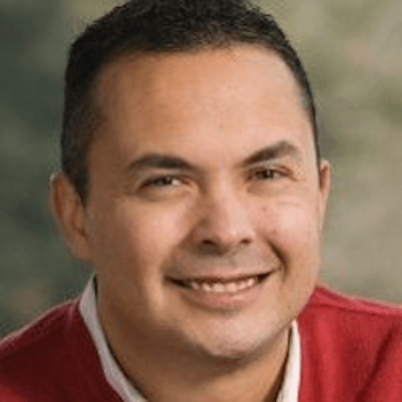
http://www.rfdf.org/

