Native People Offer a Solar Alternative to Fossil Fuels
- Chris Clarke May 2, 2017
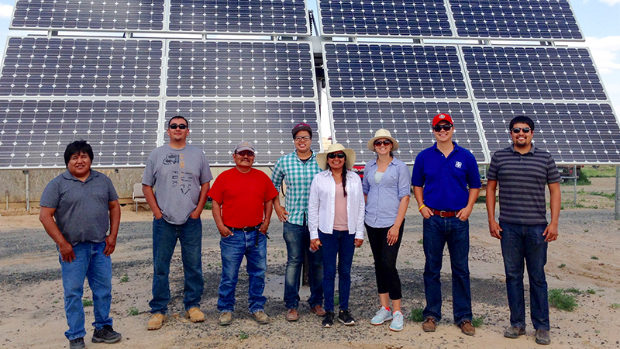
Native solar pioneer Debbie Tewa (center) and colleagues at a solar array on the Hopi Reservation. | Photo: Department of Energy
The completion of the Dakota Access Pipeline, and the recent shift in federal energy policy of which DAPL is a prominent part, may seem daunting to clean energy activists. And the pipeline’s last-minute success is indeed a major setback for the climate, as well as the safety of the Native people and others who live downstream.
[Skip to interactive map]
But DAPL and the current fossil-fuel-friendly White House are a last gasp of a doomed industry. The best-case scenario: Humanity abandons burning fossil fuels out of a desire to limit damage to global climate. The other scenario: damage to our climate rapidly makes our current economy impossible, and society collapses beyond the point where we can maintain the complex distribution system necessary to use fossil fuels.
Either way, solar power will become far more important in the way we live our lives. As it turns out, the region through which DAPL will be shipping oil is full of potential for solar energy development. And Native people are poised to play a big role in the shift to solar, raising the standard of living for those whom the fossil fuel economy has largely left behind.
How much solar energy could the DAPL corridor produce?
Though we do need to replace our current petroleum habit with renewable sources of energy, comparing energy from oil with energy from solar panels is a little tricky. Most of each barrel of oil refined in the United States is used in transportation, most of that used in private vehicles. Though electric vehicles are increasing their share of the market, the technology they use will likely change radically as increased experience and advancing technology prompt refinements. And the same is true of the solar panels that provide more and more of our electricity: they’re getting more efficient and cheaper every year.
At present, according to the Illinois-based solar company Straight Up Solar, a moderately large residential solar array of 9,500 watts capacity can power a typical home and provide enough extra electricity to charge an electric car that drives 1,000 miles each month.
For perspective, a typical solar-paneled home in 2017 has about 5,000 watts of solar panel, so this scenario involves upgrades even to homes with existing solar. That 5 kilowatt average has as much to do with utility policy as with roof size. Change the law so that utilities have to buy all the power homeowners produce, and rooftop solar sizes will jump dramatically.
That one 9.5 kilowatt array on our sample household replaces an average of 40 gallons of gasoline each month, or 480 per year. Each 42-gallon barrel of oil makes about 19 gallons of gasoline, so that one solar array eliminates demand for the gasoline from more than 25 barrels of crude oil each year.
Another 12 gallons of that crude oil gets turned into either diesel fuel — which can be made unnecessary by electric vehicles — or heating fuel. All-solar electric homes can use a combination of design, energy efficiency, solar electricity, and solar hot air furnaces to keep themselves warm. That will reduce the demand for heating oil, but since homes vary a lot more than cars do, it’s hard to calculate the actual savings.
At 1,172 miles long, the Dakota Access Pipeline takes up a lot of room on the landscape. One of the downsides of solar is that it also takes up a lot of room. That’s why many solar advocates urge building solar in places that have already been altered, such as rooftops, parking lots, and contaminated landscapes, to minimize the impact on still-intact habitats.
What would happen if we used the DAPL pipeline route for solar? Let’s say that only 1,000 miles of the total is suitable for solar panel installation, due to river crossings and other local features that make solar panels impractical. And let’s assume that along the rest of that corridor, we build a stretch of solar panels 500 feet wide — not an unusual width for a solar field.
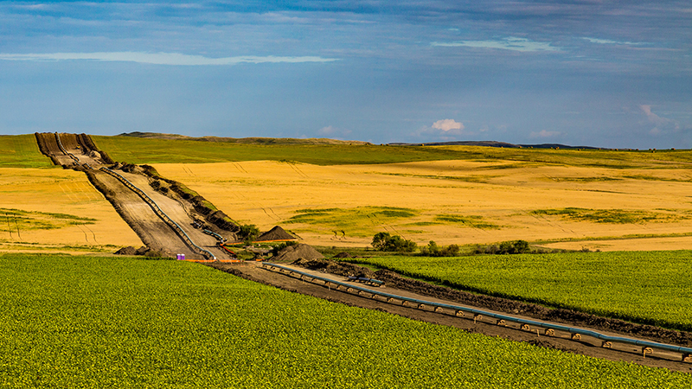
The Dakota Access Pipeline near New Salem, ND | Photo: Tony Webster, some rights reserved
That gives us 60,606 acres of solar panels along the DAPL route. On average, according to the National Renewable Energy Laboratory, 2.8 acres of fixed-tilt solar panels can produce a million kilowatt hours of electricity per year. We’ll spare you the rest of the math[1], but that means our DAPL-wide solar corridor would provide roughly the same amount of energy as 12.8 million barrels of oil.
That’s a little under a month’s worth of oil flowing through DAPL. Replacing a month’s worth of oil in a year of operation may seem inadequate, but remember that oil from DAPL will be used far outside of that corridor, and the pipeline corridor is just one of many places that could be equipped with solar panels.
Replacing all of DAPL’s energy production would take 1.1 million acres of solar panels in total.
That’s an imposing figure at first glance. But in 2004, it was estimated that there were 27.5 million acres of rooftops, roads, parking lots, and other so-called “impervious surfaces” in the United States. Putting solar on one of every 27 of those acres would replace DAPL’s energy. About a quarter million acres is either paved or repaved in the US each year. If we mandated that all new pavement in the US be built with a solar power canopy, we could replace DAPL with solar by 2022.
One other comparison. The Bakken Formation itself, where DAPL’s oil comes from, is around 200,000 square miles. If the land atop that formation was covered in solar panels, it would provide one hundred times more energy each year than the Dakota Access Pipeline. Given the fact that there are still thriving habitats atop the Bakken despite all the drills and spills, that’s probably not a great idea. But it gives you some indication of solar’s potential, and — unlike the oil in the Bakken — the sun isn’t going to run out anytime soon.
Not a solar panel in sight. Aerial view of downtown Bismarck, ND | Photo: Google Earth, by cclarke
Rooftop Solar and DAPL
The biggest recent growth in solar nationwide has been on rooftops, so how do the nation’s roofs compete with DAPL? We crunched the numbers for the pipeline’s immediate neighbors: the counties in North Dakota, South Dakota, Iowa and Illinois through which the pipeline is routed.
According to the U.S. Census Bureau, in 2015, the 49 counties traversed by DAPL had just 511,319 housing units between them, a reflection of their very rural character. Not all housing units are suitable for solar: some are shaded by trees, or parts of apartment complexes, or don’t have roofs that can hold solar panels. But let’s assume that half those housing units installed a typical 5,000-watt solar array: that’s more than 1,278 megawatts of solar power generating capacity. In a year, that much solar panel will produce energy equivalent to about 1.1 million barrels of oil.
If we zoom out to include all 7.4 million or so households in the four DAPL states, that’s solar energy equivalent to 16,011,097 barrels of oil a year, a full tenth of DAPL’s production. And that’s not counting potential solar in parking lots, along highways, on warehouses and malls, and in other places.
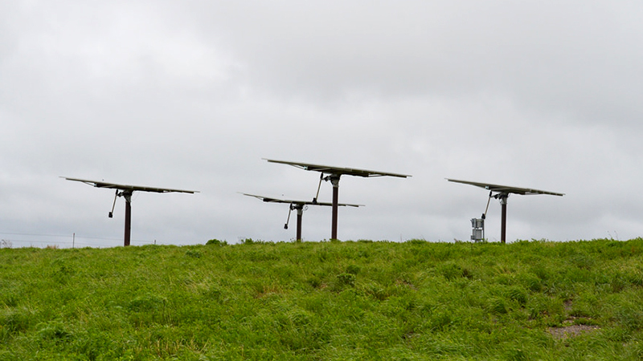
These solar panels on the Audubon National Wildlife Refuge make up a significant percentage of North Dakota's total solar capacity. | Photo; USFWS
DAPL States Have Lots of Potential for Solar Development
According to the Solar Foundation, North and South Dakota place dead last and next-to-last, respectively, among states when measured by installed solar power capacity. In 2016, North Dakota had enough installed solar panels to power just 25 homes. By contrast the District of Columbia, which is less than one-thousandth the size of North Dakota, had enough solar installed in 2016 to power 3,884 homes: more than 150 times as much solar capacity as North Dakota. In other words, Washington D.C. has more than 150,000 times as much solar per acre as North Dakota.
South Dakota isn’t much further ahead, with just enough solar to power 46 homes in 2016. Iowa and Illinois look better; Iowa’s got about 100 times more installed solar capacity than South Dakota, and Illinois has more than twice Iowa’s installed capacity, with enough solar to power more than 10,000 homes.
But when you consider that Illinois has more than 5.3 million homes, that 10,000 looks pretty small.
The good news is that this means the DAPL states have lots of room for improvement. They offer plenty of sunshine, and even the laggard Dakotas are experiencing significant growth in their solar industry. Both North and South Dakota’s solar jobs grew by 50 percent from 2015-2016, and that growth is projected to continue.
One thing that would help is policy changes. The Solar Foundation gives both the Dakotas very low ratings for state policies on things like net metering and interconnections, which can make or break local solar companies. And unlike Illinois and Iowa, neither of the Dakotas have state laws mandating a certain amount of their electrical power come from renewable sources. State legislatures in all four states have a lot of power to encourage their local solar growth.
-4:12
Now Playing: Red Power Energy: Solar
Red Power Energy: Solar
Solar Helps Native Peoples
The federal Energy Information Administration estimates that 14 percent of all households on Indian reservations don’t have access to electrical power. On some reservations in DAPL country, that figure’s a lot higher. Almost half the residences on the Pine Ridge Reservation in South Dakota don’t have electricity, for instance. At Standing Rock Reservation, the epicenter of world attention to the Dakota Access Pipeline, almost no tribal households had electricity until the 1960s. Lack of access to electrical power limits access to education, employment opportunities, and information.
Solar power is uniquely suited to address the problem of unequal access to electricity. These days, it costs less than $50 to buy enough solar panel to keep an entire family’s phones charged. Completely electrifying a house far off the grid has been possible for decades, but rapidly falling solar prices and government assistance are bringing that power within reach of the less affluent, including Native people in remote places.
In 1987, the Hopi Nation founded a company called Hopi Solar Electric Enterprise, which offered a way for Hopi people to electrify their homes on a rotating payment plan, no matter how far off the grid those homes were. The idea spread to other reservations, slowly at first, but ever faster as dropping costs made solar more accessible.
And that’s not just about solar electricity. In 2008, one notable Native solar company, Lakota Solar Enterprises, opened on the Pine Ridge Reservation in South Dakota. Lakota Solar Enterprises manufactures solar furnaces, which use sunlight to heat air that’s then blown into a house with a solar-powered fan.
“It’s a new way of honoring the old ways,” says Lakota Solar Enterprises’ founder Henry Red Cloud.

[1] Except to mention that every barrel of oil provides the equivalent of 1.69 megawatt-hours of energy.
https://www.kcet.org/shows/earth-focus/native-people-offer-a-solar-alternative-to-fossil-fuels
Note: The original article had more visuals (mostly maps) and links to other articles on the subject.

