5 Ways Alternative Spring Break Serves You and the Community

Companies with social missions want grads with hands-on experience and skills in leadership and problem solving
Isabel Thottam
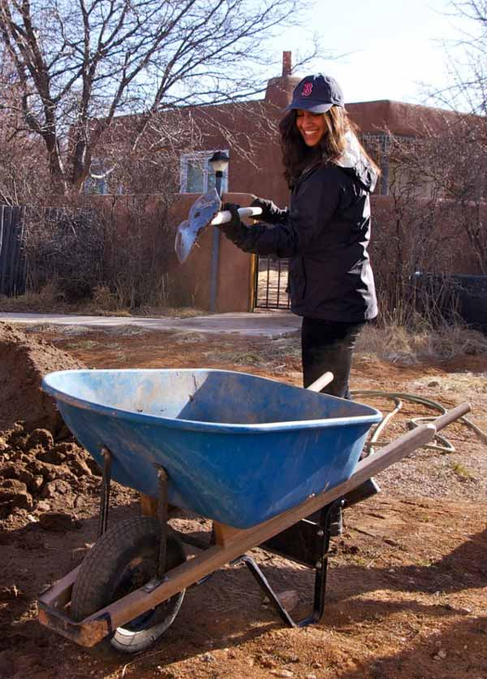
Student works to clean up the grounds of a local community center in Taos, NM | Photo courtesy Suzanne Hinton
Every March, students flock to their favorite destination spots to enjoy a break from essays and midterms. While some students may spend their time off relaxing, others may take a more alternative route to the traditional spring break.
“Alternative Spring Break,” often referred to, as “ASB” is a weeklong service opportunity most college campuses offer students as a unique way for students to spend their vacation. While some school programs will spend their week volunteering in their local communities, others may travel outside their own city to give back to a less fortunate area.
A college’s ASB program is usually offered through their campus activities or student affairs department. Some schools also partner with organizations, like Habitat for Humanity, that run college programs designed to execute volunteer trips.
Habitat For Humanity’s Collegiate Challenge program connects volunteers to needs in their communities and since its start in 1989, the program has had 230,100 students volunteer through their spring break program and 543 affiliates have hosted student groups.
Break Away is a national nonprofit organization that promotes the development of quality ASB programs through training, assisting and connecting campuses and communities. Their annual report notes that in 2014 there was a 26 percent year-to-year increase in the number of ASB volunteers alongside a 37 percent increase in the number of community partners served. Additionally, Break Away assisted with 1,551 trips and served 1,993 community partners.
ASB trips can focus on a wide range of social issues: from working in a soup kitchen or homeless shelter to rebuilding trails in national parks; there is much to benefit from and learn while on a service-oriented break.
Though it may seem like a big commitment to give up your spring break, here are five benefits from joining your school’s ASB program that'll change your mind.
Travel with a new perspective
“Participants on Alternative Spring Break get an opportunity to be a part of something bigger than themselves. They have an opportunity to learn more about issues, people and areas with which they often have no prior experience,” says Claude Bartholomew, five-year advisor of Emerson College’s ASB program located in Boston, Massachusetts. Bartholomew and his student volunteers have traveled to Iowa, Florida, New Mexico, Mississippi and Michigan to work on a variety of social issues.
If you enjoy traveling and volunteering, ASB trips offer a unique way to experience both. While it may not be the typical vacation, you’ll be witness to a first-hand account of a community’s culture. Whether you’re thinking of international or domestic service levels, volunteering is a great way to learn, engage and give back to a community while also exploring.
Organizations like Cross-Cultural Solutions and GVI USA offer a variety of domestic and international volunteer trips for students and young adults looking to have a more impactful vacation. Through a structured program both organizations offer students the opportunity to be immersed in new local cultures and experience a lifestyle you don’t witness as a normal tourist.
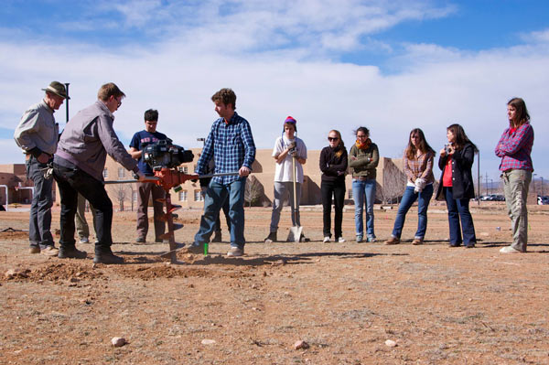
Students lay groundwork for outdoor garden at a Native American high school in Santa Fe, NM | Photo courtesy Suzanne Hinton
Impact relevant social issues
This spring, many schools with ASB programs are heading to Ferguson to participate in cleaning up the community. Students who are volunteering in Ferguson will help local businesses rebuild as well as working directly with community members with donations and voter registration. By addressing current events, ASB gives students the opportunity to engage with communities directly affected by something they watched unfold nationally.
Moreover, ASB projects that focus on current events or natural disasters are often wonderful educational opportunities that allow students to apply knowledge they’ve learned in the classroom to a real-world experience. For example, after Hurricane Katrina and Hurricane Sandy, many ASB programs sent students to assist first-hand with recovery projects.
Get ready to mingle
When you sign up for ASB, you might be joining students you don’t know or have not yet met during the school year. If you do your first trip during your last semester, you might even find yourself meeting people you never knew you went to the same school with.
ASB is a great chance to meet new peers and you’ll often leave with a few close friends since you share a common desire for volunteering. Thought it may seem like a given, meeting new people can be tough when you graduate school and having the experience of doing so under the circumstances of a volunteer trip gives you a bit more preparation.
Volunteer experience gives your resume the hands-on experience you need
Though it’s not the driving reason students join ASB, it’s a good note to consider that you can add your volunteer experience to your resume. Employers, especially ones with a driven social mission, will be interested to hear about your volunteer work and the skills gained. If you have a more leadership role in your ASB program, it will also translate to professional growth.
Bartholomew believes that there is an invaluable amount of key benefits for student trip leaders. He explains, “From the logistics to coordinating schedules and meetings to actually leading their peers in service — the process is very demanding, but extremely rewarding.”
The type of skills you earn on a service-oriented trip will vary depending on the trip’s focus, however, ASB strongly focuses on team building, communication and problem solving. Additionally, participants might learn how to operate machinery, use tools and lift heavy equipment among other tasks that you wouldn’t experience in a classroom.
Whether you lead the trip with newfound construction skills or knowledge on environmental conservation, there’s a good chance someone reviewing your application will have been on ASB or know what that experience provides. If you’re smart about it, you could show how your time spent volunteering exemplifies your work ethic and personality.
Step outside your comfort zone
One of the best aspects of ASB is that it challenges you to be comfortable with the uncomfortable. As you prepare to graduate school and enter the working world, an ASB trip is a great opportunity to test what your transition is going to be like. You’re not going to know everyone on your trip and you’ll be volunteering in underserved communities, which might be jarring or uncomfortable at times. Yet, through experiencing this, you’ll learn to be a more adaptable and introspective person, which will be useful when you start your first job.
Bartholomew has seen students change throughout the duration of the trip as well as beyond it. “During the trip itself, I often see students excited by the new situations and experiences or I see students challenged by unfamiliar surroundings and situations struggle to make sense of what they are experiencing. Many students fall somewhere between the two. There is a lot to learn. A lot to take in during that week, which is why oftentimes it isn't until a few weeks after arriving back on campus that I hear from students about their growth.”
Bartholomew also thinks the experience helps students reevaluate their lives and sometimes choose entirely different career paths after their time on a service trip.
“The experience of ASB is in some ways unique to the focus of a particular trip,” he says, “but the overall impact of the experience is opening eyes, hearts and minds.”
Once you've fine-tuned your resume with these volunteer skills, see what social advocacy jobs are available and apply with Monster!
Monster Wants to Know: Are you participating in an ASB program this spring? Share with us in the comment section

Relate Article: B Corporations: Finding Meaning and Money in Doing What You Love
https://www.monster.com/career-advice/article/5-ways-alternative-spring-break-serves-you-and-community

