Opinion

What we can do to prevent ‘climate refugees’
By Thane Kreiner Published 4:54 pm, Monday, November 30, 2015
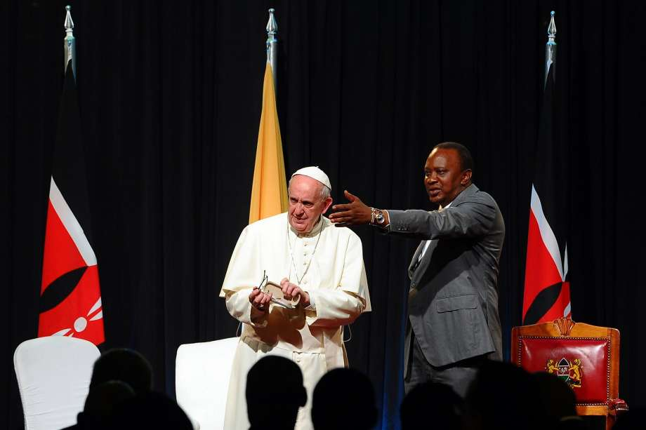
Photo: John Muchucha, AFP / Getty Images Kenyan President Uhuru Kenyatta (right) gestures next to Pope Francis at the State House of Nairobi. Pope Francis said the world was facing a “grave environmental crisis” as he arrived in Kenya before a crucial United Nations summit on climate change.
What do Pope Francis and Elon Musk have in common? The leader of the Catholic Church and one of the world’s most successful entrepreneurs both warn that climate change could trigger a global refugee crisis that will dwarf what Europe now faces with Syrian refugees.
With climate change, disasters such as drought, flooding, famine, lack of clean water, loss of crops and deforestation will become more common and more intense. The world’s poor are strongly dependent on local natural resources, so they will suffer most.
The developed world is still largely sheltered from climate change effects. But the world’s poor feel the impacts directly. If arable land is flooded or hit by drought, if crops or livestock die, if fisheries fail, if water sources dry up or become polluted, if it becomes impossible to locate or afford adequate fuel for cooking, heating and lighting — people have little option but to leave their homes.
And that’s how predictions by Pope Francis, Elon Musk and others about “climate refugees” will become reality.
What’s the solution? At the highest level we need global governmental agreements, such as those being hammered out at the U.N. conference on climate change in Paris to reduce greenhouse gas emissions and develop new technologies for carbon sequestration.
But policy-level agreements are not enough, in part because their goals lie decades in the future. Between now and then, we need to address the effects of climate change that are happening now.
The good news is that action is already taking place. One approach with proven success is generating “climate resilience” through social entrepreneurship — businesses created primarily to solve social and often environmental problems, while also generating financial returns. Climate resilience is the ability for a community to keep functioning in the face of climate change, and to create more sustainable social and ecological systems that can better handle future impacts of climate change.
Here’s how social entrepreneurship is helping to build climate resilience:
•A local social enterprise filters, treats, or distributes clean water in its neighborhood. These water systems increase access to safe water without miles of walking to find retreating water sources, while providing livelihoods to the entrepreneurs. Examples include Naandi in India, Jibu in central Africa and Nazava Water Filters in Indonesia.
•Networks of entrepreneurs, often women, sell household-sized solar energy and lighting systems to their neighbors. These off-grid solar solutions provide better lighting at lower costs, reduce the use of carbon and wood fuels, replace toxic kerosene lamps, and increase household prosperity. Models include Solar Sister in Africa, Iluméxico in Mexico, and Empower Generation in Nepal.
•Small-scale bio-digesting fermenters turn animal and even human waste into usable bio-gas. These systems help rural communities to generate affordable, easily available, clean energy; protect water sources from fecal contamination; reduce the use of chemical fertilizers and toxic fuel sources; prevent deforestation, and improve the incomes of farmers. Sistema Biobolsa in Mexico is an example.
By taking steps at a local level, communities can overcome the effects of climate change while improving their own economies, ecosystems and health. They become less likely to have to flee their home regions.
Although the Middle East refugee crisis can’t be attributed only to climate change, it would be foolhardy to ignore the potential role of climate change in large-scale migrations of people or the promise of social entrepreneurship to stem the tide.
Thane Kreiner, Ph.D., is the executive director of the Miller Center for Social Entrepreneurship at Santa Clara University.

