“Painterly” Influences on Sweet Land

In discussing what influenced him in designing the “look” of the film, the director of Sweet Land mentions two painters in particular, Andrew Wyeth and Edward Hopper. Below are some examples of their work.
Andrew Wyeth (born 1917 – died 2009) One of the most famous American painters of the 20th century. His NY Times obituary begins this way: “Andrew Wyeth, one of the most popular and also most lambasted artists in the history of American art, a reclusive linchpin in a colorful family dynasty of artists whose precise realist views of hardscrabble rural life became icons of national culture and sparked endless debates about the nature of modern art, died Friday at his home in Chadds Ford, Pa. He was 91.” Some of his most famous works:

Christina's World (1948)
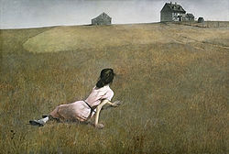
Wind from the Sea (1947)
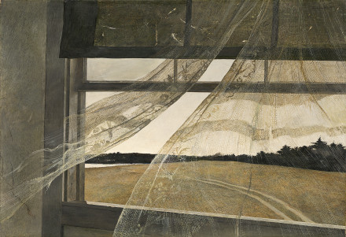

Edward Hopper (1882-1967) He is most famous for his paintings of urban life (as in the first example below), but you can see in his landscapes how his vision relates to the film’s look, as well. For a larger selection here’s a good site.
