Barack Obama brings message of change to Cuba, meeting with Raul Castro: U.S. president wants to boost Cuba's private sector by lifting trade embargo 'once and for all'
CBC News Posted: Mar 21, 2016 9:04 AM ET Last Updated: Mar 21, 2016 8:19 PM ET
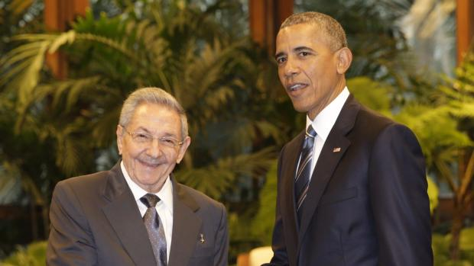
Obama and Castro official meeting in Havana 1:34
- Is Obama's Cuba visit a historic opportunity or a historic mistake?
- Rain, roadblocks can't deter Cubanos from historic Obama visit
- U.S. already engaging Cuba on many fronts to strengthen ties
- Barack Obama's visit to Cuba raises hopes amid economic hardship
Brushing off decades of distrust, U.S. President Barack Obama and Cuban President Raul Castro shook hands Monday in Havana's Palace of the Revolution, a remarkable moment for two countries working to put the bitterness of their Cold War-era enmity behind them.
Obama and Castro stood together as a Cuban military band played the national anthems of Cuba and the United States — stunning sounds in a country where resistance to the U.S. has been part of the national mission for decades. Greeting each other warmly, the two leaders inspected an honour guard before sitting down in front of U.S. and Cuban flags.
Whether Obama and Castro could use the meeting, one of the first since Cuba's 1959 revolution and the only one in Cuba, to further the ambitious diplomatic experiment they started 15 months ago was an open question, infusing Obama's historic trip to Cuba with uncertainty and tension for both governments.
At a press conference afterward, Castro listed some of the obstacles that remain between the two countries, including the economic blockade that remains even with its recent loosening. He said he recognizes that Obama wants the blockade lifted entirely, but that Congress has refused to go along.
"The blockade stands as the most important obstacle to our economic development and the wellbeing of the people," he said.
The return of the U.S. base at Guantanamo to Cuban control is a second major issue that must be settled, he said.
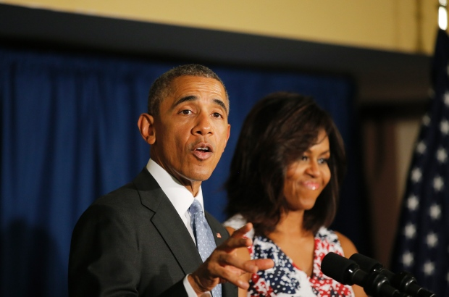
U.S. President Barack Obama and his wife Michelle talk with the staff of the U.S. Embassy at a Havana hotel, soon after their arrival for a three-day trip. (Carlos Barria/Reuters)
For Obama, there's no better place than Havana to show that engagement can do more than isolation to bring about tangible change on the communist island.
At the press conference, Obama said ties are being strengthened, and he expressed hope that process would continue — even given the irritants over differing views of human rights.
"We're moving ahead with more trade," he said. "With only 90 miles (145 km) between us, we are natural trading partners."
Yet for the Cubans, the glaring question is whether their own government is ready to prove the ambitious diplomatic opening is more than just talk.
American companies, eager for opportunities in Cuba, were wasting no time. Obama announced that tech giant Google struck a deal to expand Wi-Fi and broadband internet on the island, 145 kilometres south of Florida.
"The time is right," Obama told ABC News when asked about the timing of his visit.
"Although we still have significant differences around human rights and individual liberties inside Cuba, we felt that coming now would maximize our ability to prompt more change, particularly because this has been welcomed by the Cuban people with enormous popularity."

'Change is going to happen'
In the ABC interview, Obama said he knows change will "not happen overnight," in Cuba, but that it is happening.
"Change is going to happen [in Cuba], and I think that [President] Raul Castro understands that," he said.
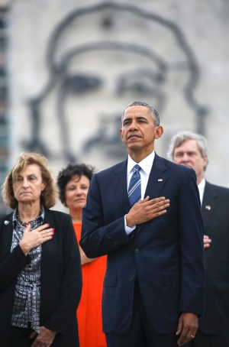
Barack Obama stands in front of a monument depicting Cuba's revolution hero Ernesto 'Che' Guevara and listens to the U.S. national anthem during a ceremony at the José Marti Monument in Havana. (Dennis Rivera/Associated Press)
Obama opened his first full day of his three-day visit to Cuba by adjusting a wreath at the Havana memorial to José Marti, where an 18-metre statue pays tribute to the Cuban independence hero and writer.
Hand on his heart, Obama stood in Revolution Square as a band played the American national anthem — stunning sounds in a country where resistance to U.S. influence has been part of the government's national mission for decades.
Obama is the first sitting U.S. president to visit Cuba in 88 years. The first and only U.S. president in office to visit the island was Calvin Coolidge in January 1928. Former president Jimmy Carter travelled to Cuba in March 2011 as a private citizen at the invitation of Raul Castro.
After their bilateral meeting, Obama and Castro addressed a room of reporters, a routine occurrence for U.S. presidents but an anomaly in a communist country where the media are tightly controlled.
It's extremely rare for Castro to preside over a formal news conference, although he has sometimes taken reporters' questions when the mood strikes. The White House worked feverishly to get him to agree, with negotiations going right up until the moment the two walked out of their meeting and faced reporters.
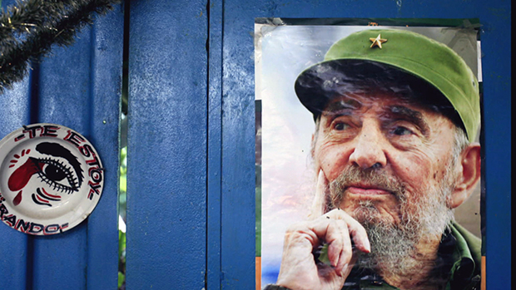
Life in Cuba then and now6:02
Asked by an American television reporter about political prisoners in Cuba, Castro seemed oblivious, first saying he couldn't hear the question, then asking whether it was directed to him or Obama. Eventually he pushed back, saying if the journalist could offer up names of anyone allegedly imprisoned, "they will be released before tonight ends."
"What political prisoners? Give me a name or names," Castro said defiantly as Cuban citizens watched on state television. He added later, "It's not correct to ask me about political prisoners in general."
After responding to a handful of questions, Castro ended the news conference abruptly, declaring, "I think this is enough."
Later in the evening, a senior aide to president Obama said Cuba has political prisoners, and the U.S. government has shared its list of them with the Cuban government.
"I've shared many such lists with the Cuban government over the course of my two and a half years now of dealing with them," U.S. deputy national security adviser Ben Rhodes told reporters, referring to Castro's earlier comments. "There certainly are additional prisoners whose names we raise on a regular basis with the Cuban government."
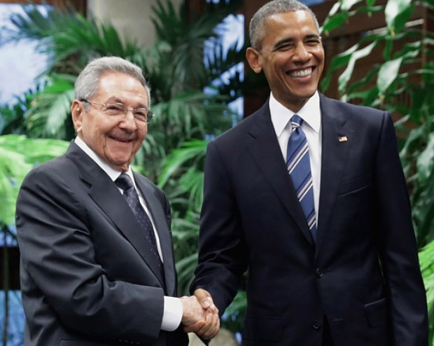
U.S. President Barack Obama, right, and Cuban President Raul Castro greet one another before a meeting at the Palace of the Revolution in Havana. (Chip Somodevilla/Getty Images)
The current U.S. president worked through a full schedule Monday. In the afternoon, he attended an event with U.S. and Cuban entrepreneurs aimed at championing Cuba's fledgling private sector.
At the entrepreneurship summit, Obama vowed to help private businesses in Cuba by lifting the trade embargo on the island "once and for all."
President Obama praised Cuba's opening its economy to private enterprise, a change that began in earnest after Raul Castro took power in 2008. Roughly a half-million Cubans today are small business owners or their employees.
He called on Cuba to help small business owners by creating wholesale markets to supply them, unify a complicated dual-currency system and refurbish infrastructure to allow goods to get to market faster.
"I'm absolutely convinced that, if given a chance, more Cubans can succeed right here at home," said Obama.
After the meeting and entrepreneurship summit, there is a state dinner in the evening.
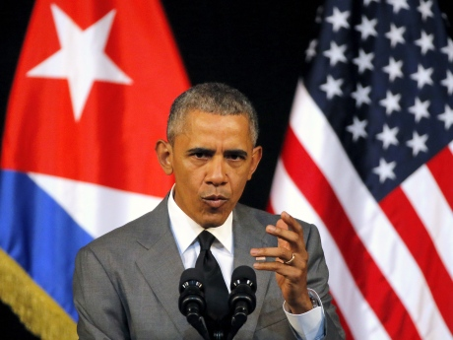
On the final day of U.S. President Barack Obama's historic visit, he delivered a speech to the Cuban people at the building that houses the island nation's national ballet company, in Havana, on March 22, 2016. In it, Obama called for an end to the half-century old trade embargo and for continued change in Cuba. (Carlos Barria/Reuters)
1 of 11
The two leaders have deep differences to discuss as they attempt to build the bilateral relationship.
Obama is under pressure from critics at home to push Castro's government to allow dissent from political opponents and further open its economy.
Castro has said Cuba will not waver from its 57-year-old revolution and government officials say the United States needs to end its economic embargo and return the Guantanamo Bay naval base to Cuba before the two nations can enjoy normal relations.
Thwarted by the U.S. Congress on the embargo, Obama has instead used his executive authority to loosen restrictions on trade and travel with the Caribbean island.
Cuba has praised those measures but Castro was expected use the meeting to press Obama to go further.​

'This is pure history'
Locals watched the presidential motorcade from balconies and backyards as Obama was driven downtown, where a small crowd of Cubans braved a tropical downpour and tight security.
They chanted "viva Obama, viva Fidel," as the U.S. president and his family left after eating dinner at a privately owned restaurant in a working-class neighbourhood.
The trip is the culmination of a diplomatic opening announced by Obama and Raul Castro in December 2014, ending an estrangement that began when the Cuban revolution ousted a pro-American government in 1959.
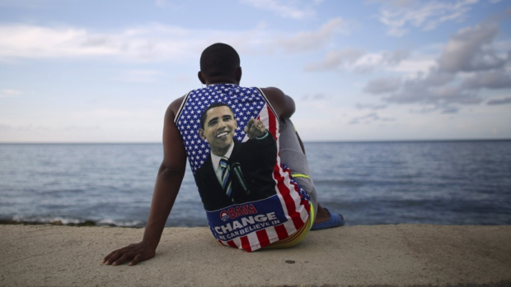
U.S. President Barack Obama has described his visit to Havana as a historic opportunity to engage with the Cuban people. (Alexandre Meneghini/Reuters )
"This is pure history and I never thought I'd see something like this," said Marlene Pino, a 47-year-old engineer. "It's difficult to quickly assimilate what's happening here. For me, it's extraordinary to see this."
On Sunday, one bystander in Havana shouted: "Down with the blockade," referring to the U.S. embargo in place for 54 years. Obama, who responded to the shout by raising his right hand, has asked Congress to rescind the embargo but has been blocked by the Republican leadership.
On Tuesday, Obama will deliver a speech on live Cuban television and attend an exhibition game between Major League Baseball's Tampa Bay Rays and Cuba's national team.
With files from The Associated Press and Reuters
http://www.cbc.ca/news/world/cuba-obama-1.3500321

