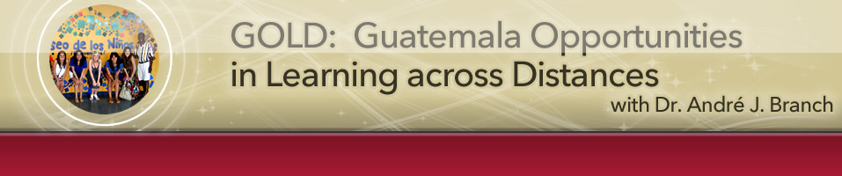

Reflection - Nahomi
The alternative Spring Break in Guatemala was an unforgettable experience, not only because it was a different spring break, but most importantly because of everything I learned while immersed in the Guatemalan culture. Starting with the team I thought was great and helped this experience be a great one. We all got along really well and each had something unique to give to the students. While one was better in planning a lesson, the other was better in playing sports with the kids, etc.
I am from Mexico and the people in Mexico are a lot like Guatemalan people. They are generous and loving. I realized that people in Guatemala are happy with what they have. They do not need to have the best house, clothes, or any material possessions; as long as their family is united they are happy. I speak fluent Spanish and I had the opportunity to talk to people in Patulup, the town we were teaching and in Chichicastenango, where we stayed. I met a woman in the market who was selling purses, while we were talking she mentioned she had five children, and how they were all a blessing from God. That really struck me to see how people in Guatemala value the importance of life and live every day to the fullest.
In addition to this wonderful experience, I also noticed how fortunate I am of having had a great education and life, I couldn’t ask for more. Having prepared the lesson plans for the students and teaching them, made me realize my passion for teaching others, especially those who have not had the same opportunities I’ve had. I have decided to teach low income students, and am looking forward for this upcoming experience, which I know this Guatemalan trip has taught me great skills that will prepare me for my future.
Finally, I want to thank you Dr. Branch for all your effort invested in this trip. It was worth it! I had one of the best times of my life!
Main page for the class: http://go.sdsu.edu/education/guatemala/Default.aspx

