Extra Credit: Rhetoric in the Real World
Overview: Below you will find two recent pieces from the SF Chronicle about the strike we might have. Your task, should you choose to accept it (for extra credit points), is to use your newly honed rhetorical analysis skills to analyze and evaluate the one that is an argument, the Op-ed piece. The article (which should be objective, even if it quotes people who have an opinion) is just included for some background.
Details: Read the article, then read and analyze the op-ed piece, written by the editors of the newspaper. Discuss how the op-ed piece uses the three appeals—pathos, logos, and ethos. You should also say whether you find the piece persuasive, and why. I’d like a full typed page in all.

“As strike looms, arbitrator says CSU faculty deserve pay raise” (article)
By Nanette Asimov Updated 4:10 pm, Monday, March 28, 2016
As thousands of California State University instructors prepare to walk off the job in two weeks, a neutral fact-finder’s report concluded Monday that they are right to demand a bigger salary increase than CSU wants to give them.
A 5 percent raise for the 23,000 California Faculty Association members — and extra pay increases for the lowest-paid instructors — are “in the interest of students, who need caring faculty, and certainly in the public interest, as our country needs a well-educated population,” Bonnie Castrey, the investigator, wrote in a 15-page nonbinding report.
Faculty representatives applauded her findings, which reflected what the union is requesting. They have set strike dates for the five weekdays between April 13 and April 19 at CSU’s 23 campuses, which enroll about 460,000 students. The union represents professors, lecturers, librarians, counselors and athletic coaches.
“If management doesn’t step up, we will hold the biggest strike in U.S. education history,” the union’s president, Jennifer Eagan, said Monday.
CSU is offering a 2 percent raise and says the university doesn’t have the $70 million it would take to meet the faculty request, much less the additional $40 million to raise other employees’ pay under contracts that tie increases to faculty raises.
The sides are negotiating pay for this academic year and next. After they were unable to reach a deal in the fall, the state Public Employment Relations Board offered the services of Castrey, an arbitrator. CSU and union officials agreed.
Putting off projects
Castrey heard three days of testimony, read through voluminous documentation, and concluded that CSU faculty members are underpaid compared with instructors at similar universities. At high-enrollment campuses, including San Francisco State and San Jose State, full professors’ salaries lag behind those of their peers by almost 18 percent, she said, and assistant and associate professors’ pay levels are 4 and 7 percent lower, respectively. At campuses with lower enrollment, the pay gap is narrower, Castrey found.
The union says 60 percent of CSU instructors are temporary lecturers working mainly part time and earning $28,000 a year on average. Full-time, tenured professors earn an average of $96,000 a year. Add assistant and associate professors, and the average drops to $85,000.
To pay for raises, Castrey recommends that CSU reallocate money from unspecified projects and delay their implementation for “a year or two.”
In response, CSU Chancellor Timothy White told The Chronicle that “if we redirected money, it would hurt students. We’d have to decrease classes, lay off (lecturers) teaching those classes, and decrease student support services and advisers.”
CSU’s operating budget is $100 million below prerecession levels, White said. “We can’t spend money that we don’t have,” he said.
Castrey recommended that CSU and the union jointly approach the state Legislature and Gov. Jerry Brown for more money. Brown, a CSU trustee, declined through a spokesman Monday to comment on the labor battle.
Threatening 1st walkout
The two sides negotiated for almost 10 hours as recently as Friday. Hanging over the dispute is the union’s threatened strike, which would be the first systemwide faculty walkout in CSU history.
Although the strike is set for five weekdays, Eagan said that if no agreement is reached by April 20, the union will schedule more strikes. Spring term instruction ends in mid-May for most campuses, followed by final exams and the summer term.
CSU has no plans to extend the spring term if a strike happens. White said CSU would encourage students to be on campus and would ask faculty members to assign work in advance of the threatened walkout.
Eagan, however, said, “The object of a strike is for the workers to withhold their labor.”
Taylor Herren, an environmental studies major at Cal State Chico and president of the statewide California State Student Association, said that students are following the conflict closely and that each side made its case to the group in March.
“Students’ greatest concern is that money for the raises would come from student programs, student services or reducing enrollment” by employing fewer instructors, Herren said.
Support from students
The association is officially neutral in the dispute, but students are sympathetic to faculty members’ need for more money and “we honor their right to strike,” Herren said. Many students may want to join faculty on the picket line if they strike, she said.
Herren added, however, that “we want to make sure that students who live and work on campus” can cross the picket line to go to their dormitories or university jobs.
Nanette Asimov is a San Francisco Chronicle staff writer. Email: nasimov@sfchronicle.com http://www.sfgate.com/education/article/As-strike-looms-report-says-CSU-faculty-deserve-7212897.php

San Francisco Chronicle

CSU needs to avoid April 13 strike (Op-Ed from the Editorial board of the Chronicle)
Updated: April 1, 2016 7:31pm
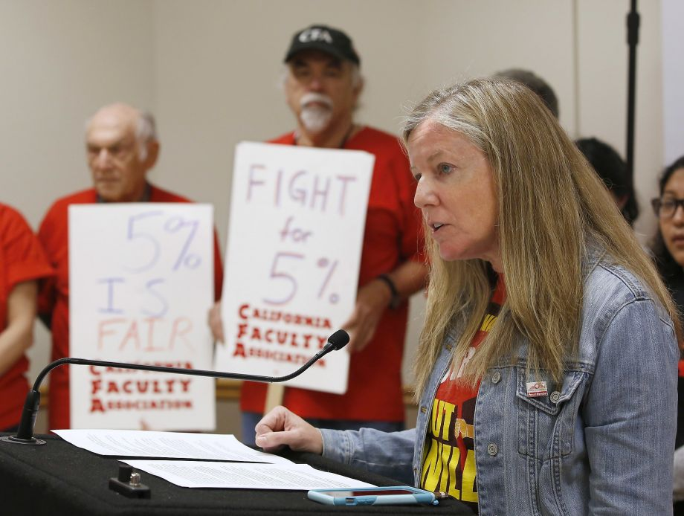
Photo: Rich Pedroncelli, AP
Jennifer Eagen, president of the California Faculty Association, discusses the independent report that supports the position that faculty members at the California State University system are underpaid, during a news conference at CSU, Sacramento, Monday, March 28, 2016. The administration says it doesn't have the money to give a 5 percent raise called for by the faculty association and has offered a 2 precent raise. Eagan said faculty members at the system's 23 campuses are preparing for a five-day strike next month if they cannot reach an agreement. (AP Photo/Rich Pedroncelli)
The 460,000 students on the California State University’s 23 campuses have more to worry about than papers due and final exams this spring. They are looking at the possibility of classes shutting down on April 13 if administrators and the California Faculty Association cannot solve their contract dispute.
First, the bottom lines: The instructors are asking for a 5 percent raise; the administration is offering 2 percent. Each side agrees that faculty members are underpaid and are critical to the quality of the CSU system, and that their comparatively modest compensation in a high-cost state complicates efforts to continue hiring and retaining the best and the brightest.
They disagree on just about everything else, starting with whether the 5 percent raise could be achieved without cutting class offerings, reducing student support services, maintaining facilities at a decent level or laying off lecturers.
An independent arbitrator last week came down squarely on the side of the faculty, concluding that a minimum 5 percent increase would be “in the interest of students, who need caring faculty, and certainly in the public interest, as our country needs a well-educated population.”
“It goes without saying that we’re pleased with the outcome,” said Jennifer Eagan, a professor of philosophy and public affairs at CSU East Bay and president of the California Faculty Association.
But just as important as what fact-finder Bonnie Castrey concluded was what she did not include in her 15-page report: Where would the money come from? A 5 percent faculty raise would cost $70 million more than the administration’s 2 percent offer — along with another $40 million to other unionized employees who have “me too” clauses in their contracts.
The union’s position, which Castrey mostly embraced, is that the money could be found in two ways:
Reallocate funds from other projects that could be delayed.
Lobby the Legislature and Gov. Jerry Brown for more funding.
Chancellor Timothy White told our editorial board in a conference call Monday that he never has disputed that CSU instructors were “underpaid relative to market.” But he insisted that the system needed to live within its means, especially with its commitments to admitting more in-state students and increasing the chances that students can graduate on time.
“That is not in the DNA of the CSU,” White said of curtailing student services.
Replied Eagan: “I’m sure there’s something that can be cut that won’t hurt students.”
The faculty argument would be more compelling if they could provide examples beyond the growth in management size and compensation. It’s reminiscent of the politicians who love to rail about “waste, fraud and abuse” on the campaign trail — but never seem to find it in any significant quantity when they get into office.
It is true that those widely publicized examples of excessive executive pay are a source of outrage — especially to families that are struggling to meet tuition bills — but they represent no more than a tiny slice of overall CSU spending.
Still, the fiscal struggle for many faculty members is very real. Sheila Tully, an anthropology lecturer at San Francisco State, noted that her monthly rent has gone up $1,000 in the past five years while her pay has remained largely stagnant.
“The irony of talking to my students about economic justice and going home and looking at my checkbook is quite something,” Tully said, adding that a university cannot be dependent on part-time faculty. “It’s not sustainable.”
Sustainability is a word the other side uses as well, with reason. While the state economy remains strong overall at the moment, salary commitments made today will bring tough decisions in the next downturn.
The CFA plan is to go on a weeklong strike on April 13 and to extend it if no deal is reached.
A strike would wreak havoc with students that each side professes to care about so deeply. We find ourselves empathetic, and frustrated, with each. In a word: compromise.
http://www.sfchronicle.com/opinion/editorials/article/CSU-needs-to-avoid-April-13-strike-7223245.php&http://www.sfchronicle.com/opinion/editorials/article/CSU-needs-to-avoid-April-13-strike-7223245.php

