Op-Ed Columnist

Oklahoma! Where the Kids Learn Early
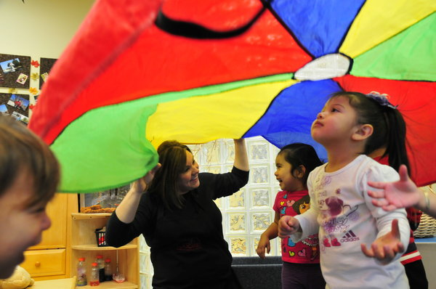
Photo by Nick Oxford for The New York Times
Every 4-year-old in Oklahoma gets access to a year of high-quality preschool. Above, toddlers participate in class at an Educare school in Tulsa.

By NICHOLAS D. KRISTOF Published: November 9, 2013
TULSA, Okla. — LIBERALS don’t expect Oklahoma to serve as a model of social policy. But, astonishingly, we can see in this reddest of red states a terrific example of what the United States can achieve in early education.
Every 4-year-old in Oklahoma gets free access to a year of high-quality prekindergarten. Even younger children from disadvantaged homes often get access to full-day, year-round nursery school, and some families get home visits to coach parents on reading and talking more to their children.
The aim is to break the cycle of poverty, which is about so much more than a lack of money. Take two girls, ages 3 and 4, I met here in one Tulsa school. Their great-grandmother had her first child at 13. The grandmother had her first at 15. The mom had her first by 13, born with drugs in his system, and she now has four children by three fathers.
But these two girls, thriving in a preschool, may break that cycle. Their stepgreat-grandmother, Patricia Ann Gaines, is raising them and getting coaching from the school on how to read to them frequently, and she is determined to see them reach the middle class.
“I want them to go to college, be trouble-free, have no problem with incarceration,” she said.
Research suggests that high-poverty parents, some of them stressed-out kids themselves, don’t always “attach” to their children or read or speak to them frequently. One well-known study found that a child of professionals hears 30 million more words by the age of 4 than a child on welfare.
So the idea is that even the poorest child in Oklahoma should have access to the kind of nurturing that is routine in middle-class homes. That way, impoverished children don’t begin elementary school far behind the starting line — and then give up.
President Obama called in his State of the Union address this year for a nationwide early education program like this, for mountains of research suggests that early childhood initiatives are the best way to chip away at inequality and reduce the toll of crime, drugs and educational failure. Repeated studies suggest that these programs pay for themselves: build preschools now, or prisons later.
Because Obama proposed this initiative, Republicans in Washington are leery. They don’t want some fuzzy new social program, nor are they inclined to build a legacy for Obama. Yet national polling suggests that a majority of Republicans favor early-education initiatives, so I’d suggest that Obama call for nationwide adoption of “The Oklahoma Project” and that Republicans seize ownership of this issue as well.
It’s promising that here in Oklahoma, early education isn’t seen as a Republican or Democratic initiative. It is simply considered an experiment that works. After all, why should we squander human capacity and perpetuate social problems as happens when we don’t reach these kids in time?
“This isn’t a liberal issue,” said Skip Steele, a Republican who is a Tulsa City Council member and strong supporter of early education. “This is investing in our kids, in our future. It’s a no-brainer.”
Teachers, administrators and outside evaluators agree that students who go through the preschool program end up about half a year ahead of where they would be otherwise.
“We’ve seen a huge change in terms of not only academically the preparation they have walking into kindergarten, but also socially,” said Kirt Hartzler, the superintendent of Union Public Schools in Tulsa. “It’s a huge jump-start for kids.”
Oklahoma began a pilot prekindergarten program in 1980, and, in 1998, it passed a law providing for free access to prekindergarten for all 4-year-olds. Families don’t have to send their children, but three-quarters of them attend.
In addition, Oklahoma provides more limited support for needy children 3 and under. Oklahoma has more preschools known as Educare schools, which focus on poor children beginning in their first year, than any other state.
Oklahoma also supports home visits so that social workers can coach stressed-out single moms (or occasionally dads) on the importance of reading to children and chatting with them constantly. The social workers also drop off books; otherwise, there may not be a single children’s book in the house.
The Oklahoma initiative is partly a reflection of the influence of George B. Kaiser, a Tulsa billionaire who searched for charitable causes with the same rigor as if he were looking at financial investments. He decided on early education as having the highest return, partly because neuroscience shows the impact of early interventions on the developing brain and partly because careful studies have documented enormous gains from early education.
So Kaiser began investing in early interventions in Oklahoma and advocating for them, and, because of his prominence and business credentials, people listened to the evidence he cited. He also argues, as a moral issue, that all children should gain fairer access to the starting line.
“Maybe the reason that rich, smart parents had rich, smart children wasn’t genetics,” Kaiser told me, “but that those rich, smart parents also held their kids, read to them, spent a lot of time with them.”
I tagged along as a social worker from Educare visited Whitney Pingleton, 27, a single mom raising three small children. They read to the youngest and talked about how to integrate literacy into daily life. When you see a stop sign, the social worker suggested, point to the letters, sound them out and show how they spell “stop.”
Some of the most careful analysis of the Oklahoma results comes from a team at Georgetown University led by William T. Gormley Jr. and published in peer-reviewed journals. The researchers find sharp gains in prereading, prewriting and prearithmetic skills, as well as improvements in social skills. Some experts think that gains in the ability to self-regulate and work with others are even more important than the educational gains — and certainly make for less disruptive classes. Gormley estimates that the benefits of Oklahoma’s program will outweigh the costs by at least a ratio of 3 to 1.
So how about it, America?
Can we embrace “The Oklahoma Project” — not because it’s liberal or conservative, but because it’s what is best for our kids and our country?
http://www.nytimes.com/2013/11/10/opinion/sunday/kristof-oklahoma-where-the-kids-learn-early.html?_r=0
I invite you to comment on this column on my blog, On the Ground. Please also join me on Facebook and Google+, watch my YouTube videos and follow me on Twitter.

